

: **INSIGHT STREAM: NAVIGATE THE NEWS LANDSCAPE**

Project submitted to the Bharathidasan University, Tiruchirappalli

In partial fulfillment of the requirements for the award of the degree of

BACHELOR OF SCIENCE IN COMPUTER SCIENCE

Submitted by

Name: Elanthamizhan.G

Reg. No: 24057011802111007

NM ID : **D831E6E2AACA9C18D804E4335B9AF7F0**

Under the Guidance of

Dr. M. RAJENDIRAN M.C.A., M.Phil., Ph. D



Department of Computer Science

Government Arts and Science College

Jayankondam-621801

November – 2025

Department of Computer Science

Government Arts and Science College

Jayankondam-621801



CERTIFICATE

This is to certify that the project entitled **INSIGHT STREAM: NAVIGATE THE NEWS LANDSCAPE**

is a bonafide report done by Elanthamizhan.G Reg. No: 24057011802111007

in partial fulfillment of the requirements for the BACHELOR OF SCIENCE IN COMPUTER SCIENCE offered by the Department of Computer Science, Government Arts and Science College, Jayankondam during the academic year 2024 to 2027.

Faculty Mentor Head of the Department

The Viva-Voce held on …………… at the Department of Computer Science, Government Arts and Science College, Jayankondam.

Internal Examiner External Examiner

ACKNOWLEDGEMENT

I would like to thank Dr. M. RAJAMOORTHY, **M.Sc., M.Phil., Ph.D.,** Principal, Government Arts and Science College, Jayankondam for providing me an opportunity and environment that made the work possible.

I would like to express my deep sense of gratitude to Dr.G. KARTHIKEYAN, M.Sc., M.Phil., Ph.D., Head,Department of Computer Science, Government Arts and Science College, Jayankondam for giving me valuable support to complete this study successfully.

I would like to extend my heartfelt thanks to my guide Dr.M.RAJENDIRAN, M.C.A.,M.Phil., Ph.D Department of Computer Science, Government Arts and Science College, Jayankondam for an efficient guidance throughout the course of my project work.

I also express my thanks to my parents, my friends and well-wisher for the encouragementandbestwishes in the successful Completion of the project.

: **INSIGHT STREAM: NAVIGATE THE NEWS LANDSCAPE**

## INTRODUCTION



**1**

Project Title: **INSIGHT STREAM: NAVIGATE THE NEWS LANDSCAPE**

Team ID: NM2025TMID34944

Team Leader: Elanthamizhan.G&g.elanthamizhan0307@gmail.com

Team Members:

1. [MUTHARASAN&mutharasana148@gmil.com](mailto:MUTHARASAN&mutharasana148@gmil.com)

2. CHANDRA MOHAN .S&mohancp8270@gmail.com

3. SATHISHKUMAR [M.A &sathish978653@gmail.com](mailto:M.A%20&sathish978653@gmail.com)

4. [SURIYA.P&pazhanisuriya2@gmail.com](mailto:SURIYA.P&pazhanisuriya2@gmail.com)



# PROJECT OVERVIEW



**2**

Purpose is a personalized music companion that helps users discover, enjoy, : **INSIGHT STREAM: NAVIGATE THE NEWS LANDSCAPE** and even generate music matching their mood and activity. It combines intelligent music recommendations, real time streaming, and interactive features to create a unique, engaging listening experience.

## Key Features

* Personalized music recommendations based on listening habits, mood, and context.
* High-quality music streaming and playlist management with seamless cross-device play back.
* AI-powered “melodic companion”: suggests songs, creates custom playlists, and can generate original melodic snippets.
* Mood-based music generation: ambient background music or AI generated tracks for study, workout, or relaxation.
* Social & community features: collaborative play lists, follow friends, share favorite tracks.
* Secure user authentication & profiles with email/password or social logins.
* Admin control panel: manage content, users, and analytics.

# SYSTEM ARCHITECTURE



**3**

## Frontend

* Technology Stack: React.js (orAngular/Vue) for building an interactive and responsive interface.
* Styling: Tail wind CSS/Bootstrap for layout and UI design.

## Backend

* Technology Stack: Node.js with Express.js (orPython Flask/Django) for server logic and APIs.
* Authentication: JWT (JSON Web Tokens) for secure login and session handling.

## Database

* Preferred: MongoDB (No SQL) for flexible, document-based storage.
* Alternative: My SQL/Postgre SQL if a relational structure is required.

# SETUP INSTRUCTIONS



**4**

## Prerequisites

Software Requirements

* Node.js (backend server and package management)
* Express.js/Flask/Django (depending on backend choice)
* MongoDB/MySQL (data base management)
* React.js/Angular/Vue.js(frontend development)
* Git for version control
* Visual Studio Code (VS Code) or any suitable IDE

SystemRequirements

* OS: Windows/Linux/macOS
* RAM: Minimum 4GB (8GB recommended)
* Processor: Inteli3/AMD equivalent (i5 or higher recommended)
* Storage: At least 500MB free space

Additional Dependencies

* Npm (Node Package Manager)
* Modern browser(Chrome/Firefox/Edge)
* Postman/Thunder Client for api testing

## Installation Steps

Clone the Repository

Gitclone<repositoryurl> cd rhythmic tunes

FrontendSetup

cd client npminstallnpm start

BackendSetup

cd../server npm install npm start

1. ​
2. DatabaseSetup
   * Install and start MongoDB (or My SQL).
   * Create a data base named rhythmic tunes db.
   * Configure connection details in server/config/db.jsorina.env file.
3. AccesstheApplication
   * Open:<http://localhost:3000>
   * Register or login to explore features.

# FOLDER STRUCTURE



**5**

│

├──client/ #Frontend

│├──public/ #Staticfiles(HTML,images,icons)

│├──src/

││├──components/ #ReusableUIcomponents

││├──pages/ #Pages(Landing,Dashboard,TrackDetails)

││├──assets/ #Images,styles,fonts

││├──services/ #APIcallsto backend

││└──App.js #RootReactcomponent

│└──package.json

│

├──server/ #Backend

│├──routes/ #APIroutedefinitions

│├──models/ #Databasemodels

│├──controllers/ #Routelogic

│├──config/ #DBconnection&environmentvariables

│└──server.js #Entrypoint

│

├──database/ #Databasescripts/seeddata

├──docs/ #Projectdocumentation

├──.env #Environmentvariables

├──README.md #Overview&instructions

└──package.json

# RUNNING THE APPLICATION



**6**

Frontend

Cd client npm start

Backend

Cd server npm start

Access via: [http://localhost:3000](http://localhost:3000/)

# API DOCUMENTATION



**7**

## User APIs

* POST/api/user/register–Register a new user
* POST/api/user/login–Authenticate user & return JWT token
* GET/api/user/profile/:id–Fetch user profile
* PUT/api/user/update/:id–Update user details
* DELETE/api/user/:id–Delete a user account

## ProjectAPIs

* POST/api/projects/create–Create a new project/track
* GET/api/projects/:id–Fetch project/track details
* GET/api/projects–Fetch all projects/tracks
* PUT/api/projects/:id–Update project/track info
* DELETE/api/projects/:id–Remove project/track

## Chat APIs

* POST/api/chat/send–Send a message
* GET/api/chat/:user Id–Fetch chat history
* GET/api/chat/conversations/:user Id– List all conversations
* DELETE/api/chat/:chat Id–Delete a chat message

# AUTHENTICATION



**8**

## Flow

* Users (listeners, artists, admins) login with-mail or user name.
* Server issues a JWT stored securely (HTTP-only cookie or local storage).
* JWT contains user role information for Role-Based Access Control (RBAC).

## Registration & Login

* Passwords has hed using bcrypt.
* After login, signed JWT returned to client.

## MiddlewareProtection

* Custom middle ware verifies JWT on protected end points:
  + Uploading music (for artists)
  + Managing playlists
  + Accessing admin dashboard

Invalid/missing tokens result in an error.

## Role-Based Access

* Listeners: Stream music, create playlists, follow artists.
* Artists: Upload/manage tracks, view analytics.
* Admins: Manage users, moderate content.

## Token Refresh & Security

* Access tokens short-lived (15–30 min).
* Refresh tokens used for silent re-authentication.
* Tokens signed with strong secret keys.

## Optional Enhancements

* Social logins (Google, Apple) via O Auth2.
* Two-Factor Authentication (2FA) for artists and admins.

# USER INTERFACE



**9**

## Landing Page

* + Hero section with tag line:*“Your Melodic Companion – Discover, Listen & Create”*
  + Trending songs & artists
  + Preview player (30-sec preview)
  + Call-to-action: Sign Up, Start Listening, Upload Track

## ListenerDashboard

. Personalized recommendations

* + Playlist creation & sharing
  + Followed-artist updates
  + Mini “Now Playing” widget
  + Favorites & Recently Played

## Artist Dashboard

* + Upload &manage tracks
  + View analytics(plays,likes,followers)
  + Monetization tools(exclusive tracks/subscriptions)
  + Fanengagement & profile customization

## Admin Panel

* + User management & content moderation
  + Plat form analytics & revenue tracking
  + Subscription management & system settings

## Track Details Page

* + High-quality audio streaming withwaveformvisualization
  + Synchronized lyrics section
  + Artist info, comments & likes
  + Related track suggestions

## Optional Mobile App Features

* + Offline mode for downloaded songs
  + Push notifications for new releases

10TESTING

## Manual Testing During Milestones

* + Feature checks: after completing modules (streaming engine, play list management, artist dashboard).
  + User journey validation: Listener (sign up→play→add to play list), Artist (upload track→view analytics), Admin (moderate content).
  + Cross-browser/device testing on Chrome, Firefox, Edge, Safari.
  + Negative testing: invalid inputs & error handling.
  + Security checks: ensure JWT- protected routes are in accessible without valid tokens

## Tools

* + Postman: Test REST APIs for JWT, uploads, playlists.
  + Chrome Dev Tools: Debug front end, monitor streaming performance, run Light house audits.

## Outcome

* + Early bug detection ensures smooth play back, secure login, and reliable music upload/streaming.

11.SCREENSHOTS OR DEMO

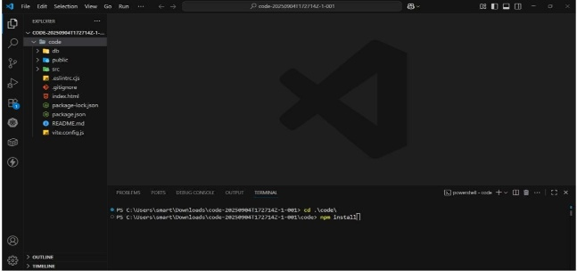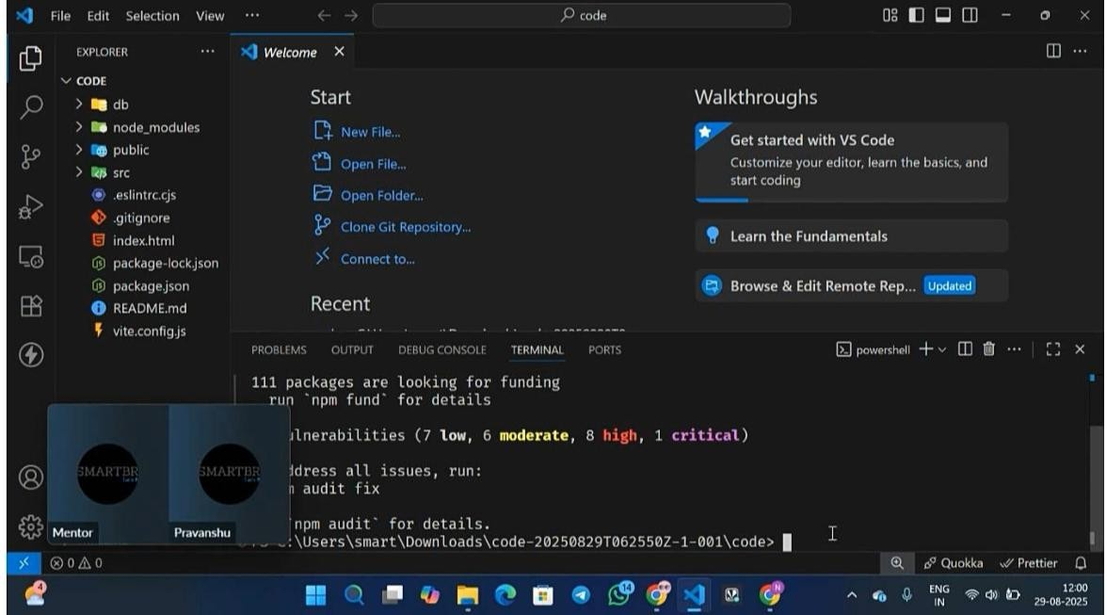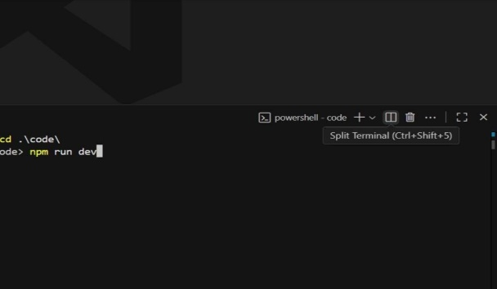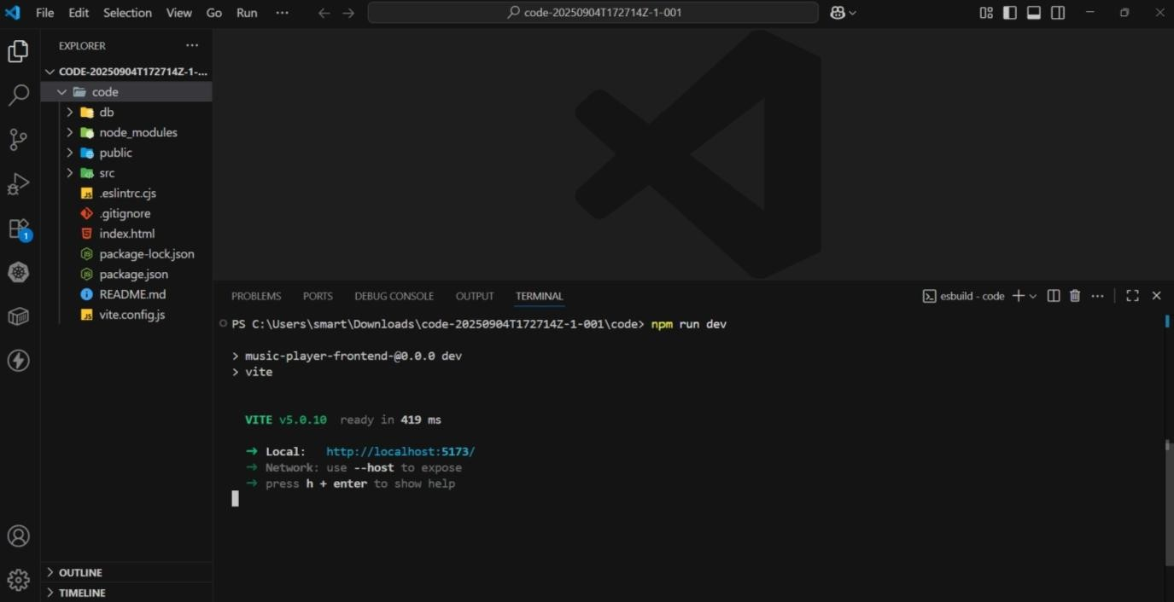

12.KNOWN ISSUES

## Audio

## Authentication & Security

* + Tokenrefreshoccasionallyforcesfullre-login.
  + Google/Appleloginintegrationpending.

## Artist Dashboard

* + Bulk upload limit(>5tracks)may fail with large files.
  + Analytics refresh every 10–15 minutes, not live.

## AdminPanel

* + Reported tracks can take upto a minute to appear in moderation.

## GeneralPerformance

* + First-time load is slow on low-end devices.
  + Browser caching sometimes shows outdated playlist artwork.

PlannedFixes

* + Optimize CDN and caching strategy.
  + Improve mobile responsiveness and dark mode.
  + Enhance real-time analytics.
  + Complete O Auth (Google/Apple) integration.

# 13 . FUTUREENHANCEMENTS

## Advanced Music Discovery

* + AI-driven recommendations based on mood and listening habits.
  + Smart play lists auto-generated and updated daily.

## EnhancedArtistTools

* + Monetization options: sell exclusive tracks or offer subscriptiontiers.
  + Collaboration platform for co-creating music.

## Social & Community Features

* + Live listening parties.
  + Song-level comments and genre-based forums.

## Mobile & Offline

* + Dedicated iOS/Android apps with push notifications.
  + Offline mode for downloaded playlists.

## 

## Advanced Streaming & Audio Quality

* + Loss less/Hi-Re saudio for premium users.
  + Adaptive bitrate streaming for seamless playback.

## Security & Authentication

* + Two-Factor Authentication (2FA).
  + O Auth login via Google, Apple, or Spotify.

## Analytics & Insights

* + Real-time listener analytics and recommendation feedback.

## Integrations & Partnerships

* + Smart speaker support (Alexa, Google Home).
  + Event & ticketing integration for concerts and virtual shows