**lab3实验报告**

**一、实验原理**

**链路发现原理:**

LLDP(Link Layer Discover Protocol) 即链路层发现协议， OSKen 主要利⽤ LLDP 发现⽹络拓

扑。 LLDP 被封装在以太⽹帧中，结构如下图。其中深灰⾊的即为 LLDP 负载， Chassis ID

TLV , Port ID TLV 和 Time to live TLV 是三个强制字段，分别代表交换机标识符（在局域⽹中是独⼀⽆⼆的），端⼝号和 TTL 。

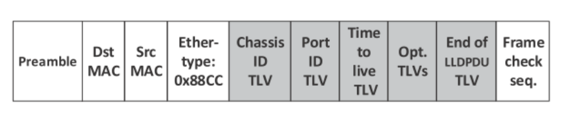

OSKen 如何利⽤ LLDP 发现链路（假设有两个 OpenFlow 交换机连接在控制器上）：

1. SDN 控制器构造 PacketOut 消息向 S1 的三个端口分别发送 LLDP 数据包，其中将 Chassis ID,TLV 和 Port ID TLV 分别置为 S1 的 dpid 和端口号；

2. 控制器向交换机 S1 中下发流表，流表规则为：将从 Controller 端口收到的 LLDP 数据包从他的对应端口发送出去；

3. 控制器向交换机 S2 中下发流表，流表规则为：将从非 Controller 接收到的 LLDP 数据包发送给控制器；

4. 控制器通过解析 LLDP 数据包，得到链路的源交换机，源接口，通过收到的 PacketIn 消息知道目的交换机和目的接口。

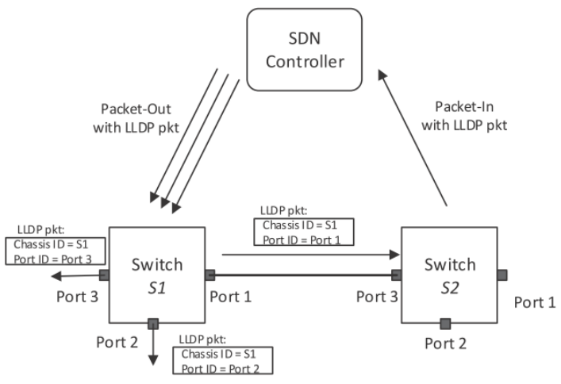

**沉默主机现象：**

主机如果没有主动发送过数据包，控制器就⽆法发现主机。运⾏前⾯的 demo.py 时，你可能会看到host 输出为空，这就是沉默主机现象导致的。你可以在 mininet 中运⾏ pingall 指令，令每个主机发出 ICMP 数据包，这样控制器就能够发现主机。当然命令的结果是 ping 不通，因为程序中并没有下发路由的代码。

**测量原理：链路时延**

控制器将带有时间戳的LLDP报⽂下发给S1，S1转发给S2，S2上传回控制器，根据收到的时间和发送时间即可计算出控制器经S1到S2再返回控制器的时延，记为lldp_delay_s12

反之，控制器经S2到S1再返回控制器的时延，记为lldp_delay_s21

交换机收到控制器发来的Echo报⽂后会⽴即回复控制器，我们可以利⽤Echo Request/Reply 报⽂求出控制器到S1、S2的往返时延，记为echo_delay_s1 , echo_delay_s2

则S1到S2的时延delay = (lldp_delay_s12 + lldp_delay_s21 - echo_delay_s1 - echo_delay_s2) / 2

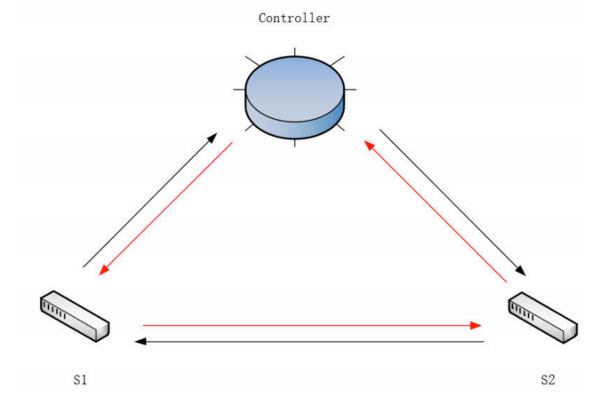

**二、实验过程**

**（一）必做题：最小时延路径**

在 least_hops.py 的基础上进行修改：

·以时延作为权重指标self.weight = 'delay'

·补充handle_arp()处理环路

·补充handle_ipv4()计算并记录路径延时

在 network_awareness.py 的基础上进行修改：

·补充packet_in_hander()记录lldp_delay

·使用lldp_delay和echo_delay字典存储链路延迟数据

·增加calculate_link_delay()计算双向链路延迟

·增加echo_send_requests()发送Echo请求

·补充_get_topology()计算总延迟delay

topo_1970.py拓扑结构：

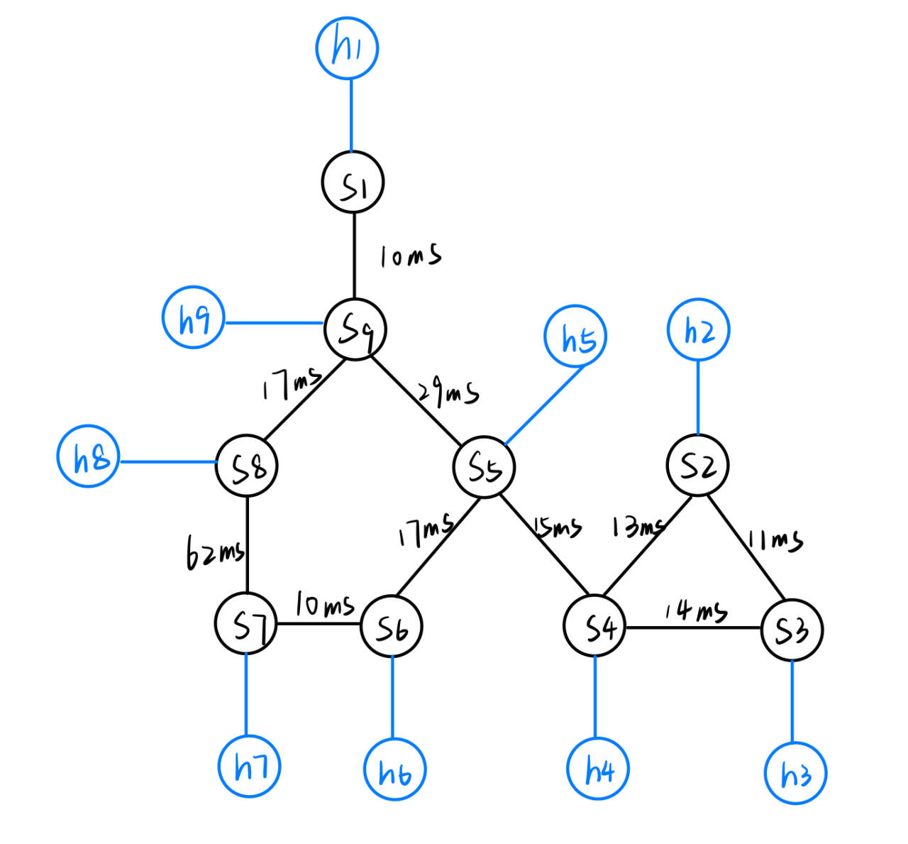

SDC ping MIT (h6 ping h8)

理论值(17+29+17)×2=126ms

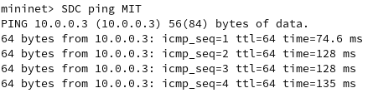

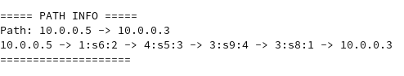

**（二）选做题：容忍链路故障**

在任务一的基础上修改network_awareness.py

·补充事件处理函数port_status_handler()检测端口变化，当端口状态变化时清空拓扑图

·补充delete_flow()删除指定交换机上特定端口关联的所有流表项

|  |
| --- |
| @set_ev_cls(ofp_event.EventOFPPortStatus, MAIN_DISPATCHER)  def port_status_handler(self, ev):  self.logger.info("Note: Now in port_status_handle")  msg = ev.msg  datapath = msg.datapath  ofproto = datapath.ofproto  if msg.reason in [ofproto.OFPPR_ADD, ofproto.OFPPR_MODIFY]:  datapath.ports[msg.desc.port_no] = msg.desc  self.topo_map.clear()  for dpid in self.port_info.keys():  for port in self.port_info[dpid]:  self.delete_flow(self.switch_info[dpid],port)  elif msg.reason == ofproto.OFPPR_DELETE:  datapath.ports.pop(msg.desc.port_no, None)  else:  return  self.send_event_to_observers(ofp_event.EventOFPPortStateChange(  datapath, msg.reason, msg.desc.port_no),  datapath.state) |

|  |
| --- |
| def delete_flow(self, datapath,port_no):  ofproto = datapath.ofproto  parser = datapath.ofproto_parser  try:  match = parser.OFPMatch(in_port=port_no)  flow_mod = parser.OFPFlowMod(datapath=datapath,command=ofproto.OFPFC_DELETE,out_port=ofproto.OFPP_ANY,  out_group=ofproto.OFPG_ANY,match=match)  datapath.send_msg(flow_mod)  self.logger.info("Deleted flow entries associated with port %s on switch %s", port_no, datapath.id)  except Exception as e:  self.logger.error("Failed to delete flow entries associated with port %s on switch %s: %s",  port_no, datapath.id, str(e)) |

删除link s9 s8

理论值(10+62)×2=144ms

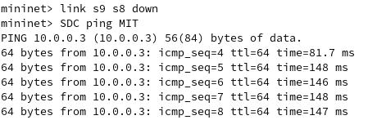

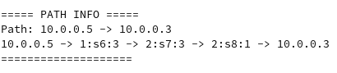

恢复链路

理论值(17+29+17)×2=126ms

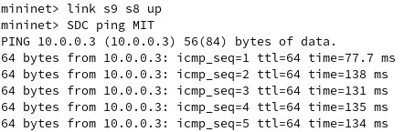



与实验一结果一致

**三、代码附录**

ShortestForward.py

|  |
| --- |
| from os_ken.base import app_manager  from os_ken.controller import ofp_event  from os_ken.controller.handler import CONFIG_DISPATCHER, MAIN_DISPATCHER, DEAD_DISPATCHER, HANDSHAKE_DISPATCHER  from os_ken.controller.handler import set_ev_cls  from os_ken.controller.handler import set_ev_cls  from os_ken.ofproto import ofproto_v1_3  from os_ken.lib.packet import packet  from os_ken.lib.packet import ethernet, arp, ipv4  from os_ken.lib.packet import ether_types  from os_ken.controller import ofp_event  from os_ken.topology import event  import sys  from network_awareness import NetworkAwareness  import networkx as nx  ETHERNET = ethernet.ethernet.__name__  ETHERNET_MULTICAST = "ff:ff:ff:ff:ff:ff"  ARP = arp.arp.__name__  class ShortestForward(app_manager.OSKenApp):  OFP_VERSIONS = [ofproto_v1_3.OFP_VERSION]  _CONTEXTS = {'network_awareness': NetworkAwareness}  def __init__(self, *args, **kwargs):  super(ShortestForward, self).__init__(*args, **kwargs)  self.network_awareness = kwargs['network_awareness']  self.weight = 'delay'  self.mac_to_port = {}  self.sw = {}  self.path=None  def add_flow(self, datapath, priority, match, actions, idle_timeout=0, hard_timeout=0):  dp = datapath  ofp = dp.ofproto  parser = dp.ofproto_parser  inst = [parser.OFPInstructionActions(ofp.OFPIT_APPLY_ACTIONS, actions)]  mod = parser.OFPFlowMod(  datapath=dp, priority=priority,  idle_timeout=idle_timeout,  hard_timeout=hard_timeout,  match=match, instructions=inst)  dp.send_msg(mod)  @set_ev_cls(ofp_event.EventOFPPacketIn, MAIN_DISPATCHER)  def packet_in_handler(self, ev):  msg = ev.msg  in_port = msg.match['in_port']  pkt = packet.Packet(msg.data)  eth_pkt = pkt.get_protocol(ethernet.ethernet)  arp_pkt = pkt.get_protocol(arp.arp)  ipv4_pkt = pkt.get_protocol(ipv4.ipv4)  pkt_type = eth_pkt.ethertype  # layer 2 self-learning  dst_mac = eth_pkt.dst  src_mac = eth_pkt.src  if isinstance(arp_pkt, arp.arp):  self.handle_arp(msg, in_port, dst_mac,src_mac, pkt,pkt_type)  if isinstance(ipv4_pkt, ipv4.ipv4):  self.handle_ipv4(msg, ipv4_pkt.src, ipv4_pkt.dst, pkt_type)  def handle_arp(self, msg, in_port, dst,src, pkt,pkt_type):  #just handle loop here  #just like your code in exp1 mission2  dp = msg.datapath  ofp = dp.ofproto  parser = dp.ofproto_parser  dpid = dp.id  self.mac_to_port.setdefault(dpid, {})  eth_pkt = pkt.get_protocol(ethernet.ethernet)  if eth_pkt.ethertype == ether_types.ETH_TYPE_LLDP:  return  if eth_pkt.ethertype == ether_types.ETH_TYPE_IPV6:  return  dst = eth_pkt.dst  src = eth_pkt.src  header_list = dict((p.protocol_name, p) for p in pkt.protocols if type(p) != str)  if dst == ETHERNET_MULTICAST and ARP in header_list:  arp_packet = header_list[ARP]  dst_ip = arp_packet.dst_ip  if (dpid, src, dst_ip) in self.sw:  if self.sw[(dpid, src, dst_ip)] != in_port:  return  else:  self.sw[(dpid, src, dst_ip)] = in_port  self.mac_to_port[dpid][src] = in_port  if dst in self.mac_to_port[dpid]:  out_port = self.mac_to_port[dpid][dst]  else:  out_port = ofp.OFPP_FLOOD  actions = [parser.OFPActionOutput(out_port)]  if out_port != ofp.OFPP_FLOOD: # Already learned, therefore sending flow table entries  match = parser.OFPMatch(in_port = in_port, eth_src = src, eth_dst = dst)  self.add_flow(dp, 1, match, actions,idle_timeout = 5,hard_timeout = 5)  out = parser.OFPPacketOut(datapath = dp, buffer_id = msg.buffer_id, in_port = in_port, actions = actions, data = msg.data)  dp.send_msg(out)  def handle_ipv4(self, msg, src_ip, dst_ip, pkt_type):  parser = msg.datapath.ofproto_parser  dpid_path = self.network_awareness.shortest_path(src_ip, dst_ip,weight=self.weight)  if not dpid_path:  return  self.path=dpid_path  # get port path: h1 -> in_port, s1, out_port -> h2  port_path = []  for i in range(1, len(dpid_path) - 1):  in_port = self.network_awareness.link_info[(dpid_path[i], dpid_path[i - 1])]  out_port = self.network_awareness.link_info[(dpid_path[i], dpid_path[i + 1])]  port_path.append((in_port, dpid_path[i], out_port))  self.show_path(src_ip, dst_ip, port_path)  # calculate path delay  delay = 0  for i in range(len(dpid_path) - 1):  src_dpid = dpid_path[i]  dst_dpid = dpid_path[i + 1]  delay += self.network_awareness.lldp_delay.get((src_dpid, dst_dpid), 0)  # send flow mod  for node in port_path:  in_port, dpid, out_port = node  self.send_flow_mod(parser, dpid, pkt_type, src_ip, dst_ip, in_port, out_port)  self.send_flow_mod(parser, dpid, pkt_type, dst_ip, src_ip, out_port, in_port)  # send packet_out  _, dpid, out_port = port_path[-1]  dp = self.network_awareness.switch_info[dpid]  actions = [parser.OFPActionOutput(out_port)]  out = parser.OFPPacketOut(  datapath=dp, buffer_id=msg.buffer_id, in_port=in_port, actions=actions, data=msg.data)  dp.send_msg(out)  def send_flow_mod(self, parser, dpid, pkt_type, src_ip, dst_ip, in_port, out_port):  dp = self.network_awareness.switch_info[dpid]  match = parser.OFPMatch(  in_port=in_port, eth_type=pkt_type, ipv4_src=src_ip, ipv4_dst=dst_ip)  actions = [parser.OFPActionOutput(out_port)]  self.add_flow(dp, 1, match, actions, 10, 30)  def show_path(self, src, dst, port_path):  self.logger.info('path: {} -> {}'.format(src, dst))  path = src + ' -> '  for node in port_path:  path += '{}:s{}:{}'.format(*node) + ' -> '  path += dst  self.logger.info(path) |

network_awareness.py

|  |
| --- |
| # network_awareness.py  from os_ken.base import app_manager  from os_ken.base.app_manager import lookup_service_brick  from os_ken.ofproto import ofproto_v1_3  from os_ken.controller.handler import set_ev_cls  from os_ken.controller.handler import MAIN_DISPATCHER, CONFIG_DISPATCHER, DEAD_DISPATCHER, HANDSHAKE_DISPATCHER  from os_ken.controller import ofp_event  from os_ken.lib.packet import packet, ethernet, arp, ether_types  from os_ken.lib import hub  from os_ken.topology import event  from os_ken.topology.api import get_host, get_link, get_switch  from os_ken.topology.switches import LLDPPacket  import networkx as nx  import copy  import time  import struct  GET_TOPOLOGY_INTERVAL = 2  SEND_ECHO_REQUEST_INTERVAL = .05  GET_DELAY_INTERVAL = 2  class NetworkAwareness(app_manager.OSKenApp):  OFP_VERSIONS = [ofproto_v1_3.OFP_VERSION]  def __init__(self, *args, **kwargs):  super(NetworkAwareness, self).__init__(*args, **kwargs)  self.switch_info = {}  self.link_info = {}  self.port_link={}  self.port_info = {}  self.topo_map = nx.Graph()  self.topo_thread = hub.spawn(self._get_topology)  self.switches = {}  self.lldp_delay = {}  self.echo_delay = {}  self.weight = 'delay'  def add_flow(self, datapath, priority, match, actions):  dp = datapath  ofp = dp.ofproto  parser = dp.ofproto_parser  inst = [parser.OFPInstructionActions(ofp.OFPIT_APPLY_ACTIONS, actions)]  mod = parser.OFPFlowMod(datapath=dp, priority=priority, match=match, instructions=inst)  dp.send_msg(mod)  @set_ev_cls(ofp_event.EventOFPSwitchFeatures, CONFIG_DISPATCHER)  def switch_features_handler(self, ev):  msg = ev.msg  dp = msg.datapath  ofp = dp.ofproto  parser = dp.ofproto_parser  match = parser.OFPMatch()  actions = [parser.OFPActionOutput(ofp.OFPP_CONTROLLER, ofp.OFPCML_NO_BUFFER)]  self.add_flow(dp, 0, match, actions)  @set_ev_cls(ofp_event.EventOFPStateChange, [MAIN_DISPATCHER, DEAD_DISPATCHER])  def state_change_handler(self, ev):  dp = ev.datapath  dpid = dp.id  if ev.state == MAIN_DISPATCHER:  self.switch_info[dpid] = dp  if ev.state == DEAD_DISPATCHER:  del self.switch_info[dpid]    @set_ev_cls(ofp_event.EventOFPPacketIn, MAIN_DISPATCHER)  def packet_in_hander(self, ev):  msg = ev.msg  dpid = msg.datapath.id  try:  src_dpid, src_port_no = LLDPPacket.lldp_parse(msg.data)  if not self.switches:  self.switches = lookup_service_brick('switches')  for port in self.switches.ports.keys():  if src_dpid == port.dpid and src_port_no == port.port_no:  self.lldp_delay[(src_dpid, dpid)] = self.switches.ports[port].delay  except:  return    @set_ev_cls(ofp_event.EventOFPEchoReply, MAIN_DISPATCHER)  def echo_hander(self,ev):  recv_time = time.time()  try:  msg = ev.msg  dpid = msg.datapath.id  send_time = struct.unpack('d', msg.data)[0]  self.echo_delay[dpid] = recv_time - send_time  except:  return    @set_ev_cls(ofp_event.EventOFPPortStatus, MAIN_DISPATCHER)  def port_status_handler(self, ev):  self.logger.info("Note: Now in port_status_handle")  msg = ev.msg  datapath = msg.datapath  ofproto = datapath.ofproto  if msg.reason in [ofproto.OFPPR_ADD, ofproto.OFPPR_MODIFY]:  datapath.ports[msg.desc.port_no] = msg.desc  self.topo_map.clear()  for dpid in self.port_info.keys():  for port in self.port_info[dpid]:  self.delete_flow(self.switch_info[dpid],port)  elif msg.reason == ofproto.OFPPR_DELETE:  datapath.ports.pop(msg.desc.port_no, None)  else:  return  self.send_event_to_observers(ofp_event.EventOFPPortStateChange(  datapath, msg.reason, msg.desc.port_no),  datapath.state)  def echo_send_requests(self, switch):  datapath = switch.dp  parser = datapath.ofproto_parser  send_time = time.time()  data = struct.pack('d', send_time)  echo_req = parser.OFPEchoRequest(datapath, data = data)  datapath.send_msg(echo_req)  hub.sleep(0.2)  return    def delete_flow(self, datapath,port_no):  ofproto = datapath.ofproto  parser = datapath.ofproto_parser  try:  match = parser.OFPMatch(in_port=port_no)  flow_mod = parser.OFPFlowMod(datapath=datapath,command=ofproto.OFPFC_DELETE,out_port=ofproto.OFPP_ANY,  out_group=ofproto.OFPG_ANY,match=match)  datapath.send_msg(flow_mod)  self.logger.info("Deleted flow entries associated with port %s on switch %s", port_no, datapath.id)  except Exception as e:  self.logger.error("Failed to delete flow entries associated with port %s on switch %s: %s",  port_no, datapath.id, str(e))  def _get_topology(self):  _hosts, _switches, _links = None, None, None  while True:  hosts = get_host(self)  switches = get_switch(self)  links = get_link(self)  # update topo_map when topology change  if [str(x) for x in hosts] == _hosts and [str(x) for x in switches] == _switches and [str(x) for x in links] == _links:  continue  _hosts, _switches, _links = [str(x) for x in hosts], [str(x) for x in switches], [str(x) for x in links]  for switch in switches:  self.port_info.setdefault(switch.dp.id, set())  # record all ports  for port in switch.ports:  self.port_info[switch.dp.id].add(port.port_no)  self.echo_send_requests(switch)  for host in hosts:  # take one ipv4 address as host id  if host.ipv4:  self.link_info[(host.port.dpid, host.ipv4[0])] = host.port.port_no  self.topo_map.add_edge(host.ipv4[0], host.port.dpid, hop=1, delay=0, is_host=True)  for link in links:  # delete ports linked switches  self.port_info[link.src.dpid].discard(link.src.port_no)  self.port_info[link.dst.dpid].discard(link.dst.port_no)  # s1 -> s2: s1.port, s2 -> s1: s2.port  self.port_link[(link.src.dpid,link.src.port_no)]=(link.src.dpid, link.dst.dpid)  self.port_link[(link.dst.dpid,link.dst.port_no)] = (link.dst.dpid, link.src.dpid)  self.link_info[(link.src.dpid, link.dst.dpid)] = link.src.port_no  self.link_info[(link.dst.dpid, link.src.dpid)] = link.dst.port_no  delay = self.calculate_link_delay(link.src.dpid, link.dst.dpid)  self.logger.info("Added link: src_dpid=%s dst_dpid=%s delay= %.5fms",link.src.dpid, link.dst.dpid, delay*1000)  self.topo_map.add_edge(link.src.dpid, link.dst.dpid, hop=1, delay=delay,is_host=False)  if self.weight == 'delay':  self.show_topo_map()  hub.sleep(GET_TOPOLOGY_INTERVAL)  def calculate_link_delay(self, src_dpid, dst_dpid):  lldp_delay_s12 = self.lldp_delay.get((src_dpid, dst_dpid), 0)  lldp_delay_s21 = self.lldp_delay.get((dst_dpid, src_dpid), 0)  echo_delay_s1 = self.echo_delay.get(src_dpid, 0)  echo_delay_s2 = self.echo_delay.get(dst_dpid, 0)  delay = (lldp_delay_s12 + lldp_delay_s21 - echo_delay_s1 - echo_delay_s2) / 2  return max(delay, 0)  def shortest_path(self, src, dst, weight='delay'):  try:  paths = list(nx.shortest_simple_paths(self.topo_map, src, dst, weight=weight))  return paths[0]  except:  self.logger.info('host not find/no path')  def show_topo_map(self):  self.logger.info('topo map:')  self.logger.info('{:^10s} -> {:^10s}'.format('node', 'node'))  for src, dst in self.topo_map.edges:  self.logger.info('{:^10s} {:^10s}'.format(str(src), str(dst)))  self.logger.info('\n') |