Android Studio IDE
Detailed Explanation of Components and Subcomponents
A visual and practical learning guide for Android application development

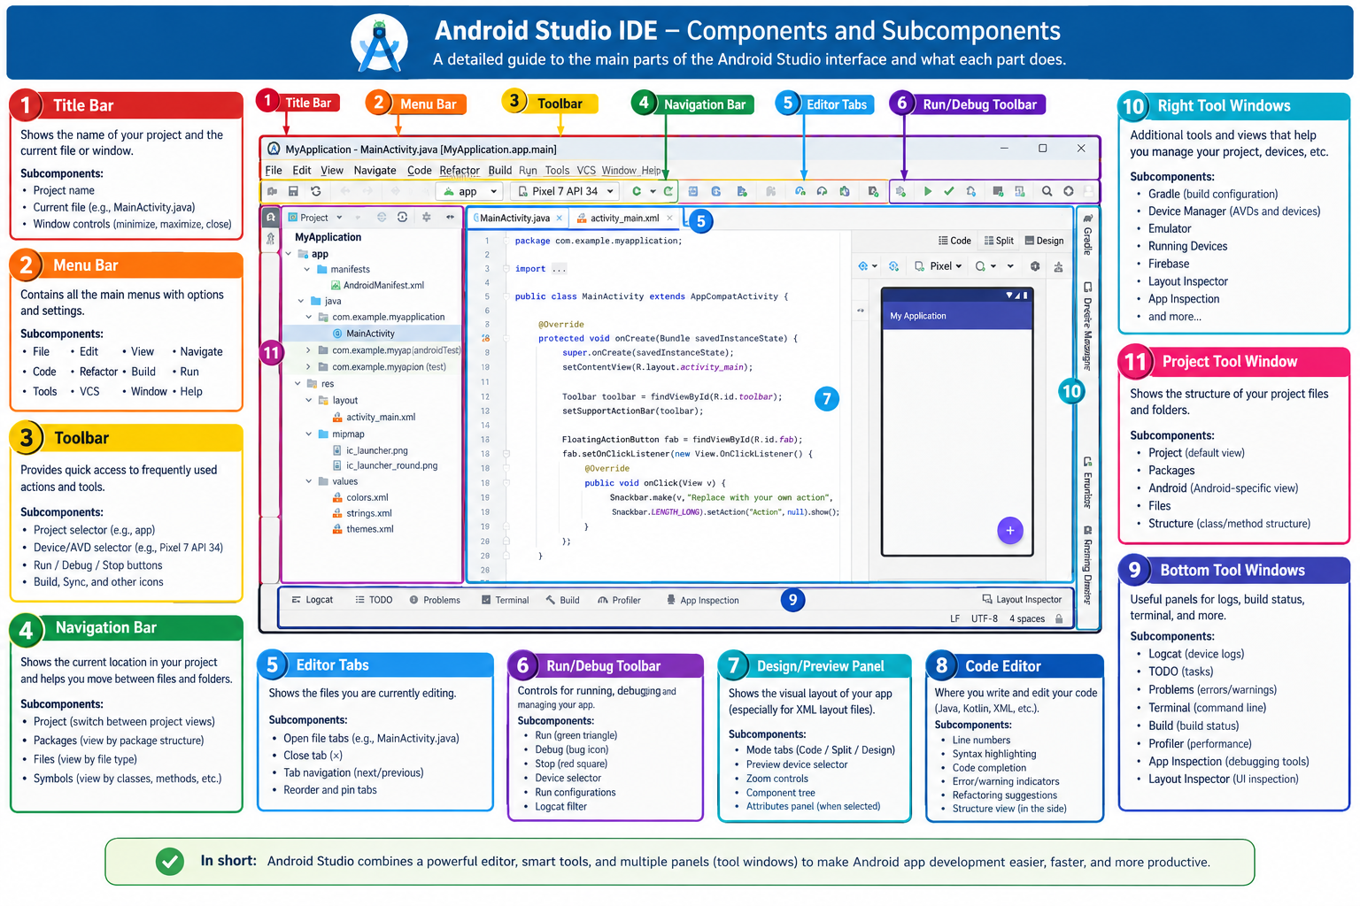
Note: The illustration is an educational overview rather than an exact screenshot of every Android Studio version. Interface arrangement and available tools can vary.

Introduction
Android Studio is the official integrated development environment (IDE) for developing Android applications. It provides tools for writing code, designing interfaces, managing project files, running applications on emulators or physical devices, testing, debugging, and preparing applications for release.
Android Studio supports Kotlin and Java, and it supports Android user-interface development using XML layouts and Jetpack Compose. The interface is divided into areas such as the menu bar, toolbar, Project window, code editor, design preview, tool windows, and status bar.
Official reference: https://developer.android.com/studio/intro/user-interface

PART I: MAIN COMPONENTS OF ANDROID STUDIO

1. Title Bar
The Title Bar is the topmost area of the application window. It identifies the project or window you are working with.
- Project name: identifies the currently open project, for example, MyApplication.
- Current file or window title: depending on the version and operating system, may identify the project or active file, such as MainActivity.kt.
- Minimize button: minimizes Android Studio to the taskbar without closing it.
- Maximize/Restore button: expands the window or returns it to its previous size.
- Close button: closes the Android Studio window.
Purpose: identify the current working environment and manage the application window.

2. Menu Bar
The Menu Bar provides access to Android Studio commands and settings. Menus and their exact placement can vary by version.
- File: Create, open, save, import, or close projects and files; access project settings.
- Edit: Undo, redo, cut, copy, paste, find, replace, and select text.
- View: Show or hide tool windows and toolbars, and adjust the interface layout.
- Navigate: Move to files, classes, methods, declarations, and recently opened items.
- Code: Reformat code, add imports, generate or override methods, and apply quick fixes.
- Refactor: Safely rename, move, or restructure code and update references.
- Build: Build or rebuild the project, clean build outputs, and prepare APK or App Bundle outputs.
- Run: Launch the application, select run configurations, and manage execution.
- Tools: Access additional development utilities and device-related tools.
- VCS: Access version-control operations such as commits, branches, and change comparisons.
- Window: Switch between project windows and manage layouts where supported.
- Help: Open documentation, shortcut references, product information, and support resources.
Purpose: provide organized access to the IDE's commands.

3. Toolbar
The Toolbar provides quick access to frequently used actions. In newer interfaces, some actions may be grouped into widgets or overflow menus.
- Project selector: helps identify or switch projects, depending on the interface.
- Run configuration selector: chooses how a particular application or task should be launched.
- Device selector: chooses a target, such as an Android Virtual Device (AVD) or connected phone.
- Run button: builds if necessary, installs, and launches the selected application/configuration.
- Debug button: launches the application in debugging mode.
- Stop button: terminates the selected running process or execution when supported.
- Build and synchronization actions: provide access to project build tasks and Gradle synchronization.
- Search and settings: help locate files, commands, tools, and configuration options.
Purpose: speed up everyday development activities.

4. Navigation Bar
The Navigation Bar shows the location of the selected file within the project and helps you move through the project hierarchy.
- Project path: displays the hierarchy leading to a file, such as StudentRegistration → app → src → main.
- Folder navigation: allows movement to parent folders or other available elements.
- File navigation: helps locate and open files.
- Relationship to Project window: the Navigation Bar is a compact navigation aid; the Project window shows a more detailed hierarchy.
Purpose: make navigation through project files easier.

PART II: EDITING AND DESIGN COMPONENTS

5. Editor Tabs
Editor Tabs appear above the central editing area. Each tab usually represents a file that is open for editing.
- File tabs: examples include MainActivity.kt, activity_main.xml, AndroidManifest.xml, and build.gradle.kts.
- Active tab: identifies the file currently displayed in the editor.
- Close tab: closes a tab but normally does not delete the file from the project.
- Tab navigation: switches between open files using the mouse or keyboard shortcuts.
- Split editor: displays multiple files or sections side by side when supported.
Example: in a login application, you might switch between LoginActivity.kt, activity_login.xml, and strings.xml.
Purpose: make it easier to work across several files.

6. Run/Debug Controls
- Run: executes the selected application or run configuration on the chosen target.
- Debug: runs the application with tools for inspecting execution.
- Breakpoints: pause execution at a selected line, subject to breakpoint conditions.
- Step Over: executes the current line without entering a called method.
- Step Into: enters a called method or function when possible.
- Step Out: continues until the current method or function returns.
- Variables panel: shows current variable values during debugging.
- Call Stack: shows the sequence of active method calls leading to the current point.
- Run configurations: define how an application or task is executed.
- Logcat filtering: filters log messages by app, severity, or search term.
Example: set a breakpoint inside a login method to inspect the entered username and understand why authentication is failing.
Purpose: run applications and diagnose unexpected behavior.

7. Design/Preview Panel
The Design/Preview Panel lets you inspect a user interface visually. The available controls depend on whether the project uses XML layouts, Jetpack Compose, or another supported UI technology.
- Design mode: shows a visual representation of supported layouts and may allow visual editing.
- Code mode: shows the source representation, such as XML markup.
- Split mode: shows source and visual representation together when supported.
- Device preview selector: lets you inspect a layout against different device sizes or configurations.
- Zoom controls: change the preview display scale, not necessarily the actual layout dimensions.
- Component Tree: shows the hierarchy of UI elements in supported visual editors.
- Attributes panel: displays properties of the selected UI element, such as ID, text, dimensions, margins, and padding.
- Preview rendering: renders the interface for inspection, though some behavior must be tested by running the app.
Example XML button:
<Button
android:layout_width="wrap_content"
android:layout_height="wrap_content"
android:text="Login" />
Purpose: create and inspect user interfaces.

8. Code Editor
The Code Editor is the main area for writing, reading, modifying, and reviewing source code. It supports Kotlin, Java, XML, Gradle configuration, and other file types.
- Text editing area: the central space where code is entered and modified.
- Line numbers: help identify lines when reading code, setting breakpoints, or discussing errors.
- Syntax highlighting: uses visual styles to distinguish keywords, strings, comments, and identifiers.
- Code completion: suggests classes, methods, variables, properties, and imports as you type.
- Error and warning indicators: highlight detected issues such as unresolved references, type mismatches, and unused declarations.
- Quick fixes: offer possible solutions to certain detected problems; Alt + Enter commonly opens intentions on Windows.
- Code folding: collapses functions, classes, or blocks to simplify large files.
- Refactoring support: supports safe renaming and other structural changes.
- Breakpoint gutter: the area beside line numbers where breakpoints can be set.
- Inspection/navigation indicators: help locate declarations, references, warnings, and related code.
Example Kotlin code:
fun greetStudent() {
println("Welcome to Android development!")
}
Purpose: provide the primary environment for writing and maintaining application code.

PART III: TOOL WINDOWS

9. Bottom Tool Windows
Bottom Tool Windows contain panels for inspecting application output, running commands, examining errors, and monitoring performance. Not all panels are visible all the time.
- Logcat: Displays log messages from Android devices and applications. It helps investigate exceptions, crashes, and unexpected behavior. Example: Log.d("StudentApp", "Student registration started") writes a debug message.
- TODO: Locates comments marking unfinished tasks, such as // TODO: Validate the student ID before saving.
- Problems: Provides a consolidated view of detected errors, warnings, and code-inspection issues. Static-analysis warnings are not necessarily runtime failures.
- Terminal: Provides command-line access, commonly through PowerShell or Command Prompt on Windows. Examples include adb devices and gradlew.bat assembleDebug, assuming the tools and project wrapper are available.
- Build: Displays build progress, compilation errors, resource-processing errors, dependency-resolution problems, and task output.
- Profiler: Helps analyze CPU use, memory use, network activity, and performance behavior.
- App Inspection: Provides tools for inspecting aspects of a running app, including supported database or network behavior.
- Layout Inspector: Inspects the UI hierarchy of a running app on a supported device or emulator and helps diagnose layout problems.
- Run: Shows output and information associated with a running configuration.
- Debug: Displays debugger information such as variables, call stacks, breakpoints, and debugger controls.
Purpose: test, observe, troubleshoot, and improve the application.

10. Right-Side Tool Windows
- Gradle: The build automation system commonly used by Android projects. The Gradle tool window gives access to available build tasks.
- Device Manager: Creates and manages Android Virtual Devices (AVDs), including device profiles and system images.
- Emulator: Simulates an Android device on the computer so you can test without a physical phone.
- Running Devices: Provides access to supported running devices and their application displays.
- Device File Explorer: Browses accessible files on a connected device or emulator, subject to Android permissions and sandbox restrictions.
- Firebase: Provides supported integration with Firebase services such as Authentication, Cloud Firestore, Realtime Database, Cloud Messaging, or crash reporting, depending on setup.
- Other tool windows: Additional tools may support version control, databases, resources, build variants, testing, and profiling.
Note: these tools are not always located on the right side; position and visibility depend on the IDE layout.
Purpose: provide access to supporting development and device-management utilities.

11. Project Tool Window
The Project Tool Window displays the files and folders that make up an Android application. It is usually on the left side of Android Studio.

11.1 Project view selector
The Android view organizes files into convenient Android development categories. The Project view shows the actual directory structure on disk more directly.

11.2 App module
The app module commonly contains the main application code, resources, and module-level build configuration.
StudentRegistration
├── app
│ ├── src
│ │ └── main
│ │ ├── AndroidManifest.xml
│ │ ├── java
│ │ └── res
│ └── build.gradle.kts
├── gradle
├── build.gradle.kts
├── settings.gradle.kts
└── gradlew.bat
This is a simplified example. Actual project structure varies by template and version.
- Manifests: AndroidManifest.xml declares important app information, such as activities, services, receivers, providers, permissions, and metadata.
- Kotlin or Java source files: contain application logic, such as activities, data models, and data-handling components.
- Test source sets: organize unit tests and instrumented tests.
- res/drawable: contains drawable resources and certain graphic assets.
- res/layout: commonly contains XML layouts for View-based projects; Compose interfaces may be defined in Kotlin instead.
- res/mipmap: commonly stores launcher icons.
- res/values: contains XML resources such as strings.xml, colors.xml, and themes.xml.
- res/menu: can contain XML menu definitions.
- res/navigation: can contain navigation graph resources when used.
- res/xml: contains other XML configuration resources.
- Gradle Scripts: groups build configuration files such as project and module build files, settings.gradle(.kts), gradle.properties, and Gradle wrapper properties.
- Libraries and dependencies: provide reusable functionality and are configured through the project's build files.
- Generated and build files: contain generated outputs and intermediate files; these generally should not be edited manually.
Purpose: provide a structured view of application files and access to project contents.

PART IV: ADDITIONAL INTERFACE COMPONENTS

12. Status Bar
The Status Bar displays information about the IDE and current project. Depending on context, it may show build or synchronization progress, notifications, current line and column, file/editor information, and background-task progress.
Purpose: monitor the IDE and project without interrupting work.

13. Tool Window Bar
The Tool Window Bar contains controls for opening and hiding specialized panels. It can appear along the left, right, or bottom edges of the IDE.
- Left-side tools may include Project, Structure, or Resource Manager.
- Right-side tools may include Gradle or device-related utilities.
- Bottom-side tools may include Build, Run, Debug, Terminal, Logcat, and Problems.
- Selecting a tool-window button opens or hides its panel; some tools may be available through an overflow menu.
- Tool windows can be rearranged where supported.
Purpose: make specialized panels accessible without displaying all tools at once.

PART V: OTHER IMPORTANT ANDROID STUDIO TOOLS

14. SDK Manager
Manages Android SDK components, such as SDK platforms, build tools, platform tools, emulator-related components, and other SDK packages. If a project requires a missing platform, you may need to install it.

15. Virtual Device Manager
Commonly accessed through Device Manager in current interfaces. Creates and manages emulated devices, device profiles, and system images.

16. Resource Manager
Helps work with supported application resources, including drawable assets and other resource types.

17. Build Variants
Selects configured build variants. A project may have debug and release variants and may define additional product flavors.

18. Version Control
Tracks changes to source code and project files. Common operations include commits, change comparisons, history, branches, and merge-conflict resolution.

19. Code Inspections
Analyze source code for potential problems or improvements, such as unused variables, style issues, and certain possible bugs. They cannot guarantee defect-free software.

20. Search Everywhere
Finds files, classes, symbols, settings, and actions. On Windows and Linux, pressing Shift twice commonly opens it.

PART VI: HOW THE COMPONENTS WORK TOGETHER
Example: developing a student registration application with a student name field, student ID field, and Save button.
Step | Component | What you do
1 | Menu Bar | Create a new Android project.
2 | Toolbar | Select the project configuration and target device.
3 | Project window | Locate source files and resources.
4 | Editor Tabs | Switch between files to edit.
5 | Code Editor | Write Kotlin or Java code.
6 | Design/Preview Panel | Inspect the interface when supported by the file type.
7 | Gradle configuration | Define build settings and dependencies.
8 | Run controls | Launch the app on an emulator or physical device.
9 | Emulator | Interact with the application as a user would.
10 | Logcat | Read logs and investigate runtime errors.
11 | Debugger | Pause execution and inspect variables.
12 | Build window | Examine build results and compilation errors.
13 | Profiler | Investigate performance when necessary.
14 | Version Control | Track changes and maintain a history.

The development cycle is: Create → Design → Code → Build → Run → Test → Debug → Improve. Repeat these steps until the application behaves as intended.

PART VII: USEFUL KEYBOARD SHORTCUTS
The following shortcuts are useful on Windows or Linux. Some shortcuts vary by keymap and configuration.
Action | Shortcut | Purpose
Search Everywhere | Press Shift twice | Find files, symbols, and actions.
Open Project window | Alt + 1 | Display project structure.
Run | Shift + F10 | Run selected configuration.
Debug | Shift + F9 | Start debugging.
Problems | Alt + 6 | Inspect reported problems.
Find in current file | Ctrl + F | Search current file.
Find in files | Ctrl + Shift + F | Search across project files.
Replace in current file | Ctrl + R | Replace text in the current file.
Recent files | Ctrl + E | Open a recently used file.
Navigate to class | Ctrl + N | Search for a class.
Navigate to file | Ctrl + Shift + N | Search for a file.
Quick fixes | Alt + Enter | Show available intentions and quick fixes.
Reformat code | Ctrl + Alt + L | Format current code.
Return to editor | Esc | Return focus to the editor in supported contexts.

Official reference: https://developer.android.com/studio/intro/user-interface

PART VIII: SUMMARY OF THE MAIN COMPONENTS
No. | Component | Main responsibility
1 | Title Bar | Identifies the project or window.
2 | Menu Bar | Provides access to commands and settings.
3 | Toolbar | Gives quick access to frequently used actions.
4 | Navigation Bar | Helps navigate the project hierarchy.
5 | Editor Tabs | Organize files open for editing.
6 | Run/Debug Controls | Execute applications and investigate behavior.
7 | Design/Preview Panel | Visually inspect supported user interfaces.
8 | Code Editor | Write and modify source code.
9 | Bottom Tool Windows | Display logs, build output, terminal, debugging, and other tools.
10 | Right-Side Tool Windows | Provide access to additional development utilities.
11 | Project Tool Window | Displays project files and folders.
12 | Status Bar | Shows IDE and project status information.
13 | Tool Window Bar | Opens and hides specialized panels.
14 | SDK Manager | Manages installed Android SDK components.
15 | Device Manager | Manages virtual Android devices.
16 | Resource Manager | Helps manage supported application resources.
17 | Build Variants | Selects configured build variants.
18 | Version Control | Tracks and manages changes to project files.
19 | Code Inspections | Detects potential issues in source code.
20 | Search Everywhere | Finds files, symbols, settings, and commands.

Recommended Learning Order
- Project window — learn where application files are stored.
- Code Editor — learn to write and modify Kotlin or Java code.
- Editor Tabs — learn to work with several files.
- Toolbar and Run controls — learn to launch an application.
- Design/Preview Panel — learn to inspect the user interface.
- Logcat and Build windows — learn to identify errors.
- Debugger — learn to investigate program execution.
- Gradle and SDK Manager — learn how projects are configured and built.
- Device Manager and Emulator — learn to test on virtual devices.
- Version Control — learn to track and manage changes.

Conclusion
Android Studio is more than a code editor. It is a complete development environment combining source-code editing, interface design, project management, building, testing, debugging, and performance analysis in one workspace.
Official documentation: https://developer.android.com/studio/intro/user-interface

