Dambi Dollo University
Research, Publication, and Ethics Directorate Office
Concept Note/ Synopsis
THEME 2: Science, Technology, and Innovation
Sub-Theme: AI and Machine Learning
Title: Automated Urban Sanitation Hotspot Monitoring System for Dambi Dollo City Using Deep Learning and Satellite Imagery
Authors:
No | Name | College | Department | Specialization | Affiliations
1 | Geleta Tilawu | CET | IT | CSE | DaDU
2 | Kibru Alemu | CET | IT | CSE | DaDU
3 | Hamba Abebe | CET | IT | CSE | DaDU

Introduction
Sanitation in urban settings is vital for sustainable city development. It involves the safe management of human waste through proper infrastructure and service delivery. However, rapid urbanization in low and middle income nations has increased pressure on sanitation systems due to population growth, inadequate infrastructure, and weak monitoring capacity. As a result, sanitation hotspot areas characterized by poor waste handling, open dumping, and unmanaged wastewater continue to threaten public health and the environment. Dambi Dollo City, Ethiopia, is experiencing similar challenges, including limited sanitation infrastructure, poor wastewater disposal practices, and insufficient monitoring mechanisms.
A major problem is the lack of timely spatial information to support informed planning. Traditional field based methods are slow, labor-intensive, and cannot frequently capture sanitation changes across the city. Although advanced geospatial technologies and artificial intelligence, particularly deep learning, have shown strong potential globally in analyzing satellite imagery for urban feature detection, their application in Ethiopia for sanitation monitoring remains limited.
This study aims to develop an automated sanitation hotspot monitoring system for Dambi Dollo City using deep learning and high-resolution satellite imagery. The system is designed to automatically detect, map, and update sanitation hotspot locations, demonstrating how AI-enhanced geospatial technologies can strengthen sanitation management in rapidly growing Ethiopian cities.
General Objective
- To develop an automated deep learning based monitoring system for detecting and mapping urban sanitation hotspots in Dambi Dollo City using high resolution geospatial data.
Specific Objectives
- To collect and georeferenced sanitation-related features such as latrines, informal dumping sites, and wastewater spots using ODK-supported field surveys for model training and validation.
  - To design, train, and validate a deep learning model capable of automatically identifying sanitation hotspot features from high-resolution satellite imagery.
  - To generate an automated and updatable sanitation hotspot map for Dambi Dollo City to support evidence based urban sanitation planning and decision making.
  - To evaluate the performance of the developed monitoring system and provide evidence-based recommendations for improving sanitation planning and targeted interventions.
Statement of the problems
Sanitation in Dambi Dollo represents a major urban challenge, similar to many rapidly growing Ethiopian towns. The city’s accelerated expansion and increased urbanization have placed pressure on existing sanitation services, resulting in inadequate toilet facilities, unmanaged wastewater, and poor solid waste disposal. Weak monitoring mechanisms further contribute to the emergence and persistence of sanitation hotspot areas across the city. At present, Dambi Dollo lacks reliable and up-to-date spatial information to effectively track these conditions.
The traditional evaluation methods used, such as field surveys and visual inspections, are resource intensive, infrequent, and limited in coverage. Consequently, the information produced is often outdated and insufficient for guiding timely interventions. This hinders authorities’ ability to allocate resources effectively, prevent contamination, and reduce sanitation-related health risks. Although geospatial technologies and artificial intelligence, particularly deep learning, have demonstrated strong potential globally for analyzing satellite imagery and detecting urban features, their application in sanitation assessment within Ethiopian secondary towns remains minimal.
There is a clear research gap in integrating high-resolution satellite imagery with deep learning approaches to identify and map sanitation hotspot regions. Addressing this gap requires innovative, automated techniques capable of providing continuous and reliable sanitation monitoring. Such an approach is essential for supporting evidence based decision-making and promoting healthier, more sustainable urban development in Dambi Dollo.
Expected Products / Outcomes
- A comprehensive sanitation hotspot map of Dambi Dollo City, providing communities, health offices, and local authorities with actionable information to identify priority sanitation problem areas and guide targeted interventions.
- An operational deep learning based monitoring workflow capable of automatically detecting sanitation hazards from high resolution satellite imagery, suitable for adoption by municipalities, NGOs, and sanitation service providers for routine and continuous monitoring.
- A georeferenced sanitation data management system, integrating ODK field data and GIS layers, that can be incorporated into local planning processes and utilized by urban planners, environmental health officers, and waste management agencies.
- A practical guideline or toolkit on applying AI and GIS for sanitation assessment, enabling replication of the approach in other towns and supporting training institutions, local governments, and sanitation focused organizations in capacity building and scale up.
Beneficiaries/Customers of the Products
- Local Government and Municipal Authorities: to enhance sanitation planning, optimize resource allocation, and implement targeted intervention strategies based on accurate, up-to-date hotspot information.
- Public Health Offices and Healthcare Providers: to strengthen disease prevention programs and monitor sanitation-related health risks using reliable spatial evidence.
- Community Members and Local Residents: who will benefit from cleaner surroundings, reduced exposure to sanitation-related hazards, and improved access to safer sanitation services.
- NGOs, Urban Planners, and Environmental Agencies: who can utilize the hotspot maps, geospatial datasets, and deep learning outputs to design more effective sanitation, environmental management, and urban development initiatives.
Brief Method or Layout
This study applies an integrated geospatial and deep learning approach to detect and map sanitation hotspots in Dambi Dollo City. High-resolution satellite images will be acquired and pre-processed using Google Earth Engine (GEE) to generate analysis-ready imagery for the study area. Field data will be collected and georeferenced using ODK, enabling the annotation of sanitation-related features such as toilets, informal dumpsites, and wastewater accumulation points. These ODK based field observations will also serve as ground-truth data for validating and training the model.
A convolutional neural network (CNN) based deep learning model will be developed to automatically identify sanitation related features from the processed satellite images. Once trained and validated, the model will classify and highlight sanitation hazards directly within the imagery. The detected features will then be extracted, georeferenced, and integrated into a GIS environment, specifically QGIS, to generate a detailed sanitation hotspot map.
The resulting hotspot map will provide spatially explicit information on high risk sanitation zones, enabling city authorities and stakeholders to prioritize interventions, improve monitoring efforts, and support evidence based sanitation planning in Dambi Dollo City.
Flow Chart
The study employs an integrated geospatial and deep learning framework to detect and map urban sanitation hotspots in Dambi Dollo City. The workflow consists of the following key steps:

1. Data Acquisition
- High-resolution satellite imagery for the study area will be obtained from Google Earth Engine (GEE).
- Sanitation related field data, including latrines, informal dumping sites, and wastewater accumulation points, will be collected using ODK and georeferenced using GPS coordinates.

2. Image Preprocessing and Annotation
- Satellite images will be clipped to the Dambi Dollo boundary, cloud-masked, and enhanced to improve visual clarity and model interpretability.
- ODK field observations will guide the manual annotation of sanitation features, forming a labeled dataset essential for training the deep learning model.

3. Model Development and Validation
- A deep learning model (e.g., a CNN or image segmentation architecture such as U-Net) will be developed and trained using the annotated dataset.
- The model will be validated using a separate subset of the data to assess accuracy, precision, and reliability in detecting sanitation features.

4. Hotspot Mapping and Spatial Analysis
- Model detected sanitation features will be exported into GIS platforms (QGIS/ArcGIS) to produce detailed sanitation hotspot maps.
- Spatial analysis will identify high risk zones, supporting informed decision-making, targeted interventions, and evidence based urban sanitation planning.
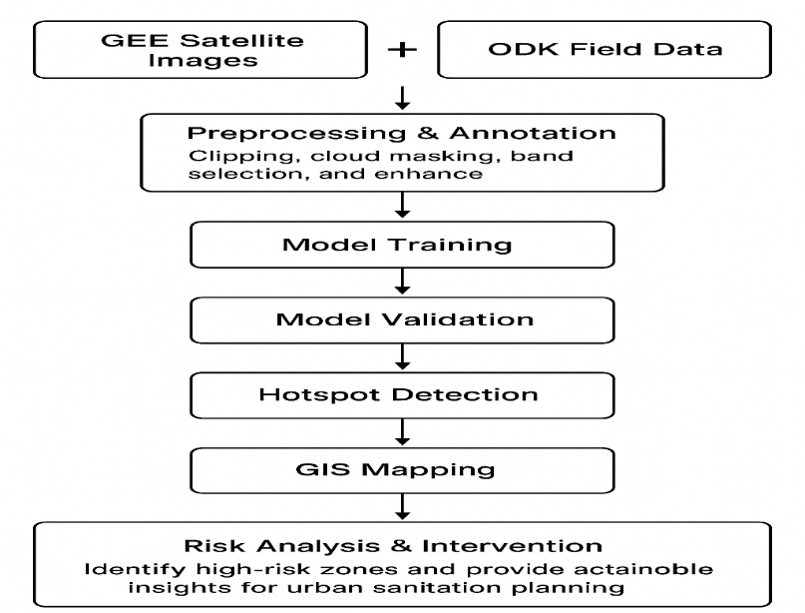
Collaboration with Industries and Other Institutes
This research will be conducted in collaboration with local municipal authorities and the Dambi Dollo University Department of Information Technology to support data collection and validation.
Estimated Budget (total figure): 350,000 ETB
Expected number of publications: 2

