1-Homepage
The first page that you find is the Homepage. I introduce myself with a general overview. On top of the page, there is a picture of Asmara, the capital city of Eritrea.
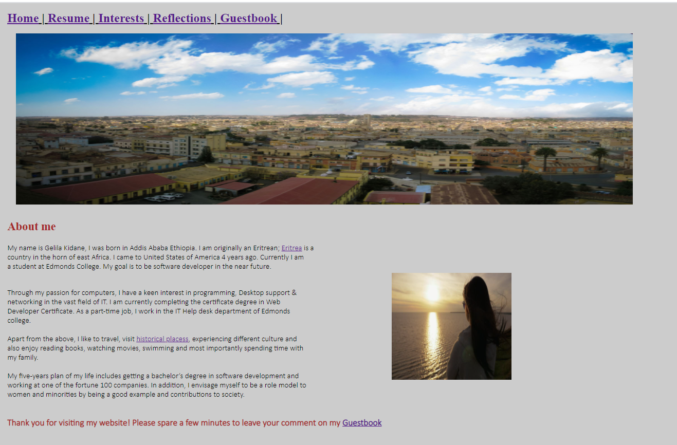

2-Resume
The second page contains all the details of my resume. It details different skills I have acquired in my life as well as my education and work history.
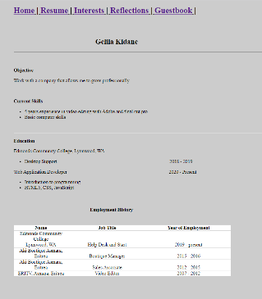

3-Interests
This page contains 4 distinct interests and passions that I have. With pictorial representation. In each one of them there is a link that takes you to different websites.
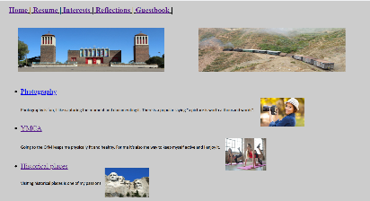
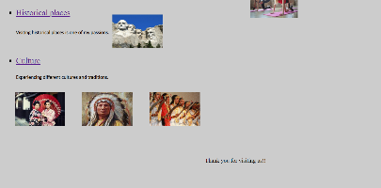

4-Reflections
This part explains my personal experience and lessons learned in the course (CIS241).
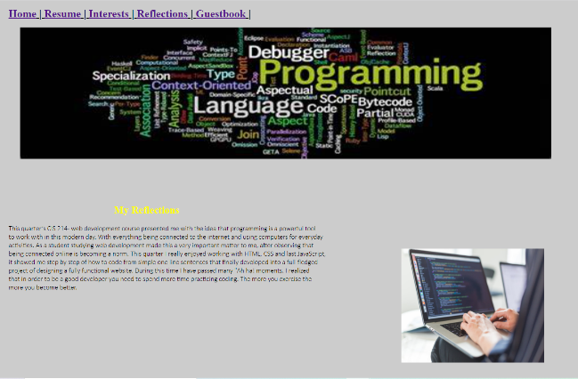

5-Guestbook
The Guestbook page is the last one. This page has a form that gathers information from the end user. This page is very important as the comments we get from the end users will benefit us to develop (update) the website continuously.
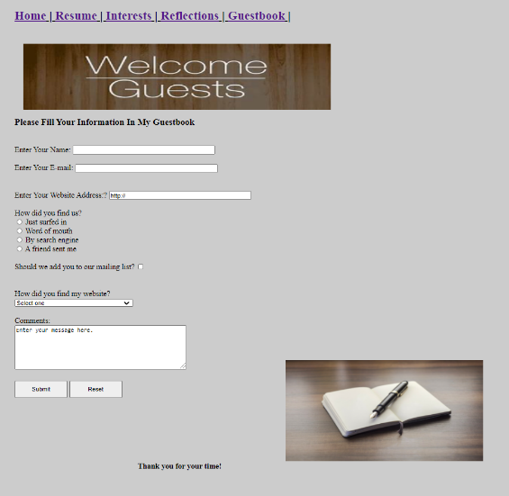

In general, all pages contain embedded, inline, and external styles. This project has 5 html documents and one CSS file.

