CONCLUSION:

**VIRAT KOHLI VS SACHIN TENDULKAR IN ODIS**

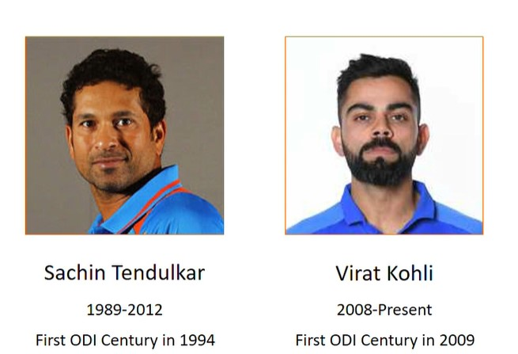

|  |  |  |  |
| --- | --- | --- | --- |
| PARAMETER | SACHIN | KOHLI | WINNER |
| RUNS PER INNINGS | **1.94** | **2.03** | **KOHLI** |
| STRIKE RATE | **1.22** | **1.12** | **SACHIN** |
| 100’S PER MATCH | **0.15** | **0.18** | **SACHIN** |
| 50’S PER MATCH | **0.57** | **0.55** | **KOHLI** |
| TEAM CONTRIBUTION | **16.90%** | **17.61%** | **KOHLI** |