In object-oriented systems, classes are often related in hierarchical relationships.
These relationships help reuse common features and model real-world concepts more effectively.

1. Generalization
Generalization is a relationship between a more general element and a more specific element.
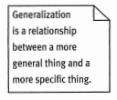
The specific element is consistent with the general element but contains additional details.
Generalization can be applied to:
- Use cases
- Actors
- Classes
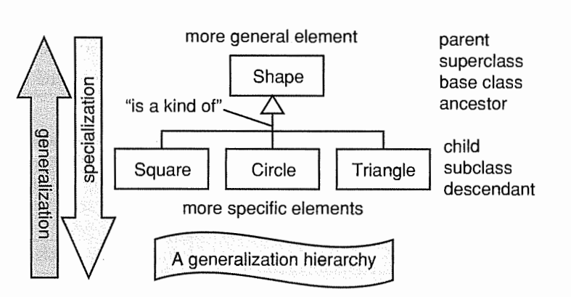
Specialization: Start with a general class and create more specific subclasses.
Generalization: Start with specific classes and extract common features into a general superclass.

2. Class Inheritance
A subclass inherits features from its superclass, including:
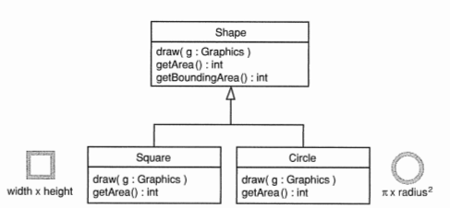
- Attributes
- Operations (methods)
- Relationships
- Constraints
Subclasses may:
- Add new attributes or operations
- Override inherited operations

3. Polymorphism
Polymorphism means “many forms.”
A polymorphic operation has multiple implementations in different classes.
Each subclass provides its own implementation.
Thus:
- same operation name
- different behavior

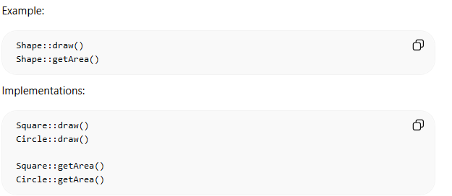
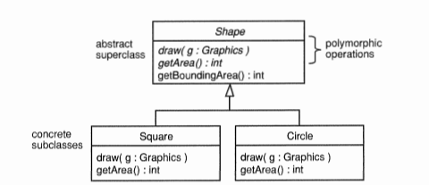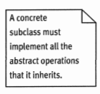
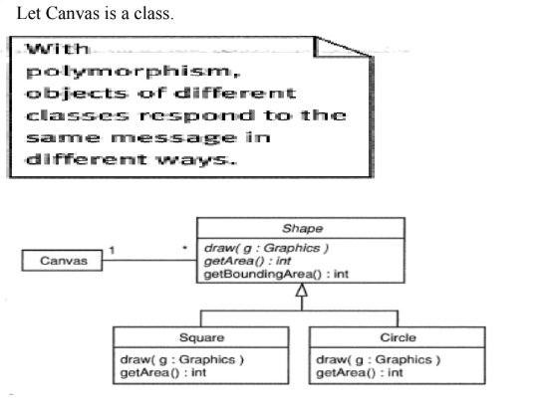
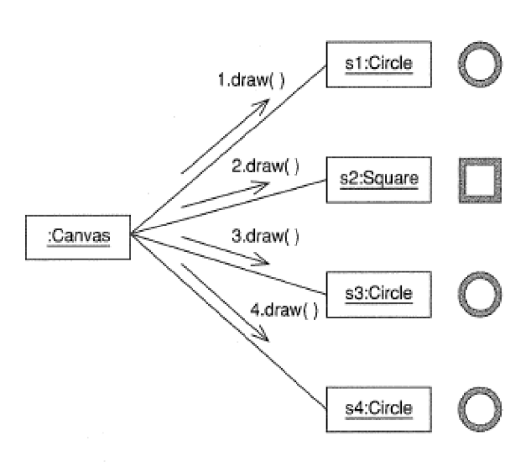

Advanced Generalization Concepts
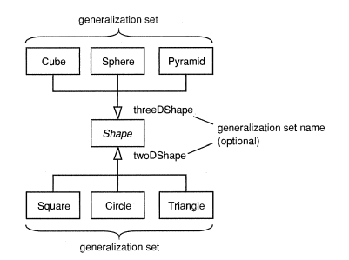

A generalization set groups subclasses according to a rule.
Constraint | Meaning
{complete} | All possible subclasses included
{incomplete} | More subclasses may exist
{disjoint} | Object belongs to only one subclass
{overlapping} | Object may belong to multiple subclasses

1. Interactions
An interaction describes how objects communicate with each other to perform a specific task or realize a use case. It represents the dynamic behavior of the system.
Definition
An interaction is a unit of behavior of a classifier.
The classifier that provides the context for the interaction is called the context classifier.
In use case realization, the context classifier is usually a use case.
Purpose
Interactions are used to show:
- How objects collaborate
- The sequence of communication between objects
- How a system performs a particular functionality
Key Elements of Interaction Diagrams
The two main elements are:
- Lifelines
- Messages
Interaction diagrams (such as sequence diagrams) use these elements to represent communication between objects.
An interaction may also use temporary or global variables during execution.

2. Lifelines
A lifeline represents a single participant in an interaction.
Definition
A lifeline represents how an instance of a classifier participates in an interaction.
In sequence diagrams, a lifeline represents an object involved in the communication process.
Characteristics
Each lifeline may have:
- Name – name of the object in the interaction
- Type – the classifier (class) of which the lifeline is an instance
- Selector (optional) – a condition used to select a specific instance
Example
Example lifeline notation:
jimsAccount [ id = "1234" ] : Account
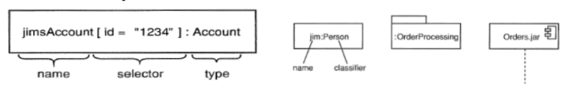
Explanation:
Part | Meaning
jimsAccount | name of the lifeline
[id="1234"] | selector identifying a specific instance
Account | classifier type
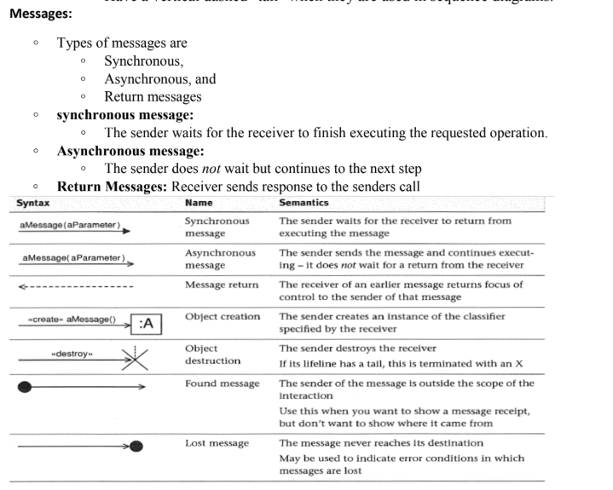

1️⃣ Parameters in Interaction (Sequence Diagram)
Definition
Parameters are values supplied to an interaction or message in a sequence diagram to provide specific input data required to perform an operation.
They allow interactions to work with different values during execution.

Explanation
- Parameters pass input values to messages in interactions.
- They make interactions reusable with different data.
- The values passed during execution are assigned to temporary variables in the sequence diagram.
- These variables exist only within the scope of the interaction.

Syntax
A parameter is written in the message as:
operation(parameter : type)
Example:
findStudent(name : String)
findCourse(name : String)

Example
Interaction:
findStudent("Jim")
findCourse("UML")
Here:
Parameter | Value
name | "Jim"
name | "UML"
The returned values are stored in temporary variables:
theStudent = FindStudent("Jim")
theCourse = FindCourse("UML")

Key Points
- Parameters supply specific values to interactions.
- They make interactions flexible and reusable.
- Temporary variables exist only within the sequence diagram scope.4
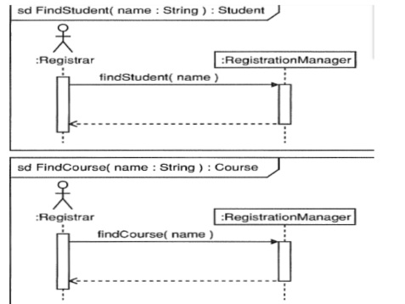
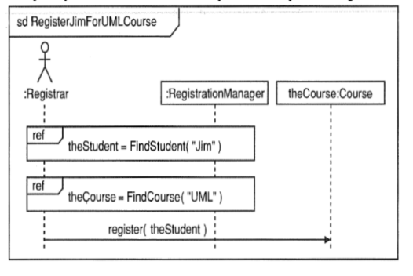

2️⃣ Gates in Sequence Diagrams
Definition
A gate is a connection point on the boundary of a sequence diagram that allows messages to pass between interactions inside the diagram and elements outside the diagram.

Explanation
- Gates act as inputs and outputs of interactions.
- They are located on the frame of the sequence diagram.
- They connect messages outside the frame with messages inside the frame.
- Both messages connected by the gate must have matching signatures.

When Gates Are Used
Gates are used when:
- An interaction is triggered by an external lifeline.
- A sequence diagram calls another interaction.
- Messages must enter or leave the sequence diagram.

Example
Main sequence diagram:
RegisterJimForUMLCourse
Steps:
theStudent = findStudent("Jim")
theCourse = findCourse("UML")
register(theStudent)
Here:
ref FindStudent
ref FindCourse
These referenced interactions are connected using gates.

Diagram Meaning
Main interaction → Gate → Referenced interaction
Example:
findStudent("Jim") → gate → FindStudent interaction

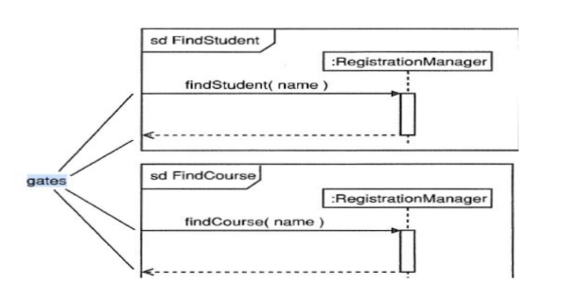
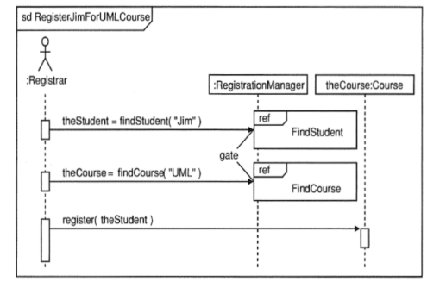

Continuation in Sequence Diagrams
Definition
A continuation is an interaction fragment used in sequence diagrams to indicate a point where one interaction fragment ends and another interaction fragment continues from the same state.

Explanation
- Continuations help connect different interaction fragments.
- They allow a sequence diagram to be split into smaller parts.
- When one interaction finishes, the next interaction can continue from the same point.
- It helps manage large and complex interaction diagrams.

Syntax / Notation
A continuation is represented as:
- A label inside a rounded rectangle.
- It is placed at the point where the interaction continues.
Example:
+-------------+
| continuation|
+-------------+

Working
- A continuation indicates that the flow of interaction will continue in another fragment.
- It marks a specific state of lifelines where another interaction can start.
Two cases are commonly used:
- First continuation
Indicates that the interaction is continuing from a previous fragment.
- Last continuation
Indicates the point where the current interaction fragment finishes.

Example
In a course registration system:
- User selects a course option.
- System checks the option:
addCourse
removeCourse
findCourse
After performing the selected operation, the interaction may continue to another interaction fragment such as updating the database or displaying results.
