DingTalk Attendance Setup
Office & Field Staff Check-In / Check-Out Configuration
This document describes how to configure DingTalk attendance so that office-based staff can only clock in from the office Wi-Fi network, while field staff (engineers and sales) can clock in from client sites using GPS-based rules. It also covers common troubleshooting steps and how to handle test/erroneous records.

1. Overview
Two separate attendance groups are used:
- Office Staff — restricted to the office Wi-Fi network (MAC-address bound), fixed shift hours.
- Field Staff (Engineers / Sales) — GPS geofencing or multiple designated locations, flexible shift hours.
Each employee belongs to exactly one attendance group. DingTalk applies whichever group an employee is assigned to; an employee cannot be validly assigned to two groups with conflicting rules.

2. Workflow Diagram
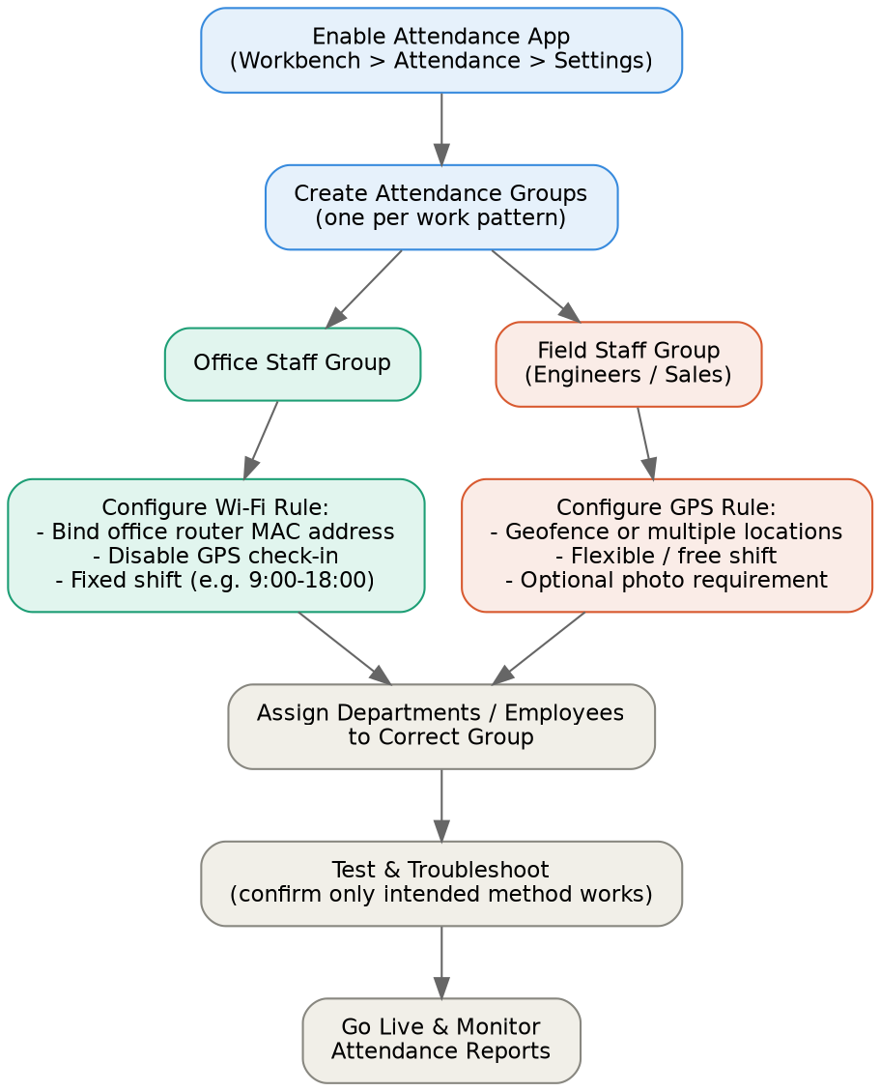

3. Step-by-Step Setup

3.1 Enable the Attendance App
- Open DingTalk and go to Workbench.
- Tap Attendance, then Settings (admin rights required).

3.2 Create the Office Staff Group
- Under Attendance Groups, tap + Add Attendance Group.
- Name the group (e.g. "Office Attendance").
- Add participants: select the department(s) or individuals who work from the office.
- Set check-in method to Wi-Fi check-in and bind the office router's MAC address (not just the SSID name, which can be spoofed).
- Turn OFF GPS/location check-in for this group. Leaving GPS enabled alongside Wi-Fi lets employees clock in via either method, defeating the Wi-Fi-only restriction.
- Set shift type to Fixed Shift (e.g. 9:00–18:00).
- Save.

3.3 Create the Field Staff Group
- Add a second attendance group (e.g. "Field Sales & Engineers").
- Add participants: the engineers/sales department, or individually selected employees.
- Set check-in method to GPS location check-in with a wider radius, or add multiple designated locations (e.g. common client sites). "No location restriction" can be used for fully mobile staff who just need a timestamp.
- Optionally require a photo at check-in for extra verification.
- Set shift type to Flexible/Free Shift, or a schedule with wider check-in windows.
- Save.

3.4 Assign and Verify
- Confirm no department or individual is included in both groups.
- Have a test user from each group attempt to clock in from both the correct and an incorrect context (e.g. office Wi-Fi vs. mobile data) to confirm the rule is enforced as intended.

4. Troubleshooting: Employee Can Still Clock In on Mobile Data
This happens almost always because GPS/location check-in is still enabled alongside Wi-Fi in the same group — DingTalk allows clock-in if any enabled method passes, not only if all pass.

Checklist
- Open the Office group's Check-in Method settings and confirm GPS/location is turned OFF, leaving only Wi-Fi enabled.
- Confirm the Wi-Fi entry is bound to the office router's MAC address, not just an SSID name.
- Check the group isn't defaulting to a "Free clock-in / no restriction" fallback underneath the Wi-Fi setting.
- Save changes, then fully close and reopen the DingTalk app before retesting (settings may not sync live).
- Confirm the test account is actually assigned to the Office group and not still sitting in an older, more permissive group — an employee in two groups may get the more permissive rule.

5. Handling Test / Erroneous Attendance Records
DingTalk does not allow admins to directly delete individual clock-in/out records, since attendance data is kept as an audit trail. Available options:
- Exclude from calculation: in Attendance > Statistics, mark a specific record as an exception/abnormal so it is ignored in reports, without deleting the underlying entry.
- Attendance correction: manually override how a specific day is counted for an employee (e.g. mark as normal or leave) without deleting the original punch.
- Sandbox group: for ongoing testing, remove the test account from the live group and test inside a separate group with no real employees, so test punches never touch real reporting data.
- Enterprise support: for bulk or system-level errors affecting payroll, contact DingTalk support via Admin Console > Help & Feedback.

6. Quick Reference
Setting | Office Group | Field Group
Check-in method | Wi-Fi (MAC-bound) | GPS geofence or multiple locations
GPS enabled? | No | Yes
Shift type | Fixed shift | Flexible / free shift
Typical members | Office-based staff | Engineers, sales, field roles
Photo requirement | Optional | Recommended

