GitHub and Git You can use GitHub and Git to collaborate on work.

About GitHub
GitHub is a cloud-based platform where you can store, share and work together with others to write code.
Storing your code in a “repository” on GitHub allows you to:
- Showcase or share your work
- Track and manage changes to your code over time.
- Let others review your code and make suggestions to improve it.
- Collaborate on a shared project, without worrying that your changes will impact the work of your collaborators before you’re ready to integrate them.
About Git
Git is a version control system that intelligently tracks changes in files. Git is particularly useful when you and a group of people are all making changes to the same files at the same time.
Typically, to do this in a Git-based work flow you would:
- Create a branch off from the main copy of files that you (and your collaborators) are working on.
- Make edits to the files independently and safely on your own personal branch.
- Let Git intelligently merge your specific changes back into the main copy of files, so that your changes don’t impact other people’s updates.
- Let Git keep track of your and other people’s changes, so you all stay working on the most up-to-date version of the project.

Git and GitHub work together
When you upload files to GitHub, you’ll store them in a “Git repository.” This means that when you make changes (or “commits”) to your files in GitHub, Git will automatically start to track and manage your changes.
There are plenty of Git-related actions that you can complete on GitHub directly in your browser, such as creating a Git repository, creating branches and uploading and editing files.
However, most people work on their files locally (on their own computer), then continually sync these local changes-and all the related Git data—with the central "remote" repository on GitHub. There are plenty of tools that you can use to do this, such as GitHub Desktop.
Once you start to collaborate with others and all need to work on the same repository at the same time, you’ll continually:
- Pull all the latest changes made by your collaborators from the remote repository on GitHub.
- Push back your own changes to the same remote repository on GitHub.
Git figures out how to intelligently merge this flow of changes, and GitHub helps you manage the flow through features such as "pull requests."
About git push
The git push command takes two arguments:
- A remote name, for example, origin
- A branch name, for example, main
For example:
git push REMOTE-NAME LOCAL-BRANCH-NAME:REMOTE-BRANCH-NAME
Renaming Branches
To rename a branch, you’d use the same git push command, but you would add one more argument: the name of the new branch, For example:
git push REMOTE-NAME LOCAL-BRANCH-NAME:REMOTE-BRANCH-NAME
This pushes the LOCAL-BRANCH-NAME to your REMOTE-NAME , but it is renamed to REMOTE-BRANCH-NAME.
Dealing with "non-fast-forward" errors
If your local copy of a repository is out of sync with, or "behind," the upstream repository you're pushing to, you'll get a message saying non-fast-forward updates were rejected. This means that you must retrieve, or "fetch," the upstream changes, before you are able to push your local changes.
Resolving blocked commits
To maintain the security of the repository you're pushing to, GitHub's push protection automatically protects you from accidentally committing secrets to public repositories on GitHub.com. Exposed secrets can pose serious security risks to your repository and your supply chain. If GitHub detects that the commit you're attempting to push contains a supported secret, it blocks the push. In order to resolve the block, you should either:
- Remove the secret from your commit(s).
- Follow the provided URL to see options to allow the push.

Pushing tags
By default, and without additional parameters, git push sends all matching branches that have the same names as remote branches.
To push a single tag, you can issue the same command as pushing a branch:
git push REMOTE-NAME TAG-NAME
To push all your tags, you can type the command:
git push REMOTE-NAME --tags

Deleting a remote branch or tag
The syntax to delete a branch is a bit arcane at first glance:
git push REMOTE-NAME :BRANCH-NAME
Note that there is a space before the colon. The command resembles the same steps you'd take to rename a branch. However, here, you're telling Git to push nothing into BRANCH-NAME on REMOTE-NAME. Because of this, git push deletes the branch on the remote repository.

Remotes and forks
You might already know that you can "fork" repositories on GitHub.
When you clone a repository you own, you provide it with a remote URL that tells Git where to fetch and push updates. If you want to collaborate with the original repository, you'd add a new remote URL, typically called upstream, to your local Git clone:
git remote add upstream THEIR_REMOTE_URL
Now, you can fetch updates and branches from their fork:
git fetch upstream
# Grab the upstream remote's branches
> remote: Counting objects: 75, done.
> remote: Compressing objects: 100% (53/53), done.
> remote: Total 62 (delta 27), reused 44 (delta 9)
> Unpacking objects: 100% (62/62), done.
> From https://github.com/OCTOCAT/REPO
> * [new branch] main -> upstream/main

Getting changes from a remote repository
You can use common Git commands to access remote repositories.
Options for getting changes
These commands are very useful when interacting with a remote repository. Clone and fetch download remote code from a repository's remote URL to your local computer, merge is used to merge different people's work together with yours, and pull is a combination of fetch and merge.
Cloning a repository
To grab a complete copy of another user's repository, use git clone like this:
$ git clone https://github.com/USERNAME/REPOSITORY.git
# Clones a repository to your computer
You can choose from several different URLs when cloning a repository. While logged in to GitHub, these URLs are available on the main page of the repository when you click Code.
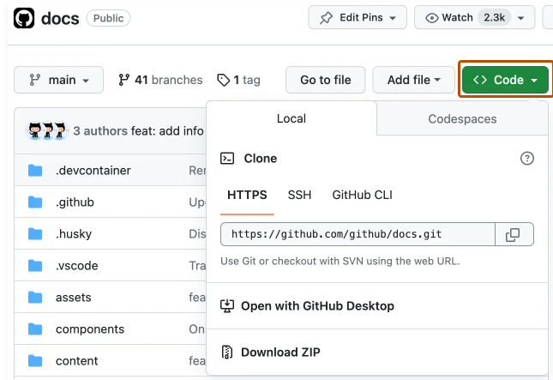

When you run git clone, the following actions occur:
- A new folder called repo is made
- It is initialized as a Git repository
- A remote named origin is created, pointing to the URL you cloned from
- All of the repository's files and commits are downloaded there
- The default branch is checked out
For every branch of foo in the remote repository, a corresponding remote-tracking branch refs/remotes/origin/foo is created in your local repository. You can usually abbreviate such remote-tracking branch names to origin/foo.
Fetching changes from a remote repository
Use git fetch to retrieve new work done by other people. Fetching from a repository grabs all the new remote-tracking branches and tags without merging those changes into your own branches.
If you already have a local repository with a remote URL set up for the desired project, you can grab all the new information by using git fetch *remotename* in the terminal:
$ git fetch REMOTE-NAME
# Fetches updates made to a remote repository
Merging changes into your local branch
Merging combines your local changes with changes made by others.
Typically, you'd merge a remote-tracking branch (i.e., a branch fetched from a remote repository) with your local branch:
$ git merge REMOTE-NAME/BRANCH-NAME
# Merges updates made online with your local work
Pulling changes from a remote repository
git pull is a convenient shortcut for completing both git fetch and git merge in the same command:
$ git pull REMOTE-NAME BRANCH-NAME
# Grabs online updates and merge them with your local work
Because pull performs a merge on the retrieved changes, you should ensure that your local work is committed before running the pull command. If you run into a merge conflict you cannot resolve, or if you decide to quit the merge, you can use git merge --abort to take the branch back to where it was in before you pulled.
Dealing with non-fast-forward errors
Sometimes, Git can't make your change to a remote repository without losing commits. When this happens, your push is refused.
If another person has pushed to the same branch as you, Git won't be able to push your changes:
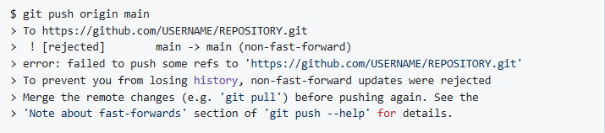
You can fix this by fetching and merging the changes made on the remote branch with the changes that you have made locally:

Or you can simply use git pull to perform both commands at once:

Splitting a subfolder out into a new repository
You can turn a folder within a Git repository into a brand-new repository.
If you create a new clone of the repository, you won't lose any of your Git history or changes when you split a folder into a separate repository. However, note that the new repository won't have the branches and tags of the original repository.
- Open Git Bash.
- Change the current working directory to the location where you want to create your new repository.
- Clone the repository that contains the subfolder.
- Change the current working directory to your cloned repository.
- To filter out the subfolder from the rest of the files in the repository, install git-filter-repo, then run git filter-repo with the following arguments.
- FOLDER-NAME: The folder within your project where you'd like to create a separate repository.

The repository should now only contain the files that were in your subfolder(s).
If you want one specific subfolder to be the new root folder of the new repository, you can use the following command:
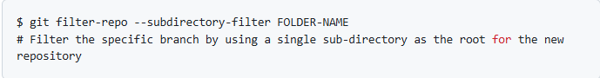
- Create a new repository on GitHub.
- At the top of your new repository on GitHub's Quick Setup page, click to copy the remote repository URL.
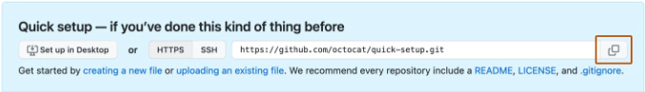

- Add a new remote name with the URL you copied for your repository. For example, origin or upstream are two common choices.
- Verify that the remote URL was added with your new repository name.
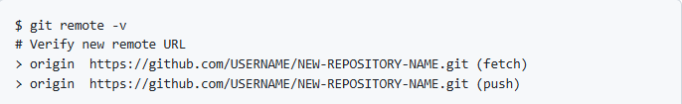
- Push your changes to the new repository on GitHub.

About Git subtree merges
If you need to manage multiple projects within a single repository, you can use a subtree merge to handle all the references.
Typically, a subtree merge is used to contain a repository within a repository. The "subrepository" is stored in a folder of the main repository.
The best way to explain subtree merges is to show by example. We will:
- Make an empty repository called test that represents our project.
- Merge another repository into it as a subtree called Spoon-Knife.
- The test project will use that subproject as if it were part of the same repository.
- Fetch updates from Spoon-Knife into our test project.
Setting up the empty repository for a subtree merge
- Open Git Bash.
- Create a new directory and navigate to it.
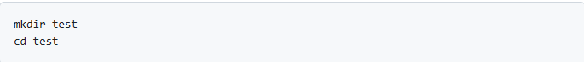
- Initialize a new Git repository.
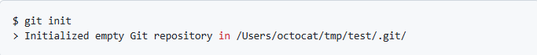
- Create and commit a new file.
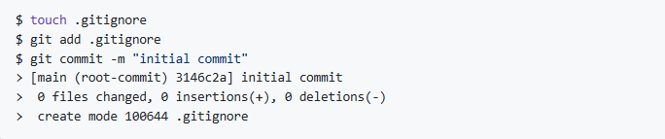
Adding a new repository as a subtree
- Add a new remote URL pointing to the separate project that we're interested in.
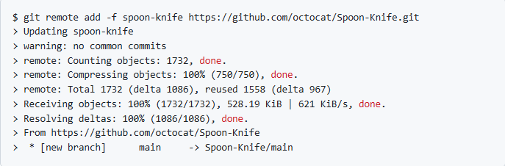
- Merge the Spoon-Knife project into the local Git project. This doesn't change any of your files locally, but it does prepare Git for the next step.
If you're using Git 2.9 or above:
If you're using Git 2.8 or below:
- Create a new directory called spoon-knife, and copy the Git history of the Spoon-Knife project into it.
- Commit the changes to keep them safe.
Although we've only added one subproject, any number of subprojects can be incorporated into a Git repository.

Synchronizing with updates and changes
When a subproject is added, it is not automatically kept in sync with the upstream changes. You will need to update the subproject with the following command:
For the example above, this would be:

