Assesment of Population Exposures to Airborne Allergnic Pollen in the US from 1994 to 2010

DRAFT OF 2014-01-10 (WITH SOME CORRECTIONS - LE)

**Abstract**

Airborne allergenic pollen is a main cause of Allergic Airway Disease (AAD), which affects 5%-30% of the population in industrialized countries. Furthermore, allergenic pollen has been reported to act synergistically with common air pollutants, such as oregion and particular matter, to exacerbate allergy symptoms. Studies of population exposures to allergenic pollen will help to provide useful information for the scientific community to aid allergy sufferers.

In the present study, a probabilistic exposure modeling system has been developed using Monte Carlo methods to simulate exposures pollen of the general population in the United States (US) to airborne allergenic. Simulations were conducted by sampling randomly from distributions of outdoor and indoor allergenic pollen concentrations and distributions of activity data from the general US population. These activity data include time spent indoors and outdoors, inhalation rates, exposed skin area, hand-to-mouth touch frequency, etc. Distributions of airborne allergenic pollen concentrations from representative trees, weeds and grass in nine climate regions were developed from observed pollen counts collected of the American Academy of Allergy Asthma and Immunology (AAAAI) monitoring stations. US demographic data were used to generate the distributions of activities stratified by age and gender in the corresponding climate regions.

The medians of daily total exposures from 1994 to 2010 in the whole US continent were 88±317 pollen grains/day for birch (Ambrosia), 263±1293 pollen grains/day for ragweed (Artemisia), 284±927 pollen grains/day for mugwort (Betula), 933±4065 pollen grains/day for grass (Gramineae), and 822±3171 pollen grains/day for oak (Quercus), in their respected pollen period. Global sensitivity analysis of the simulations based on Morris’ design was used to investigate sensitivity and interaction effects of the daily intakes of allergencis pollen to the model parameters and inputs. Exposure estimates were sensitive to parameters affecting to pollen deposition such as such as viscosity of air and friction velocity. The inhalation route contributes 140 and 157 times higher pollen exposure levels for subjects of the general population than dermal contact and unintentional ingestion route, respectively.

# Background Information

Airborne allergenic pollen, acting synergistically with air pollutants like oregion, will cause allergic airway disease (AAD), resulting to increased related health care costs (Lamb, Ratner et al. 2006, Singh, Axelrod et al. 2010). It has beenreported that over one third of the US population suffer allergic symptoms and diseases at different levels, including rhinitis, hay fever, asthma, and atopic dermatitis (Bielory, Lyons et al. 2012). These allergic diseases can be potentially triggered and/or aggravated by allergenic pollen, such as ragweed, birch, grass, mugwort and oak (Shea, Truckner et al. 2008)..

## Pollen and allergy

Asthma, rhinitis, and conjunctivitis are often considered as the typical clinical pictures of allergy to pollen, and they often occur in the same patient simultaneously during the pollen season (Sofiev, Belmonte et al. 2013). Among these three symptoms, asthma is often considered to of most concern. It is a chronic inflammatory disease of the airways characterized by recurrent episodes of wheezing, breathlessness, chest tightness and coughing (Bateman, Hurd et al. 2008). Exposure to allergens represents as a key factor among environmental determinants of asthma, rhinitis, and conjunctivitis (Eder, Ege et al. 2006). IgE, which is a class of antibody in humans, plays an essential role in hypersensitivity (Gould, Sutton et al. 2003), causing various allergic diseases. Allergic rhinitis is defined as a symptomatic disorder of the nose induced by an IgE-mediated inflammation after allergen exposure of the membranes lining the nose. Symptoms of rhinitis include rhinorrhea, nasal obstruction, nasal itching and sneezing, which are reversible spontaneously (Brożek, Bousquet et al. 2010) or under treatment. Pathophysiological and clinical studies have strongly suggested a relationship between rhinitis and asthma. However, epidemiology provides the most convincing data, showing that the prevalence of asthma in patients with rhinitis varies from 10 to 40 % depending on the study (Sofiev, Belmonte et al. 2013). Moreover, allergic rhinitis is correlated to, and constitutes a risk factor for, the occurrence of asthma. Taken together, these epidemiology data have led to the concept that upper and lower airways may be considered as a unique entity influenced by a common, evolving inflammatory process (Passalacqua and Durham 2007). Conjunctivitis is also commonly associated to pollen-induced rhinitis.

Sensitization occurs at the site of primary allergen exposure, i.e. airways, but can also occur through dermal contact. However, not everybody who is exposed will become sensitized and have allergic reactions. Aside from the individual exposure conditions, there is high variability in individual responsiveness to a given allergen dose.

The most important allergen carriers in outdoor as well as in indoor air are pollen grains– with a diameter between typically 15 and 60 µm – from anemophilic plants that include trees, grasses and weeds. In this thesis, we consider five different species, ragweed (Ambrosia), mugwort (Artemisia), birch (Betula), grass (Gramineae) and oak (Quercus). However, whole pollen grains are generally too large to penetrate into the respiratory tract. Since pollen is able to evoke IgE-mediated allergic reactions within seconds after contact with the mucosa, pollen allergens must be extremely water soluble and readily available. In fact allergen liberation from pollen grains can occur on the mucosal surface of the upper respiratory tract after exposure to pollen (Behrendt and Becker 2001). Symptoms can be explained by the interaction between the antigen and its corresponding IgE antibody and this phase is situated at the end of a cascade of events leading to allergy.

## Pollen Season

Observations and measurements, such as phenological events (i.e flowering and withering) and pollen counts, are used to characterize the same phenomenon - plant flowering.Both phenological and aerobiological data can be analyzed in methods such as regression, that can be used to predict phenological phases, start date and end date of the pollen season, and the peak value. An alternative approach are the phenological models which can also predict the starting dates of phenological phases as well as the start, peak, and end of the pollen season. Phenological models are sometimes classified as process-based models (Chuine, Belmonte et al. 2000), as they are based on mechanistic assumptions rooted in experimental results on plant physiological responses to various environmental variables. In this thesis, pollen counts are used as the key data to calculate the length and start dats of plant flowering.

# Methods

## Data Collection

### Pollen Data Collection

Data on observed airborne pollen were retrieved from the measurement at the American Academy of Allergy Asthma and Immunology (AAAAI) monitoring stations performed during the period of 1994-2010 in the contiguous US (CONUS). The geographic locations of the AAAAI pollen monitoring stations are shown in Figure 5. The reported pollen data were classified only at the level of genus. Species with the genera of Ambrosia, Artemisia, Betula, Gramineae or Quercus were not differentiated. The collected airborne pollen counts were used to generate the distributions of daily average pollen concentrations in nine climate regions as shown in Figure 4.

### Population Data and Exposure Factors

Population data were retrieved from the United States Census Bureau. Demographic data are the general population(Census Bureau. U.S 2010), classify the state-level population by age group and sex. We used ArcGIS, to compile population data stratified by age and gender in 9 different climate regions as defined and couple them with the corresponding airborne pollen data To perfrom Monte Carlo simulations, a random sample of individuals, so as to represent the age and gender structure of the full population was developed for each of the climate regions and plant speciesExposure Factors were obtained from USEPA’s Exposure Factors Handbook (U.S. Environmental Protection Agency 2010). These factors include inhalation rate (Figure 7), dermal contact frequency, skin surface area (Figure 8), hand surface area, time spent indoors and outdoors (Table 6) and in different age groups and within genders. In each age group, ten representative percentile levels (5th, 10th, 25th, 50th, 75th, 90th, and 95th) and mean values of exposure factors were used to generate exposure scenarios for each of the nine climate regionregion.

These exposure factors characterize population variability of the national level. Inhalation rate distribution and other exposure factors are the same for different climate regions, although the temperature, day and night time, and other environmental factors may affect values of those factors.

## Exposure Method Selection

Exposures to allergenic pollen can occur via inhalation and dermal contact (Sofiev, Belmonte et al. 2013), as well as unintentional ingestion (Cohen, Yunginger et al. 1979).

### Inhalation

Exposure intake are of ten quantified by multiplying the concentration of an agent and the exposeure duration. Exposure can be instantaneous when the contact between an agent and a target occurs at a single point in time and space. The summation of instantaneous exposures over the exposure duration is called the time-integrated exposure. Equation defines a time_integrated intake (Fogh and Andersson 2000).



where:

1. *E* = Time-integrated intake for each time ( pollen grains ),
2. *t2– t1* = Exposure duration (ED) (time),
3. *C* = Exposure concentration as a function of time ( pollen grains/m3 ).
4. *I* = Inhalation rate factors ( m3/day).

Time-averaged exposure was obtained by dividing the integrated exposure by exposure duration.

Since only daily avearges of airborne pollen concentrations are available from the AAAAI monitor network, only distribution of daily intakes can be calculated considering outdoor and indoor exposures via the following equation.

Outdoor:



Indoor



where



1. *E* = Time-integrated exposure (pollen grains),
2. *t2– t1* = Exposure duration (ED) (day),
3. *C* = Exposure concentration as a function of time (pollen/m3).
4. *I* = Inhalation factors (m3/day).
5. *Ad*is the surface area available for particle deposition (m2)
6. *V* is the volume of the building (m3)
7. *vd* is the indoor deposition velocity (m s-1)
8. (s-1) is ventilation rate

### Dermal Exposure and Ingestion

Dermal exposures to chemical compounds have been studied ([Hu, Zhang et al. 2011](#_ENREF_13" \o "Hu, 2011 #19)), but studies of dermal exposure to pollen remain rare,which are qualities’ study. We used a dry deposition model to estimate the adherence of pollen to human skin.

The dry deposition model assumes that the transport of material to the surface is governed by three resistances in series: the aerodynamic resistance , The quasi-laminar layer resistance , and the surface or canopy resistance . The total resistance, by definition, is the inverse of the deposition velocity.



For pollen dry deposition, becomes



where is the particle settling velocity.









Where is the density of the pollen, is the aerodynamic pollen grain diameter, *g* is the gravitational acceleration, μ is the viscosity of air, *u\** is the friction velocity,*z* and *z0* are reference height (at the top of the constant flux layer) and initial height(at the bottom of the constant flux layer),respectfully.is the slip correction factor.







Where *Sc* is the Schmidt number, *St* is the Stokes number, and *D* is the molecular diffusivity,

So, the direct deposition to the skin can be calculated as

1 outdoor



2 indoor



Where

1. the mass of the substance on the skin surface
2. is the exposed skin area (m2) .
3. The parameters (m s-1) and (dimensionless) are indoor deposition velocity and ventilation rate, respectively.

After the pollens deposit on the skin, some pollen may adhere to it, and cause an allergic reaction such as irritation and redness of the skin. We use a dermal adherence rate to illustrate this effect:



Where

1. Ederm is the dermal exposure.
2. M the mass of the pollen on the skin surface (pollen grains/m2)
3. Sa the total surface of human skin ( m2 )
4. Rt the ratio of the skin which are exposed to pollens(head, arm, hand, leg) (dimensionless)
5. rm the removal coefficient of the pollens on the skin (dimensionless)
6. Lr the efficiency of adherence to skin (dimensionless)

### Unintentional Ingestion

Another possible route is unintentional ingestion ([Cohen, Yunginger et al. 1979](#_ENREF_8" \o "Cohen, 1979 #7)). Some individuals, especially children, may use hands loaded with pollen to touch the mouth, and this may cause unintentional ingestion of pollen. This effect may in general be neglected when we consider exposures of adults.



Where

1. *Eingest* is the ingestion exposure, the mass of the pollen intake through ingestion
2. the mass of the pollen on the skin surface (pollen grains/m2)
3. *Sa* is the total surface of human skin ( m2 )
4. *Rh* the ratio of the hands in the total skin area (dimensionless)
5. *Fr* hand-to-mouth contact frequency (times/hour)

### Exposure Calculation Method

The Monte Carlo method was used to generate the exposure data. The activity data of 5000 virtual people were generated based on the corresponding exposure factor data distribution and demographic data in each climate region. For example, the data of a virtual 75 year old man was generated by calculating the corresponding exposure factors in 71-80 years, male group. Then the observed data of pollen counts were combined with the activity data using the Monte Carlo method, by randomly choosing two values from each of the datasets and multiplying them at a time. 5000 exposure values were generated in that way for each climate regionregion. The mean of the results of different climate regionregions could be described as the population exposure to pollen.

## Sensitivity Analysis

Sensitivity analysis is the analysis of how the uncertainty in the output of a mathematical system or modeling (numerical or otherwise) can be apportioned to various sources of uncertainty in its inputs.

Mean daily mass intake exposure to pollens was selected as a metric for testing the system’s sensitivity to multiple inputs and parameters. Global sensitivity analysis was performed based on Morris’s Design. This design estimates the main effect of a parameter by computing a number of local sensitivities at random points of the parameter space. The mean of these randomized local sensitivities indicates the overall influence of a given parameter on the output metric, while the corresponding standard deviation indicates the effects of interacting and nonlinearity ([Zhang, Isukapalli et al. 2013](#_ENREF_24" \o "Zhang, 2013 #20)).

In the current study, each of the 18 parameters (Table 1) was sampled 3600 times according to the Morris method from 200 trajectories (each has 18 steps) in the parameter space. Each of the parameters in the simulation was perturbed from 50% to 150% of its base value or its distribution while keeping other parameters unchanged.

The mean daily exposure for sensitivity analyses was generated using 10000 “virtual men” in each climate regions in the flowering season. Equation was used to calculate the Normalized Sensitivity Coefficients (NSC) at a local point (Figure 1).



In this equation, the *NSCi,j* is the *NSC* for exposure route *i* (inhalation, ingestion, dermal) in different climate regions *j*. The p is the input parameter value, and r is the corresponding daily mean output of the exposure effect. The Δr and Δp are the corresponding perturbation of the parameter values and perturbation of the output, respectively. The global NSC of a certain parameter, NSCg could be defined as the mean of the corresponding local sensitivities. The overall mean absolute for each route and region could be obtained by averaging the NSC values for the corresponding route and region. Similarly, the overall mean absolute standard deviations are average over each exposure route and different climate regions.

## Statistics of Concentrations, Exposure and Sensitivity Analysis

To generated statistics of concentrations, surface loading, exposures and sensitivity analysis, simulations were conducted using 5000 “virtual residents” in each of the 9 different climate regions. Each resident will experience the whole in different scenarios (outdoor and indoor).

# Result and Discussion

## Pollen Season Discussion

For most of the studied stations, comparison of mean pollen indices between the periods of 1994–2000 and 2001–2011 showed that these five different species pollen were observed to flower 1–2 weeks earlier; The observed pollen season lengths varied for Ambrosia, Artemisia, Betula, Gramineae and Quercus across the different monitoring stations in the United States. Optimum start date was found to be 25th July for Ambrosia [Figure 9]. The start data for Artemisia was 11th April [Figure 10], the start data for Betula was 29th March [Figure 11]. The start date for Gramineae was 28th April [Figure 12], the start date for Quercus was 22nd March [Figure 13]. Simulation results indicated that responses of these different species to climate are expected to vary for different regions. Data used here are from March to September, which covers all of the pollen season for all of the pollen species discussed above. The spatial distribution scenario for oak (Quercus) in 2004 is displayed as an example, using VERDI (Figure 14). Low concentrations of pollens were observed only in the southwest coast, which is in the southwest climate region. Concentrations of pollen are close to zero in other climate regions.

Figure 9 - Figure 13 show time series of observed daily concentrations of birch, oak, ragweed, mugwort and grass pollen from 1994 to 2010 at UMDNJ and Cherry Hill monitoring stations in New Jersey, USA. The start dates of pollen of different species were varied. The pollen season ranges from early March to late October. We also discovered that the peak values often appear in the middle of the pollen seasons. Figure 14 shows the spatial distribution of Quercus pollen at the start date (15th March) at the national scale. The peak value observed in the figure was 4 in the southwest.

Figure 15 to Figure 19 summarizes the cumulative probability of pollen concentrations in different climate regions. The reported peak values were 1794 pollen/m3 for Ambrosia, 1242 pollen/m3 for Artemisia, 1827 pollen/m3 for Betula, 1320 pollen/m3 for Gramineae and 1423 pollen/m3 for Quercus, respectively. Different climate regions show different pollen concentrations. In the Northeast, Central and East North Central climate regions, the mean concentrations of Betula and Quercus are higher than those in other climate regions. In the West, South and Southwest climate regions, Ambrosia and Artemisia show the high concentrations.

The surface loading was calculated based on small particle transport model, dry deposition model, and Einstein-stokes equation. The key parameter is the pollen deposition velocity, which is 0.0909 m/s-1 for airborne pollen. This parameter is affected by various physical parameters, which are listed in Table 3.

Time spent indoors and outdoors would affect the human exposure scenario significantly ([Fogh and Andersson 2000](#_ENREF_10" \o "Fogh, 2000 #18)). The ventilation rate (V*e*) is the key parameter to describe the air exchange rate of the indoor scenario. High value of V*e* means more convection of the indoor and outdoor air, thus the concentration of pollen indoors would be closer to the concentration outdoors. The outdoor concentration of pollen is normally 5-8 times higher than indoor concentration. There are no reports showing to validate this prediction. However, similar methods and data are reported, mainly about particulate matter (PM2.5 and PM10) ([Hu, Zhang et al. 2011](#_ENREF_13" \o "Hu, 2011 #19)) and pesticides (Zhang, Y., et al. 2013).

## Exposures to Pollen

The exposures in each climate region could be compared since the same number of virtual residents in each region was selected to study exposures. The 5000 residents have the same age and sex composition as the real-world demographic data.

Figure 20 to Figure 24 show the simulated cumulative probability of residents’ daily exposures to pollen under three different exposure routes. The medians of the daily total exposures of ragweed (Ambrosia), mugwort (Artemisia), birch (Betula), grass (Gramineae) and oak (Quercus) are shown in Table 3. Daily total exposures to birch (Betula) are relatively low, from 13.45 pollen/day in the East North Central RegionRegion to 45.67 pollen/day in the Northwest RegionRegion. The daily total exposures to ragweed (Ambrosia) are slightly higher, from 33 pollen/day in the Northwest Region to 81 pollen/day in the East North Central Region. The daily total exposures to mugwort (Artemisia) vary widely, from 150 pollen/day in the South Region to 14 pollen/day in the Northwest Region. The daily total exposure to grass are generally low, ranging from 21 pollen/day in the Southeast Region to 48 pollen/day in the Northwest Region. However, exposure to grass is surprisingly high in the West Region. For Oak, the daily total exposures range from 23 pollen/day in the Southeast to 432 in the South Region. In general, residents in the Southwest Region suffer the least pollen count (99 pollen/day) while residents in the South Region suffer the highest pollen count (682 pollen/day).

Exposure data for 5 different species in the Central Climate Region were used to study exposures through 3 different routes (Table 5). Inhalation was found to be the dominant route compared with ingestion and dermal contact. The median of inhalation exposure to birch is 14.019 pollen/day, while the corresponding median of exposure through ingestion and dermal contact is, 0.040 pollen/day and 0.091 pollen/day respectively. The exposure from inhalation is about 140 times larger than the other two routes which are based on skin contact (Figure 2).

## Sensitivity Analysis

Scatter plots of the global sensitivity (based on Morris’s design) of the simulated exposures to 18 different parameters are illustrated in Figure 25 and Figure 26, for the Central and Southeast Climate Regions, respectively. Overall, the global NSC of all parameters varied between 0.0 and 0.35, indicating the robustness of this modeling approach. Ingestion exposures are shown to be more sensitive to parameter perturbations, with average global NSC of these 18 parameters, , being 0.2550 and 0.2569, respectively. Sensitive parameters for unintentional ingestion route include: viscosity of air (µ), diameter of pollen (D*p*), friction velocity (u*) and hand surface area ratio (S*r*). Inhalation exposure is less sensitive to modeling parameters. Total exposures have nearly the same sensitivity to the 18 parameters as the inhalation exposure. This is caused by the fact that exposure from inhalation is much higher than the other two routes which are based on the skin contact to pollens.

High interaction and nonlinearity effects among parameters were found in dermal contact and ingestion routes for pollen exposures. Average interaction effects were 0.3007 and 0.5690, in Central and Southeast climate region respectively. Parameters with high interaction and nonlinearity effects included friction velocity (u*), viscosity of air (µ), low interaction effects were found for exposure parameters in inhalation route. However, parameter density of air (P*a*) showed an extraordinary high value, with 0.3648 and 0.3631 in NSC data of Central and Southeast climate region. As we discussed above, the NSC values in different region (Figure 25 Figure 26) are slightly different. This could be explained as the effect of the different age and sex composition of the demographic data in different climate regions, since these are the only changing parameters in the process.

Uncertainties in sensitive and interactive input parameters would result in large deviations of model predictions. Parameters derived from large population studies([U.S. Environmental Protection Agency 2010](#_ENREF_23" \o "U.S. Environmental Protection Agency, 2010 #17)), such as distribution of inhalation rate (Ih*f*, Ih*m*), hand surface area ratio(S*r*), are supposed to bear lower uncertainties. Distribution of hand to mouth touch frequency (F*r*) is derived medium size of population, which are supposed to bear medium uncertainties. High uncertainties are expected for sensitive parameters: L*r* NSC = 0.0475; V*d*, NSC =0.0614, and interactive parameters: u*, STD =0.3109; L*r*, STD = 0.3181; and, V*d,* STD = 0.03561.

The dermal loading rate coefficients depend on surface characteristics (dry or wet), temperatures and. physical transport effects. The ventilation rate depends on temperatures and physical transport effects. Data on these dependencies are extremely limited for pollen deposition and ventilation. The values of V*d* and u* used in the current study were derived from references (Hu, Zhang et al. 2011) on particulate matter and small particles. Widely different pollen dermal contact effect due to hand touch have been reported in the literature (Behrendt and Becker 2001, Brożek, Bousquet et al. 2010). Further investigations to reduce the uncertainties in V*d* and L*r*, are important and crucial for accurate assessments of residents, exposures to pollens in United States

# Conclusion

An exposure model was developed based on physical transport knowledge, human activity data and demographical data in the current study.

Daily pollen concentration data in different climate regions were generated by analyzing the time series data.

The exposures to pollen of five different kind of allergic pollen in nine climate regions are illustrated in this model.

In addition, sensitivity analyses of the modeling system provide helpful information for uncertainties study about physical parameters that would affect the human exposure to pollen.

Meanwhile, this model could be also easily adapted to simulated exposure to particulate matter (PM)/

# Figure

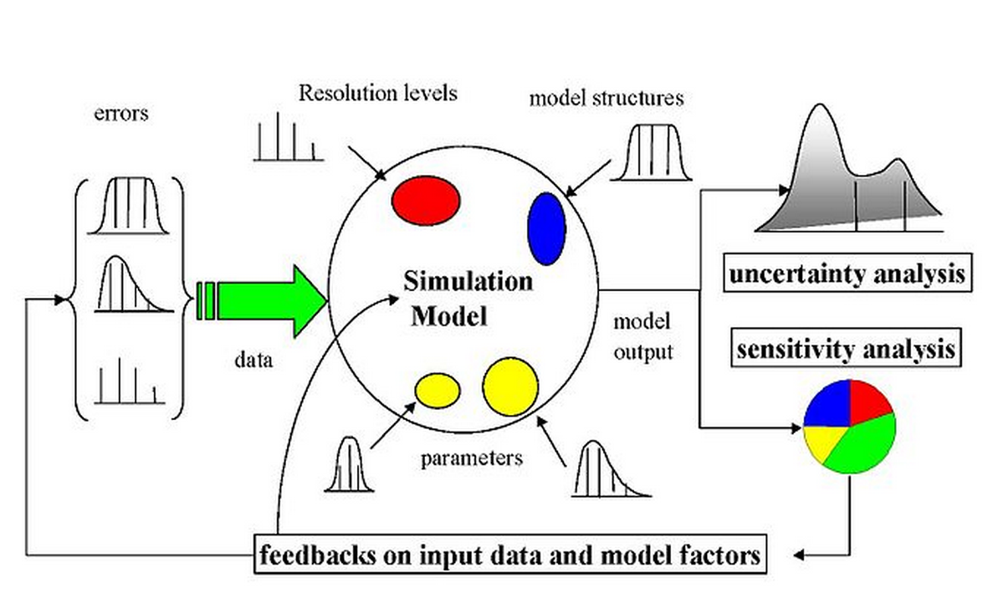

Figure 1 The scheme of a sampling-based sensitivity analysis. Uncertainty would arise from different sources—errors in the data, parameter estimation procedure, and alternative model structures—they are propagated through the model for uncertainty analysis and their relative importance is quantified via sensitivity analysis.



Figure 2 Three different exposure intake routes of the pollen.



Figure 3 Schematic diagram of modeling exposure to pollen in 9 climate regions. Concentrations and surface loading of pollen were simulated based on observed daily pollen counts from AAAAI monitoring stations. Exposures to pollens were simulated based on the concentration profiles and activity data of different groups by ages and sex from United States Census Bureau. The intake dose calculated from exposure modeling is then used as input to conduct sensitivity analysis.

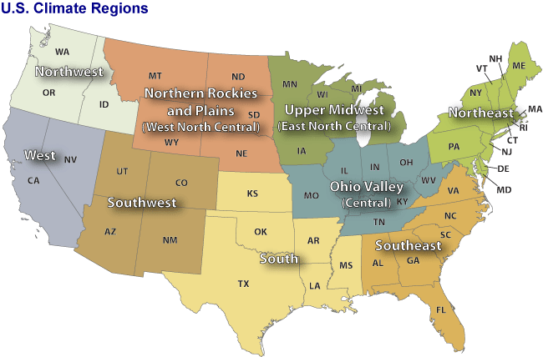

Figure 4 Nine climate regions in the contiguous United States. Through climate analysis, National Climatic Data Center scientists have identified nine climatically consistent regions within the contiguous United States which are useful for putting current climate anomalies into a historical perspective(Karl and Koss 1984)

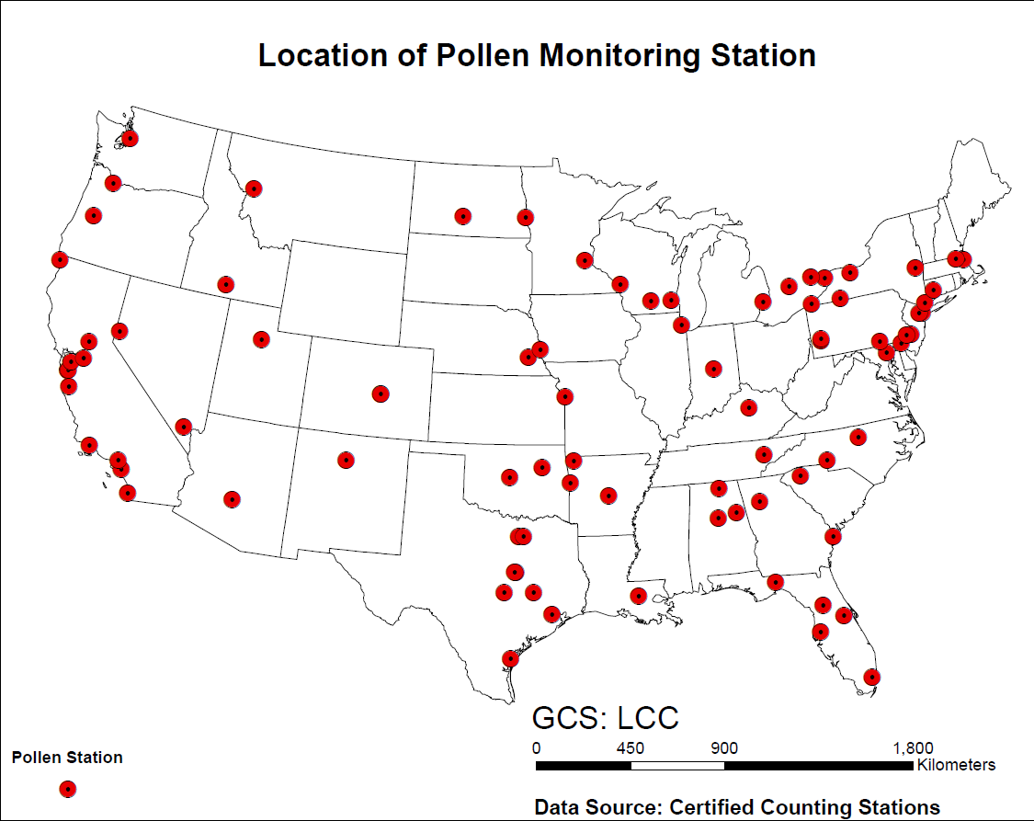

Figure 5 Locations of the American Academy of Allergy Asthma and Immunology (AAAAI) monitor stations for airborne pollen in the United States. Pollen counts data were obtained from these monitor stations in each climate regions.



Figure 6 Inhalation rate by weight of male and female, respectively. The data are from EFH handbook (U.S. Environmental Protection Agency 2010). There are 14 age groups from the original data resources, for each gender. The age groups are 0-1 year, 1-2 years, 2-3 years, 3-6 years, 6-11 years, 11-16 years, 16-21 years, 21-31 years, 31-41 years, 41-51 years, 51-61 years, 61-71 years, and 71-81 years. The percentiles are from 5th to 95th. (5th, 10th, 25th, 50th, 75th, 90th, 95th)



Figure 7 Inhalation rate of male and female, respectively. The data are from EFH handbook (U.S. Environmental Protection Agency 2010). There are 14 age groups from the original data resources, for each gender. The age groups are 0-1 year, 1-2 years, 2-3 years, 3-6 years, 6-11 years, 11-16 years, 16-21 years, 21-31 years, 31-41 years, 41-51 years, 51-61 years, 61-71 years, and 71-81 years. The percentiles are from 5th to 95th. (5th, 10th, 25th, 50th, 75th, 90th, 95th)



Figure 8 Surface area of human body. The data are from EFH handbook (U.S. Environmental Protection Agency 2010). There are 17 age groups from the original data resources, for each gender. The age groups are 1-3 months, 3-6 months, 6-12 months, 1-2 years, 2-3 years, 3-6 years, 6-11 years, 11-16 years, 16-21 years, 21-31 years, 31-41 years, 41-51 years, 51-61 years, 61-71 years, and 71-81 years.81 years and older. The percentiles are from 5th to 95th. (5th, 10th, 25th, 50th, 75th, 90th, 95th)





Figure 9 Time series of observed daily pollen concentration of Ambrosia at Cherry Hill (top) and Newark (Bottom) monitor stations which locate in the Northeast Climate Regions. The pollen data are from National Allergy Bureau(National Allergy Bureau 2010).





Figure 10 Time series of observed daily pollen concentration of Artemisia in Cherry Hill (top) and Newark (Bottom) monitor stations which locate in the Northeast Climate Regions. The pollen data are from National Allergy Bureau(National Allergy Bureau 2010)





Figure 11 Time series of observed daily pollen concentration of Betula in Cherry Hill (top) and Newark (Bottom) monitor stations which locate in the Northeast. The pollen data are from National Allergy Bureau(National Allergy Bureau 2010).





Figure 12 Time series of observed daily pollen concentration of Gramineae in Cherry Hill (top) and Newark (Bottom) monitor station which locate in the Northeast. The pollen data are from National Allergy Bureau(National Allergy Bureau 2010).



Figure 13 Time series of observed daily pollen concentration of pollen concentration of Ambrosia in Cherry Hill (top) and Newark (Bottom) monitor stations which locate in the Northeast. The pollen data are from National Allergy Bureau(National Allergy Bureau 2010)



Figure 15 The observed cumulative probability distributions of daily pollen concentration for Ambrosia in the 9 nine climates regions.



Figure 16 The observed cumulative probability distributions of daily pollen concentration for Artemisia in the 9 climates regions. The concentration profile in southwest is slightly smooth than in other climate regions.



Figure 17 The observed cumulative probability distributions of daily pollen concentration for Betula in the 9 nine climates regions.



Figure 18 The observed cumulative probability distributions of daily pollen concentration for Gramineae in the 9 nine climates regions.



Figure 19 t The observed cumulative probability distributions of daily pollen concentration for Quercus in the 9 nine climates regions.



Figure 20 Simulated cumulative probability distribution of daily exposure to Ambrosia pollen in different climate regions. Data were from simulation results of 5000 virtual residents in each climate regions under three different exposure routes.



Figure 21 Simulated cumulative probability distribution of daily exposure to Artemisia pollen in different climate regions. Data were from simulation results of 5000 virtual residents in each climate regions under three different exposure routes.



Figure 22 Simulated cumulative probability distribution of daily exposure to Betula pollen in different climate regions. Data were from simulation results of 5000 virtual residents in each climate regions under three different exposure routes.



Figure 23 Simulated cumulative probability distribution of daily exposure to Gramineae pollen in different climate regions. Data were from simulation results of 5000 virtual residents in each climate regions under three different exposure routes.



Figure 24 Simulated cumulative probability distribution of daily exposure to Quercus pollen in different climate regions. Data were from simulation results of 5000 virtual residents in each climate regions under three different exposure routes.



Figure 25 Mean and Standard Deviation of Normalized Sensitivity Coefficient (NSC) for population exposure in Central Climate Region(Ohio Valley)(A) Inhalation (B)Dermal (C) Ingestion (D)Total Exposures The vertical dashed lines represent the NSC values of 0. Number in the figure are parameter IDs:1 u*, 2 k, 3 D*p*, 4 P*p*, 5 µ, 6λ, 7 P*a*, 8 T, 9 V*e*, 10 T*ind*, 11 T*out*, 12 F, 13 S*a*, 14 S*r*, 15 In*f*, 16 In*m*, 17 V*d*, 18 L*r*.



Figure 26 Mean and Standard Deviation of Normalized Sensitivity Coefficient (NSC) for population exposure in Southeast Climate Region (A) Inhalation (B)Dermal (C) Ingestion (D)Total Exposures The vertical dashed lines represent the NSC values OF 0. Number in the figure are parameter IDs:1 u*, 2 k, 3 D*p*, 4 P*p*, 5 µ, 6λ, 7 P*a*, 8 T, 9 V*e*, 10 T*ind*, 11 T*out*, 12 F, 13 S*a*, 14 S*r*, 15 In*f*, 16 In*m*, 17 V*d*, 18 L*r*.

# Table

Table 1 Coordinates, elevation, main climate characteristics of the studied AAAAI pollen monitoring stations.

|  |  |  |  |  |  |
| --- | --- | --- | --- | --- | --- |
| **Station Name** | **Lat (N)** | **Lon (W)** | **Elevation** | **Climate Region** | **Mean Temp** |
| Corpus Christi, TX | 27.8 | 97.4 | 2 | South | 22.21 |
| Tampa, FL | 28.06 | 82.43 | 12 | Southeast | 22.73 |
| Tallahassee, FL | 30.44 | 84.28 | 62 | Southeast | 19.67 |
| Georgetown, TX | 30.64 | 96.31 | 91 | South | 19.48 |
| College Station, TX | 30.64 | 97.76 | 269 | South | 20.31 |
| Waco, TX | 31.51 | 97.2 | 185 | South | 19.44 |
| Dallas, TX | 33.04 | 96.83 | 207 | South | 19.29 |
| Scottsdale, AZ | 33.49 | 111.92 | 377 | Southwest | 23.98 |
| Orange, CA | 33.78 | 117.86 | 53 | West | 17.93 |
| Atlanta, GA | 33.97 | 84.55 | 366 | Southeast | 16.83 |
| Santa Barbara, CA | 34.44 | 119.76 | 57 | West | 14.86 |
| Huntsville, AL | 34.73 | 86.59 | 191 | Southeast | 16.26 |
| Little Rock, AR | 34.75 | 92.39 | 115 | South | 17.28 |
| Charlotte, NC | 35.3 | 80.75 | 229 | Southeast | 16.02 |
| Fort Smith, AR | 35.35 | 94.39 | 186 | South | 16.49 |
| Oklahoma City, OK | 35.61 | 97.6 | 340 | South | 15.90 |
| Los Alamos, NM | 35.88 | 106.32 | 2227 | Southwest | 11.80 |
| Knoxville, TN | 35.95 | 84.01 | 305 | Central | 15.01 |
| Tulsa 1, OK | 36.03 | 95.87 | 207 | South | 16.17 |
| Durham, NC | 36.05 | 78.9 | 110 | Southeast | 15.71 |
| Las Vegas, NV | 36.17 | 115.15 | 620 | West | 20.93 |
| San Jose 2, CA | 37.31 | 121.97 | 47 | West | 15.69 |
| San Jose 2, CA | 37.33 | 121.94 | 35 | West | 15.69 |
| Pleasanton, CA | 37.69 | 121.91 | 100 | West | 14.18 |
| Lexington, KY | 38.04 | 84.5 | 299 | Central | 13.11 |
| Roseville, CA | 38.76 | 121.27 | 57 | West | 16.96 |
| Colorado Springs 2, CO | 38.87 | 104.82 | 1867 | Southwest | 9.75 |
| Colorado Springs 1, CO | 38.87 | 104.83 | 1868 | Southwest | 9.64 |
| Kansas City, MO | 39.08 | 94.58 | 288 | Central | 13.91 |
| Baltimore, MD | 39.37 | 76.47 | 36 | Northeast | 13.33 |
| Reno, NV | 39.56 | 119.77 | 1382 | West | 12.08 |
| New Castle, DE | 39.66 | 75.57 | 3 | Northeast | 13.46 |
| Indianapolis, IN | 39.91 | 86.2 | 254 | Central | 11.98 |
| York, PA | 39.94 | 74.91 | 13 | Northeast | 12.72 |
| Cherry Hill, NJ | 39.94 | 76.71 | 195 | Northeast | 13.04 |
| Philadelphia, PA | 39.96 | 75.16 | 12 | Northeast | 13.46 |
| Pittsburgh, PA | 40.47 | 79.95 | 287 | Northeast | 11.20 |
| Newark, NJ | 40.74 | 74.19 | 43 | Northeast | 13.02 |
| Lincoln, NE | 40.82 | 96.64 | 371 | West North Central | 11.03 |
| Armonk, NY | 41.13 | 73.73 | 187 | Northeast | 11.09 |
| Omaha, NE | 41.14 | 95.97 | 305 | West North Central | 10.95 |
| Waterbury, CT | 41.55 | 73.07 | 140 | Northeast | 11.83 |
| Chicago, IL | 41.91 | 87.77 | 189 | Central | 11.03 |
| Olean, NY | 42.09 | 78.43 | 433 | Northeast | 7.30 |
| Erie, PA | 42.1 | 80.13 | 215 | Northeast | 10.12 |
| Salem, MA | 42.5 | 70.92 | 42 | Northeast | 10.90 |
| St. Clair Shores, MI | 42.51 | 82.9 | 180 | East North Central | 9.82 |
| Twin Falls, ID | 42.58 | 114.46 | 1124 | Northwest | 10.23 |
| Chelmsford, MA | 42.6 | 71.35 | 37 | Northeast | 10.01 |
| Albany, NY | 42.68 | 73.77 | 72 | Northeast | 9.41 |
| London, ON, Canada | 42.99 | 81.25 | 250 | Central | 8.34 |
| Waukesha, WI | 43.02 | 88.24 | 270 | East North Central | 9.60 |
| Madison, WI | 43.08 | 89.43 | 263 | East North Central | 8.66 |
| Niagara Falls, ON , Canada | 43.09 | 79.09 | 188 | Northeast | 9.27 |
| Rochester, NY | 43.1 | 77.58 | 148 | Northeast | 9.33 |
| LaCrosse, WI | 43.88 | 91.19 | 216 | East North Central | 8.96 |
| Eugene, OR | 44.04 | 123.09 | 129 | Northwest | 11.35 |
| Vancouver, WA | 45.62 | 122.5 | 89 | Northwest | 12.25 |
| Fargo, ND | 46.84 | 96.87 | 277 | West North Central | 5.89 |
| Seattle, WA | 47.66 | 122.29 | 20 | Northwest | 11.94 |

Table 2 Parameters for calculating population exposure to pollen in 9 different climate regions in United States. These parameters were listed either as fixed values, known distributions or unknown empirical distribution derived from the literatures.(Sofiev, Belmonte et al. 2013)

|  |  |  |  |  |  |  |
| --- | --- | --- | --- | --- | --- | --- |
| **parameter1** | **Parameter** | **ID** | **Distribution** | **Mean(STD)** | **Range** | **Ref.** |
| u* | friction velocity (m/s) | 1 | fixed | 1.17 | - | (Helbig, Vogel et al. 2004) |
| k | von karman constant(dimensionless) | 2 | fixed | 0.41 | - | (Sofiev, Belmonte et al. 2013) |
| D*p* | diameter of pollen (m) | 3 | fixed | 2.00E-05 | - | (National Allergy Bureau 2010) |
| P*p* | density of pollen (kg/m3) | 4 | fixed | 840 | - | (Sofiev, Belmonte et al. 2013) |
| µ | viscosity of air (m/s) | 5 | fixed | 1.81E-05 | - | (Helbig, Vogel et al. 2004) |
| λ | mean free path of air molecules (m) | 6 | fixed | 6.80E-08 | - | (Seinfeld and Pandis 2012) |
| P*a* | density of air (kg/m3) | 7 | fixed | 1.145 | - | (Seinfeld and Pandis 2012) |
| T | Temperature (k) | 8 | range | 298 | 283-310 | (Shea, Truckner et al. 2008) |
| V*e* | ventilation rate (dimensionless) | 9 | range | 1.2 | 0.5-2 | (Fogh and Andersson 2000) |
| T*ind* | indoor time (min) | 10 | norm | 1279(21) | - | (U.S. Environmental Protection Agency 2010) |
| T*out* | outdoor time (min) | 11 | norm | 174(4) | - | (U.S. Environmental Protection Agency 2010) |
| F | hand to mouth contact frequency (times) | 12 | empirical | 30 | 3-65 | (U.S. Environmental Protection Agency 2010) |
| S*a* | human surface area (m2) | 13 | lognorm | 1.76 | 0.41-2.51 | (U.S. Environmental Protection Agency 2010) |
| S*r* | hand surface area ratio (dimensionless) | 14 | lognorm | 5.3 | 4.8-5.6 | (U.S. Environmental Protection Agency 2010) |
| Ih*f* | female inhalation rate (m3/day) | 15 | uniform | 1.33 | 0.19-1.91 | (U.S. Environmental Protection Agency 2010) |
| Ih*m* | male inhalation rate (m3/day) | 16 | uniform | 1.45 | 0.20-1.50 | (U.S. Environmental Protection Agency 2010) |
| V*d* | indoor ventilation rate (dimensionless) | 17 | empirical | 1.75 | - | (Fogh and Andersson 2000) |
| L*r* | derm loading rate (dimensionless) | 18 | empirical | 0.001 |  | (Cohen, Ecker et al. 1930) |

Table 3 Median and Range of the Total Exposure Values in 9 Climate Regions ( Pollen / Day )

|  |  |  |  |  |  |  |
| --- | --- | --- | --- | --- | --- | --- |
| **Species** | **Percentile** | **Central** | **EastNorthCentral** | **NorthEast** | **NorthWest** | **South** |
| birch (Betula) | 25% | 9 | 7 | 12 | 14 | 11 |
|  | 50% (Median) | 14 | 13 | 26 | 45 | 21 |
|  | 75% | 30 | 28 | 77 | 176 | 53 |
|  | 95% | 120 | 79 | 362 | 645 | 167 |
| ragweed (Ambrosia) | 25% | 17 | 23 | 39 | 14 | 13 |
|  | 50% (Median) | 47 | 82 | 74 | 35 | 37 |
|  | 75% | 139 | 264 | 279 | 160 | 159 |
|  | 95% | 739 | 1176 | 2553 | 1325 | 1272 |
| mugwort (Artemisia) | 25% | 37 | 26 | 17 | 7 | 35 |
|  | 50% (Median) | 90 | 118 | 50 | 15 | 150 |
|  | 75% | 359 | 444 | 145 | 25 | 684 |
|  | 95% | 2191 | 1246 | 641 | 53 | 3264 |
| grass (Gramineae) | 25% | 13 | 10 | 14 | 15 | 16 |
|  | 50% (Median) | 33 | 23 | 28 | 48 | 41 |
|  | 75% | 100 | 61 | 72 | 179 | 128 |
|  | 95% | 534 | 235 | 296 | 1520 | 4026 |
| oak (Quercus) | 25% | 31 | 42 | 57 | 14 | 76 |
|  | 50% (Median) | 100 | 172 | 129 | 48 | 433 |
|  | 75% | 380 | 716 | 682 | 184 | 1693 |
|  | 95% | 2740 | 2049 | 5250 | 733 | 6044 |
| **Species** | **Percentile** | **SouthEast** | **SouthWest** | **West** | **WestNorthCentral** | **US** |
| birch (Betula) | 25% | 8 | 10 | 10 | 8 | 10 |
|  | 50% (Median) | 18 | 25 | 20 | 17 | 22 |
|  | 75% | 48 | 220 | 49 | 40 | 80 |
|  | 95% | 125 | 1517 | 172 | 139 | 370 |
| ragweed (Ambrosia) | 25% | 17 | 5 | 13 | 15 | 17 |
|  | 50% (Median) | 51 | 7 | 33 | 48 | 46 |
|  | 75% | 185 | 10 | 114 | 167 | 164 |
|  | 95% | 901 | 57 | 703 | 936 | 1074 |
| mugwort (Artemisia) | 25% | 13 | 10 | 9 | 18 | 64 |
|  | 50% (Median) | 38 | 22 | 17 | 76 | 64 |
|  | 75% | 122 | 94 | 48 | 336 | 251 |
|  | 95% | 531 | 1092 | 297 | 1554 | 1208 |
| grass (Gramineae) | 25% | 11 | 10 | 109 | 10.8.3 | 25 |
|  | 50% (Median) | 21 | 22 | 141 | 23 | 42 |
|  | 75% | 50 | 49 | 189 | 64 | 99 |
|  | 95% | 182 | 222 | 314 | 267 | 844 |
| oak (Quercus) | 25% | 43 | 10 | 26 | 27 | 36 |
|  | 50% (Median) | 211 | 24 | 79 | 93 | 143 |
|  | 75% | 1440 | 98 | 237 | 383 | 646 |
|  | 95% | 8564 | 724 | 1330 | 2714 | 3350 |

Table 4 Mean and Standard Deviation of the Total Exposure Values in 9 Climate Regions ( Pollen / Day )

|  |  |  |  |  |  |
| --- | --- | --- | --- | --- | --- |
| **Species** | **Central** | **EastNorthCentral** | **NorthEast** | **NorthWest** | **South** |
| birch (Betula) | 42 (150) | 23 (28) | 91 (236) | 152 (245) | 47 (72) |
| ragweed (Ambrosia) | 200(799) | 273 (587) | 658 (3173) | 305 (1064) | 293 (1007) |
| mugwort (Artemisia) | 527(1754) | 329(51) | 151 (307) | 19 (18) | 702 (1419) |
| grass (Gramineae) | 139 (431) | 59.63 (108) | 82 (211) | 317 (1301) | 250 (680) |
| oak (Quercus) | 649 (2451) | 787 (1654) | 1277 (7453) | 173 (341) | 1593 (5033) |
| **Species** | **SouthEast** | **SouthWest** | **West** | **WestNorthCentral** | **US** |
| birch (Betula) | 36 (48) | 313 (821) | 51 (115) | 37 (60) | 88 (317) |
| ragweed (Ambrosia) | 244 (901) | 13 (24) | 158 (437) | 224 (793) | 263 (1293) |
| mugwort (Artemisia) | 124 (263) | 227 (781) | 105 (497) | 369 (98) | 284 (927) |
| grass (Gramineae) | 51 (110) | 57 (128) | 7374 (12159) | 69 (169) | 933 (4065) |
| oak (Quercus) | 1856 (4998) | 159 (430) | 347 (1145) | 604 (2294) | 822 (3171) |

Table 5 Median of the Exposure in Central Climate Region through Different Exposure Routes ( Pollen / Day )

|  |  |  |  |  |  |
| --- | --- | --- | --- | --- | --- |
| **Species** | **Median or Mean** | **Inhalation** | **Dermal Contact** | **Ingestion** | **Total** |
| birch (Betula) | Median | 22.00 | 0.04 | 0.09 | 22.00 |
|  | Mean | 88.00 | 0.00 | 0.00 | 89.00 |
| ragweed (Ambrosia) | Median | 46.00 | 0.12 | 0.27 | 47.00 |
|  | Mean | 263.00 | 0.00 | 1.00 | 264.00 |
| mugwort (Artemisia) | Median | 64.00 | 0.23 | 0.00 | 65.00 |
|  | Mean | 284.00 | 0.00 | 1.00 | 285.00 |
| grass (Gramineae) | Median | 42.00 | 0.09 | 0.19 | 43.00 |
|  | Mean | 933.00 | 1.00 | 1.00 | 936.00 |
| oak (Quercus) | Median | 143.00 | 0.26 | 0.59 | 144.00 |
|  | Mean | 822.00 | 1.00 | 1.00 | 824.00 |

Table 6 Mean Time Spent at 3 Locations for Both CARB and National Studies (Robinson and Thomas 1991, U.S. Environmental Protection Agency 2010)

|  |  |  |  |  |
| --- | --- | --- | --- | --- |
| **Mean Duration(Minutes/Day)** | | | | |
| **Location Category** | **CARB** | **SE** | **National** | **SE** |
| Indoor | 1279.0 | 21.0 | 1279.0 | 21.0 |
| outdoor | 74 | 4 | 74 | 4 |
| In-vehicle | 87.0 | 2.0 | 87.0 | 2.0 |

SE = Standard error of mean.

CARB=California Air Resources Board

Difference between the mean values for the CARB and national studies is not statistically significant.

Difference between the mean values for the CARB and national studies is statistically significant at the 0.05 level.

Reference

Bateman, E., et al. (2008). "Global strategy for asthma management and prevention: GINA executive summary." European Respiratory Journal **31**(1): 143-178.

Behrendt, H. and W.-M. Becker (2001). "Localization, release and bioavailability of pollen allergens: the influence of environmental factors." Current Opinion in Immunology **13**(6): 709-715.

Bielory, L., et al. (2012). "Climate change and allergic disease." Current allergy and asthma reports **12**(6): 485-494.

Brożek, J. L., et al. (2010). "Allergic Rhinitis and its Impact on Asthma (ARIA) guidelines: 2010 revision." Journal of Allergy and Clinical Immunology **126**(3): 466-476.

Census Bureau. U.S (2010). "Profile of General Population and Housing Characteristics: 2010 ".

Chuine, I., et al. (2000). "A modelling analysis of the genetic variation of phenology between tree populations." Journal of Ecology **88**(4): 561-570.

Cohen, M. B., et al. (1930). "The rate of absorption of ragweed pollen material from the nose." The Journal of Immunology **18**(6): 419-425.

Cohen, S. H., et al. (1979). "Acute allergic reaction after composite pollen ingestion." Journal of Allergy and Clinical Immunology **64**(4): 270-274.

Eder, W., et al. (2006). "The asthma epidemic." New England Journal of Medicine **355**(21): 2226-2235.

Fogh, C. L. and K. G. Andersson (2000). "Modelling of skin exposure from distributed sources." Annals of Occupational Hygiene **44**(7): 529-532.

Gould, H. J., et al. (2003). "The biology of IgE and the basis of allergic disease." Annual review of immunology **21**(1): 579-628.

Helbig, N., et al. (2004). "Numerical modelling of pollen dispersion on the regional scale." Aerobiologia **20**(1): 3-19.

Hu, X., et al. (2011). "Bioaccessibility and health risk of arsenic, mercury and other metals in urban street dusts from a mega-city, Nanjing, China." Environmental Pollution **159**(5): 1215-1221.

Karl, T. and W. J. Koss (1984). Regional and National Monthly, Seasonal, and Annual Temperature Weighted by Area, 1895-1983, National Climatic Data Center.

Lamb, C. E., et al. (2006). "Economic impact of workplace productivity losses due to allergic rhinitis compared with select medical conditions in the United States from an employer perspective." Current Medical Research and Opinion® **22**(6): 1203-1210.

National Allergy Bureau (2010). NAB Pollen Counts.

Passalacqua, G. and S. R. Durham (2007). "Allergic rhinitis and its impact on asthma update: allergen immunotherapy." Journal of Allergy and Clinical Immunology **119**(4): 881-891.

Robinson, J. P. and J. Thomas (1991). Time spent in activities, locations, and microenvironments: A California-national comparison. Project report, General Sciences Corp., Laurel, MD (United States).

Seinfeld, J. H. and S. N. Pandis (2012). Atmospheric chemistry and physics: from air pollution to climate change, John Wiley & Sons.

Shea, K. M., et al. (2008). "Climate change and allergic disease." Journal of Allergy and Clinical Immunology **122**(3): 443-453.

Singh, K., et al. (2010). "The epidemiology of ocular and nasal allergy in the United States, 1988-1994." Journal of Allergy and Clinical Immunology **126**(4): 778-783. e776.

Sofiev, M., et al. (2013). Airborne Pollen Transport. Allergenic Pollen, Springer**:** 127-159.

U.S. Environmental Protection Agency (2010). Exposure factors handbook, EPA Washington, DC.

Zhang, Y., et al. (2013). "Modeling Flight Attendants’ Exposures to Pesticide in Disinsected Aircraft Cabins." Environmental Science & Technology.