

TRAINING REPORT
SUBMITTED TO :
DEPARTMENT OF COMPUTER SCIENCE
SUBMITTED BY : Tripta Sahni (ROLL NO. – 1910991140)

DECLARATION

I hereby declare that the dissertation entitled Training Report submitted as part of Bachelor’s degree in Computer Science, at Chitkara University, Punjab, is an authentic record of my own work and the dissertation has not formed the basis for the award of any degree, associateship, fellowship or any other similar titles.

Tripta Sahni
1910991140
Date: 4th May, 2023

ACKNOWLEDGEMENT

I'd like to express my gratitude to everyone that assisted me in completing this project during this internship. All of the tasks I've completed successfully under their supervision contributes to the project's success and outcome. First and foremost, I want to express my gratitude to the Vice-Chancellor and Dean, Chitkara University for providing me with this fantastic opportunity to further my talents by providing me with a company where I can put my theoretical knowledge into practice. I'd like to express my gratitude to Mr. Simarpreet Singh Gujral and Ms. Neetu Rishi for mentoring me during this internship period. I would like to thank my manager Mrs. Richa Khatri for helping me during the project and throughout the internship period. I also want to thank my Team members for providing me the environment to learn and help the organisation with my skill set. Finally, I want to express my gratitude to Chitkara University and the coordinator of the practice school program for providing me with this incredible opportunity to gain valuable experience in the field of my choosing.

TABLE OF CONTENTS

S.No. | Contents | Page No.
1. | Declaration | 2
2. | Acknowledgement | 3
3. | Table of Contents | 4
4. | Introduction of the Organisation’s Business Sector | 5-9
5. | Projects Undertaken | 10
6. | Technologies and Tools Used | 11-16
7. | Work Done | 17-20
8. | Conclusion and Reference | 21-22

INTRODUCTION OF THE ORGANISATION’S BUSINESS SECTOR

Started in 2012, Gemini Solutions is a global IT consulting firm and a leading offshore outsourcing company with a specialized focus on financial services. Having well equipped automated corporate office in Gurgaon and nationwide network of associate offices.
It provide asset owners and fund managers with a wide range of support, operations outsourcing solutions and servicing to offshore development. Company also delivers innovative performance measurement and analytics tools, giving our clients the information they need to make better-informed decisions.
It has structured the IT community in a way that not only fosters teamwork, but actually depends on it. It also optimizes IT best practices with IT resources available around the clock. The result is technology that provides clients with valuable investment information and helps make them productive.

With a creative management system, a skilled team, and an inherent ability, Gemini Solutions strive to provide custom, affordable, and quality services to its patrons.

Organization caters to the diversified portfolio of clients across sectors such as banking & financial services, retail, healthcare, education and government sector. Company has a well-structured IT community that has been handpicked from the best colleges across India who keep abreast with today’s rapidly changing and ever-evolving technological advancements.

It strives to continuously provide customizable, affordable and quality products & services to our patrons through our creative & skilled teams who demonstrate an inherent agility towards projects.

- Commitment to Customer Success
As Peter Drucker, the founder of modern management, once stated, “The customer is the foundation of a business and keeps it in existence. He alone gives employment. And it is to supply the consumer that society entrusts wealth-producing resources to the business enterprise.” We embrace this philosophy in every aspect of our business. Many businesses preach adages about placing the customer first, but we truly believe we don’t succeed unless our customers succeed. For this reason, our commitment to customer success remains our core motivation in every project we pursue.

- Adoption of the Latest Technologies

Gemini offers several management services and is able to combine our range of services to suit a diverse range of needs. Our dedicated and responsive Managed Services consistently deliver and respond to business needs with proactive support in an agile IT environment. We offer end-to-end IT support services to help streamline and achieve business objectives resulting in high levels of performance within defined SLAs. Adopting the latest technologies is closely tied to our commitment to continual learning. We pride ourselves on our knowledge of new technology, which allows us to confidently develop creative, cutting edge solutions. Adopting the latest technology and automation processes also allows us to increase efficiency, thus providing the best possible economic value to our customers. In turn, the advancements in technology we pass to our clients allow them to outpace their competition.

- Delivery Orientation
Continuous software delivery is a critical component of our commitment to customer success and our agile workflow. Because modern business environments are so dynamic, product requirements often shift midway through the production process. Daily builds allow our clients to test software as early as possible and identify issues or required changes immediately. Involving the client in the development process also builds trust, resulting in a final product that is precisely tailored to the client’s needs. With continuous delivery, our teams gauge clients’ reactions throughout the build process and quickly adjust their behavior to improve effectiveness.

WORKFORCE & DIVERSITY

Gemini Solutions works with companies, governments, nonprofits and other organizations to address complex challenges on a worldwide scale. Their ideas help us build stronger communities .

BUSINESS SIZE

The company has 900+ employees , 60+ technologies , 24/7 support , 7 locations- .USA , Gurugram , Panchkula , Bengaluru , Pun e , Hyderabad , Noida .

LEARNING & DEVELOPMENT

We use a peer-based active learning approach to train our engineers. Our training program is very different from the classroom-style of education used in the broader software industry.

CERTIFICATIONS

Because continuous learning is one of our core values, we emphasize independent vendor- based certifications. These certifications give our team members pride in their technical expertise and add to their professional qualifications. When we evaluate promotions, we emphasize progress towards certifications. Team members that demonstrate increased proficiency via certifications perform more complex tasks and assume greater responsibilities. While the certifications are a substantial expense for our company, we view them as an investment in the future success of our team members.

We provide L&D portal to our team which contains various self-evaluating courses for better learning and growth.

BUSINESS KNOWLEDGE SESSIONS

Occurs every 15 days, gives information about stocks, finance, shares. Also focuses on investment and investment firms. Gives basic idea about the market.

PRESENTATION

A topic related to area of work is given on which we need to prepare our presentation and present it to our colleagues. It not only improves communication but also builds confidence.

LEARNING HOUR

Every week, each of our office locations conducts a one hour “Learning Hour” session. In the learning hour, individual team members present on topics relevant to their expertise. Topics range from project status updates, to new software features, to writing tips. The learning hours are an excellent opportunity for team members to expand their knowledge in a relaxed setting.

HAPPY HOUR

Occurs every week, where 7-8 random colleagues get a chance to interact with each other, know each other’s area of interest. Not only this, people get to play fun games and activities through which they break the monotonous work mood and get a place to relax.

EXTEMPORE
Occurs once in 6 months, where we are given random topics to think upon and speak for atleast 2 minutes. This checks person’s ability to think and speak efficiently and deliver the ideas effectively in the given time span.

MONTHLY TESTS

To test everyone on the trainings provided by team. Not just this quantitative and qualitative analysis is also done with comprehensive skills.

PROJECTS UNDERTAKEN

- Pricing Portal -Implements Pimco Pricing Policy on vendor data, provides operational controls and checks on the data workflow.

- Sigma - Sigma is an application utilized by PM's and trader and originally published as an alternative to the native application in EMEA due to network issues . More recently the published application has been used by APAC users as it provides better performance. At this time ,Sigma is provisioned on INT001P083 and INT0D1P003 .

- PLIL – Pramerica Life Insurance

- HRIS - HRIS is a managing portal which is used by the Gemini HR team for onboarding candidates. The candidates are of two type - lateral and fresher. After the candidate has joined the organisation till the probation period is served by him all the processes are taken care through this portal(training and probation .

- ATS - Applicant tracking system is an application which will be used to ease the work of HRs' by automating the entire hiring process from sourcing applicant to making an offer.

​
Technologies Used

- Selenium
- RestAssured
- Java
- TestNG
- API Automation

Tools

- UiPath
- Eclipse
- Postman
- Visual Studio Code

1. UiPath

UiPath is a robotic process automation tool for large-scale end-to-end automation. For an accelerated business change, it provides solutions for businesses to automate routine office activities. It uses a variety of methods to transform tedious tasks into automated processes.

Features of UiPath
Now that you have understood what UiPath is, this tutorial will now look at the key features of UiPath.
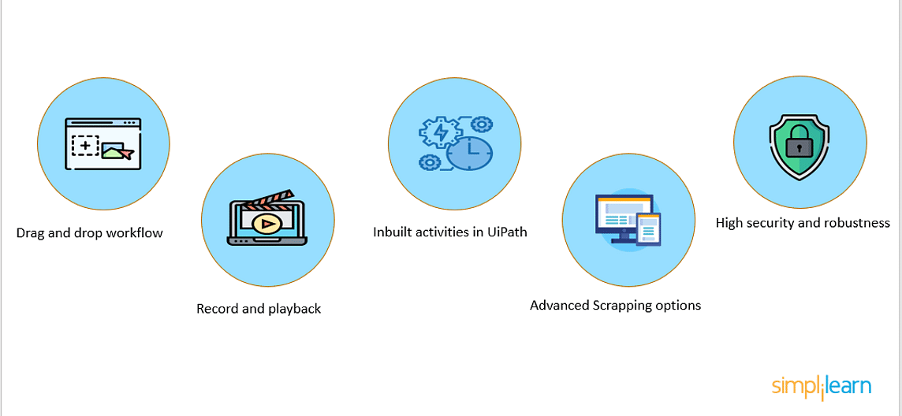

Drag and Drop Workflow
The UiPath user will develop visual process steps by dragging and dropping related tasks onto the graphical workspace. Then, with user interface properties, they can transform those process steps into a visual workflow. Users may also use the recorder wizard in the UiPath tool to build web-based or application workflows.

Record and Playback
The user can use this function to record actions and transform them into an automated process series. UiPath has the following types of recording options:
Basic recording- It focuses on automating single tasks and is commonly used to develop each activity's complete selector.
Desktop recording- It can be used for a variety of actions as well as application development.
Web recording- Web recording is a common tool for viewing and recording web page activities.
Citrix recording- It is very widely used for recording stuff like pictures and virtualized environment automation.
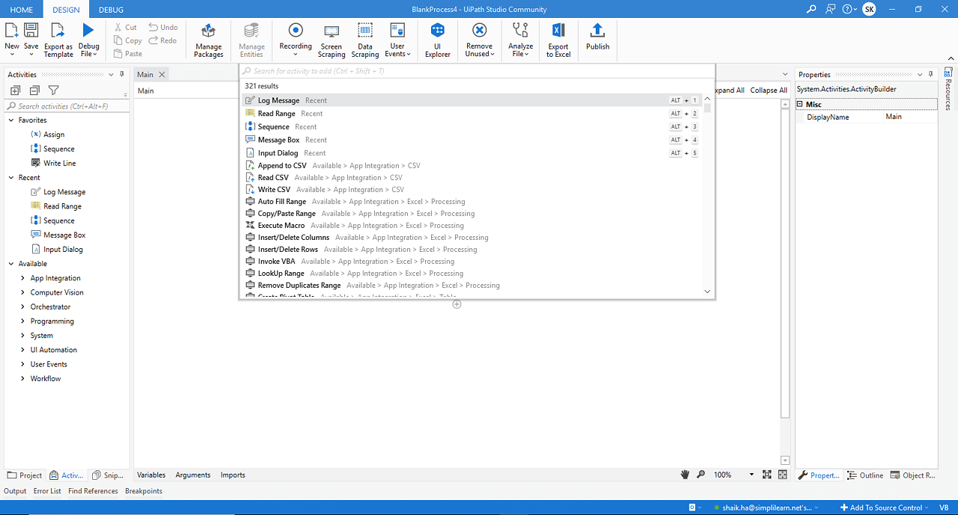
Inbuilt activities in UiPath

UiPath comes with over 300 built-in activities covering a wide range of process automation and application integration design tasks. You can find these activities in the Activities pane, which covers most design tasks such as data extraction, data entry, and automation.

2. Postman
Postman is an API(application programming interface) development tool that helps to build, test, and modify APIs. Almost any functionality that could be needed by any developer is encapsulated in this tool. It is used by over 5 million developers every month to make their API development easy and simple. It can make various types of HTTP requests(GET, POST, PUT, PATCH), saving environments for later use, converting the API to code for various languages(like JavaScript, Python).

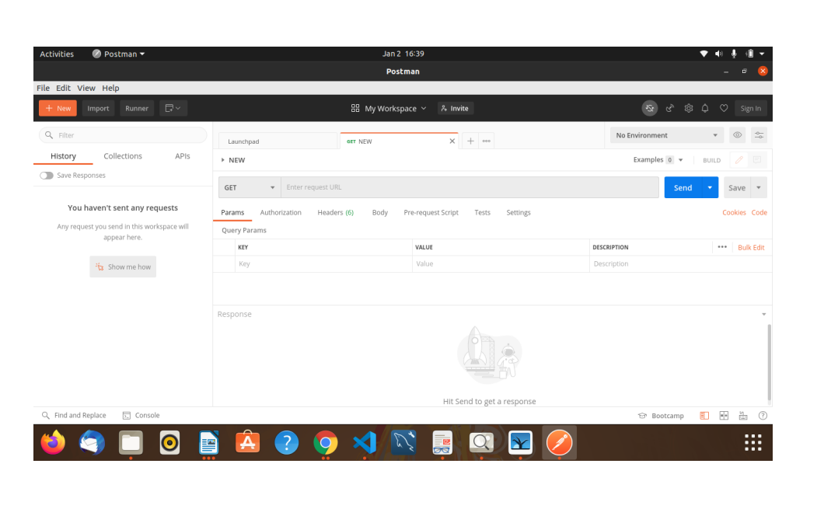

3. Visual Studio Code

Visual Studio Code is a lightweight but powerful source code editor that runs on your desktop and is available for Windows, macOS, and Linux. It comes with 11 built-in support for JavaScript, TypeScript, and Node.js and has a rich ecosystem of extensions for other languages. Visual Studio Code features a lightning fast source code editor, perfect for day-to-day use. With support for hundreds of languages, VS Code helps you be instantly productive with syntax highlighting, bracket-matching, auto-indentation, boxselection, snippets, and more. Intuitive keyboard shortcuts, easy customization, and community-contributed keyboard shortcut mappings let you navigate your code with ease.
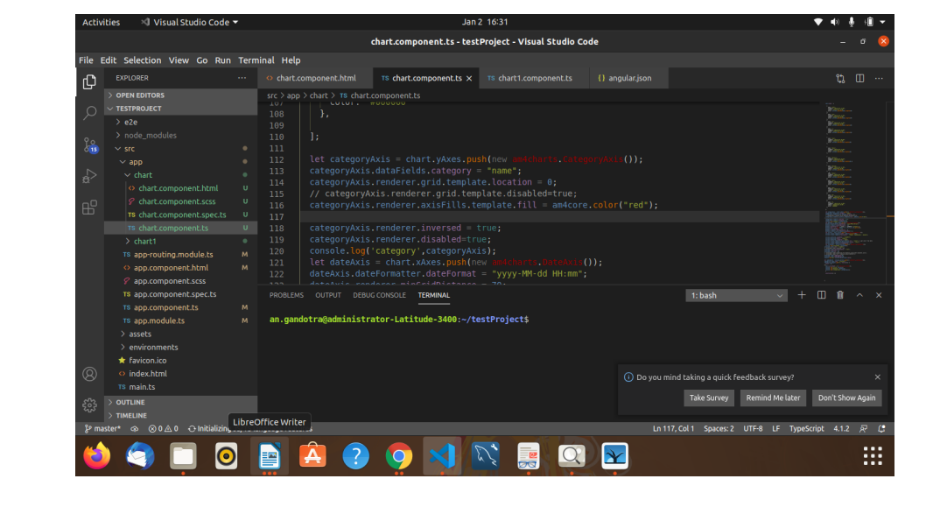
4. JIRA
Jira helps teams plan, assign, track, report, and manage work and brings teams together for everything from agile software development and customer support to start-ups and enterprises. Software teams build better with Jira Software, the #1 tool for agile teams.
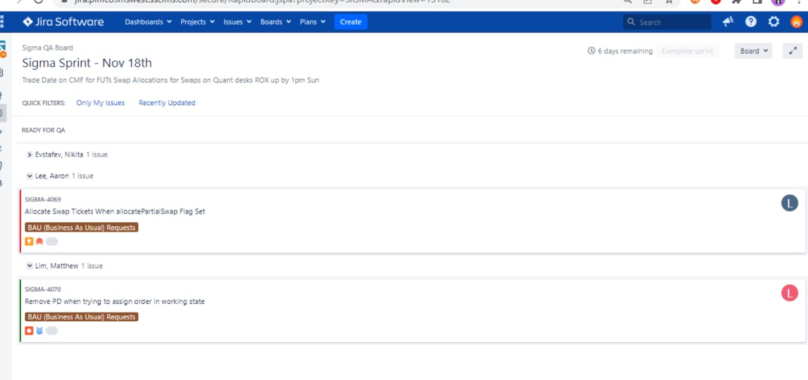

Language used-

JAVA

Java is a popular programming language, created in 1995.
It is owned by Oracle, and more than 3 billion devices run Java.
It is used for:
- Mobile applications (specially Android apps)
- Desktop applications
- Web applications
- Web servers and application servers
- Games
- Database connection
- Java works on different platforms (Windows, Mac, Linux, Raspberry Pi, etc.)
- It is one of the most popular programming language in the world
- It has a large demand in the current job market
- It is easy to learn and simple to use
- It is open-source and free
- It is secure, fast and powerful
- It has a huge community support (tens of millions of developers)
- Java is an object oriented language which gives a clear structure to programs and allows code to be reused, lowering development costs
- As Java is close to C++ and C#, it makes it easy for programmers to switch to Java or vice versa

Work Done
“Pricing Portal”

- Manually tested the ALM test cases of various modules like cusip view, vendor challenges, maintenance, model security, security info, etc. It covered around 150+ test cases which helped me to have a good hands -on practice of ALM and understand the functionalities of various screens of "Pricing Portal".
- Had a deep study of already automated UiPath test cases of the Project from scratch and understood it's flow. Automated the maintenance module(6 testcases) of Pricing Portal using UiPath as the tool.

“SIGMA”
- Manually tested the ALM testcases of Orders Bulk Upload ,Orders blotter, tickets Blotter etc. screens initially and then went through the already made UiPath scripts of the screens.
- Carried out a daily task of ROX Regression of 10 UiPath scripts which includes making of orders of various types, staging them and checking their status in the ROX screen as well as their tickets and it's report is made . Also while executing the scripts, I have often encountered bugs and a few unusual behavior in the UI and reported them to the Developers.
- Carried out the biweekly Regression of various modules of SIGMA – Order Bulk Upload, Orders Blotter, ROX, Positions, RollBook , Inforeach , Tradeweb , Bondvision etc by executing automated run of the UiPath scripts of the respective modules.
- Post the report generation of the Biweekly SIGMA release, Fixed the failed UiPath scripts of Order Bulk Upload, Orders Blotter ,tickets blotter etc. which included about 50-60 UiPath scripts of different modules.
- Worked on more than 30 Jiras .
- Carried out API testing using postman through the task of daily check of the API-REGRESSION report.
- Made 10 UiPath test scripts in the Orders Blotter suite and 3 in the Order Bulk Upload suite using UiPath.
- Automated 22 UiPath scripts in "Positions" and 13 scripts in "RollBook" suite.
- Made 20 functions and added assertions to it for the API-REGRESSION automation through java.

“PLIL”

- Automated the following 5 test scenarios using Selenium BDD with GemJar as framework :
- Consent form - 22 Test Steps
- Write User (Bulk Upload ) - 13 Test steps
- Admin User - 14 Test Steps
- GOPS User ( Reverse Feed Upload ) - 11 Test Steps
- Super Admin User ( Product Masters ) - 11 test Steps
- Carried out mutiple regressions and worked on code optimization.
“HRIS”

- Made 17 manual testcases for the Accounts screen.
- Made 4 manual testcases for the Employee Skills screen.
- Raised a crucial functionality bug.

“ATS”

- Reported about 70 bugs in the application out of which 28 consisted of major functionalities defects.
- Created 40 manual testcases for the Interviews , Jobs , Applicants screen .
- Created a documentation of all the (59 APIs) being used in the four screens Applicants , Interviews , Jobs and Dashboard.
- Created an API Regression and Health Check suite for all the (59) APIs covering all the major functionalities of the Application ( around 15+common functions ) using GemJar framework .
- Tested 40+ tickets as assigned by Developers .

Conclusion

After completing 12 months in my internship, I feel more confident as a learner. Working on several on demand technologies and getting hands on experience undoubtedly provided a boost to the initial phase of my career. I realized that it requires a lot of effort and skill to fulfil the requirements of the clients. I got to learn various cutting-edge technologies including Selenium BDD,UiPath, Postman,RestAssured, Restful APIs etc. during this period and even learnt how to learn properly. I learnt about the industrial practices that even when your code is working perfectly but you need to minimize your code size and should always use a proper nomenclature for the variables, functions, classes and all other identifiers even the file name should also be proper so that there is no need of comments inside the code. I got proper hands-on on UiPath mainly by debugging the already existing scripts and making the new ones for SIGMA. and learnt how websites are automated and bugs are detected, I feel confident now and I know where I need to improve and which part of my learning, I need to work on to outshine others. I got to know and follow the rigorous testing that we implemented to provide error free deliverables to the clients. This also gave me an insight into real world development, where every feature that you will develop will cost money, how decisions are made, and a sustainable environment is maintained.
Explanation of testing methodologies, protocols, and approaches.
Practical experience with Selenium, UiPath, and Cucumber.
Acquired proficiency in efficient debugging of test cases.
Demonstrated practical expertise with Postman and Autosys.
Developed familiarity with best practices in industrial programming, and demonstrated ability to write efficient code.
Refined problem-solving skills through experience working on diverse projects.

REFERENCES

● https://angular.io/
● https://www.ag-grid.com/javascript-grid-getting-started/
● https://javascript.info/
● https://www.primefaces.org/primeng/
● https://www.javatpoint.com/manual-testing
● https://www.geminisolutions.com
● https://about.gitlab.com/


Thank You !!

