Autonumb.lsp will automatically update selected text to add a specified string. You can select the “Replace” option to sequentially number selected text. Previous settings are stored for future use.

COMMAND = DDNUMB

Installing Auto Number

Extract all files in Autonumb.zip into a directory that is in the AutoCAD search path and create a menu button using the following information:

Using “Copy & Paste” copy the following text into the appropriate spaces on the “Button Properties” dialog box:

LABEL TEXT TO COPY
Name: Auto Number
Macro: ^C^C^P(cond ((null c:ddnumb) (load "autonumb")) (T (princ))) ^P^C^Cddnumb

You can use Autonumb.bmp, included in Autonumb.zip, or create your own icon.

Running Auto Number

To run the program select the button you just added to the menu, or load Autonumb.lsp and enter DDNUMB at the command line. The following dialog box will appear:

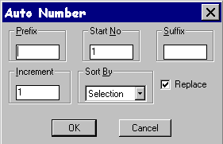

Enter the required information into the appropriate boxes. And select the desired sort method from the pull down list.

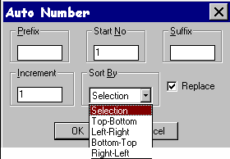

With the “Replace” option selected, any selected text will be changed to sequential numbers starting with the “Start No” value and incrementing by the value specified in the “Increment” box. The order that the text will be numbered is determined by the sort method selected. Any specified prefix and/or suffix will be added to the string accordingly. If the “Selection” sort mode is selected, then the numbering will be in the order you select the text. If you select any other sort method, you can select desired text with a selection window and the sorting will be done automatically.

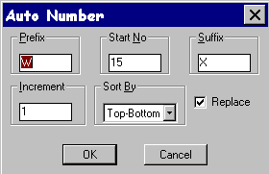

Auto Number remembers the previously used settings and sets the “Start No” to the next available number, based on the last number used, plus the “Increment” setting.

With the “Replace” option unselected, only the “Prefix” and “Suffix” boxes are available.

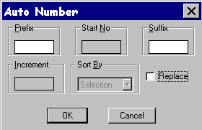

Any selected text will now be modified to include the specified prefix and/or suffix. A selection window can be used, since sorting is not required.

Note: In all cases, objects other than text (including attributes and mtext) will be automatically filtered out of the selection set. So, if you accidentally select other types of objects, you do not have to unselect them.

Any feedback is welcome.

Thank you,
Scott Restmeyer
Globecomm Systems, Inc.
srestmeyer@globecommsystems.com

