Software Requirements Specification

Research Project Management System for Gambella University

Version 1.1

Date: 06 August 2026
Place: Adama, Ethiopia
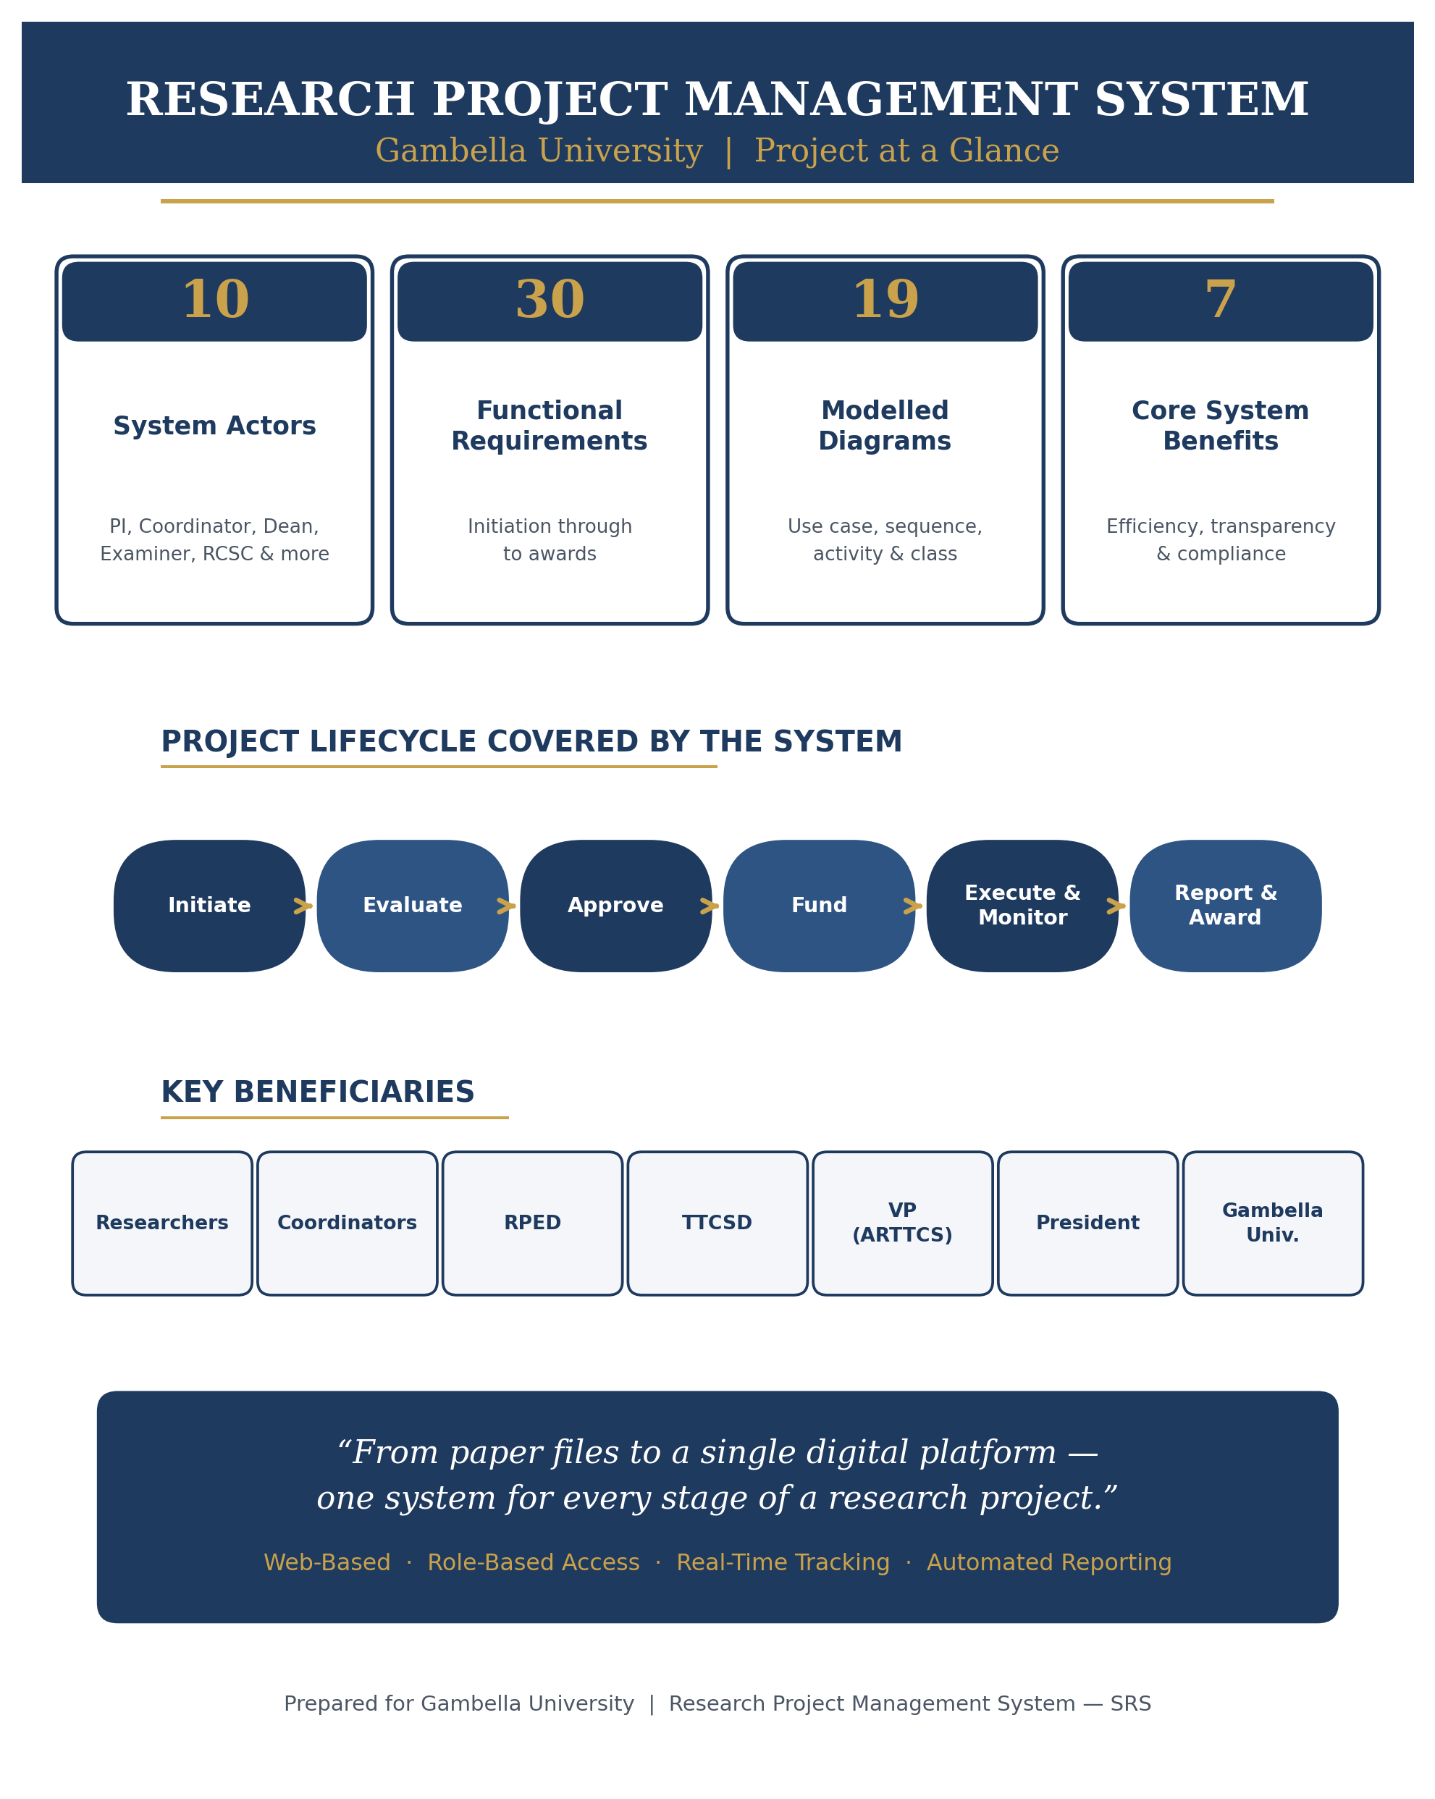

Contents
List of Figures III
List of Tables IV
1. Introduction 1
1.1. Purpose 1
1.2. Scope of the Project 1
1.3. Glossary 3
1.4. Overview of Document 4
2. Overall Description 5
2.1. User Needs 5
2.2. Assumptions and Dependencies 12
3. System Features and Requirements 15
3.1. Functional Requirements 15
3.2. Non-functional Requirements 18
3.2.1. Security 18
3.2.2. Reliability 19
3.2.3. Maintainability 19
3.2.4. Portability 19
3.2.5. Extensibility 20
3.3. External Interface Requirements 20
3.4. System Models 20
3.4.1. Use Case Diagram 20
3.4.2. Use Case Descriptions 23
3.4.2. Sequence Diagram 53
3.4.3. Activity diagram 59
3.4.4. Class Diagram 66
3.4.5. State Chart Diagram 68
4. Appendices 70
5. References 71

List of Figures
Figure 1 Essential use case diagram for Research Project Management System 22
Figure 2. Project Termination and Extension use case 36
Figure 3 PI Transfer and TM replacement use cases 44
Figure 4 Project management use case 48
Figure 5 Sequence diagram for project initiation 54
Figure 6 Project evaluation sequence diagram 55
Figure 7 Sequence diagram for assigning examiner 56
Figure 8 Sequence diagram for project approval 57
Figure 9 Sequence diagram for project progress 58
Figure 10 Sequence diagram for project inspection 59
Figure 11 Activity diagram for budget request processing 61
Figure 12 Activity diagram for examiner assignment 62
Figure 13 Activity diagram for project evaluation 63
Figure 14 Activity diagram for project submission 64
Figure 15 Activity diagram for project progress report 65
Figure 16 Activity diagram for project progress inspection 66
Figure 17 Class diagram for RPMS 67
Figure 18. State chart diagram for project initiation 68
Figure 19. State chart diagram for project evaluation 69

List of Tables
Table 1 Functional requirements of the system 15
Table 2 List of abbreviation used in the essential use case diagram 21
Table 3 Assign Evaluator Use case 23
Table 4Evaluate Project Use Case 24
Table 5Project progress Use Case 25
Table 6 Inspect Progress Use Case 26
Table 7 Approve Budget Use Case 27
Table 8 User Management Use Case 28
Table 9 Initiate Project use case 29
Table 10 Revise Project Use Case 30
Table 11 Approve Project Use Case 31
Table 12Process Budget Use Case 32
Table 13 Arrange Schedule Use Case 33
Table 14 Ethical Clearance Use Case 34
Table 15 Agreement Use Case 35
Table 16 Initiate Project Termination use case 37
Table 17 Project termination process use case 38
Table 18 Refund budget use case 39
Table 19 Request extension use case 40
Table 20 Process time extension use case 41
Table 21Approve time extension use case 43
Table 22 Request PI Transfer 45
Table 23 Approve PI Transfer 45
Table 24 TM Replacement request 46
Table 25 Approve TM Replacement 47
Table 26 Submit Paper 49
Table 27 Evaluate Journal/Project Index 49
Table 28 Approve paper 50
Table 29 Award 51
Table 30 Record Paper 52
Table 31 Award 53

Introduction

1.1 Background and description of the existing system
Established in 2014, Gambella University is a public institution mandated to advance research, community engagement, and the transfer of technology across the region it serves. University-led research is a major source of policy-relevant findings, new development insights, and applied innovation, and it feeds directly into the wellbeing of the surrounding community. Gambella University has, in recent years, made deliberate efforts to position itself as an innovation-driven institution in line with its stated vision, mission, and core values. As part of this drive, academic and research staff are expected to carry out problem-solving research and community-oriented projects alongside their regular teaching load. The university currently runs several research units whose work targets national development priorities set by federal and regional bodies, in addition to global research trends. The volume and quality of this day-to-day research activity is itself one of the metrics used to rank universities, both nationally and internationally.
A significant share of the university budget is set aside for research, community service, and technology-transfer work carried out by staff across its colleges and centers, and the resulting portfolio of active projects and initiatives is coordinated through the Office of the Vice President together with directors and research coordinators in each school and center. Despite these efforts to build a supportive research environment, the underlying processes are not yet backed by any form of digital system.
Instead, these activities are still handled manually on paper, a practice that has produced slow coordination, inconsistent records, no real-time view of budgets or project progress, and difficulty producing accurate reports for University Management, the Ministry of Education, and other stakeholders. Together, these gaps limit the university's ability to manage its research portfolio and to make timely, informed decisions. These challenges can be summarised as follows:
- Lack of notification or alarm systems for delayed or over-budget projects
- Limited error detection in data and information handling
- Inconsistency of data related to research projects - Inability to analyze time and budget usage against progress
- Inefficient access to data, resulting in wasted effort and resources
- High storage requirements for maintaining records of research developments, community services, and technology transfer
- Lack of durability of paper-based records, and waste of time and materials
- Non-compliance with regulations, as many research projects are not completed within the specified timeframe or estimated budget
This document therefore proposes a web-based Research Project Management System to close these gaps. The system will let the research office manage, administer, and coordinate project activities, schedules, and resources from a single platform, generate reports for the relevant offices on demand, and flag projects that are running late or over budget. The overall aim is to implement, test, and deploy a system that supports the full project lifecycle, from proposal submission through to final report delivery.

1.2 Objectives

General Objective
To improve the efficiency, transparency, and effectiveness of research project management at Gambella University through the deployment of an integrated, web-based Research Project Management System (RPMS).

Specific Objectives
- To analyze and document the specific workflows, user roles, and approval hierarchies of GMU’s research ecosystem.
- To accurately align GMU’s organizational structure, including the President, ARTTCS Vice President Office, the Research, Publication and Ethics Directorate (RPED), and Technology Transfer and Community Service Directorate (TTCSD), the Research and Community Service Council (RCSC).
- To configure role-based access and approval workflows for all stakeholders, including researchers, school-level research coordinators, the RPED director, TTCSD director, Vice President, and the President.
- To implement and test the system to ensure it meets GMU’s functional and performance requirements.
- To deploy the system and provide comprehensive user training and documentation.
- To establish a system that automates reporting, budget tracking, and project status notifications.

1.3 Benefits and Beneficiaries

1.3.1 Benefits
After the development of the new system, the major expected outcomes are:
- Increased efficiency: Automates manual processes, drastically reducing administrative workload and processing times.
- RPMS streamlines various research and project management processes
  - Research project initiation, submission, review, and approval: AC/Senate standing
  - Agreement and research project status reporting including terminal report
  - Budget oversight, notifications, instant messaging, email, and etc.
- Improved data integrity: Provides a centralized, consistent source of truth for all research projects, eliminating data redundancy and errors.
- Enhanced transparency: Real-time visibility into project status, budget utilization, and approval processes for all stakeholders.
- Better decision-making: Enables management to make data-driven decisions through on-demand, accurate reports.
- Streamlined compliance: Facilitates timely reporting to the Ministry of Education and other regulatory bodies.
- Resource optimization: Reduces waste associated with paper-based systems and manual effort.

1.3.2 Beneficiaries
The major system beneficiaries are:
- Researchers: Easier proposal submissions, real-time status updates, and clear communication with the research office.
- School-level research coordinators: Streamlined oversight of projects within their school and a tool to manage local workflows.
- Research, Publication and Ethics Directorate (RPED): Centralized management of all research activities, efficient reporting, and simplified budget and compliance monitoring.
- Technology Transfer and Community Service Directorate (TTCSD): Centralized management of all technology transfer and community service activities, efficient reporting, and simplified budget, and compliance monitoring.
- Vice President (ARTTCS): High-level visibility into the university’s research performance and resource utilization to inform strategic planning.
- University President: Overall accessing and getting reports
- Gambella University (GMU): Enhanced institutional reputation, improved research output, and a more robust infrastructure for fulfilling its mission.

1.4 Scope of the Project
The proposed system is expected to cover the following areas:
- To build a system through which the researchers can apply for projects to the Research office at different levels within the universities.
- The department/College or research deans/coordinators publish or post call for project/call for abstract, posting information to the research community (like submission date, thematic areas, fund organization and other), monitor projects progresses, assign examiners, maintain reports on project progresses and generate different reports related with on-going, terminated and/or completed projects.
- Generate summarised reports (i.e., monthly, quarterly, biannually and/or annually) for the respective offices to monitor the project status.
- Provide a platform for officers to process the project approval it includes both technical and financial/budget of the project.
- Provide a platform for project examiners to evaluate projects proposal or final document after the completion of on-going project works by the university research community.
- The system shall provide a platform for the department heads in order to perform an initial project evaluation.
- The system shall provide a platform to change co-researchers in the on-going project works.
- The system shall provide a platform to transfer on-going project work from the current Principal Investigator into new Principal Investigator (this can be taking into consideration in case of serious circumstance on the Principal Investigator and approved by a respective officer in the university).
- The system shall provide an interface to terminate on-going project works that can’t be completed in time or halted due to different reasons happened in the project or members of the project.
- The system shall provide an interface in order to request financial amendments in case of inflation or price changes for the items requested by the team in the time of research proposal.
- The system shall also provide an interface in order to make a budget change by the university senate or higher officials in order to motivate researchers to complete on-going project works (this is especially critical in case of national level per-diem changes for employees to mitigate expenses in their field works).
- The system shall provide an interface to the Principal Investigator in order to request the procurement office to purchase items required for the successful completion of an on-going project work.
- The system shall provide different forms necessary for the researchers in order to follow the university research development documentation format (it includes formats for financial breakdown, technical documentation structure and reference structure).
- The system shall provide an interface to the Principal Investigator to request project time extension.
- The system shall support migration data from the existing project management documents found in different offices that can be in different file formats.
- Provide a means to monitor the project progress and budget managements for on-going project works.
- To issue certificates for successfully completed project works by the university research community.
- The system shall provide an interface to the university and/or school ethical review board in order to approve the proposal of submitted project works in line with the national as well as the university ethical guidelines.
- The system shall provide an interface to the research community in order to view the results of completed project works by the university research community.
- The system shall provide an interface to the university research community to view on-going, completed, terminated and rejected project work titles and short summaries (abstracts) to inform them the overall activities of the university research community.
- The system shall provide an interface to the Principal Investigator to see related project works that are submitted to the office prior to him/her.
- The system shall provide consistent and user-friendly interfaces for all stakeholders of the project management system.

1.5 Glossary
- GMU- Gambella University
- TTCSD -Technology Transfer and Community Service Directorate
- RPED- Research, Publication and Ethics Directorate
- RCSC- Research and Community Service Committee
- IRERC- Institutional Research Ethics Review Committee
- ARTTCS - Academic, Research, Technology Transfer, and Community Service
- RPMS- Research Project Management System
- PI- Principal Investigator
- Admin- A system administrator that has a full privilege to manage the overall activities of the proposed system.
- TM- Team Members other than the PI
- Examiner/Evaluator- A person assigned by the respective office to evaluate the proposed project work submitted by the PI and TM.
- DH- Department Heads

1.6 Overview of Document
This document sets out the work carried out during the requirements-specification stage of the software development lifecycle, following the IEEE SRS documentation standard, and it uses an object-oriented approach to translate the existing manual workflow into inputs for the new system. It is organised so that the next section gives a brief overall picture of the project, followed by the functional and non-functional requirements of the proposed system, and closing with the system models expressed in the Unified Modelling Language (UML).

Overall Description

User Needs
The proposed project work for RPMS has the following users actively engaged in the system to process data related with the project works.
PI | - Researcher or project developers submit his/her idea to the coordinator to secure grants the financial sponsorship for his/her proposed project work.  - Researchers submit their Project requests to the offices for evaluation.  - The researcher checks the overall status of the project using the system. He/she communicates to the officer (mainly Coordinator in the school and equivalent officers in technology transfer & community services) about the current status of the project.  - Check the presentation dates  - Initial project defence,  - Budget approval RCSC meeting when the project overall budget is greater than 500,000 Birr  - Project progress report,  - Final project defence with stakeholders and examiners.  - Submitting project progress reports to the respective offices.  - Requesting budget process for the on-going project work.  - Submitting challenges/changes that hinder the success of the project; the challenges may be either technical or financial to the office.  - Submitting the final project output to the respective offices and terminate the project.  - Requesting team member replacement to the officers in order to change members from the group by stating the reason.  - Requesting the office to transfer the current PI role into other staff either one of the staff in the team or other staff in the university community.  - Requesting budget amendment for the on-going project work in the group to address price inflations on the items listed under the technical proposal of the project.  - Submitting request for purchasing items to the project to purchasing officers.  - Submitting time extensions to the on-going project work and specify its reason for time extension.
Coordinator |  | - Posting request for project and abstract to the researchers in seasonal or urgent manners.  - Accept submitted projects and make preliminary assessments in the project proposal.  - Assign project examiners (at least two) for newly submitted project proposals in a given timeframe.  - Forward the project proposal to examiner for their comments and send the projects overall examination results to the PI.  - Inform approved projects with budget to the PI and other responsible bodies.  - Inform the final decision of the project proposal defence to the PI as well as other offices.  - Control the overall progress of on-going project work in respective schools.  - Process budget request of the PI and transfer budget requests to the school dean.  - Process team member replacement requests initiated from the PI or the team member itself.  - Process project PI transfer request from the current PI to the newly appointed PI in the project team.  - Handle the item purchase request initiated by the PI and forward into the purchasing department.  - Process time extension request of the PI for the on-going based on the guideline of the university.  - Process budget amendment request of the PI and forward it to the responsible officer in the line.  - Process project termination requested by the PI to gracefully terminate on-going project work.  - Initiate the project termination request; in case of over delayed project work or the PI and/or team member were left from the university without prior information to the office.  - Arrange presentation schedule for the PI/TM to present:  - Initial project defence presentation  - Project progress reports  - Final project presentation when the project is completed successfully by the team.  - Generate annual, biannual or quarter reports of on-going project works.
VPARTTCS |  | - View the overall status of on-going project funded by the university budget as well as other funding modalities.  - Approve project budget especially in case of project cost is greater than or equal to 500,000 Br (1,000,000 Br).  - Sign the contractual agreement between the PI and the university on behalf of the university.  - View the summarised reports of projects monthly, quarterly, biannually and annually.  - Approve budget requests from the PI for the on-going research works in the university (especially those project works their finance were greater than 500,000 or 1,000,000 Br and their financial processing were handled in the central finance office).  - Approve budget amendments for on-going project works in the university to address changes in the market.
Examiner |  | - Evaluate the projects assigned by the coordinator.  - Give comments on the evaluated project. And reassess the project again to check the PI/TM addresses comments in their modified document.  - Gives the final decision on the evaluated project work (i.e., accepted, accepted with minor modification or rejected).  - Evaluate the progress of projects assigned by the coordinator and write/give his/her comment on the project to the team members in order to addresses the issues should be handled in the on-going project work.  - Write on-going project progress evaluation results on the platform to inform other officers the state of the projects in the university.  - Evaluate the final document/deliverables of the successfully completed project works assigned by the coordinator.  - Write the final decision of the completed projects evaluation based on the proposal promises and the final work; the final decision can be either accepted without any modification or gives a detail comments to the members to amend the project according or totally reject the project.
Admin |  | - Create, grant, revoke, role assignment and manage user accounts in the system.  - Manage the data backup and recovery to maintain the overall reliability of the proposed system.  - Maintain the performance parameters of the project to reliably provide services to clients.  - Manage data migration from the current manual and/or semi-manual system in to the new system.
TTCSD/RPED |  | - Evaluate the high-level project works before approved by the RCSC  - View the project status.  - Inspect the overall performance of on-going project works in consultation with the coordinator and other officers.  - Communicate with the respective officer to properly manage and inspect in case of delayed project works.  - Process request of project termination from the coordinator and/or PI for delayed or aborted project works.  - Engaged in the large-scale project approval process; especially related with financial budget of the project.  - Process budget amendment request from the PI.  - Process time extension requests from the PI
RCSC |  | - Approve project budget greater than or equal to 500,000 Br/ 1,000,000 Br.  - View project progress and reports from different stakeholders and researchers.  - Evaluate and monitor the overall project progress at the university level; this committee mainly focuses of on large scale project works financed by the university or external parties.  - The university president becomes the chairman of the university RCSC that decided budgets of high-level project works financed by the university budget and/or external financial sources.  - The action of AC can be done in the system by either the VPARTTCS or any assigned actor in the proposed system.  - Evaluate the financial breakdown of research proposals based on the following criteria:  - Title of the proposed project work  - Abstract of the proposed project work  - Financial breakdown of the proposed work &  - Members of the proposed project work
DH |  | - Posting/sharing call for research, project and community services to the staffs in the department.  - View list of project/community service papers submitted to the school by the department members.  - Conduct a preliminary assessment on the project/community service proposals.  - Post information to the staffs in order to examiners different projects/community service proposals and/or final documentation projects.
Dean |  | - View list of on-going or completed project/community service activities in the school.  - Plan the budget and other tasks related with projects in coordination with the school associate dean.  - Approve the budget for small and medium size projects works done by the school staffs in collaboration with the project evaluators.  - Approve budget requests by the PI.  - View quarter, mid-term and annual reports of on-going projects works in the school level.
IRERC |  | - Assess the proposal submitted by the researchers whether the project can’t violate any ethical issues.  - Approve the researchers’ proposal ethical concerns especially for high-level project works (i.e., either financed by the university or other external sources).

Assumptions and Dependencies
The following assumptions were taken into account while developing the Research Project Management System so that it meets its functional and non-functional requirements:
- Researchers may submit Project to the Department Head/Coordinator.
- One project proposal must be submitted in one department/College by a researcher.
- Team members in a given project work are directly accountable for PI. The PI assigns tasks and/or allocates resources for the team members according to the proposal of the project.
- The project team size is not limited and always dependent on the complexity of the project. The project may/may not incorporate staffs from different departments in the university.
- The team members can be changed or replaced by other staff for different reasons with the consent of the coordinator.
- The PI can be changed in case of serious situations like study leave, health problems or resignation from the university. In this case the PI and team members must reach agreements to select a new PI either from the team members or other university staff and contact the coordinator for approval.
- PI is a focal person for the given project work. Any communication from the university and/or other parties regarding the project can be done by the PI.
- Project budget should be audited according to the university/national financial guidelines and the project PI is responsible to processes the project financial clearance from the finance offices.
- The project budget amendments should be approved by RCSC of the university.
- Only the project evaluators have the right to make any form of technical decisions on the technical proposal of a project work; other officers in the research wing have a right to make only financial decisions on the project works.
- The team members can be either the university community or working in other university and/or organization.
- The PI must be academic or research staff member of the university.
- Project proposal must be viewed by responsible officers and examiners in order to secure intellectual property right of the staffs.
- Completed project works can be viewed by anybody in the university as well as in the entire research community.
- The team member found in much delayed project work can’t submit any project work as a PI until the current project work is completed.
- Any university staff can’t be a PI in the same category (type) of project work in the same time. When the projects are in different category the staff can have a chance to submit maximum of two project works.
- The PI request project time extension maximum of three times; the first two project extension can be accepted or rejected by the coordinator/equivalent offices with a maximum of six months in each project extension. However, the third time project extension request of the PI is evaluated by the university RCSC and they can make the final project extension.
- Budget amendment requested by the Principal Investigator can be considered to address market inflations for purchasing items required for the project work.
- In rare conditions the university senate decided to budget amendments to address other inflations in the on-going project works; like transportation, per-diem and other costs on the project implementation.
- The reviewer evaluates the document without the prior knowledge of the PI (i.e., the university prefers a blind-review approach to evaluate the research proposal as well as final document evaluations).
- The PI doesn’t know in advance the reviewer of the research proposal/ final documentation of the project.
- PI checks the university and/or schools’ thematic areas in advance before proposing the project title and the project title should be at least in one of the thematic areas identified by the university.
- The reviewers assigned by the coordinator are responsible to conduct project evaluation according to the university and their willingness can be well known by the coordinator before assigned to the project evaluation.
- In most cases for evaluating the project the coordinator can assign two evaluators; in some cases, the coordinator has a write to assign more than two evaluators to examine the proposal as well as the final documentation of the project.
- The approved project proposals should be active if and only if the PI signs a contractual agreement with the university with in specified period of time (in most cases within a month). Other with, the university considered the PI withdraw the proposed project work by itself and the system changes the state of the proposal to withdrawal state.
- PI for team-based research projects shall be a permanent full-time academic staff of Gambella University (GMU). An expatriate staff can be a PI, but he/she shall not handle financial matters.
- Research projects submitted for university research grant shall be aligned with the university research thematic areas or the national research priorities.
- The PI is responsible for ensuring that ethical review and approval is in place if the research involves human participants’ personal data or animal studies.
- The research grant of the university shall go first to its own staff. However, collaborative research proposals can be initiated by staff from other Ethiopian or foreign universities, research centres, and industries. In this case, the PI shall be from GMU. In addition, the co-investigators from other institution shall present their CV, consent letter, and formal support letter indicating the willingness of their respective institution.
- The deadline for the submission of project proposals shall be strictly observed. Late project proposals may be rejected or shall be considered in the next fiscal year/next round.

System Features and Requirements

Functional Requirements
The following list represents the functional requirements for the RPMS in GMU:
Table 1 Functional requirements of the system
Functional Req. ID | Functional Name | Functional requirement description | Functional requirement step
1 | User Management | Manage the overall tasks related with the system user and role management. | 1
2 | Registration | Basic data manipulation operations for projects and Projects; Insert, Deleting, Updating and Retrieve operations. | 2
3 | Initiate Project | The PI submitted the project proposal for the office. | 2a
4 | Assign Evaluator | Relate project proposal with a group of examiners. | 2b
5 | Evaluate Project | The examiners evaluate the project and submit their comments as well as evaluation results to the office. | 3
6 | Revise Project | The PI and its team members amend the proposal according to comments, guidelines and technical evaluation of the project examiners. This activity is done repeatedly until the team meets the requirements of the examiners. | 4
7 | Approve Project | Officers and examiners make final decisions on the project. Push the evaluation result to the PI. | 5
8 | Approve Budget | The coordinator and/or RCSC approve the budget request for the given project by evaluating the project budget proposal. | 5a
9 | Project Progress | PI and team members submit the project progress to the system. | 6
10 | Inspect Progress | The officers view and write comments on on-going project works. It is also used as an input for project evaluation, monitoring and planning. | 6a
11 | Request Budget | The PI submits the budget request to respective officers. | 7
12 | Approve Budget Request | The Dean approve budget requests based on project progress evaluation results. | 7a
13 | Releasing Budget | The finance officers’ process approved budget requests according to the budget framework of the university. | 7b
14 | Collecting budget | The PI may receive the project released budget either in check/cashes from the finance officer. | 7c
15 | Certification | The coordinator prepares letters to successful project completion awards to the PI and its project members. | 13
16 | Dashboards | The overall project status information to respective user privilege levels. Every user views the system based on its privilege level. | 14
17 | Backup/Recovery | The system administrator manages data by creating backup and recovery to replace any form of intentional and/or accidental data losses in the system. | 20
18 | Team Member Replacement | The PI can request the coordinator in order to change the team members by new researcher. | 8
19 | PI Transfer | The PI initiates the on-going project work transfer to other staff (mostly from the team). | 8a
20 | Project Extension | The PI can request the office to expand the timeframe assigned for the project. The PI justifies the reason why the team can’t accomplish the tasks according to the initial timeframe. | 9
21 | Project Termination | Either the PI or coordinator initiates the project termination. It should clearly state the reasons why the on-going project work be terminated. | 12
22 | Budget amendment | PI requests the budget amendment in order to accomplish the on-going project. | 10
25 | Request Budget Refund | The coordinator or Finance officers initiate the budget refunding for terminated project works. The PI and team members of the terminated projects work are responsible to refund the collected budget of the project. | 12a
30 | Award | The university higher officials will give awards for those staffs that published their finding in reputable journals. | 19

Non-functional Requirements

Security
Access to the Research Project Management System requires users to either hold membership status within the university, be specifically granted access for project evaluation, or be a member of the project itself. Authentication for users is facilitated through the system by inputting their designated username and password.
All actions performed by users within the system, including updates, are meticulously logged. During system audits, these logs are readily accessible to the system auditor. This mechanism ensures thorough monitoring of data management activities, upholding accountability among legitimate users within the proposed system.
The system employs diverse encryption (like AES, 3DES) and hashing (like MD5, SHA-256, SHA-384, and SHA-512) methods (for application services as well as storing users’ credentials in the database) to safeguard passwords and sensitive information, shielding them from unauthorized access and potential privilege escalation by legitimate users. Furthermore, it automatically detects and alerts the system administrator to any instances of privilege escalation attempts within the proposed system by legitimate users.
Moreover, the system employs session management techniques to systematically regulate user sessions across the entire system, exclusively catering to legitimate users. This method curtails unauthorized access by preventing the hijacking of user session information.

Reliability
The majority of system functions are designed to operate offline, deployed in the intranet, ensuring seamless access for local university staff accessing the proposed system within the university's local area network. This approach eliminates concerns related to internet connectivity issues, enhancing the reliability of the system, which is primarily reliant on the performance of the university's local ICT infrastructure. Furthermore, the system is being developed with a focus on service reliability, enabling access from the internet without encountering any reliability challenges.

Maintainability
The development team will follow best practices for clean code and software modularity in order to make the application is maintainable as possible. The team follows loosely coupled and cohesion development approach in the overall software development life cycle. It can be supported by appropriate frameworks (i.e., Laravel framework in PHP programming language, bootstrap and others) and tools in the phase of software development process.

Portability
Users can access this web-based application from both personal computers (PCs) and mobile devices, with support for various operating systems, web browsers, system architectures, and technical variations.

Extensibility
The system will be highly extensible in terms of adding new features and organisational structure changes in the university. Most structural considerations of the organization are created dynamically by the system users to meet their current structures. Therefore, system component changes slightly affect the overall system functionality due to the system modules being cohesion and decoupled from each other.

External Interface Requirements
This section of the software documentation is related with external systems that are integrated with our proposed system to perform certain tasks. Currently the system can require an external interface from the following in house developed systems:
- Human resource management system: this system was developed by the university ICT staffs to manage the overall tasks related with the university academic and administrative staffs. The proposed Research Project Management System can require detail information of PI, Team members, examiners and other officials from the system. To achieve this objective the proposed system requires an application program interface (API) to access the university human resource management system.
- Procurement Management System: it is another system we are expecting to access for the successful completion of the proposed Research Project Management System. This system help us to facilitate the purchase request of PI for the given project work done by the team.

System Models

Use Case Diagram
The system use case diagram shows the interaction of actors with use cases in the proposed Research Project Management System for GMU. The following diagram depicts the high level of actor and system interaction in the essential use case of the proposed system.
Abbreviation | Meaning
Coordinator | College Research Coordinator
TTCSD/RPED | Technology Transfer, and Community Service Directorate/ Research, Publication and Ethics Directorate
RCSC | Research and Community Service Committee
VPARTTCS | Vice-President Academic, Research, Technology Transfer, and Community Service
PI | Principal Investigator
Table 2 List of abbreviation used in the essential use case diagram
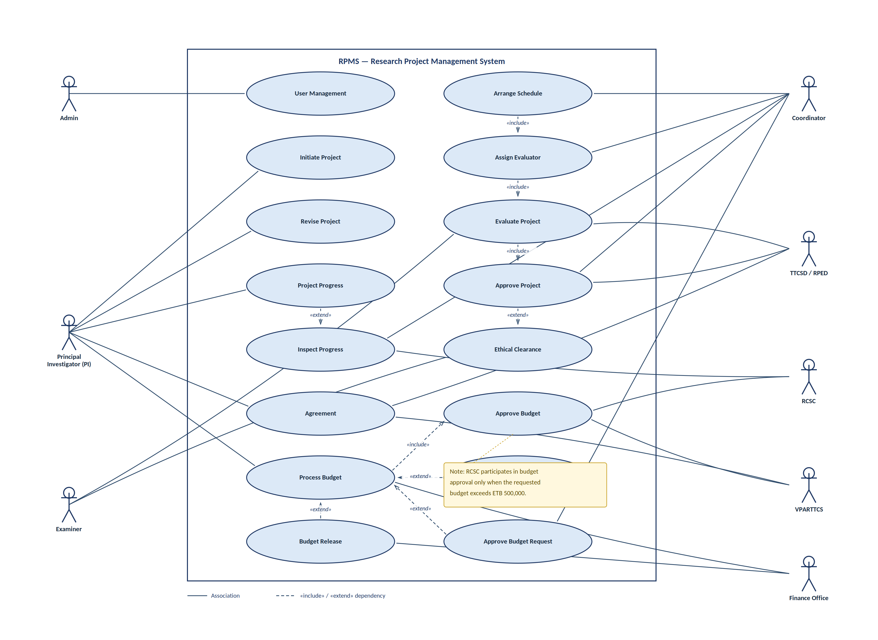

Figure 1 Essential use case diagram for Research Project Management System

Use Case Descriptions
Table 3 Assign Evaluator Use case
Description 1
Use case name | Assign Evaluator
Use case number | 2b
Use case description | It enables the coordinator to assign an evaluator or project examiner to the submitted project.
Participating actor | Coordinator
Pre-condition | The coordinator is logged into the system.
Flow-of events | - The user clicks projects button.  - The system lists all submitted projects with some  information.  - Then the user clicks on one of the project / Projects need to view or search by using the author’s name, or project title and click on it.  - The system views all detail information about the project.  - The user clicks on the assign examiner button  - The system shows all available examiner / reviewer that are related to the project along with a form.  - The user clicks on one of the examiner / reviewers and fills the form.  - The user clicks on the done button.
Alternative flow | - The User clicks on the reject button, the system stops the workflow and the Principal Investigator is notified.  - The User clicks on the comment button, the system displays the comment form, the user fills the form and submits, the project / Project initiator is notified.  - If user clicks a done button leaving required  form input blank, the system view popup window of error, so that the user fills it.  - If the user clicks a cancel button, the system displays confirm dialog box.
Post-condition | The system notifies the examiner / reviewer about the project / Project assignment.  The system notifies the Principal Investigator about the project assignment for the examiner (NOTE: the examiner can’t be seen by the project initiator).

Table 4Evaluate Project Use Case
Description 2
Use case name | Evaluate Project
Use case number | 3
Use case description | It enables the Examiner to review / evaluate the Assigned projects.
Participating actor | Examiner
Pre-condition | The Examiner is logged into the system.
Flow-of events | - The user clicks projects button.  - The system lists all Assigned projects with some information.  - Then the user clicks on one of the projects need to review / evaluate or search by using the author’s name, or project title and click on it.  - The system views all detail information about the project.  - The user clicks on the Evaluate button.  - The system shows the Evaluation Form (contains comment field, evaluation score and so on)  - The user fills the form (includes comment if any, evaluation score).  - The user clicks on the done button.
Alternative flow | - If user clicks a done button leaving required  form input blank, the system view popup window of error, so that the user fills it.  - If the user clicks a cancel button, the system displays confirm dialog box.
Post-condition | - The system calculates the evaluation scores and notifies the Principal Investigator and coordinator on the result for further actions done by them.
Table 5Project progress Use Case
Description 3
Use case name | Project Progress
Use case number | 6
Use case description | It enables the PI to report the progress of the project
Participating actor | PI
Pre-condition | The PI is logged into the system.
Flow-of events | - The user clicks on my projects button.  - The system lists all projects that the user is involved in with some information.  - Then the user clicks on one of the project need to view or search by using the date, or project title and click on it.  - The system views all detail information about the project.  - The user clicks on the report progress button.  - The system shows the progress report submission form.  - The user fills the form and attaches necessary documentations or files.  - The user clicks on the done button.
Alternative flow | - If user clicks a done button leaving required  form input blank, the system view popup window of error, so that the user fills it.  - If the user clicks a cancel button, the system displays confirm dialog box.
Post-condition | The system saves the progress report and notifies the coordinators and other actors.
Table 6 Inspect Progress Use Case
Description 4
Use case name | Inspect Progress
Use case number | 6a
Use case description | It enables the RCSC to Inspect the progress of accepted and funded projects.
Participating actor | RCSC and TTCSD/RPED
Pre-condition | The RCSC and TTCSD/RPED are logged into the system.
Flow-of events | - The user clicks on the projects button.  - The system lists all accepted and on-going projects with some information.  - Then the user clicks on one of the projects need to view or search by using the author’s name, or project title and click on it.  - The system views all detail information about the project along with a form for a comment.  - The user views the report progress submitted by PI.  - The user adds a comment (if any).  - The user clicks on the done button.
Alternative flow | - If user clicks a done button leaving required  form input blank, the system view popup window of error, so that the user fills it.  - If the user clicks a cancel button, the system displays confirm dialog box.
Post-condition | The system saves the comment on the progress report and notifies the PI and other responsible actors.

Table 7 Approve Budget Use Case
Description 5
Use case name | Approve Budget
Use case number | 5a
Use case description | It enables the RCSC, TTCSD/RPED and VPARTTCS to approve the Budget for the submitted projects.
Participating actor | RCSC, TTCSD/RPED and VPARTTCS
Pre-condition | The TTCSD/RPED and VPARTTCS are logged into the system.
Flow-of events | - The user clicks projects button.  - The system lists all submitted and/or evaluated projects, where the budget is not approved, with some information.  - The user clicks on one of the project need to approve Budget for or search by using the author name, or project title and click on it.  - The system views all detail information about the project.  - The user views all the detail budget specification.  - The user may modify the budget request in the given form.  - The user clicks on the approve button.
Alternative flow | - If the total budget is more than 500,000, then the project budget is forwarded to the RCSC.  - RCSC members/delegates login in the system and perform step 1 – 7.  - If the user does not find the budget specification written as per guideline  - The user clicks on add comment button,  - The system shows the comment field.  - The user writes the comments on the budget specification, and clicks on done button,  - The system notifies the PI about the comment.  - If user clicks a done button leaving required  form input blank, the system view popup window of error, so that the user fills it.  - If the user clicks a cancel button, the system displays confirm dialog box.
Post-condition | - The system saves the status of the project and notifies the Principal Investigator on the result.

Table 8 User Management Use Case
Description 6
Use case name | User Management
Use case number | 1
Use case description | Allows the administrator to manage users of the system
Participating actor | Admin
Pre-condition | The administrator should already have a super-user an account to log in.
Flow-of events | - The admin should first Login to the System by providing necessary information.  - The admin examines the activity of users on the System.  - Admin perform update, delete, Activate, deactivate users based on the Activity of users.  - The System Save the Changes Made by the Admin.  - The system displays response message.
Alternative flow | - Missed required field/s or incorrect information A3. The system displays data entry error message.
Post-condition | - The Admin fully manages users of the system. Inform the users their privileges and action done on the account.

Table 9 Initiate Project use case
Description 7
Use case name | Initiate Project
Use case number | 2a
Use case description | Allows The Principal Investigator to submit project/Project to Coordinator
Participating actor | Project Initiator
Pre-condition | The Principal Investigator should already have an account to log in.
Flow-of events | - The Principal Investigator should first Login to the System by providing necessary information  - The Principal Investigator select and upload Project to the System Database  - The system registers the record  - The system displays a response message  - The System displays the submitted Project on the coordinator and other actors’ page.  - The use case ends
Alternative flow | - Missed required field/s or incorrect information A3. The system displays data entry error message.
Post-condition | - The project is successfully initiated.
Table 10 Revise Project Use Case
Description 8
Use case name | Revise Project
Use case number | 4
Use case description | Allows the examiners and Principal Investigator to revise the project
Participating actor | Examiners, Project Initiator
Pre-condition | The examiner and Principal Investigator should already have an account to log in.
Flow-of events | - The examiner and Principal Investigator should first Login to the System by providing necessary information  - The system displays the project to the Principal Investigator and assigned projects for project examiners.  - The Principal Investigator select the appropriate project and revise it  - The Principal Investigator submits revised project based on the examiner comments for the Project.  - The system registers the record on the Database  - The system displays a response message to project examiners.  - The use case ends
Alternative flow | - If the Principal Investigator submit required inputs without filling the value. The system displays “please fill form correctly” message.
Post-condition | - The project will be successfully revised.
Table 11 Approve Project Use Case
Description 9
Use case name | Approve Project
Use case number | 5
Use case description | Allows the examiner/coordinator to approve project sometimes it excludes budget.
Participating actor | Examiner, coordinator
Pre-condition | The examiner ad coordinator should already have an account to log in.
Flow-of events | - The examiner and coordinator should first Login to the System  - The system displays all the revised and active projects.  - The Examiner and coordinator fill marks of the form and marks their final comment on Project as Accepted or rejected  - The system registers the record on the Database  - The system displays a response message to project initiator, TTCSD/RPED and other actors.  - The use case ends
Alternative flow | - If the Principal Investigator submit required inputs without filling the value. The system displays “please fill form correctly” message.
Post-condition | - The Project/Project will successfully approve.

Table 12 Process Budget Use Case
Description 10
Use case name | Process Budget
Use case number | 7
Use case description | Allows the project initiator, finance and VPARTTCS to process Budget
Participating actor | Project Initiator, Finance, VPARTTCS
Pre-condition | The Project initiator, finance and VPARTTCS should already have an account to log in.
Flow-of events | - The VPARTTCS, Principal Investigator and finance should first Login to the System  - The Principal Investigator initiates the process by requesting a budget from the approved budget.  - The VPARTTCS by viewing the request and approve the request after evaluating the project status report.  - The finance processes budget for the appropriate project and save their results in the database.  - The system registers the record on the Database  - The system displays a response message to the Principal Investigator and other actors.  - The use case ends
Alternative flow | - When the Principal Investigator request the second and other budget request the finance should evaluate the previous budget request.  - When the Principal Investigator doesn’t fulfil the preconditions the finance writes comments on the form.  - The Principal Investigator fulfils the finance request and reinitiates the budget request again.  - No record is found in the database A5. The system displays “no record” message.
Post-condition | - Budget is processed by the Principal Investigator and finance for the particular project and the budget is released for the project initiator.
Table 13 Arrange Schedule Use Case
Description 11
Use case name | Arrange Schedule
Use case number | 3a
Use case description | It enables the coordinator to arrange the project presentation day.
Participating actor | coordinator
Pre-condition | The coordinator is logged into the system.
Flow-of events | - The user clicks on the projects button.  - The system lists all submitted projects with some information.  - Then the user clicks on one of the project need to assign the examiner or search by using the author name, or project title and click on it.  - The system views all detail information about the project.  - The user click on examiner button.  - The system lists an examiner for the projects and selects appropriate examiners for the project and assigns the project to them.  - The user clicks on the done button.
Alternative flow | - If user clicks a done button leaving required  form input blank, the system view popup window of error, so that the user fills it.  - If the coordinator doesn’t found appropriate evaluator for the given project dispatch the information for project initiators and other actors.  - If the user clicks a cancel button, the system displays confirm dialog box.
Post-condition | The system saves the schedule and informs the presentation schedule to the project initiator, examiner and other actors.
Table 14 Ethical Clearance Use Case
Description 12
Use case name | Ethical Clearance
Use case number | 4a
Use case description | It enables the coordinator to fulfil the ethical clearance of a project [if required].
Participating actor | Coordinator
Pre-condition | The coordinator is logged into the system.
Flow-of events | - The user clicks on the projects button.  - The system lists all evaluated projects with some information.  - Then the user clicks on one of the project need write an ethical clearance.  - The system views all detail information about the project.  - The user clicks on ethical clearance button and fills the form.  - The user clicks on the done button.
Alternative flow | - If user clicks a done button leaving required  form input blank, the system view popup window of error, so that the user fills it.  - If the project doesn’t fulfils the university ethical clearance standard write necessary comments on the form.  - If the user clicks a cancel button, the system displays confirm dialog box.
Post-condition | The system saves the ethical clearance and informs the result to the project initiator, examiner and other actors that required it for approval processes/amendment.
Table 15 Agreement Use Case
Description 13
Use case name | Agreement
Use case number | 5b
Use case description | It enables the PI, TTCSD/RPED and VPARTTCS to fulfil the contractual agreement of an approved project.
Participating actor | PI, TTCSD/RPED and VPARTTCS
Pre-condition | The PI, TTCSD/RPED and VPARTTCS are logged into the system.
Flow-of events | - The user clicks on the projects button.  - The system lists for TTCSD/RPED and VPARTTCS all approved projects with some information.  - Then the user clicks on one of the project need to set a contractual agreement between the PI and VPARTTCS and/or TTCSD/RPED.  - The PI and TTCSD/RPED and/or VPARTTCS fulfil the forms based on their privileges.  - The user clicks on the done button.
Alternative flow | - If user clicks a done button leaving required  form input blank, the system view popup window of error, so that the user fills it.  - If the user clicks a cancel button, the system displays confirm dialog box.
Post-condition | The system saves the contractual agreement and informs the result to the project initiator, TTCSD/RPED, VPARTTCS, and other actors.

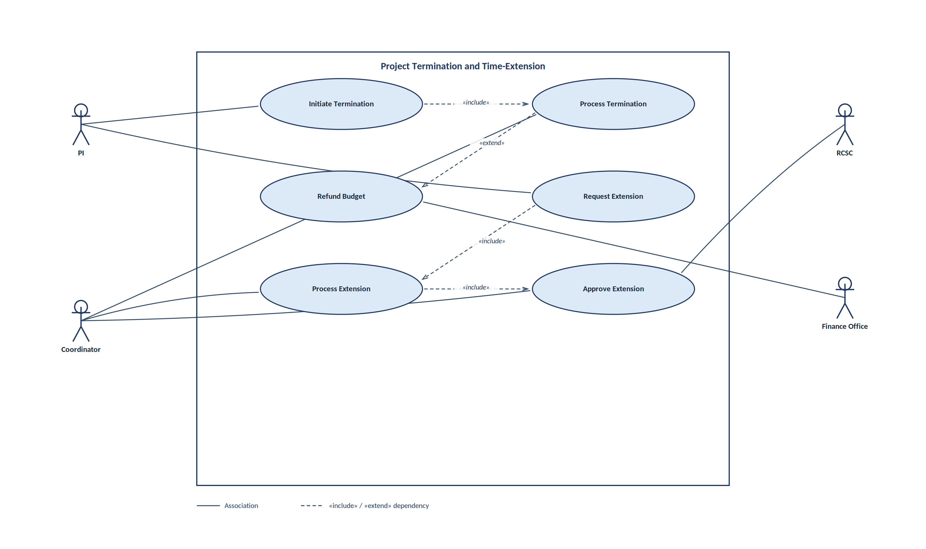
Figure 2 Project Termination and Extension use case
Table 16 Initiate Project Termination use case
Description 14
Use case name | Initiate Termination
Use case number | 12
Use case description | It enables the PI or coordinator to submit the project termination request.
Participating actor | PI/coordinator
Pre-condition | The PI/coordinator is logged into the system.
Flow-of events | - The PI/coordinator clicks projects button.  - The system lists all projects done by the PI/ list of on-going projects in the school with some information.  - Then the user clicks on one of the project need to submit project termination by clicking a terminate button in the given project.  - The system display a confirm message to the PI/coordinator to assure their request.  - The user clicks YES on the dialog box to assure his/her project termination request.  - The system display successful message to the PI/Coordinator.
Alternative flow | - If the user clicks a cancel button, the system displays confirm dialog box.
Post-condition | - The system sends the PI/coordinator project termination request to the respective user in the hierarchy for further actions to terminate the project.
Table 17 Project termination process use case
Description 15
Use case name | Process Termination
Use case number | 12a
Use case description | It enables the coordinator/RCSC to process the project termination request by PI/coordinator.
Participating actor | coordinator/RCSC
Pre-condition | The coordinator/RCSC is logged into the system.
Flow-of events | - The coordinator/RCSC clicks request button.  - The system lists all requests for on-going projects in the school/university with its request related information.  - Then the user clicks on one of the projects that requests the project termination.  - The user checks the current status of the project and a set of reasons written by either PI or coordinator to terminate the current project.  - The user evaluates reasons written by the PI or coordinator to terminate the project.  - The user writes his/her final decision regarding the PI/coordinator request to terminate the project.  - The user clicks YES on the dialog box to save his/her project termination decision.  - The system display successful message to the coordinator/RCSC.
Alternative flow | - The user can’t understand the written reasons write message to the PI/coordinator to clarify their reasons to terminate the project.  - The PI/coordinators writes their clarification for coordinator/RCSC comments on the project termination process.  - If the user clicks a cancel button, the system displays confirm dialog box.  - The system sent a decline massage to the PI/coordinators for their project termination request.
Post-condition | - The system sends the project termination message to the PI/coordinators and finance office for other activities related with project termination.

Table 18 Refund budget use case
Description 16
Use case name | Refund budget
Use case number | 12b
Use case description | It enables the finance office to calculate the amount of budget to be refunded from the PI for the terminated project works.
Participating actor | Finance/PI
Pre-condition | The finance/PI is logged into the system.
Flow-of events | - The finance officer clicks on terminated projects list.  - The system lists all terminated project works that are not yet refund the project budget to the finance office.  - Then the finance officer clicks on one of the terminated project that needs refunding the budget to the office.  - The finance officer clicks on calculate refund budget to exactly knew the amount of birr refunded to the office from the PI.  - The finance officer clicks YES on the dialog box to save his/her project refund decision.  - The system display successful message to the coordinator/RCSC.  - The system sent the amount of birr refunded to the office to the PI and other researcher officials in the system.
Alternative flow | - The PI can write request the clarification for the amount of birr refunded to the office.  - If the PI clicks a submit button, the system displays confirm dialog box.  - The finance officer writes comments for each request from the PI and click the save button to register changes on the system.  - If the finance officer/ PI click a cancel button the system sent a decline massage to the finance officer/PI for their request.
Post-condition | - The system sends the amount of birr that can be refunded from the terminated project to the PI and other officers in the system.
Table 19 Request extension use case
Description 17
Use case name | Request extension
Use case number | 9
Use case description | It enables the PI to request a time extension on the on-going project work.
Participating actor | PI
Pre-condition | The PI is logged into the system.
Flow-of events | - The PI clicks project button.  - The system lists all on-going projects.  - Then the user clicks on one of the project that required a time extension.  - The user views how many times he/she already extends the project.  - The user writes a set of reasons to request a time extension to the project.  - The user clicks YES on the dialog box to save his/her project time extension request.  - The system display successful message to the PI.
Alternative flow
Post-condition | - The system sends the project extension message to the coordinator/RCSC depend on how many time the PI request time extension for the project.
Table 20 Process time extension use case
Description 18
Use case name | Process extension
Use case number | 9a
Use case description | It enables the coordinator/RCSC to process a time extension from the PI on the on-going project work.
Participating actor | coordinator/RCSC
Pre-condition | The coordinator/RCSC is logged into the system.
Flow-of events | - The coordinators clicks request button.  - The system lists all on-going projects works in the school.  - Then the coordinators click on one of the project that requests the project time extension.  - The coordinators views how many times the PI already requests the time extension to the on-going project work.  - The coordinators check the PI reasons for project time extension and check the university guidelines to make a decision.  - The coordinators write his comments on it for further decisions and clicks YES on the dialog box to save his/her decision on the project time extension request.  - The system displays successful message to the coordinators.
Alternative flow | - The RCSC clicks request button.  - The RCSC views a list of requests for project time extension (the RCSC only views those projects request time extension for the third time).  - The AC evaluates the reasons written by the PI for project time extension.  - The RCSC write his comments on it for further decisions and clicks YES on the dialog box to save his/her decision on the project time extension request.  - The system display successful message to the RCSC.  - The RCSC click the “CANCEL” button the system displays a decline message and terminate the process without updating the changes.  - The coordinators clicks the “CANCEL” button the systems displays a decline message and terminate the process without updating the changes.
Post-condition | - The system sends the project extension process message to the respective officers in the system for further processing and decision on it.

Table 21Approve time extension use case
Description 19
Use case name | Approve extension
Use case number | 9b
Use case description | It enables the coordinator/RCSC to make decisions on the time extension request of the PI for on-going project work.
Participating actor | coordinator/RCSC
Pre-condition | The coordinator/RCSC is logged into the system.
Flow-of events | - The coordinator/RCSC clicks project time extension button.  - The system lists all on-going projects time extension requests and their initial processing results.  - Then the coordinator/RCSC clicks on one of the project that requests the project time extension.  - The coordinator/RCSC writes the allowed time for project extension after evaluating requests.  - The coordinator/RCSC clicks YES on the dialog box to save his/her project time extension decisions.  - The system display successful message to the PI.
Alternative flow | - The coordinator/RCSC clicks “CANCEL” button on the dialog box to reject a time extension request of the PI for the on-going project work.  - The system display decline message to the coordinator/RCSC.
Post-condition | - The system sends the project extension message to the PI and other officers in the platform.

PI Transfer and TM Replacement use case
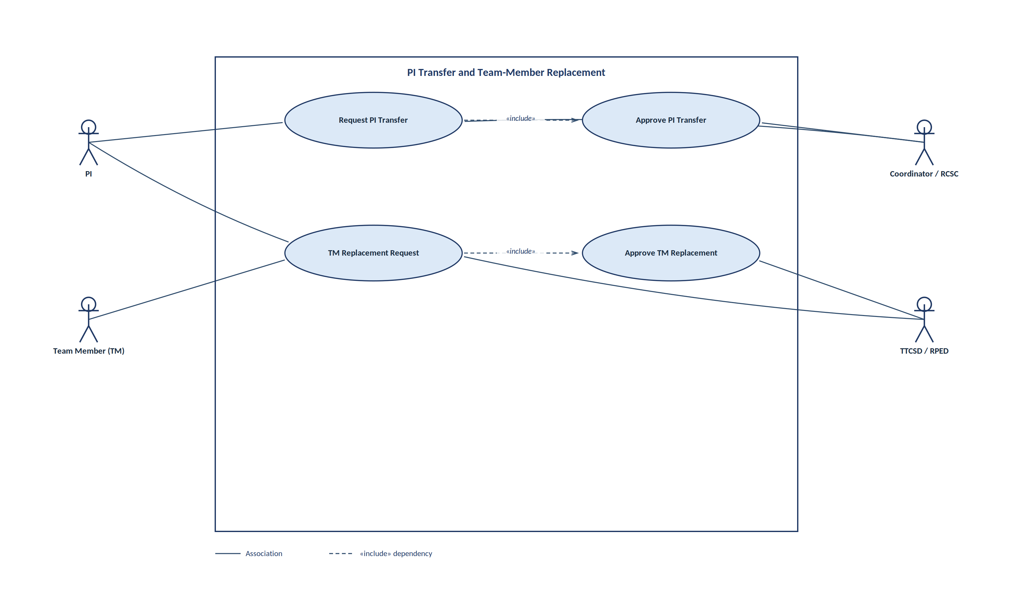
Figure 3 PI Transfer and TM replacement use cases
Table 22 Request PI Transfer
Description 20
Use case name | Request PI Transfer
Use case number | 8a
Use case description | It enables the PI/Coordinator to initiate the request for changing the current project PI by new PI from the team members or other university staffs.
Participating actor | PI/Coordinator
Pre-condition | The PI/Coordinator is logged into the system.
Flow-of events | - The PI/Coordinator clicks project click on PI transfer button.  - The system displays a dialog box to accept comments from PI/Coordinator.  - Then the PI/Coordinator writes a detail reason why the PI transfer is required.  - The PI/Coordinator clicks YES on the dialog box to save his/her PI transfer request.  - The system displays successful message to the PI/Coordinator.
Alternative flow | - The PI/Coordinator clicks “CANCEL” button on the dialog box to reject a PI transfer request.  - The system display decline message to the PI/Coordinator.
Post-condition | - The system sends the PI transfer request notification message to Coordinator/RCSC officers.
Table 23 Approve PI Transfer
Description 21
Use case name | Approve PI Transfer
Use case number | 8b
Use case description | It enables the Coordinator/RCSC to make decisions on the PI transfer request.
Participating actor | Coordinator/RCSC
Pre-condition | The Coordinator/RCSC is logged into the system.
Flow-of events | - The Coordinator/RCSC clicks on PI transfer request button.  - The system lists all PI transfer requests (if available).  - Then the Coordinator/RCSC clicks on one of the projects that requests the PI transfer request.  - The Coordinator/RCSC views the current status of the project and comments from the project team members about the PI transfer request.  - The Coordinator/RCSC accepts the request and assigns new PI to the project.  - The Coordinator/RCSC clicks YES on the dialog box to save his/her PI transfer decisions.  - The system displays successful message to the PI.
Alternative flow | - The Coordinator/RCSC clicks “CANCEL” button on the dialog box to reject a PI transfer request of the PI/coordinators for the on-going project work.  - The system display decline message to the Coordinator/RCSC.
Post-condition | - The system sends the PI transfer successful/decline notification to PI, TM and other officers in the platform.
Table 24 TM Replacement request
Description 22
Use case name | TM Replacement Request
Use case number | 8
Use case description | It enables the PI/TM to request a replacement of team member with new member.
Participating actor | PI/TM
Pre-condition | The PI/TM is logged into the system.
Flow-of events | - The PI/TM clicks on TM replacement request button.  - The system displays a dialog box that filled by PI/TM.  - Then the PI/TM fills the form and click a submit button.  - The PI/TM clicks YES button on the dialog box to save his/her TM replacement request.  - The system displays successful message to the PI/TM.
Alternative flow | - The PI/TM clicks “CANCEL” button on the dialog box to reject TM replacement request.  - The system display decline message to the PI/TM.
Post-condition | - The system sends the TM replacement request to RAD and /or RA for further processing.
Table 25 Approve TM Replacement
Description 23
Use case name | Approve TM Replacement
Use case number | 8c
Use case description | It enables the Coordinator/TTCSD/RPED to make decisions on the TM replacement request.
Participating actor | Coordinator/TTCSD/RPED
Pre-condition | The Coordinator/TTCSD/RPED is logged into the system.
Flow-of events | - The Coordinator/TTCSD/RPED clicks on TM replacement request button.  - The system lists all TM replacement requests (if available).  - Then the Coordinator/TTCSD/RPED clicks on one of the projects that requests the TM replacement request.  - The Coordinator/TTCSD/RPED views the current status of the project and comments from the project team members about the TM replacement request.  - The Coordinator/TTCSD/RPED accepts the request and communicates the team whether they can add new team member or not.  - The Coordinator/TTCSD/RPED clicks YES on the dialog box to save his/her TM replacement decisions.  - The system displays successful message to the PI and TM.
Alternative flow | - The Coordinator/TTCSD/RPED clicks “CANCEL” button on the dialog box to reject a TM replacement request of the PI/TM for the on-going project work.  - The system display decline message to the Coordinator/TTCSD/RPED.
Post-condition | - The system sends the TM replacement successful/decline notification to PI, TM and other officers in the platform.

The publication and award workflow, covering paper submission, journal/project-index evaluation, approval, recording and staff awards, is summarised in the following use case diagram.
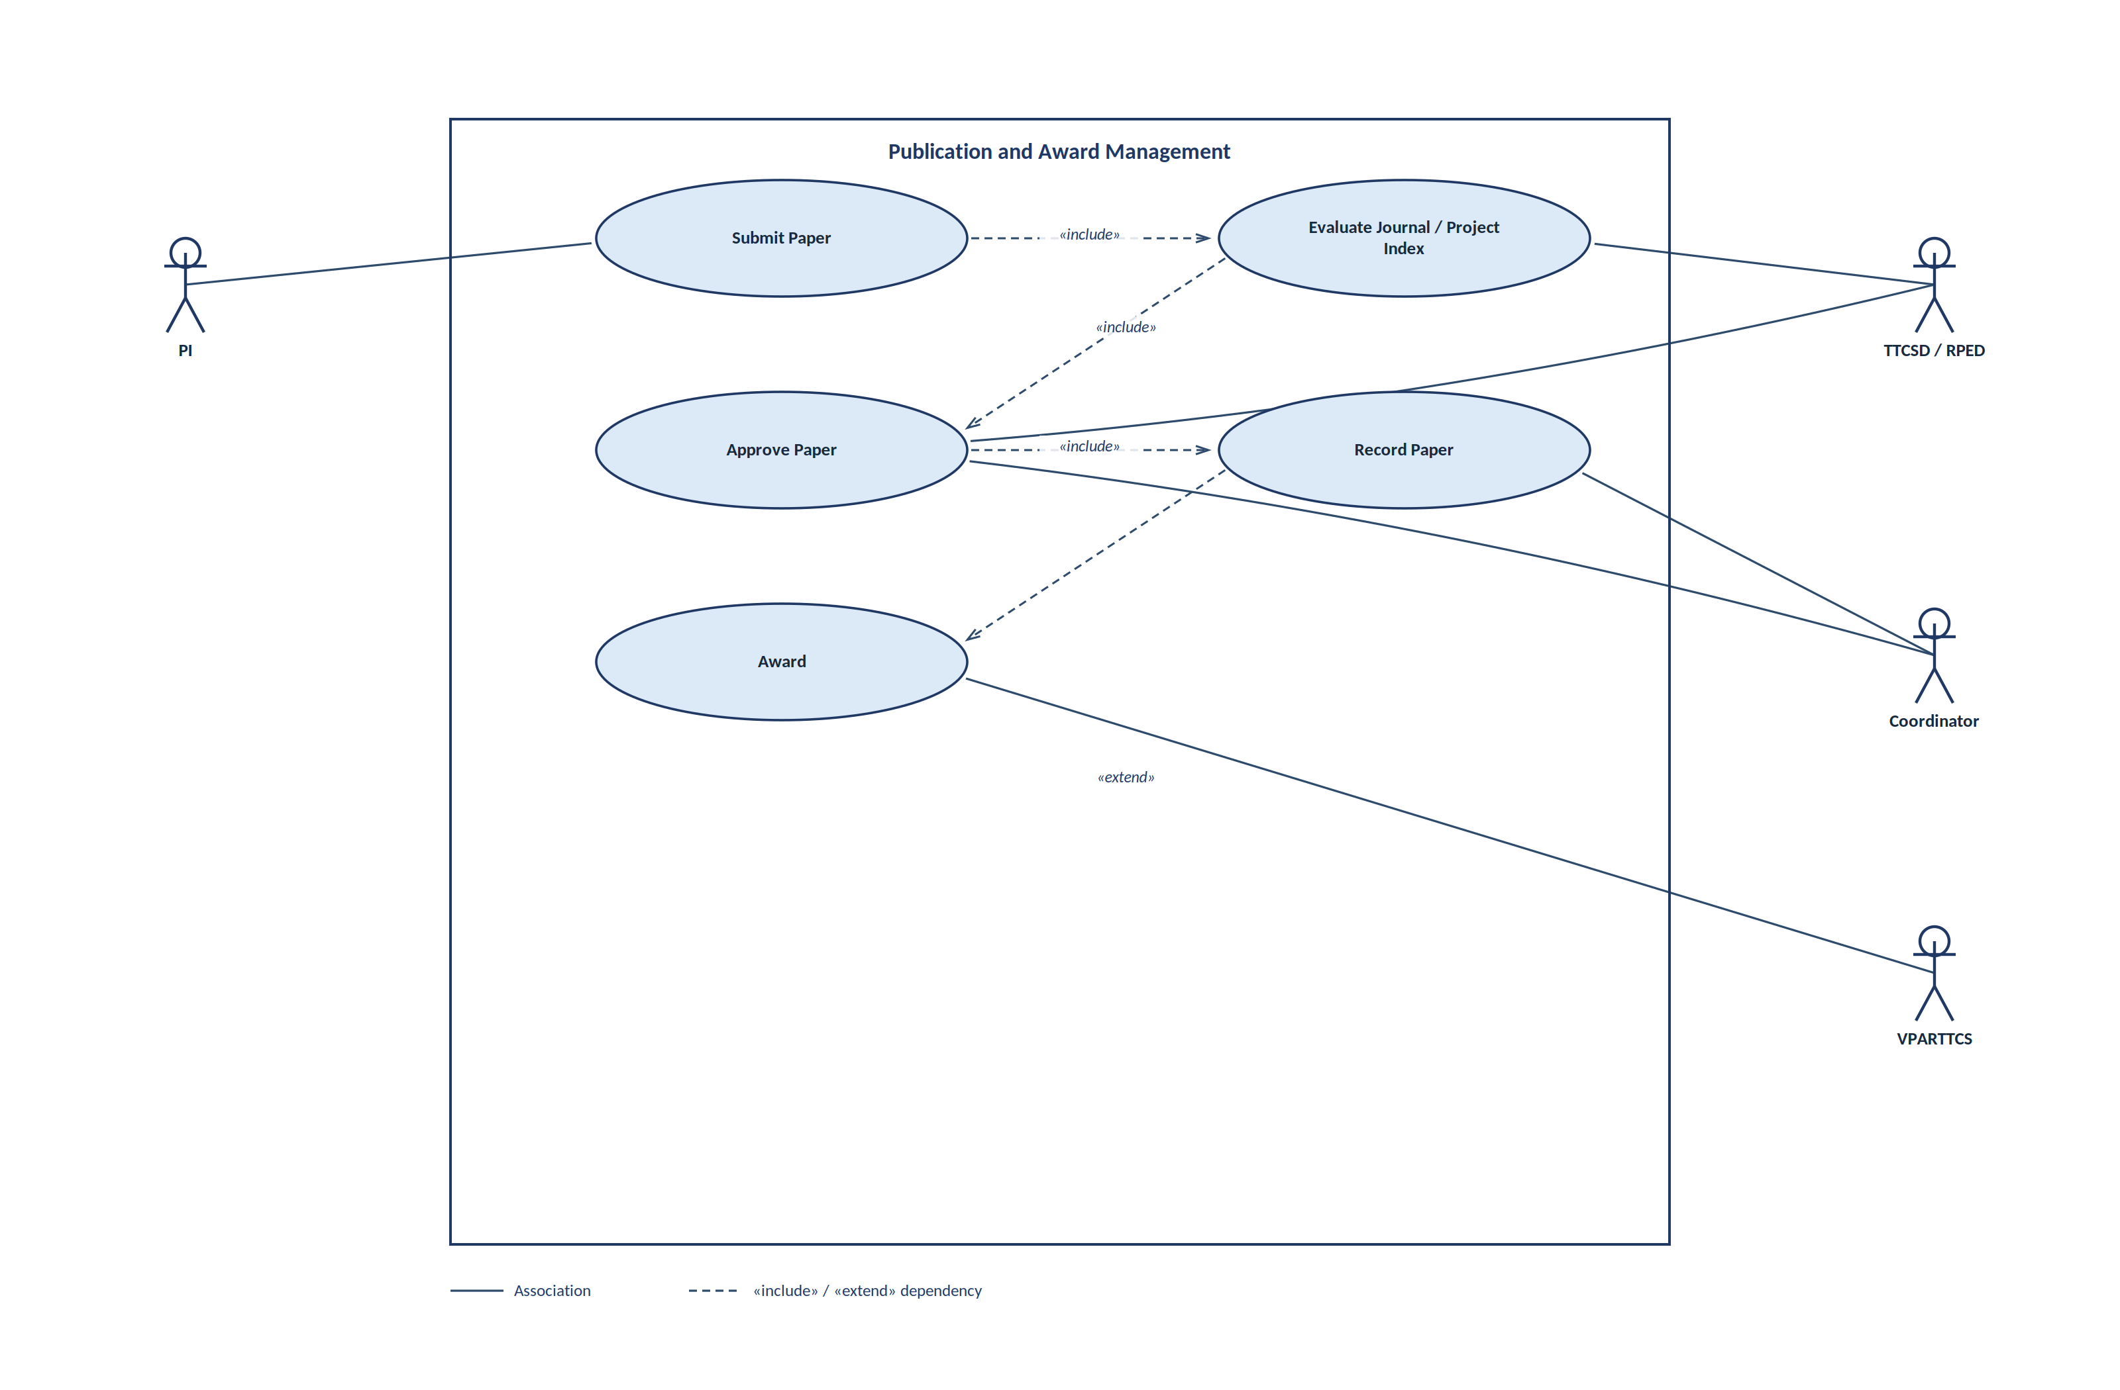
Figure 4 Publication and Award Management use case

Sequence Diagram
Project Initiation Sequence Diagram
The following picture depicts the interaction of components and actors in order to accomplish the project initiation phase in the project. The PI actor is an initiator for a project by logging into the system and fills all necessary information required for the project initiation activity. Beside the PI also submit all required attachment files to the system in order to successfully initiate the project proposal.
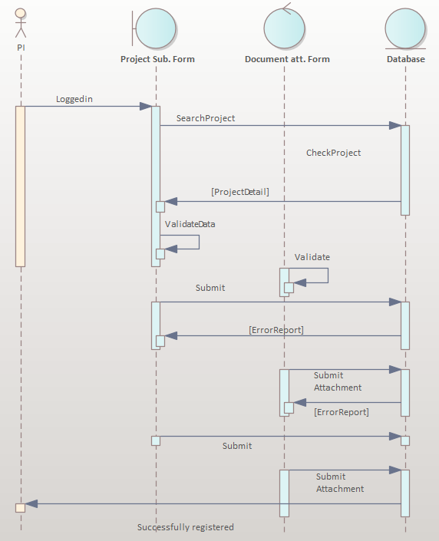
Figure 5 Sequence diagram for project initiation
Project Evaluation Sequence Diagram
The figure shown below depicts the project evaluation process done by the assigned project examiner. In the process of examining the project work submitted by the project initiator, the examiner logged in to the system by using a valid username and password. After that the examiner views the project titles assigned for him from the school/College Research Coordinator. Then the examiner loads the files and reads it carefully and writes necessary comments on it. Finally, the examiner records his comments, results and additional suggestion about the project on the database.
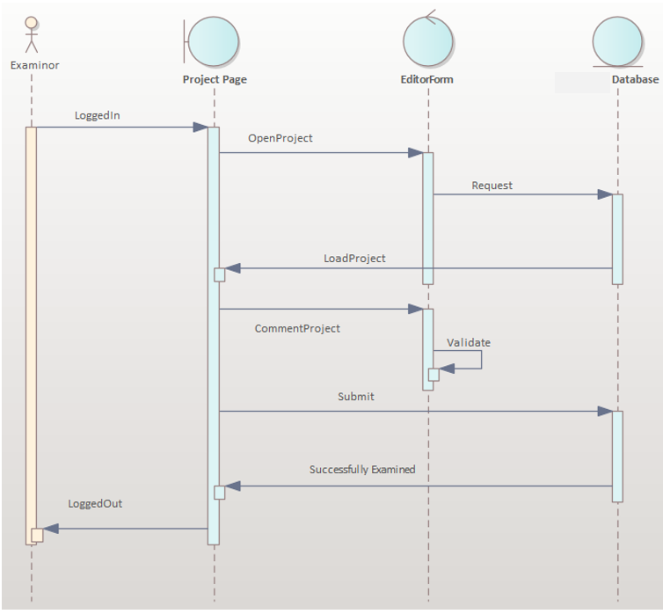
Figure 6 Project evaluation sequence diagram

Activity diagram
Activity Diagram for Examiner Assignment
The figure shown below demonstrates the activities done by the school research associate deans to assign an examiner for the project works submitted by the project initiators. The officer first logged in into the system in order to view a list of project works that required examiners. After that the officer checks the list of available staff in the area of the proposed project work. When the officer finds the required examiners for the project, automatically push a message to them in order to know their interest to evaluate the project. Based on their response the officer either further processes the project assignment task or requests other examiners to evaluate the proposed project work.
Once the officer gets the examiner, directly assign the project work for it and allow necessary privileges to the examiner to perform all required activities in the proposed project work. Finally, the officer informs the examiners last date for submitting their evaluation results to the office and permits them to fill comments and results on paper evaluation form prepared for this purpose.
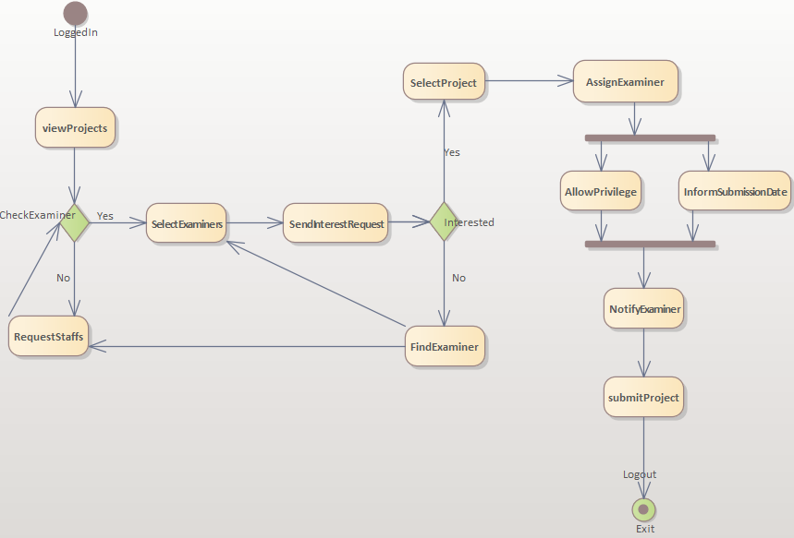
Figure 12 Activity diagram for examiner assignment
Activity Diagram for Project Evaluation
The project evaluation process begins with a legitimate examiner login into the proposed project work using a valid username and password. Once the examiner logged in into the system list of projects assigned for him/her for review were listed in ascending order based on the last date of submitting the result. In this process the examiners first read a project then evaluate the project according to his/her subject matter knowledge and evaluate the project based on the university forms.
Once the examiner accomplishes evaluating the proposed project work; then he/she writes the comments and final remark on the proposed project. Finally, the examiner submits the forms, comments, and general remarks on the proposed work to the officer.
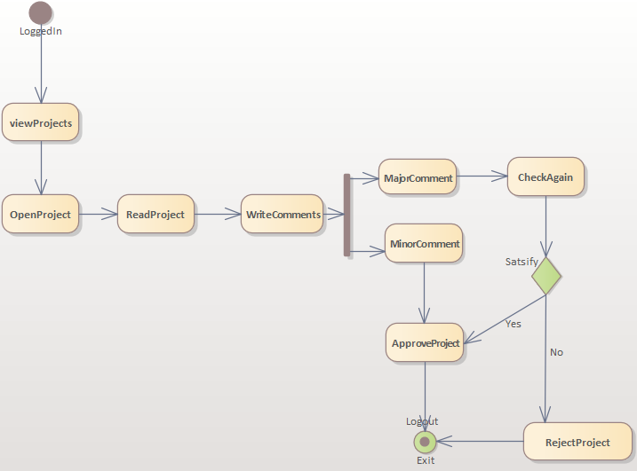
Figure 13 Activity diagram for project evaluation
Activity Diagram for Project Submission
The process of project submission to the office begins with the PI logged into the proposed system. When the PI has an account, the PI directly login into the system otherwise the PI create a new account in the system and request verification from the admin then after login into the system using a valid username and password.
Once the PI login into the system using a valid username and password, he/she views all posts from the offices about the project proposal submission and other additional information. Then the PI checks open projects in his/her knowledge areas. When there is a list of requests for proposal or request for abstract then the PI fill forms, register other group members and submit project proposal and/or abstract to the office.
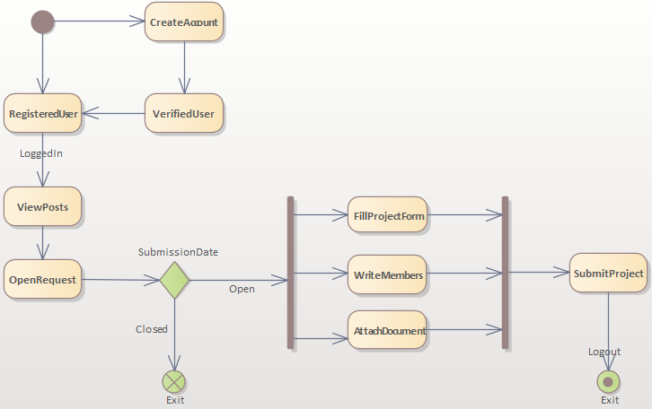
Figure 14 Activity diagram for project submission

Class Diagram
The following class diagram represents the overall structure of the proposed system interactions among classes. It depicts interaction of main classes in the proposed Research Project Management System. It lists a set of classes with attributes and properties that performed by the classes. The list of methods and attributes are limited compared to the actual attributes and methods that are exists in each class due to reducing class diagram complexity and make the class diagram more readable for the users. The team tries to concentrate on the classes’ main attributes and methods that are critical for the overall design of the proposed system class diagram.
In the diagram we are trying to address different concepts in object-oriented design methodologies to efficiently represent system concepts in the proposed system class diagram design.

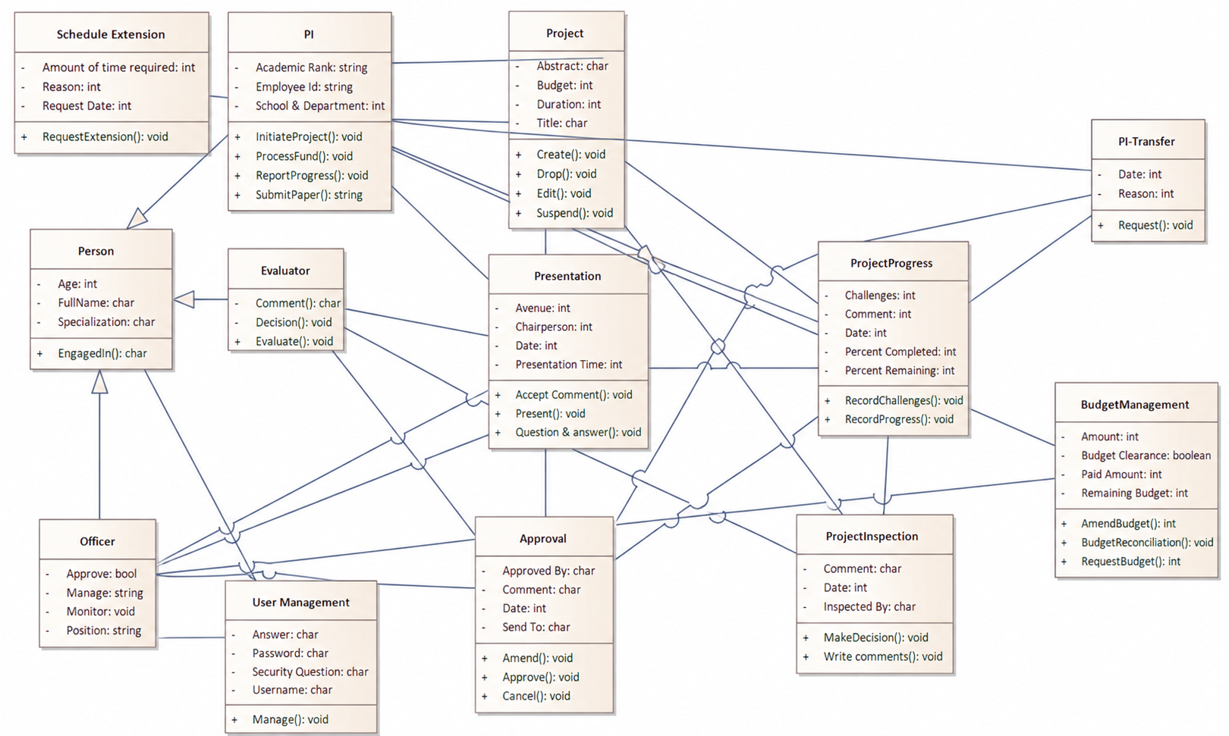

Figure 17 Class diagram for RPMS

State Chart Diagram
State Chart Diagram for Project Initiation
The following state chart diagram shows the states that are passes through to successfully initiate the project/Project in the proposed Research Project Management System. In this diagram the operation always begins with by entering a valid username and passwords in the login page. After that the system displays different project/Project related information to the PI, who initiated the proposed project work. The PI check open project/Project dates for the researchers then after he/she register team member, abstract and additional information to the system. Finally, the PI uploads the project proposal and submits the project initiation form to the office to complete for open request for proposal in the university.
The PI can know the application is successful or not by a simple popup message from the system about its project application process. The system also sends a notification message using a PI email address and other social media platform if required.
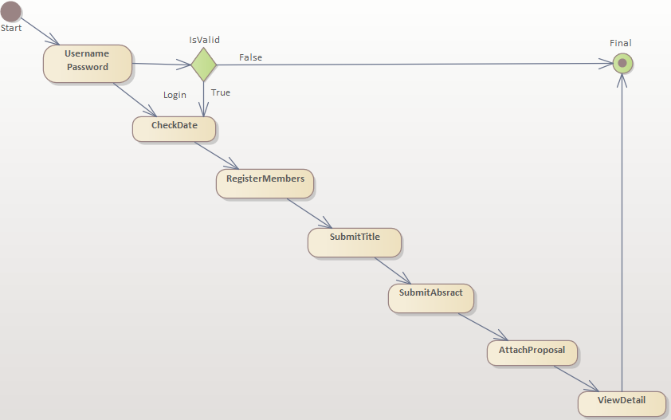
Figure 18. State chart diagram for project initiation

State Chart Diagram for Project Evaluation
The following state chart diagram shows the flow of activities that are done under the process of project evaluation by a list of project examiners. The process begins with the users’ login, project examiners, to the proposed system by a valid username and password. If the user misses either the username or password the system allows the user tries to his/her password and/or username for a maximum of three trials, this can be done in order to limit the username and password guesses by unauthorized users to access the proposed system.
Once the examiner enters into the system he/she views a list of projects assigned for him/her by an officer responsible for this task. The examiner selects one of the project/Project works and start reading to evaluate the proposed project work submitted by the PI. The examiner evaluates the project work and writes all necessary comments to amend the project to meet the scientific requirements as well as solves the problems stated under the statement of the problem section. Finally, the examiner writes his personal evaluation results in the forms based on stated evaluation criteria and submit the evaluation results.
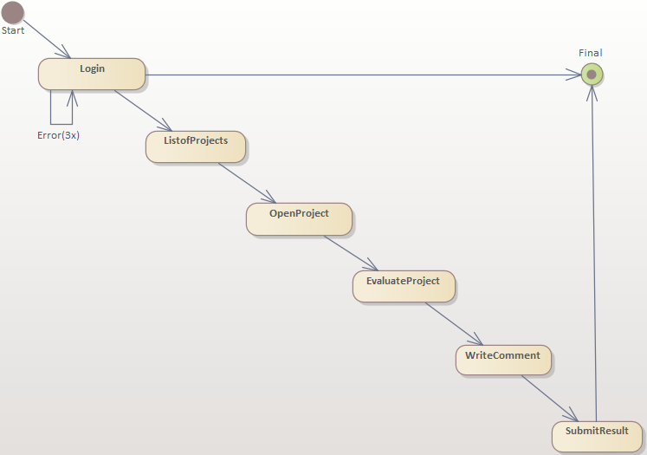
Figure 19. State chart diagram for project evaluation

Appendices

Completed project report format
List and Status of completed projects Since (from year 2004 -2015Ec.)
S. No | Name of the Researcher | Title of the Project | Year Approved | Budget approved | Status
A. School of Applied Natural Sciences
2004
1 | Worku Dinku (PI) Lemma Teshome | Physico-chemical Characterization of Eastern Shoa Honey & Its implication |  | 25,000.00 | Soft copy not submitted
2005
2006

Terminated project report format
Lists of Officially Terminated research projects (from year 2004 -2010 Ec.)
S.No | Name of the Researcher | Title of the Project | Dead line |  | Budget Approved | Reason for Termination | Remark
A. School of Applied Natural Sciences
1 | Dr. Mesele Admasu (PI)  Dr. Senthilkumar Subramanian | Levels of proinflammatory cytokines and hematological parameters in helminthes infected diabetic people in Adama city |  | 16-Dec | 235,400.00 | Lack of kit, Problem of Feasibility | Budget reimbursed

Summary of researches by School
Name of Schools | Active | Delayed | Total on-going Projects | # Completed |  |  | # Terminated | Total Projects
SoANS | 11 | 17 | 28 | 57 |  |  | 20 | 105
SoCEA | 2 | 17 | 19 | 12 |  |  | 6 | 37
SoMCME | 2 | 7 | 9 | 15 |  |  | 11 | 35
SoEEC | 10 | 13 | 23 | 16 |  |  | 6 | 45
SoHSS | 6 | 21 | 27 | 22 |  |  | 4 | 53
Partly funded Stdnt Prjts | 0 | 11 | 11 | 1 |  |  | 0 | 12
Grand Total | 31 | 86 | 117 | 123 |  |  | 47 | 287
Projects Approved  in 2014E.C |  |  | Projects Completed  in 2014 E.C |  |  |  |  | Projects Terminated in 2014 E.C
School | # |  | School |  | # |  |  | School | #
SoANS | 7 |  | SoANS |  | 0 |  |  | SoANS | 3
SoCEA | 1 |  | SoCEA |  | 0 |  |  | SoCEA | 0
SoMCME | 1 |  | SoMCME |  | 2 |  |  | SoMCME | 4
SoEEC | 5 |  | SoEEC |  | 4 |  |  | SoEEC | 1
SoHSS | 5 |  | SoHSS |  | 2 |  |  | SoHSS | 1
Total | 19 |  | Total |  | 8 |  |  | Total | 9

References
- Gambella University Research Guideline, Revised Edition, 2020.
- Gambella University, https://www.GMU.edu.et.
- Modern Systems Analysis and Design, Joseph S. Valacich, Joey F. George, Jeffrey A. Hoffer, 10th Edition, Prentice Hall PTR, 2010.
- Scrum: The Art of Doing Twice the Work in Half the Time, Jeff Sutherland & J.J. Sutherland, 2014.

In the diagram the team mainly focuses of including main classes that are found in the project work. Since it is very difficult to incorporate all classes found in the project into the class diagram we are focuses on core classes.

