Computer Graphics Project

Design Report

Topic: AEI Tower

Malika Uskembayeva

Adam Gembala

Robert Lotawiec

**Description of the project**

AEI Tower is a Icy Tower remake inspired by the day-to-day reality of students of the [Faculty Of Automatic Control, Electronics And Computer Science](https://www.polsl.pl/rau/en). The game consists in controlling a character representing a student of the AEI faculty as he/she makes his/her way to the top of the Mage Tower by jumping on successive stairs and advancing to successive floors of the faculty. The character is controlled with the keyboard. It is a platform game set in a tower, where the player's goal is to jump from one "floor" to the next and go as high as possible without falling and plunging off the screen.

Platforms are grouped to levels - each in distinct color according to the colors of the faculty floors. On each platform there is randomly generated challenge which student faces in his day-to-day life (such as rejected report or unexpected quiz on the platform). Player has to collect 30 ECTS on each floor to level up. If player falls before collecting 26 ECTS on the level the game is over, otherwise he can use conditional pass, and collect missing points in order to complete level.

[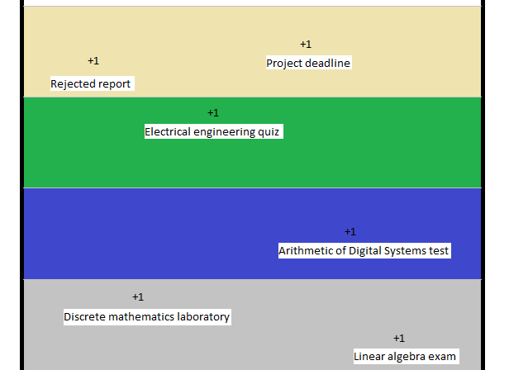](https://github.com/gemadam/AEI-Tower/blob/main/Docs/Img/AEI-Tower-concept.png)

## Task analysis

### Theoretical basis of the problem

The movement of the character on the floor will be described by the sum of two vectors - horizontal and vertical.

[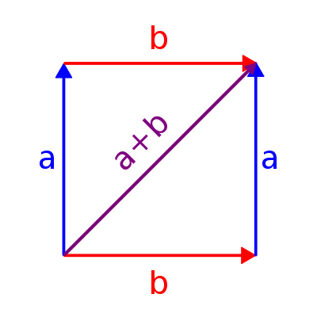](https://github.com/gemadam/AEI-Tower/blob/main/Docs/Img/400px-Perpendicular_Vector_Addition.jpg)

The physics of the game is described by two rules:

* The more speed the character acquires before jumping, the higher that jump will be.
* The speed (and direction) of movement of the character can also be changed during the jump. This rule allows you to increase the speed of your character by "bouncing" him/her off the walls of the tower. To "bounce" a character, point them towards a wall and immediately after the collision reverse the direction of the jump.

### Gameplay

The player starts the game on the ground floor of a tower, inside of which the player character can run and jump from step to step. The freedom of the character is limited by the two walls of the tower and the semi-permeable structure of the steps, which can only be penetrated from the bottom. When the character reaches the 5th step, the whole content of the screen begins to slowly fall down. From then on, the player's task is to maintain the imposed speed and not to fall off its bottom edge, which ends the game. As the player climbs higher, the speed of the screen increases several times during the game (the maximum number of accelerations is 5 throughout the game). The screen becomes damaged and no further increase in speed occurs.

The player's goal is to reach the highest possible floor and to obtain the highest possible number of points. Points are awarded for each step reached and for the spectacularity of the jumps themselves.

The length of the stairs depends on the number of the corresponding floor and a random factor. The positioning of the stairs is completely random. The appearance of the stairs changes every x stairs.

### Computer graphics topics

Project mostly utilize the knowledge from laboratories about collision detection, computer animation and colors. Game is implemented in C# with use of Unity engine.

## Schedule

| **Person** | **30-03-2022** | **11-05-2022** | **22-06-2022** |
| --- | --- | --- | --- |
| Malika Uskembayeva | Theoretical analysis of the project | Beta version of game logic | Final version of game logic |
| Adam Gembala | Theoretical analysis of the project | Beta version of game logic | Final version of game logic |
| Robert Lotawiec | Theoretical analysis of the project | Beta version of assets | Final version of assets |

## Project organization

### Workflow

[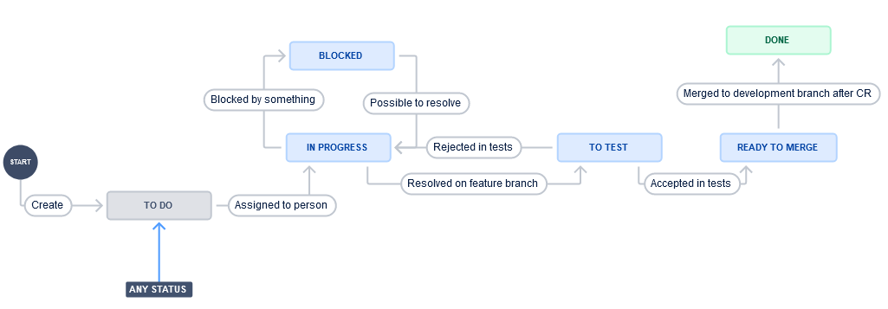](https://github.com/gemadam/AEI-Tower/blob/main/Docs/Img/ProjectWorkflow.png)

## Useful links

### Project organization

[Jira Project](https://aei-tower.atlassian.net)

[GitHub Repository](https://github.com/gemadam/AEI-Tower)