**ANS 1:**

Mail servers of the following domain:

|  |  |  |
| --- | --- | --- |
| Domain | Mail Server | IP |
| Ibm.com | mx0a-001b2d01.pphosted.com | 148.163.156.1 |
| Ibm.com | mx0b-001b2d01.pphosted.com | 148.163.158.5 |
| Wipro.com | wipro-com.mail.protection.outlook.com | 104.47.125.36 |

**ANS 2:**

Find the locations, where these email servers are hosted.

|  |  |  |
| --- | --- | --- |
| Domain | Mail Server | Location of email servers |
| Ibm.com | mx0a-001b2d01.pphosted.com | Sunnyvale, California ,USA |
| Ibm.com | mx0b-001b2d01.pphosted.com | Sunnyvale, California ,USA |
| Wipro.com | wipro-com.mail.protection.outlook.com | Singapore |

A3: Scan and find out port numbers open 203.163.246.23

Not able to ping host, seems it down

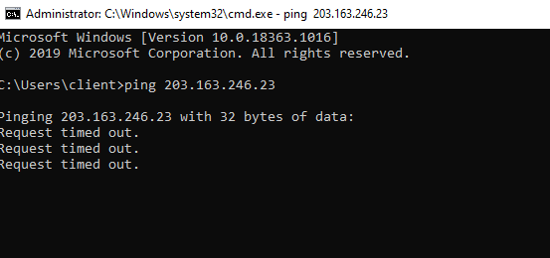

Ans 4 Install nessus in a VM and scan your laptop/desktop for CVE.