CprE 288 Fall 2012 – Homework 7
Due Thu. Oct. 18 in the class

Notes:
- Start early on homework
- Homework answers must be typed using a word editor. Hand in a hard copy in the class.
- Late homework is accepted within three days from the due date. E-mail late homework to both of the grading TAs, Min Sang Yoon (my222@iastate.edu) and Zhen Chen (zchen@iastate.edu). Late penalty is 10% per day (counting from 10:45am of the due date if you are in the morning class or 2:10pm if you are in the afternoon class).

Question 1: Cell phone drop results (25 pts)
Students are to use the mechanism below to raise a cell phone between 0 to 5 meters. They must guess how high they can drop the phone from without breaking it. The mechanism has no markings to indicate how high the phone is.
When the phone is released a switch closes setting the TIMER1 Input Capture pin (Port D bit 4, i.e. PD4) to 1. When the phone hits the ground the switch opens, setting PD4 to 0.
Your job is to program the ATMega128 to send a message to putty saying if the phone has broken or not. Part b) gives specifics on what to send to putty using UART0.

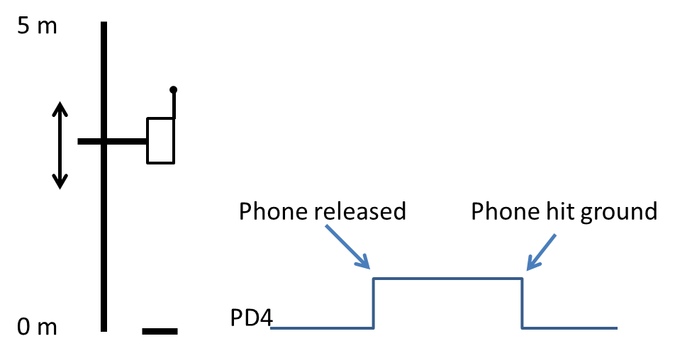

a) Write C code to setup the 16-bit TIMER1 configuration registers for the ATMEGA128 as follows (5 pts)

- 15.625 KHz tick rate
- Input Capture interrupt enabled
- Timer Overflow interrupt enabled
- Noise cancellation disabled

init_TIMER1()
{

}

b) Write a C program that will Transmit the following messages from UART0, each time an cell phone is dropped. ( 20 pts)

SAFE, if the phone was dropped from less than 1 meter
WARN, if the phone was dropped from 1 to 3 meters
BUST, if the phone was dropped from greater than 3 meters.

Assume UART0 has been configured appropriately, and no UART interrupts are to be used.

// Input Capture ISR
ISR(TIMER1_CAPT_vect)
{

}

// Timer 1 overflow ISR
ISR(TIMER1_OVF_vect)
{

}

main()
{
init_TIMER1();

}

Question 2: Timer Accuracy (10 pts)
A laser that works similar to your Lab 7 Ping sensor is used to measure the distance to the Moon from Earth. The laser is fired at a mirror placed on the Moon, and a sensor attached to the laser detects when the reflection arrives back to the laser. As shown below. This is similar to an actual method used for measuring the Earth-Moon distance, see: http://en.wikipedia.org/wiki/Lunar_Laser_Ranging_experiment
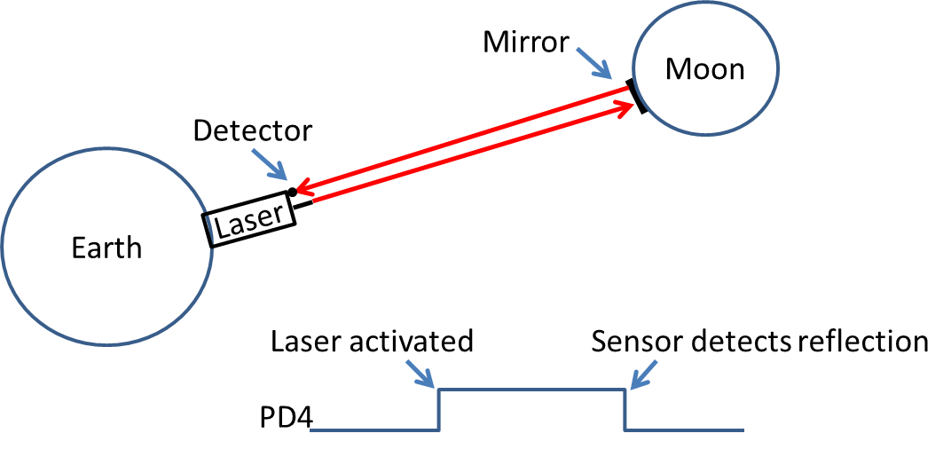
When the laser is activated, TIMER1’s Input Capture pin is set to a 1. When the sensor detects the reflection, this pin is set to 0. A program has been written that uses Input Capture to compute the distance between the Earth and the Moon.
Given that Input Capture measures time in Timer ticks (i.e. clock cycles), how different can the programs calculation of the Earth-Moon distance be from the actual distance?
a) Explain what causes the error in the measured distance

b) Compute the maximum error in distance for each legal prescaler of TIMER1.

Question 3: Edge Detection (15 pts)
The following simple block diagram illustrates how one may implement an Input Capture circuit.
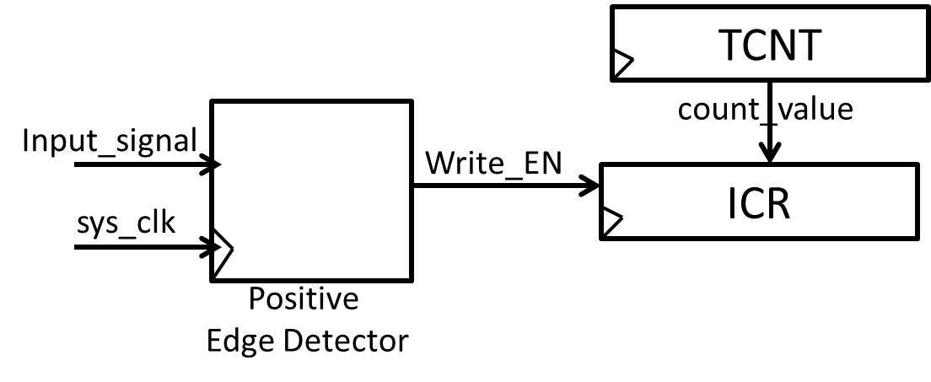
An example timing diagram for capturing the rising edge of Input_signal is given below. In summary, on the occurrence of a positive edge on Input_signal: 1) Write_EN pulses ‘1’ for one sys_clk cycle, and the value in the Timer/Counter Register (TCNT) is loaded into the Input Capture Register (ICR).
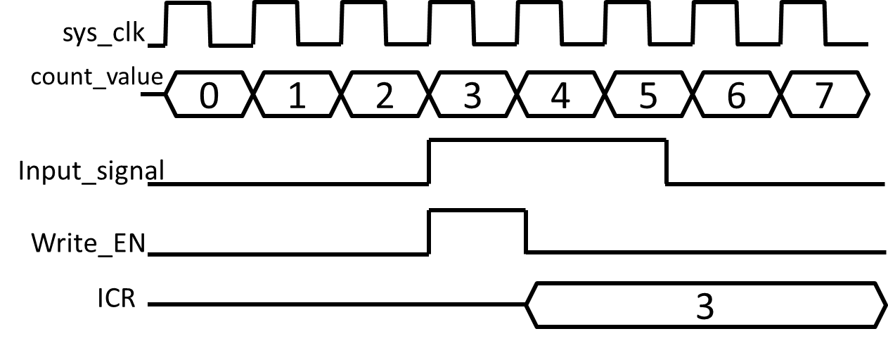

a) Draw out a digital circuit to implement an Edge Detector that creates a 1-sys_clk-wide pulse on Write_EN to load the TCNT register into the ICR register when a rising edge occurs on Input_signal. The only components you can use are D-Flip Flops, and AND, OR, NOT gates ( 5 pts)
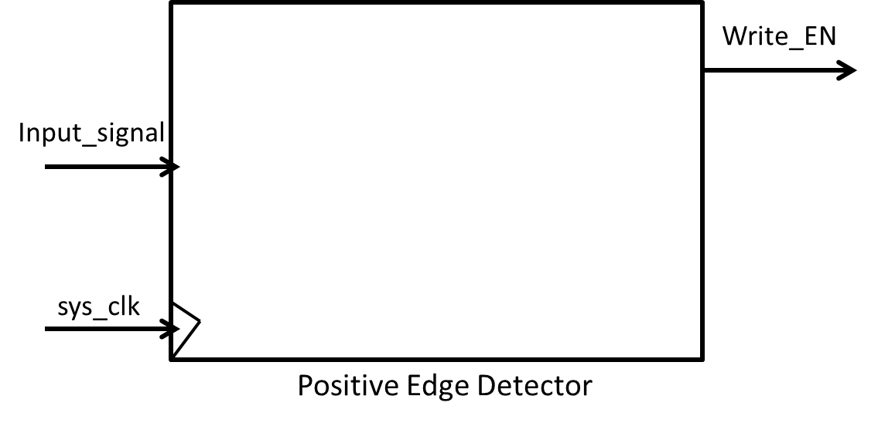

b) Repeat a) for an edge detector that creates a Write_EN pulse for detecting the falling edge of Input_signal. ( 5 pts)
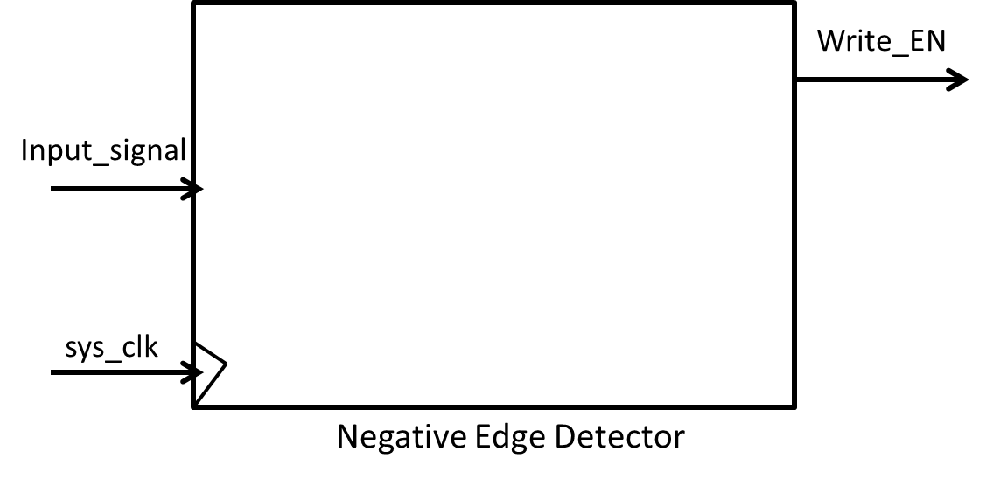

c) The ATMEGA128 allows for detecting either the positive edge or negative edge of an input by configuring the “Edge Select” bit of a configuration register. Draw the digital circuit to allow the Edge Detector to detect a positive edge when ES=1, and a negative edge when ES=0. You may now use multiplexers in addition to D-Flip Flops, and AND, OR, NOT gates ( 5 pts)
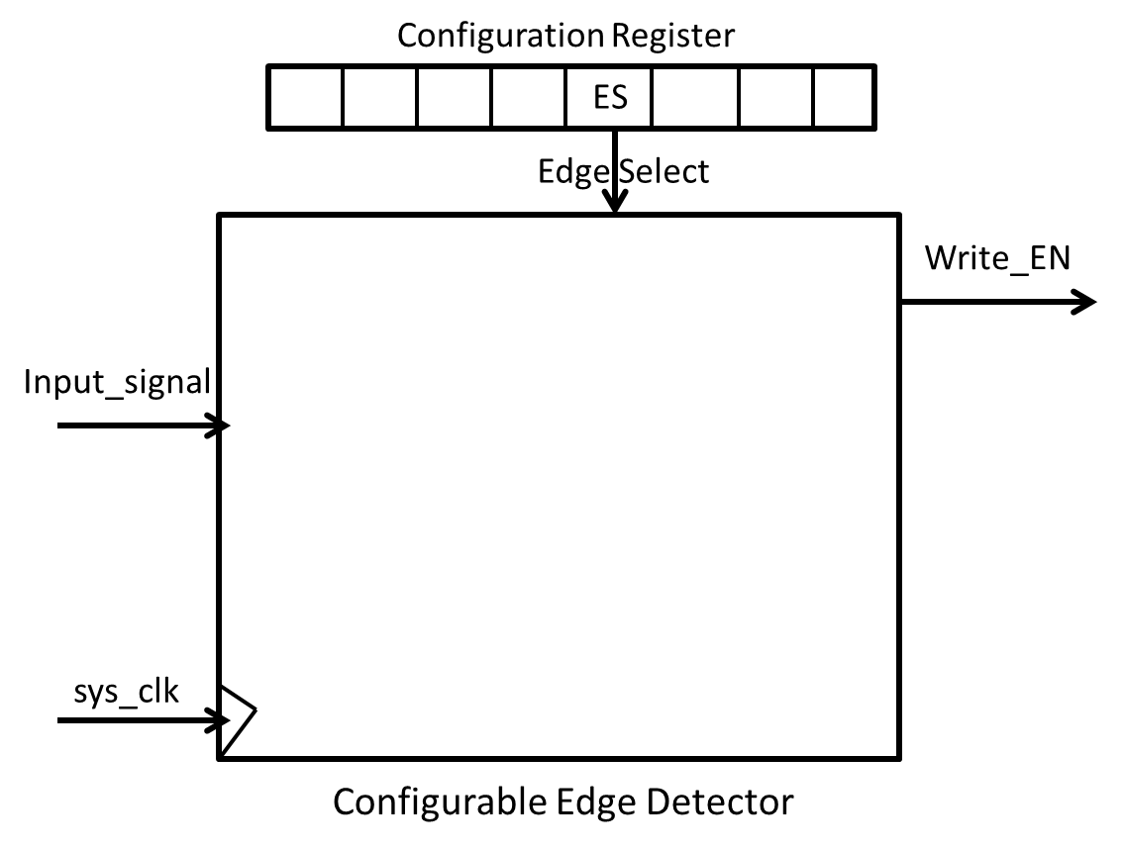

Question 4: Software implemented Input Capture (15 pts)

a) Assume the ATMEGA128 does not have Interrupts or Input Capture hardware. Write a C program to save TIMER1’s count value when a positive edge event occurs on PortD, pin4 (9 pts)

b) Describe two disadvantages of your software-implemented input capture program, as compared to using Input Capture hardware and Interrupts. (6 pts)

