**Chapter 5 Case Study: (Part I for assignment)**

**Examine the site map in Figure 2.32.**

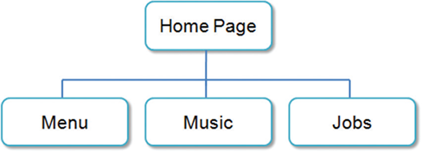

**What type of site organization is used for the JavaJam website?**

**Is it the most appropriate organization for the site?**

**Why or why not?**

The Pacific Trails Resort website uses a hierarchical organization. It's like having all the menu options on the home page, making it easy to decide where to go next. I think it's a smart move because a friendly and simple menu benefits both customers and the company. Customers find what they need easily, and the company gets to showcase its offerings. It's a win-win situation!

**Review the recommended web design practices from this chapter. Use the Web Design Best Practices Checklist (Table 5.1) to evaluate the JavaJam site that you created in earlier chapters. Cite three design practices that have been well implemented. Cite three design practices that could be implemented in a better way. How else would you improve the website.**

Three design practices acing the game on the Pacific Trails Resort site:

Content Presentation: The font is spot-on, everything's tidy and organized, and finding info is a breeze with minimal clicks.

Navigation: All the navigation links are on point, even if one page is still under construction. Seamless travel through the website!

Color and Graphics: Keeping it consistent with a limited color scheme, and the contrast between text and background is not bad.

However, let's talk about a few areas that could use a little extra love:

Browser compatibility: It's time to bring the site into the 21st century. Make sure the layout is as smooth on smartphones as it is on desktops or laptops.

Multimedia: Spice things up a bit! Incorporate some interactive elements to engage users and make their journey through the site more memorable and avoiding being distractive.

Page layout: The colors are not bad, but I think we can make it more appealing to the target audience. It looks kind of boring.

**Second Part**

Can you try to organize your pages using linear or random organization? Please include your summary with either linear or random organization. Also, compare and contrast with which organization type was best fitted and which one was the most ill-suited?

Linear Organization:

Pages follow a structured order, like Home, Activities, Reservations, and Yurts. Offers a clear, systematic user journey.

Random Organization:

Content is less predictable, with sections like a calendar or special events not following a strict sequence. Adds an element of surprise but may make navigation less straightforward. The type of structure might not be the best for commercial web sites. The navigating could become challenging if we add more elements like pictures or submenus.

Summary:

For Pacific Trails Resort, I recommend linear organization for a user-friendly and logical experience. Random organization, while adding excitement, may make navigation less intuitive, which isn't ideal for attracting visitors to a resort they might find a better page to navigate,