NAME | Dr. Joshua Urrete, LPT
POSITION / TITLE | Associate Professor 1
PROFESSIONAL ORGANIZATION | NU MOA
NO. OF YEARS OF PROFESSIONAL EXPERIENCE | 6
LICENSE NO. | 1815498
EDUCATIONAL ATTAINMENT | Doctor of Philosophy in Education major in Filipino (2025)  Master of Arts in Filipino (2022)  Bachelor of Secondary Education major in Filipino (2019)
GRADUATE COURSE(S) | - Pagsasalin sa Iba't Ibang Disiplina  - Istruktura ng Wikang Filipino  - Seminar sa Pagsulat ng Disertasyon

VALIDATION CERTIFICATE

This certifies that I have personally validated the research instrument developed by Genesis A. Cadigal, Rayan Kennard O. Chuayap, Luigi Karl B. Limos, and Gean Dhylan E. Mapesos for their study titled ‘’Doomscrolling Detection and Digital Mindfulness Mobile Application for Short-Form Video Platforms using Vader and Fuzzy Logic’’ on May 22, 2026. I have also provided the necessary revisions for the further refinement of the tool.

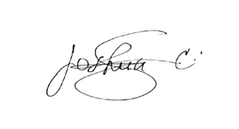

Dr. Joshua Urrete, LPT
Signature Over Printed of Validator

