Econ3140HW4

Nick Gembs

3/6/2022

#install.packages('haven')  
  
  
library(haven)  
  
data <- read_dta('C:/Users/Nick/Downloads/jtrain98.dta')  
data

## # A tibble: 1,130 x 10  
## train age educ black hisp married earn96 unem96 earn98 unem98  
## <dbl> <dbl> <dbl> <dbl> <dbl> <dbl> <dbl> <dbl> <dbl> <dbl>  
## 1 0 37 11 1 0 1 0 1 1.62 0  
## 2 0 30 12 1 0 0 0 1 0 1  
## 3 1 27 11 1 0 0 0 1 0 1  
## 4 1 33 8 1 0 0 0 1 9.07 0  
## 5 0 22 9 1 0 0 0 1 4.02 0  
## 6 1 23 12 1 0 0 0 1 7.34 0  
## 7 0 32 11 1 0 0 0 1 2.62 0  
## 8 1 22 16 1 0 0 0 1 7.60 0  
## 9 0 19 9 1 0 0 0 1 0 1  
## 10 1 21 13 1 0 0 0 1 13.4 0  
## # ... with 1,120 more rows

x1 <- data$train  
x2 <- data$earn96  
y <- data$earn98  
  
lmtot <- lm(y~x1+x2)  
lmtot

##   
## Call:  
## lm(formula = y ~ x1 + x2)  
##   
## Coefficients:  
## (Intercept) x1 x2   
## 3.9534 2.5120 0.4212

lmy <- lm(y~x1)  
lmy

##   
## Call:  
## lm(formula = y ~ x1)  
##   
## Coefficients:  
## (Intercept) x1   
## 10.61 -2.05

lmx2tot <- lm(x2~x1+y)  
lmx2tot

##   
## Call:  
## lm(formula = x2 ~ x1 + y)  
##   
## Coefficients:  
## (Intercept) x1 y   
## 8.409 -9.402 0.697

lmx2 <- lm(x2~x1)  
lmx2

##   
## Call:  
## lm(formula = x2 ~ x1)  
##   
## Coefficients:  
## (Intercept) x1   
## 15.80 -10.83

#cov(x1,x2)  
#var(x1)  
  
cov(x1,x2)/var(x1)

## [1] -10.83136

cov(x1,y)

## [1] -0.4555667

var(x1)

## [1] 0.2222219

cov(x1,y)/var(x1)

## [1] -2.050053

plot(x1,y)

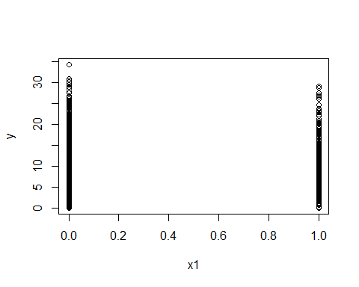

plot(x2,y)

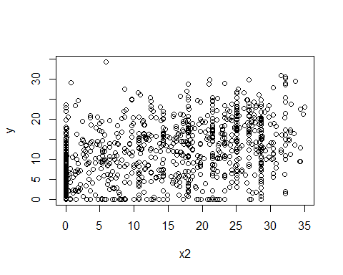

plot(x1,x2)

