Chuck’s Recreated Growth Curves

Nick Gembs

10/3/2022

library("ggplot2")

df = read.csv("C:/Users/Nick/Documents/GrowthCurve ALZ 131 Data Analysis Excel ng.csv")

##   
## Call:  
## lm(formula = correct ~ poly(CHILDAGE, degree = 3), data = task2)  
##   
## Residuals:  
## Min 1Q Median 3Q Max   
## -0.6539 -0.1711 -0.1316 0.3461 0.8684   
##   
## Coefficients:  
## Estimate Std. Error t value Pr(>|t|)   
## (Intercept) 0.34635 0.01462 23.687 <2e-16 ***  
## poly(CHILDAGE, degree = 3)1 4.42346 0.35093 12.605 <2e-16 ***  
## poly(CHILDAGE, degree = 3)2 0.88651 0.35093 2.526 0.0118 *   
## poly(CHILDAGE, degree = 3)3 -0.59839 0.35093 -1.705 0.0887 .   
## ---  
## Signif. codes: 0 '***' 0.001 '**' 0.01 '*' 0.05 '.' 0.1 ' ' 1  
##   
## Residual standard error: 0.3509 on 572 degrees of freedom  
## Multiple R-squared: 0.2272, Adjusted R-squared: 0.2232   
## F-statistic: 56.06 on 3 and 572 DF, p-value: < 2.2e-16

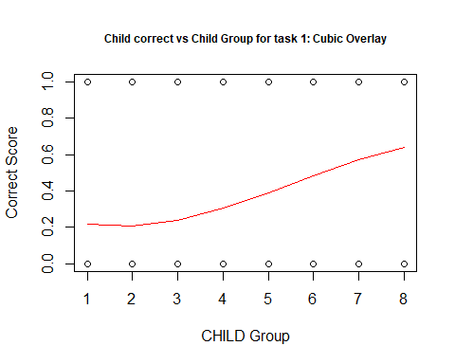

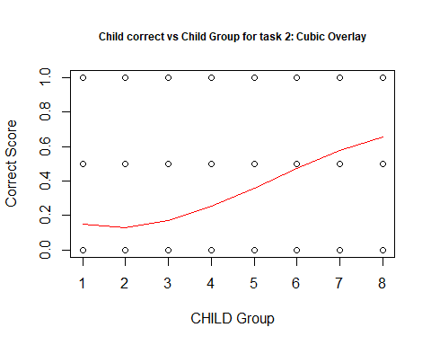

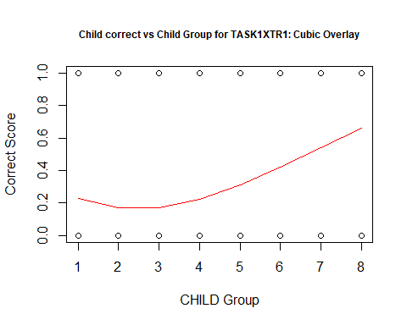

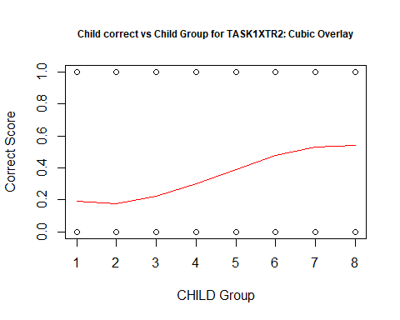

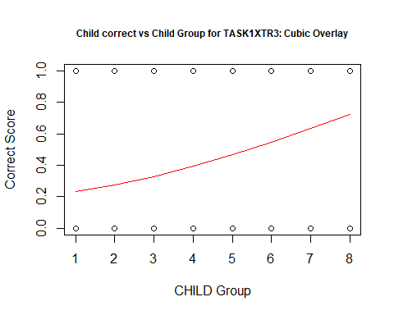

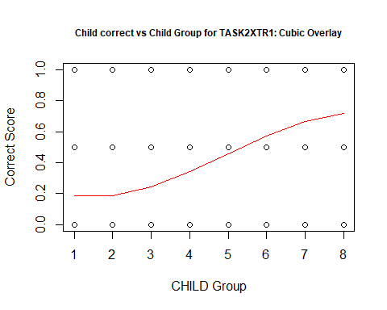

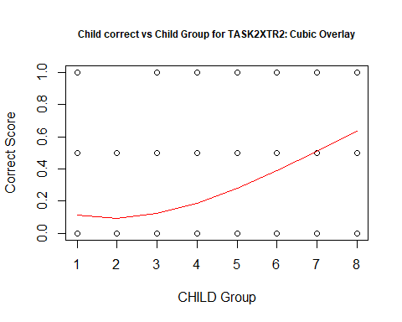

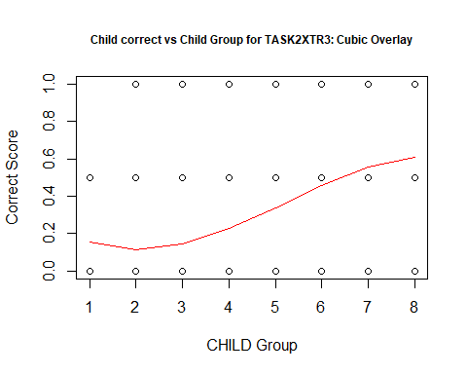

Alternative Formatting:

