Untitled

Nick Gembs

10/3/2022

library("ggplot2")

df = read.csv("C:/Users/Nick/Documents/GrowthCurve ALZ 131 Data Analysis Excel ng.csv")

task1 = df[df[4] == 1,]  
task2 = df[df[4] == 2,]

lm.fit1 = lm(data = task1, correct ~ poly(CHILDAGE, degree=3))  
lm.fit2 = lm(data = task2, correct ~ poly(CHILDAGE, degree=3))  
summary(lm.fit2)

##   
## Call:  
## lm(formula = correct ~ poly(CHILDAGE, degree = 3), data = task2)  
##   
## Residuals:  
## Min 1Q Median 3Q Max   
## -0.6539 -0.1711 -0.1316 0.3461 0.8684   
##   
## Coefficients:  
## Estimate Std. Error t value Pr(>|t|)   
## (Intercept) 0.34635 0.01462 23.687 <2e-16 ***  
## poly(CHILDAGE, degree = 3)1 4.42346 0.35093 12.605 <2e-16 ***  
## poly(CHILDAGE, degree = 3)2 0.88651 0.35093 2.526 0.0118 *   
## poly(CHILDAGE, degree = 3)3 -0.59839 0.35093 -1.705 0.0887 .   
## ---  
## Signif. codes: 0 '***' 0.001 '**' 0.01 '*' 0.05 '.' 0.1 ' ' 1  
##   
## Residual standard error: 0.3509 on 572 degrees of freedom  
## Multiple R-squared: 0.2272, Adjusted R-squared: 0.2232   
## F-statistic: 56.06 on 3 and 572 DF, p-value: < 2.2e-16

plot(task1$CHILDAGE, task1$correct, main = "Child correct vs Child Group for task 1: Cubic Overlay", xlab = "CHILD Group", ylab = "Correct Score", cex.main = .72)  
lines(sort(task1$CHILDAGE), # Draw polynomial regression curve  
 fitted(lm.fit1)[order(task1$CHILDAGE)],  
 col = "red",  
 type = "l")

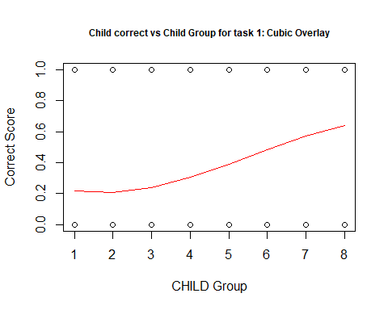

plot(task2$CHILDAGE, task2$correct, main = "Child correct vs Child Group for task 2: Cubic Overlay", xlab = "CHILD Group", ylab = "Correct Score", cex.main = .72 )  
lines(sort(task2$CHILDAGE), # Draw polynomial regression curve  
 fitted(lm.fit2)[order(task2$CHILDAGE)],  
 col = "red",  
 type = "l")

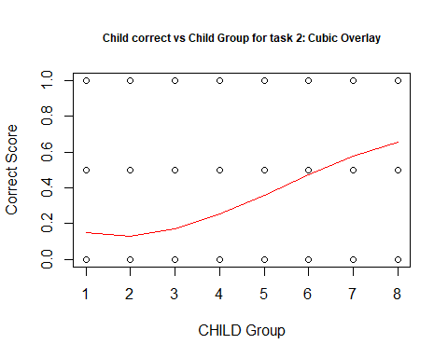

ggp <- ggplot(task1, aes(CHILDAGE, correct), title = "Child correct vs Child Group for task 1: Cubic Overlay") + # Create ggplot2 scatterplot  
 geom_point()  
  
ggp + # Add polynomial regression curve  
 stat_smooth(method = "lm",  
 formula = y ~ poly(x, 3),  
 se = TRUE)

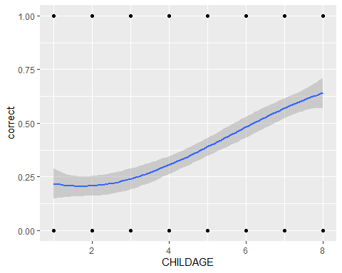

ggp <- ggplot(task2, aes(CHILDAGE, correct)) + # Create ggplot2 scatterplot  
 geom_point()  
  
ggp + # Add polynomial regression curve  
 stat_smooth(method = "lm",  
 formula = y ~ poly(x, 3),  
 se = TRUE)

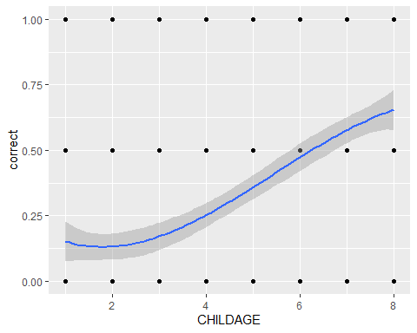

task1tr1 = task1[task1[7] == 1,]  
task1tr2 = task1[task1[7] == 2,]  
task1tr3 = task1[task1[7] == 3,]  
task2tr1 = task2[task2[7] == 1,]  
task2tr2 = task2[task2[7] == 2,]  
task2tr3 = task2[task2[7] == 3,]

lm.fit = lm(data = task1tr1, correct ~ poly(CHILDAGE, degree=3))  
plot(task1tr1$CHILDAGE, task1tr1$correct, main = "Child correct vs Child Group for TASK1XTR1: Cubic Overlay", xlab = "CHILD Group", ylab = "Correct Score", cex.main = .72 )  
lines(sort(task1tr1$CHILDAGE), # Draw polynomial regression curve  
 fitted(lm.fit)[order(task1tr1$CHILDAGE)],  
 col = "red",  
 type = "l")

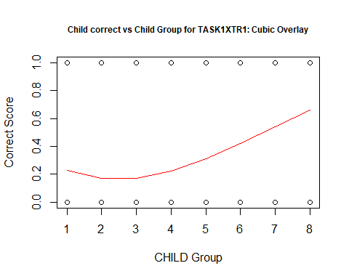

lm.fit = lm(data = task1tr2, correct ~ poly(CHILDAGE, degree=3))  
plot(task1tr2$CHILDAGE, task1tr2$correct, main = "Child correct vs Child Group for TASK1XTR2: Cubic Overlay", xlab = "CHILD Group", ylab = "Correct Score" , cex.main = .72)  
lines(sort(task1tr2$CHILDAGE), # Draw polynomial regression curve  
 fitted(lm.fit)[order(task1tr2$CHILDAGE)],  
 col = "red",  
 type = "l")

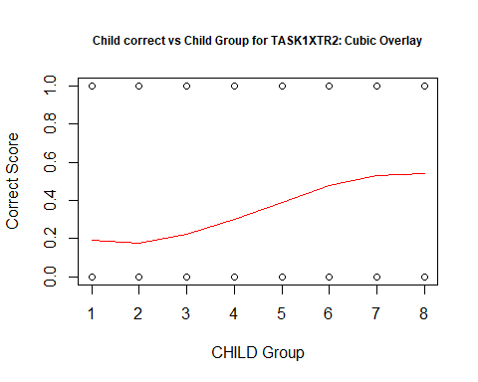

lm.fit = lm(data = task1tr3, correct ~ poly(CHILDAGE, degree=3))  
plot(task1tr3$CHILDAGE, task1tr3$correct, main = "Child correct vs Child Group for TASK1XTR3: Cubic Overlay", xlab = "CHILD Group", ylab = "Correct Score" , cex.main = .72)  
lines(sort(task1tr3$CHILDAGE), # Draw polynomial regression curve  
 fitted(lm.fit)[order(task1tr3$CHILDAGE)],  
 col = "red",  
 type = "l")

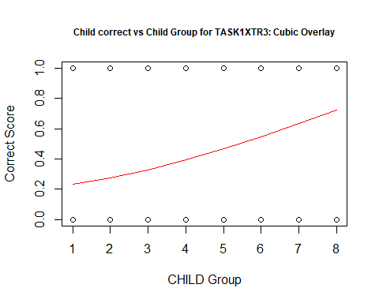

lm.fit = lm(data = task2tr1, correct ~ poly(CHILDAGE, degree=3))  
plot(task2tr1$CHILDAGE, task2tr1$correct, main = "Child correct vs Child Group for TASK2XTR1: Cubic Overlay", xlab = "CHILD Group", ylab = "Correct Score" , cex.main = .72)  
lines(sort(task2tr1$CHILDAGE), # Draw polynomial regression curve  
 fitted(lm.fit)[order(task2tr1$CHILDAGE)],  
 col = "red",  
 type = "l")

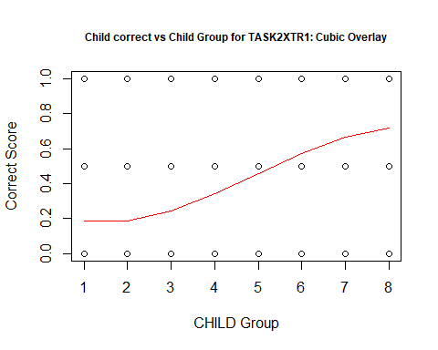

lm.fit = lm(data = task2tr2, correct ~ poly(CHILDAGE, degree=3))  
plot(task2tr2$CHILDAGE, task2tr2$correct, main = "Child correct vs Child Group for TASK2XTR2: Cubic Overlay", xlab = "CHILD Group", ylab = "Correct Score", cex.main = .72 )  
lines(sort(task2tr2$CHILDAGE), # Draw polynomial regression curve  
 fitted(lm.fit)[order(task2tr2$CHILDAGE)],  
 col = "red",  
 type = "l")

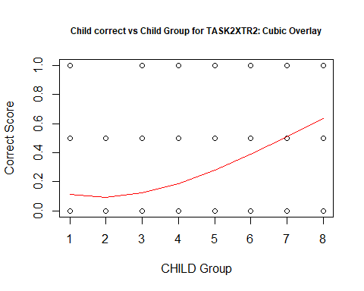

lm.fit = lm(data = task2tr3, correct ~ poly(CHILDAGE, degree=3))  
plot(task2tr3$CHILDAGE, task2tr3$correct, main = "Child correct vs Child Group for TASK2XTR3: Cubic Overlay", xlab = "CHILD Group", ylab = "Correct Score", cex.main = .72 )  
lines(sort(task2tr3$CHILDAGE), # Draw polynomial regression curve  
 fitted(lm.fit)[order(task2tr3$CHILDAGE)],  
 col = "red",  
 type = "l")

