Amazon Update Order Without Name Guide

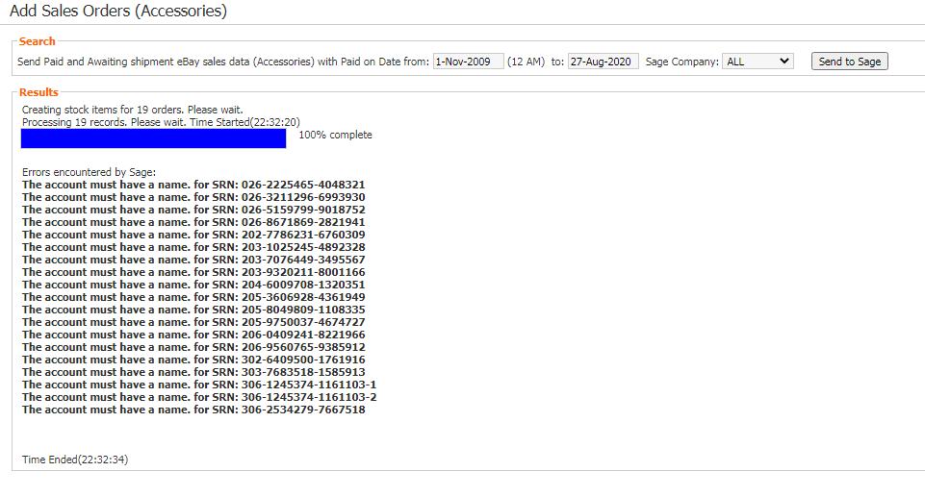
**** When encountered this error: (Send to Sage – Error: The account must have a name)

- Identify the SRN Amazon Account, you can check this on the page: http://34.196.137.61/barcode/srn_pl_check_status.php under Transaction ID
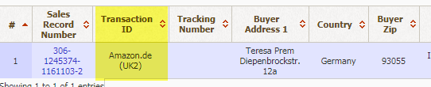

- Login to Amazon Account.

- On the Menu, Select Orders > Order Reports
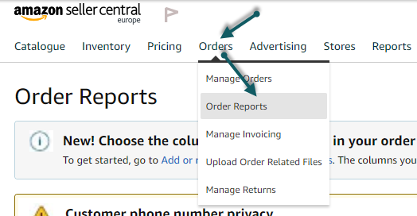

- Select New Orders Tab
  - Under Reports
  - Date Range: Last 7 Days
  - Click Request

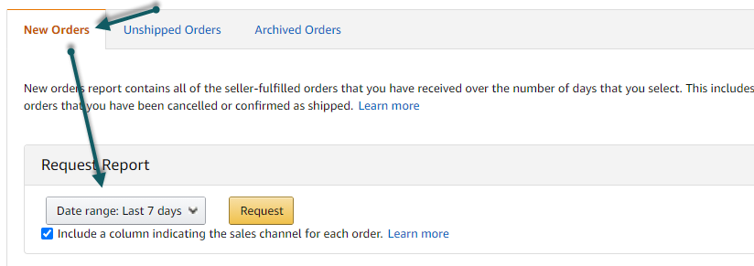

- Wait for the page to refresh for 5 seconds

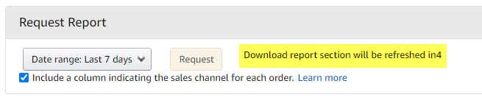

- Page will reload, then will show the report is in progress under Download Report.
  - Note on the Batch ID, then click Refresh button, until the Report Status changed to Ready and Download button is available
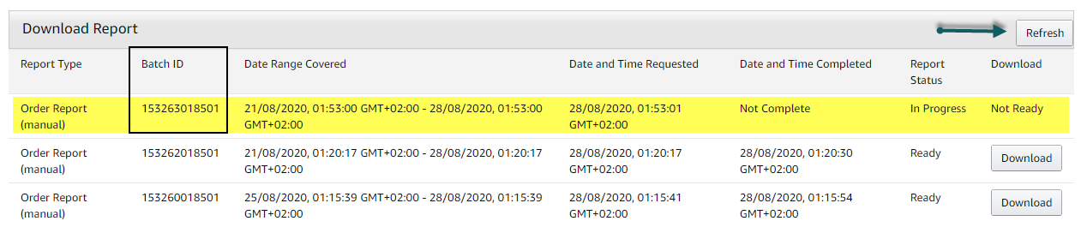

- Once ready click on the Download button to download the file
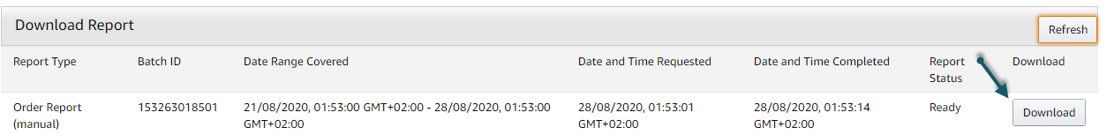

- Upload the downloaded file to this page: http://34.196.137.61/barcode/AmazonImportOrdersUpdateRecords.php

*** Follow Steps 2 – 8 until all accounts with error are downloaded/updated

