Practice: Using GemFire Tools

In this lab, you will use gfsh to launch and exit GemFire members and locator. In addition, you will use Pulse to monitor the members.

**What you will learn:**

* Launch GemFire members by using gfsh.
* Monitor GemFire members by using Pulse.

.

### Start GemFire Locator by using gfsh

1. Start a Command prompt window, and add the example class directories to your CLASSPATH (if not done as a part of the earlier practice).

set CLASSPATH=  
<product_directory>\ SampleCode\tutorial\classes;

<product_directory>\SampleCode\helloworld\classes;

<product_directory>\SampleCode\quickstart\classes;

<product_directory>\SampleCode\examples\dist\classes;

<product_directory>\lib\gemfire.jar;

%CLASSPATH%

where <product_directory> corresponds to the location where you installed GemFire.

**IMPORTANT**: Make sure that for each Command prompt window, you need to set the required PATH as mentioned in the installation practice.

1. Change directories to the tutorial directory, <product_directory>/SampleCode/tutorial. For example:

$ cd <product_directory>/SampleCode/tutorial

1. Type the following command at the prompt:

$ gfsh start locator --name=locator1 --port=55221

The locator process runs in the background, listening for connections on port 55221.

**Note:** To stop the process, you can type:

$ gfsh -e "connect --locator=localhost[55221]" -e "stop locator --name=locator1"

But don't stop it yet.

### Start two GemFire Instance

1. You already have one window open where you started the locator. Start another terminal window, and set the CLASSPATH. In each window, run the Peer application:

$ java com.gemstone.gemfire.tutorial.Peer

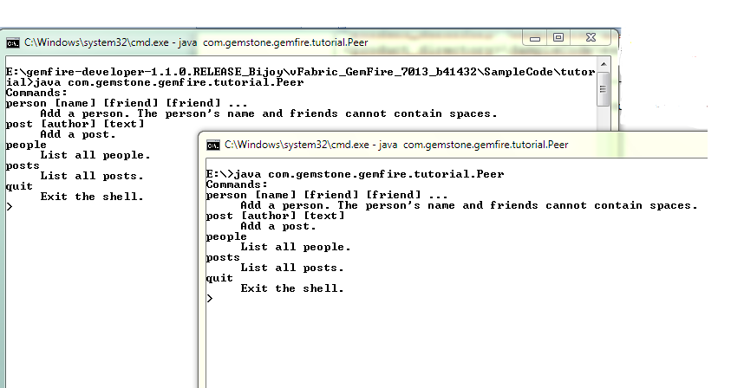

### Enter Data for Replicated Region

1. In one of your terminal windows, type:

person Isabella

person Ethan

1. You will see the users show up in the both the window:

In region people created key Isabella value Profile [friends=[]]

In region people created key Ethan value Profile [friends=[]]

This is because the cache listener, attached to the region fires notification on both the GemFire instances. This means that the data got replicated on both the instances.

### Enter Data for Partitioned Region

1. Start another Command prompt Window and launch the peer application in that Window. Make sure to set the CLASSPATH for the new Window before executing any application.

java com.gemstone.gemfire.tutorial.Peer

You should have three peers running now.

1. Add some posts in any of the terminal window. For example:

> post Isabella I like toast

> post Isabella LOL!

> post Ethan Hello

You see the notification in only one of the Peers, and not all of them unlike the 'person' notification. That's because partitioned regions make one copy of the post, the primary copy. By default GemFire only invokes the listener in the peer that holds the primary copy of each post.

1. From any window, list the available posts with the posts command. You should be able to list all posts, because GemFire fetches them from the peer that hosts each post.

### Launch Pulse for Monitoring

1. Enter the following command to launch pulse:

gfsh -e "connect --locator localhost[55221]" -e "start pulse"

1. Enter 'admin/admin' for the username and password, and log in.
2. Click on the respective servers and locator icons to view their respective information.
3. Stop all the servers and locator. For example:

gfsh -e "connect --locator localhost[55221]" -e "stop locator --name=locator1"