**Redirect**

**Game Design Document**

**GAM150su15**

**Summer 2015**

**Team Lambda Alpaca**

**Team # A01**

**Sawyer Simpson – Project Manager**

**Christian Ayson - Producer**

**James Hammond – Tech Director**

**Alexander Torres – Designer Director**

Contents

High Concept: 3

Summary: 3

Game Flow: 3

Game Mechanics: 4

Puzzle Solving: 4

Portals: 4

Blocks: 4

Lasers: 4

Game Characters: 5

Vectoria: 5

Buddy Block: 5

Game Resources: 5

Blocks: 5

Portals: 5

Walls: 6

Lasers: 6

Tiles: 6

Game Environment: 7

Game Controls: 8

Visual Design: 8

Audio Design: 8

Behavior Design: 8

Physics Design: 9

Basic Physics 9

Portal Physics: 9

Multiplayer Design: 9

High Concept:

2D top down cute-science themed puzzle game where players manipulate blocks, portals, and lasers to solve challenges.

# Summary:

Redirect is a single player puzzle game where players play as the Nano-bot Vectoria. Vectoria works for Pipeline industries, her job is to get the valuable memory blocks to every levels exit. Memory blocks have a distinct property which restricts there movement to 1 of 4 directions; Up, Down, Left, Right. Vectoria must use portals and the environment to redirect where the block will move. While moving the memory block to the exit, Laser and block puzzles will obstruct the Vectoria’s path. Vectoria must solve each puzzle in a room to progress. As the game progress the puzzles will get progressively more difficult going toward the final level. This final level is the buddy block level in which the player solves multiple rooms of puzzles while escorting the buddy block. This final level uses all the mechanics in the game to act like a “boss”.

# Game Flow:

Typically game session will be on the quick side. Player will probably do a 2-3 levels per sessions. These levels will be design to bet on small puzzles that will only involve one or two mechanics at a time. There will be 1 distinct segment in the game that will be longer and more complex. The final level will be the one exception where the player must use all of the mechanics to guide a single block across multiple puzzle rooms. Movement will be freeform in 8 directions. Blocks will have restricted movement in direction, but not in speed. The player will be able to move blocks fluidly, being able to quickly change from pushing the block to moving around the room. Portals will have free movement in between them. The portal transportation of the player will be fluid and non-jarring.

The overall intensity of the game is low because there are no puzzles that are time sensitive. Players will wander around the room trying to access what to do with the room they are given. Once the player solves a room they move on to the next one. Complexity and difficulty of the puzzle increase as the player progresses.

# Game Mechanics:

## Puzzle Solving:

Players are put into a room full of puzzles that the player has to solve to finish each level. The puzzle design revolves around three mechanics portals, blocks, and lasers.

## Portals:

Portals can be shot on to the wall by the player Portals act as a doorway between two points which allows the player to move freely through the room. Portals let the player change the direction of blocks and lasers to solve the puzzles in the room.

## Blocks:

Blocks can be pushed around to set off different switches to unlock doors so that the player can continue. Each level the player will get a single block that has to be pushed to the exit. This is the win condition of every level. Each block can only move in one assigned direction. Blocks can move through portals and can be rotated to change which direction they face. Blocks can also obstruct lasers. Blocks also activate any tile they are placed on.

## Lasers:

Laser move in a straight line and collide with the first thing in their path. Each laser has a source and a repository that need to be connected to open doors that block the player’s path. The Player can use portals and blocks to where the laser will point to solve the puzzle.

# Game Characters:

## Vectoria:

Players play the game as Vectoria whom is a Nano-bot trying to do her job redirecting memory blocks for Pipeline Industries. She has a cute simple look to her with a distinct bow that can be seen at the top of her head. She has on purpose, to do her job.



## Buddy Block:

This is the block that will be used for the final level in the game. This block will have a face and be destroyable in the puzzle. The blocks purpose is to get to the end of the final level. It is also meant to serve as something precious the player will want to protect. If the Buddy block dies a new one will spawn for the player.

# Game Resources:

Blocks:

Players can push blocks around to solve the puzzle room. There are 4 types of blocks

1. Memory Block – the player’s goal is to get this to the exit on each level.
2. Destroyer Block – When the player pushes two of these blocks together they will destroy adjacent blocks
3. Laser – movable laser source
4. Blank – generic block with standard block properties

## Portals:

Portals collide with walls and make pathways for the player. One portal will be purple and the other portal will yellow. Each will have particle effects coming out to convey where they are in the environment

## Walls:

There are two types of walls, Portable and Non-portables. Portables surfaces will look neat with a light gray color. Non-portable walls will be brown and rough

## Lasers:

Laser will have 2 components, sources and repositories. Each laser is connected to a door that it will open or close.

## Tiles:

Switch Tile on the map that will open a door if the player places a block on it.

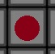

Rotation tiles on the map that will rotate blocks if the player places one on it.



Circuit tiles which are a series of switch tile that need specific block types.



Empty tiles block the player’s path, but not their line of sight.



# Game Environment:

The player will encounter blocks, lasers, portals, and different tiles that will be necessary for the solution of the puzzle. The room will be filled with all of these components to present the player a puzzle. Walls in the room as wells blank blocks are in the rooms to prevent the player’s movement. There is no way to die in the game and so there will not be environment hazards that will kill the player. Levels will typically use 1-2 different mechanics at a time to present the players a puzzle. This is to keep the overall complexity of each puzzle low. The layout of each room is extremely relevant to each level design. Each level will be designed around the fact that blocks are restricted in there movement. There are walls in the environment that the player cannot put a portal on; these will have a distinct visual look.

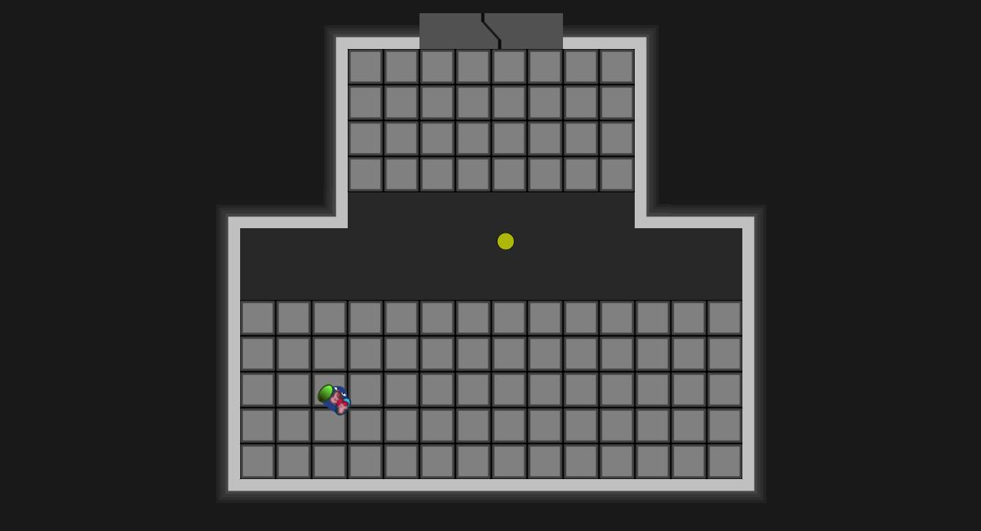

# Game Controls:

* The player will use WASD for 8 directional movement.
* Player will use the E key to interact will the game environment.
* When the player grabs a block they will be able to move the block in the direction it’s pointing to.
* Players can aim portals using the mouse and shoot them with both of the mouse buttons.

# Visual Design:

* There is a cute-scientific theme to the game
* Blocks have arrows to show players clearly where they can move.



* Blocks will have a specific icon and color to convey what type they are.
* Portals will have particle affects to signify there place in a top down environment.

# Audio Design:

* The game has a very simple sound design.
* There will be 2 songs, 1 for the menu and 1 for the puzzle rooms.
* This music will be calm so that the player can focus on puzzle-solving.
* There will be a jingle to give the player audio feedback when they solve a puzzle.

# Behavior Design:

No significant behavior design is need for the game. Certain puzzles will use simple pathing.

# Physics Design:

## Basic Physics

* Basic collision and response
* Rotating blocks

## Portal Physics:

Portals act as a doorway that connects two locations. The player can place these portals and travel between them. Lasers and Blocks also travel between the portals that the player places. Going through portals can change the direction of blocks and lasers.

# Multiplayer Design:

There will be no multiplayer in this game.