Group 14

Author: Zhangsihan

Software Specifications

Elevator

Table of Contents

System Architecture 2

Software Specifications 3

S1: ElevatorUI implementation and FloorUI Implementation 3

S1.1: Passenger press buttons on a random floor……………………………………………………………………….4

S1.2: Passenger press the buttons in the elevator……………………………………………………………………….4

## System Architecture

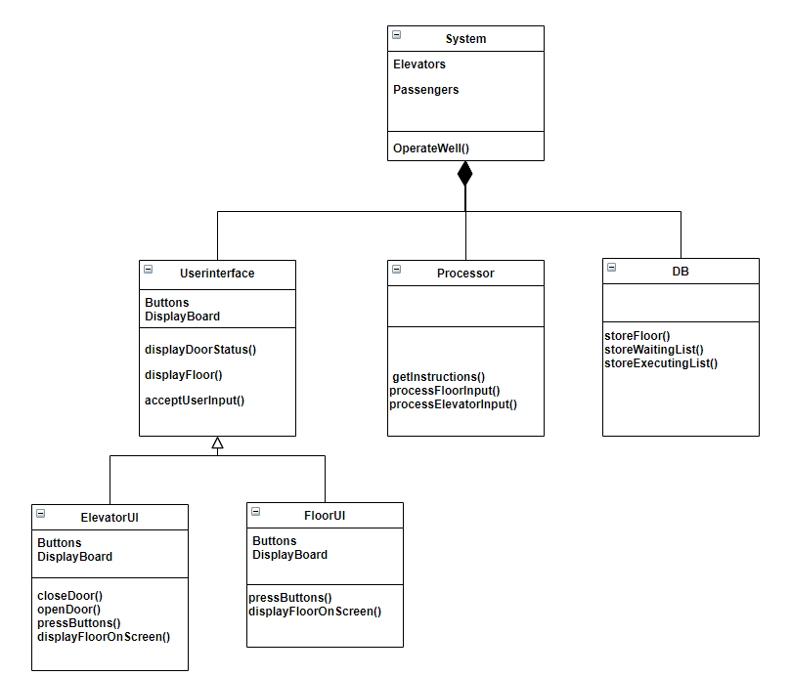The system architecture is shown below:

## Software Specifications

### S1: ElevatorUI implementation and FloorUI Implementation

### D:\qq消息记录\1550031971\Image\C2C\RA%~KMA]LGDH(MRM[[M[S7Y.pngD:\qq消息记录\1550031971\Image\C2C\0IJDHF[]P@TA9AJ8Q@10YR1.png

### D:\qq消息记录\1550031971\Image\C2C\5CZ)6]5CP_7V6(%_B@OJR5K.pngD:\qq消息记录\1550031971\Image\C2C\%56@0A}STVHOHA$)O7E5673.pngD:\qq消息记录\1550031971\Image\C2C\$%V2`44A6(}ZK5~UFQZH3_Y.png

#### C:\Users\zhangsh\AppData\Local\Temp\1593693168(1).pngS1.1: Passenger press buttons on a random floor

* S1.1.1: Number should be displayed on a certain floor

1. Press ”UP” or ”DOWN” button
2. Call the elevator
   1. If both elevators are free, and they are in the same position, call the left one.
   2. If one elevator is occupied, call the other freed one.
   3. Otherwise, call the nearest.
   4. The elevator must be able to give a ride to passengers on the way (e.g. when one comes from 3 to 1, the other press down at 2, the elevator should stop)

* S1.1.2: Elevator chosen

1. The chosen one come and display the process on the display board.
2. The chosen elevator stop and open the door on the targeted floor.

#### S1.2: Passenger press the buttons in the elevator

* S1.2.1: On a certain floor

1.The elevator should display the current floor.

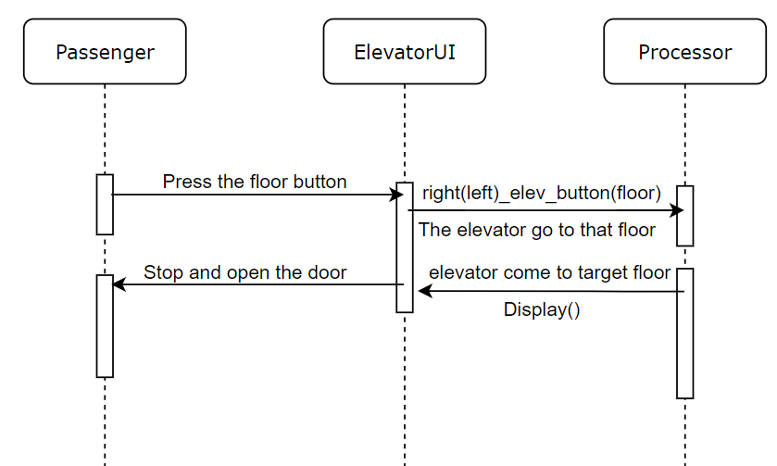

#### S1.3: The number on the display board in the elevator should be equal with the number of that on each floor