Group 14

Author: Chenfang

User Manual

Elevator

Table of Contents

System Architecture 2

User Manual in elevator 2

User Manual on each floor 3

## System Architecture

The system architecture is shown below:

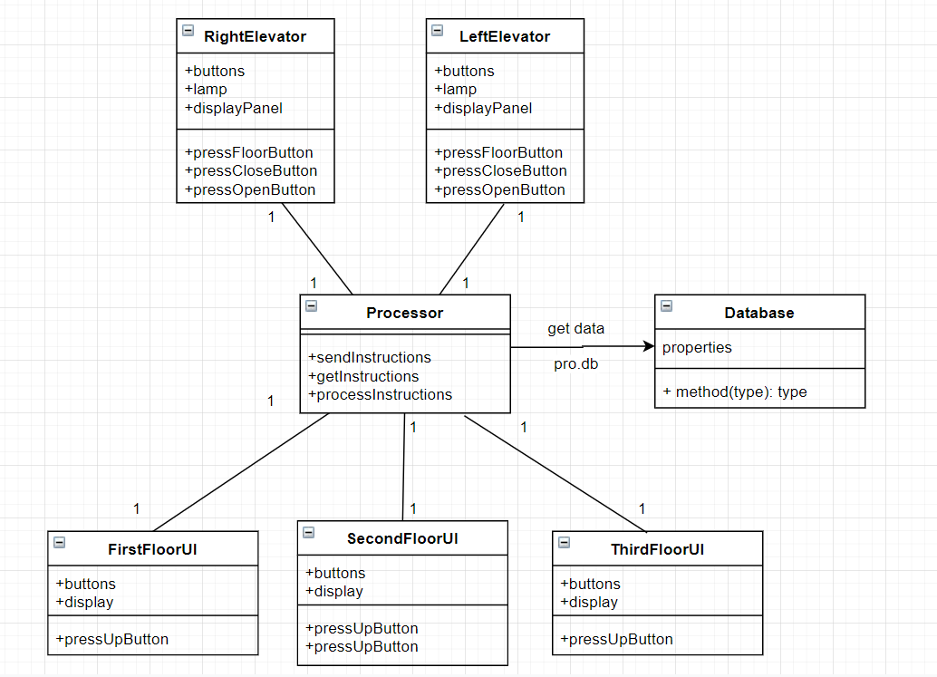

## User Manual in elevator

The passenger has a UI in each elevator which is shown below:

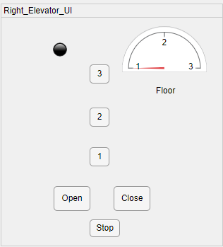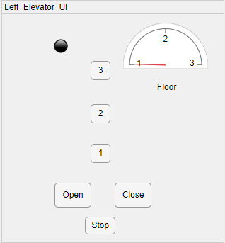

#### Coming into the elevator

#### Press the floor button which he or she wants to arrive

#### The elevator will reach the floor where the passengers have pressed

#### Pressing the “stop” button will make the elevator stop immediately

#### The green light means the door is open

#### The red light means the door is closed

#### The yellow light means the door is opening or closing

#### The semicircle shows which floor the elevator is on

## D:\qq消息记录\1550031971\Image\C2C\$%V2`44A6(}ZK5~UFQZH3_Y.pngD:\qq消息记录\1550031971\Image\C2C\%56@0A}STVHOHA$)O7E5673.pngD:\qq消息记录\1550031971\Image\C2C\5CZ)6]5CP_7V6(%_B@OJR5K.pngUser Manual on each floor

#### Press the “UP” or “DOWN” button if you want to go up or down

#### The display panel will show the floor of the two elevators (The initial floor of the two elevators are both on 1st floor)