Group 14

Author: Wangyi

Traceability Report

Elevator

Table of Contents

System Architecture 2

Software Traceability 2

## System Architecture

The system architecture is shown below:

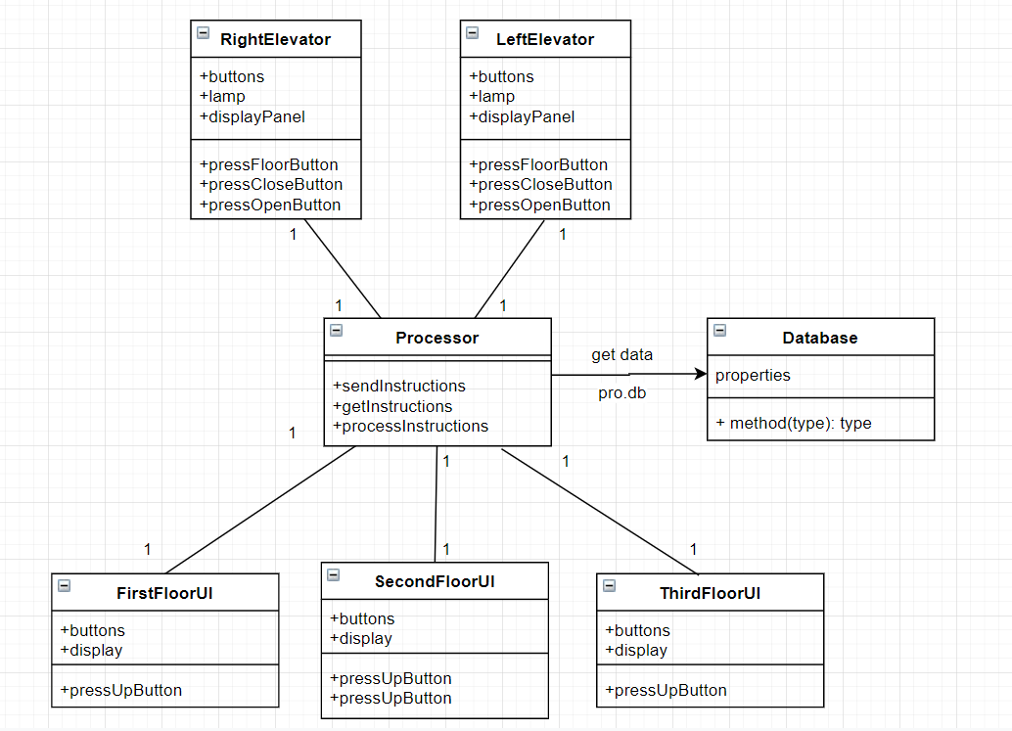

## Software Traceability

|  |  |  |
| --- | --- | --- |
|  | Is implemented by | Is validated by |
| R1.1.3 | S1.3 | T1.1 |
| R1.1.1 | S1.1.1 | T1.2 |
| R4.2.2 | S1.1.1.2.d | T1.3 |
| R2.1.1 | S1.2.1.1 | T1.4 |