Group 14

Author: Wangyi

Validation

Elevator

Table of Contents

System Architecture 2

T1: Unit Test 2

T1.1: OrderDB Unit Test 2

T2: Integration Test 3

T3: Functional Test 3

## System Architecture

The system architecture is shown below:

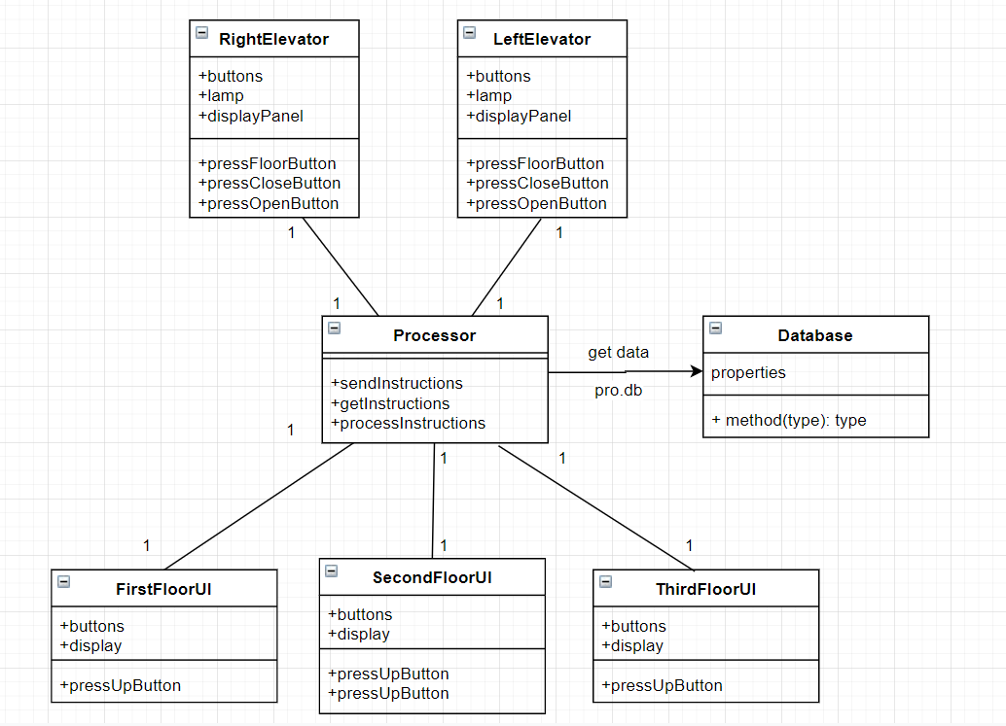

## T1: The Tests

### T1.1: the floor the elevator is on

function test4(testCase)

testCase.verifyEqual(testCase.ff.lui.FloorGauge.Value,1);

testCase.verifyEqual(testCase.ff.rui.FloorGauge.Value,1);

end

* Test result: 1 passed

## T1.2: The elevators’ floor info should be displayed on each floor

function test3(testCase)

testCase.verifyEqual(testCase.ff.lui.FloorGauge.Value,testCase.ff.EditField_1.Value);

end

* Test result: 1 passed

T1.3: The elevator will stop during the process when one press on the floor that the elevator will pass by

function test2(testCase)%%%

testCase.press(testCase.ff.T.DOWNButton);

pause(3);

testCase.press(testCase.ff.s.DOWNButton);

pause(3);

testCase.verifyEqual(testCase.ff.lui.FloorGauge.Value,2);

end

* Test result: 1 passed

T1.4: The elevator will come to the floor the user press on the elevatorUI

function test1(testCase)%%%

testCase.press(testCase.ff.lui.Button_3);

pause(5);

testCase.verifyEqual(testCase.ff.lui.FloorGauge.Value,3);

end

* Test result: 1 passed