Group 14

Author: Wang Yi

Software Specifications

Proj.3 Painkiller Injection System

Table of Contents

System Architecture 2

Software Specifications 2

S1: PatientUI implementation 2

S2: PhysicianUI Implementation 3

S3: InjectionDB Implementation 5

S4: InjectionProcessor Implementation 6

## System Architecture

The system architecture is shown below:

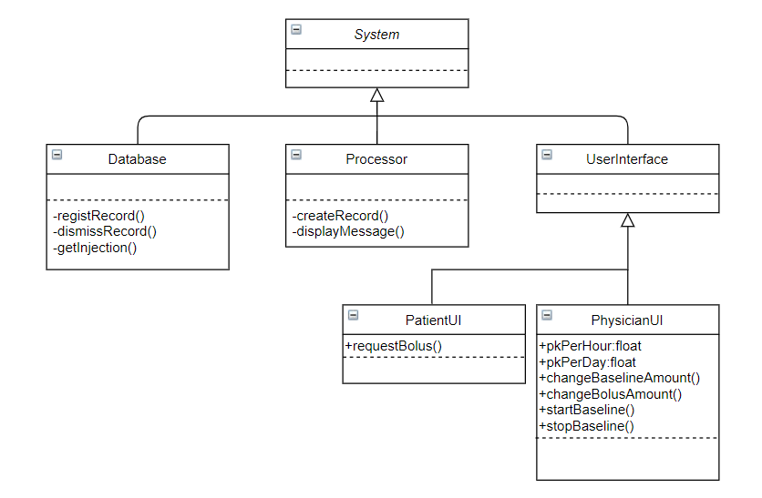

## Software Specifications

### S1: PatientUI implementation

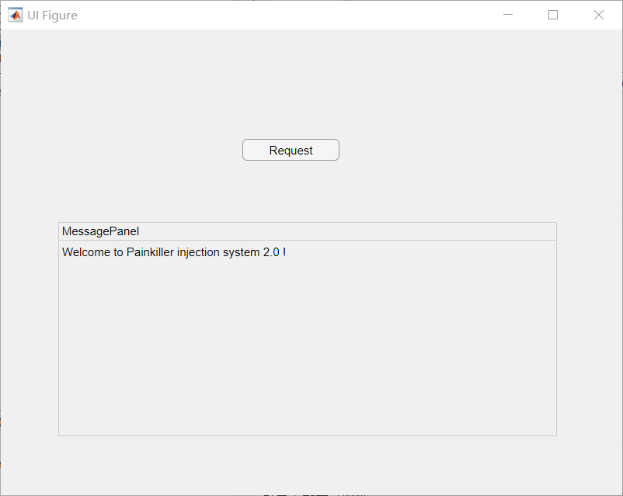

#### S1.1: Make a Request for “Bolus” injection

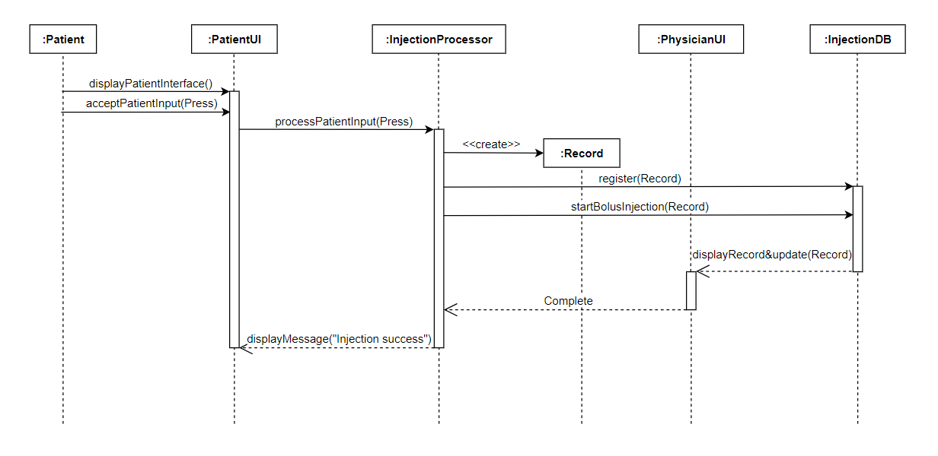

* S1.1.1: Make a request for “Bolus” injection

1. Request button pressed
2. For a request,
   1. If request successfully, injection will be made instantly and the related values like painkiller in one hour will be updated.
   2. If request failed, the panel will show related message. (exceed the limit)

### S2: PhysicianUI Implementation

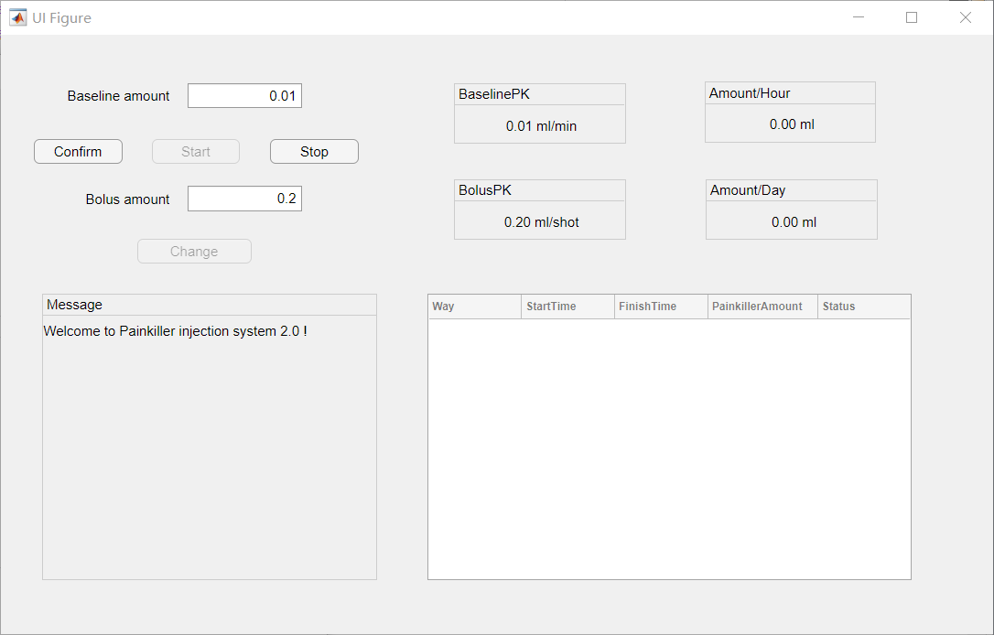

#### S2.1: Change painkiller amount of “Bolus” injection or “Baseline” injection

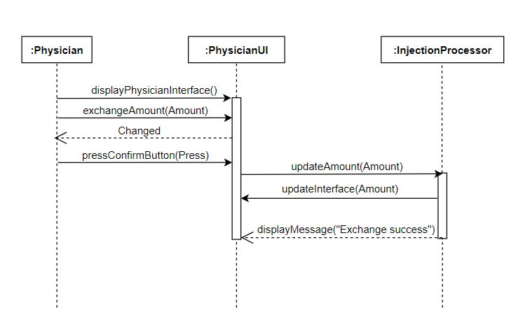

* S2.1.1: Exchange the painkiller amount

1. Input the painkiller amount
2. For the amount of injection
3. If the amount is in the proper range, the confirm button will be ready.
4. If the amount is not in the proper range, nothing would happen and need to input again.

* S2.1.2: Confirm the change

1. Press the Confirm Button
2. The amount will be updated in the system and related information in the panel will also be updated

#### S2.2: Give a “Baseline” injection and control the process

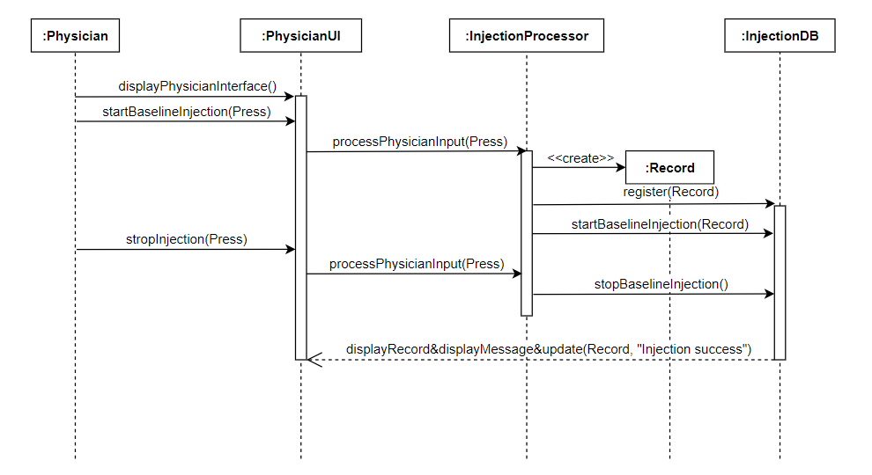

* S2.2.1: Start Baseline injection

1. Press Start Button
2. If not exceed the limitation, the injection will start until stop button pushed or reach the limit. The related value: painkiller in one hour and in one day will be updated as time passed.
3. If already reach the limitation, the message will show on the panel and will not start the injection.

* S2.2.2: Stop the injection

1. Press the Stop Button
2. The process of Baseline injection will stop and the record will be updated on the panel.

### S3: InjectionDB Implementation

#### S3.1: Register a record and dismiss the recordinglist

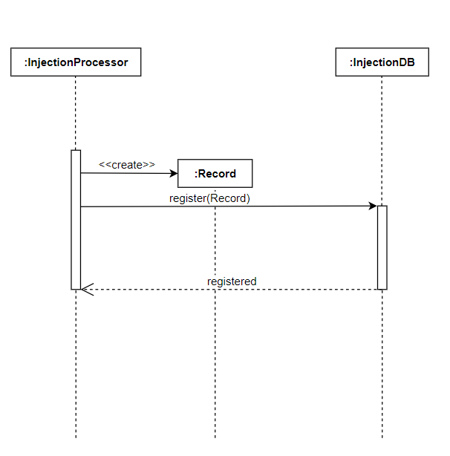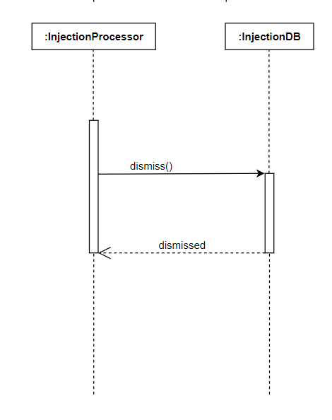

* S3.1.1: The processor creates a new record
* S3.1.2: The database gets the record and registers it.
* S3.1.3: The database dismissed the recording list in database.

### S4: InjectionProcessor Implementation

#### S4.1: Handle the invalid input and show the message

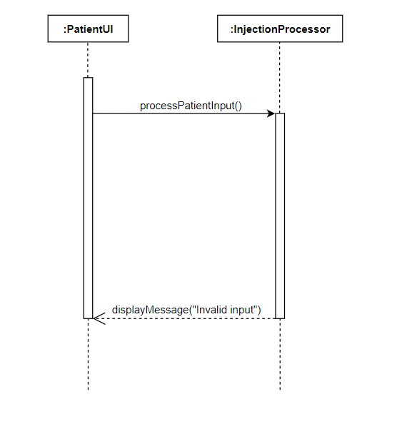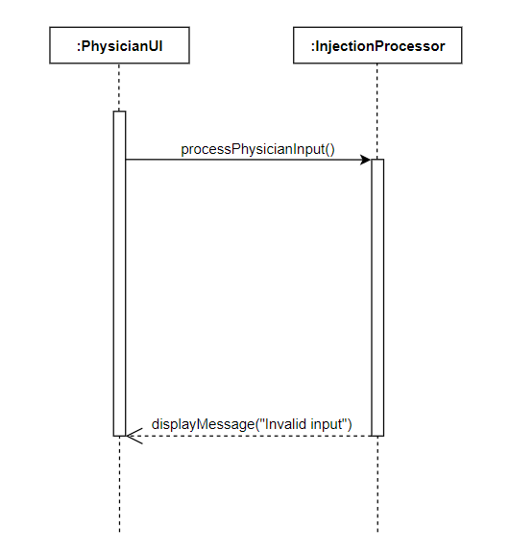

* S4.1.1: The processor gets invalid input from patient/physician
* S3.1.2: The processor returns the message and does nothing.