Group 14

Author: Zhang Sihan

User Manual

Proj.3 Painkiller Injection System

Table of Contents

System Architecture 2

Patient Manual 2

Physician Manual 3

## System Architecture

The system architecture is shown below:

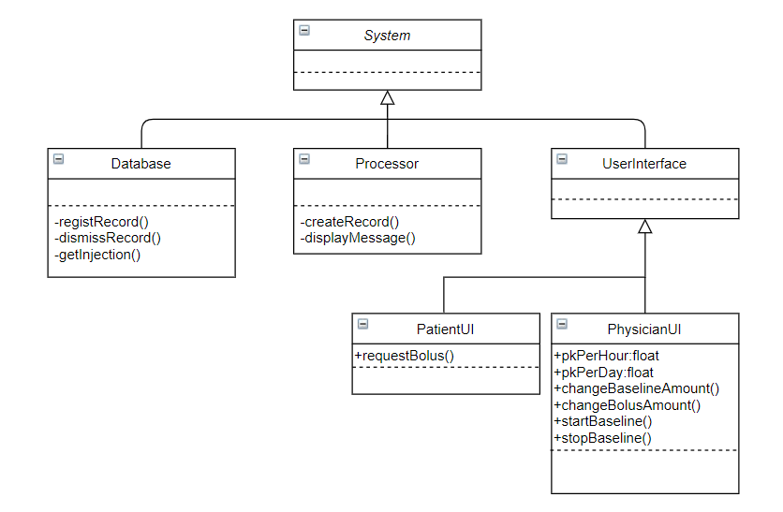

## Patient Manual

The server has a UI which is shown below:

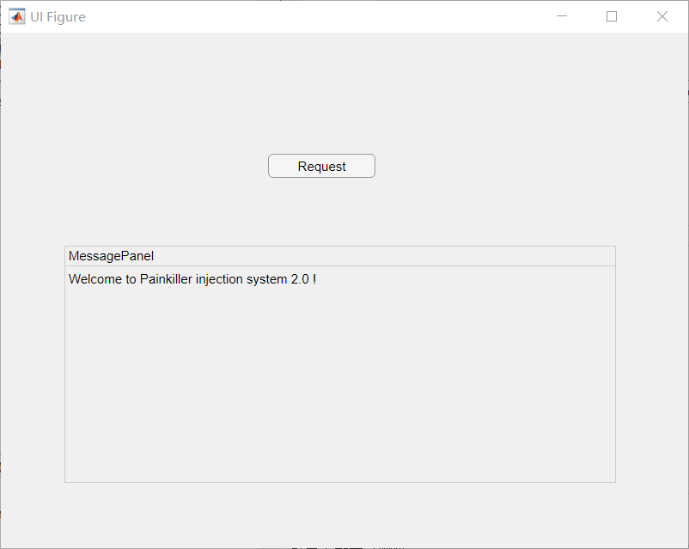

#### Make a request for Bolus injection

When wanting a “Bolus” injection, the patient could press the *Request* button to make a request for that. If he/she does not get too much painkiller (not exceed the limit), then the system would give the shot and show the message on the *MessagePanel*; else, there would be message like “You get too much painkiller!” to tell you that you can not get a “Bolus” injection as you have reached the limitation.

## Physician Manual

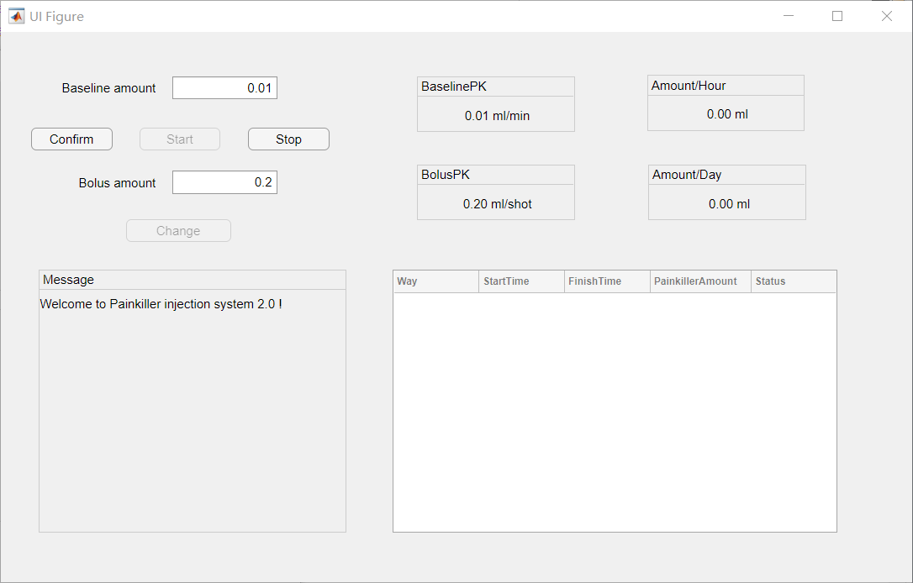

#### Exchange the painkiller amount of the two ways of injection

When the physician wants to exchange the painkiller amount of the two ways of injection, he/she should type the new amount in the corresponding editing field. The new amount should be in the proper range or else the amount wont change. After typing, press the *Confirm* or *Change* button to commit the change. If success, the related information on the right will change to the new amount and the message would be shown in the *Message* panel.

#### Make a Baseline injection and control the process

If the physician wants to give a Baseline injection to the patient, he/she should first set the painkiller amount and then press the *Start* button to start injection. The *Amount/Hour* and *Amount/Day* would change as time passed. If the injection reaches the limitation, it would stop automatically and update the record list. If the physician wants to stop the process manually, he/she should press the *Stop* button and then the process would be stopped and the record list will be updated. The related message will be shown in the *Message* panel if the injection failed or complete.