Group 14

Author: Chen Fang

Traceability Report

Proj.3 Painkiller Injection System

Table of Contents

System Architecture 2

Software Traceability 2

## System Architecture

The system architecture is shown below:

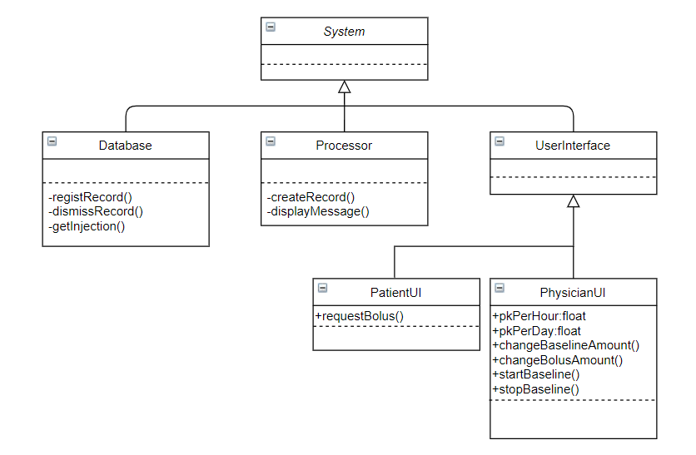

## Software Traceability

|  |  |  |
| --- | --- | --- |
|  | Is implemented by | Is validated by |
| R1.1 | S1.1 | T3.1 |
| R2.1 | S2.2 | T3.2 |
| R2.2 | S2.1 | T3.1 & T3.2 |
| R2.3 & R2.4 | S2.1 & S2.2 | T2.2 & T3.1 & T3.2 |
| R3.1 | S3.1 | T1.1 |
| R3.2 | S1.1 & S2.2 | T3.1 & T3.2 |
| R4.1.1 | S4.1 | T2.2 |
| R4.1.2 | S1.1 & S2.2 | T2.1 |