University of Lincolnshire and Humberside
Master in Business Administration



ASSIGNMENT OF MARKETING





Student: Nguyen Trung Thanh

Enrolment number: 008022000

E-mail: nguyentrungthanh@hotmail.com

DEVENTER 20/10/2000

INTRODUCTION

We are living in a changing world. The changes from environment create uncertainty, threat and opportunities for any companies. Although future is not predictable but an organisation can plan to react the changes or quickly response. The changes that we mention here are external forces that directly or indirectly influence to an organisation’s acquisition of inputs and generation of outputs. (Marketing - third European edition - Dibb, Simkin, Pride, Ferrell – Houghton Mifflin Company, 1997).

Vinamilk is the leading dairy producer in Vietnam. Started doing business from a small state-owned company, which had only few products, till now Vinamilk produces more than 70 products and exports to North and South America, Middle East, Europe and some Asian countries. Vinamilk is one of the most successful companies and becomes a symbol for state-owned company in Vietnam. Vinamilk also gained award of the third Rank Labor Medal by VietNam Government in 1985; the Second Rank Labor Medal by VietNam Governement in 1991; the First Rank Labor Medal by VietNam Governement in 1996. Vinamilk ranked number one on top ten list of Vietnamese consumer goods in 1995, 1996 and 1997 and number one in top ten list of high quality consumer goods in both 1997 and 1998.

The structure of this assignment is:
- The first part brings an overview of Vinamilk about its products, production, and environmental context of sweetened condensed milk.
- The second part brings insight into sweetened condensed milk and its key environmental factors. The reason for me to choose sweetened condensed milk is that this is the strategic product of Vinamilk. We will find the answer for the question “How Vinamilk increase its flexibility in order to respond more rapidly to environmental changes?”
- The last part is recommendation for Vinamilk, what they still haven’t done yet to increase flexibility?

Within a small assignment with a limited time, we cannot cover in detail of problem we are discussing (the ways to increase flexibility) but I hope that it can give readers some idea about Vinamilk and its challenges.

Nguyen Trung Thanh

PART I – AN OVERVIEW OF VINAMILK AND ITS SWEETENED CONDENSED MILK

VINAMILK, a state-own company, in the early of year 90s, Vinamilk was still quite small and produced only 10 products. But now, Vinamilk - number 1 dairy company in Vietnam - produces more than 70 products. Annual sale is 386 million units. The company is taking over 70% of Viet Nam dairy products market. Revenue increase rate of Vinamilk is 23.6% in 1998; 32% in 1999 and 82% in first two months of year 2000. Sweetened condensed milk, a typical adjunct to either hot or iced coffee, is high in calories and does not require refrigeration. Since 1989 Vinamilk has rocketed five-fold to 160 million units (397 gram can). (Source: Vinamilk boosts export, Vietnam News Agency – October 1999)

Operation management targets to high-quality and long product range.
Vinamilk is using modern technology and production lines which are imported from Italia, France, Denmark, Sweden ... the high quality raw material for Vinamilk's production are imported from Australia, New Zealand, Japan and partly from the milking cow farms in VietNam. Vinamilk has 4 modern plants which have total annual production capacity of more than 270 million cans of condensed milk (Source: Vinamilk website http://www.vnn.vn/yellowpage/vinamilk/). The company is applying international standard for its production ISO 9002, no chemical substances to keep milk.

Market is a big potential.
With population of 77 million inhabitant, the market has a big potential. Consumption of sweetened condensed milk has soared an impressive 20% annually. Age range 0-14 years occupies 34% of population will have a great demand for drink milk. Annual consumption per people was 3,14kg in 1998 and 4kg in 1999 and will reach 6kg in 2000. The annual increase rate of population is 2% and GDP per capita is 8%, which ensure the high increase the rate of market volume. (Source: Vietnam Investment Review- November 1999).

Market competition has been higher and higher.
The competition is higher with foreign companies. Wall's Division of Unilever operated a 9 million-litre production plant in mid-1997. (Source: US department of chamber and industry, report 1998). Vietnam Nestle Co and Vietnam Foremost Dairy Company also participated in competition in 1998. A $5 million dairy farm in Lam Dong, US-based St. Lawrence International Farms and Moc Chau Dairy Farm. Recently, the Australia Dairy Corporation (Ausdairy) and New Zealand's Dairy Technology Ltd. set up a $22 million dairy factory in Da Nang. New Zealand's National Dairy Association, an Australian investment company and the HCMC's Foreign Trade Development and Investment Corporation (Fideco) form Saigon Dairy Corporation. (Source: Dissertation - Marketing strategies for Dutch dairy companies which are penetrating into Vietnamese dairy market, Hogeschool Ijsellands)

Politics, legal and authority forces are more and more open.
In 1997, the National Assembly passed a law concerning land transactions and legislation, which provides for the country's first Commercial Code. A revised Foreign Investment Law was put into place at the end of 1996. In April 2000, Vietnamese Congress has changed the Investment Law, which makes equality for foreign investors and domestic investors. In 1999, Vietnamese government demolished more than 70 types of fees in local provinces. Vietnam is a member of ASEAN Free Trade Area (AFTA), Asia-Pacific Economic Co-operation Forum (APEC) and going to join in World Trade Organisation in next year.

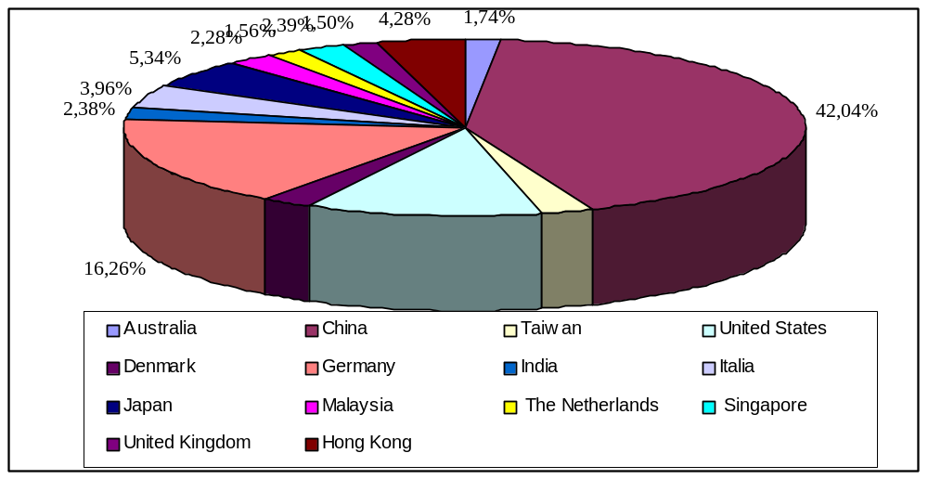 Modern technology is a trend.

Diagram 1 – Vietnamese food-process equipment import proportion. Source: U. S. Department of Commerce - National Trade Data Bank

Although the high proportion of technology is from China because it makes output price is cheap but western technology is a trend. Reducing output price can be done by many ways. Sweetened condensed milk is essential and perishable product. Thus, quality must be placed on top. High quality requires high technology and high effort of company. Second reason for modern technology is that main players of the market are powerful group such as Nestle, Mead Johnson Nutritionals, Delta Foremost Chemical Corp, Uniliver, which use modern technology.

Analysis of some economic and demographic factors
GDP has been increasing average 8% per year. This increase is quite stable even in Asian financial crisis. This increase will bring a higher annual income to Vietnamese and so is the reason for a higher consumption. Vietnam has a young population. 34% of it is in the range from 0-14 years old; 61% is in labor force, ranges from 14-61 years old. This is the big pie for any milk producers. Although 77% of population is living in rural areas, the power of purchase in rural area is not high.

PART II – VINAMILK INCREASES FLEXIBILITY TO RESPONSE TO RAPID ENVIRONMENTAL CHANGES

SWOT ANALYSIS

STRENGTHS AND WEAKNESSES | KEY ISSUES IN THE ENVIRONMENT
STRENGTHS AND WEAKNESSES | Political  Legislation | Supplier | Technology | Social factors | Competition | Globalisation | +
Main strengthens
Technology | - | + | + | - | + | - | 3
Good products | - | ++ | ++ | - | - | - | 4
Distribution | ++ | - | - | + | + | ++ | 6
Fame | - | - | + | + | + | - | 3
Main weaknesses
Divided resources | - | - | - | - | - | + | 1
International experience | + | - | - | - | - | ++ | 2
+ | 3 | 3 | 4 | 2 | 4 | 5

Tables 2 – The relationships between key environmental issues and core competencies.

According to the SWOT analysis, distribution and good products (delicious, package, ingredients) is affected much by environmental changes. Globalisation, competition and technology are the factors affect much to Vinamilk. Globalisation in Vinamilk point of view is the affects of market forces during Vietnam join in global economy.
Customer satisfaction
Efficiency
Convenience
Service
Key success factor
Cost efficiency
Quality
Time and Innovation
Continuous improvement
Total value
Chain analysis
Employee empowerment

Diagram 2-Focus on customer satisfaction (Source: Colin Dgury – Management in business environment)
People often talk about flexibility, its advantage and it seems that flexibility is the target for everyone. But till now, still no article bring an insight how we can measure flexibility. Is flexibility adaptability to environment or ability to response quickly to the market? Do we need the same level of flexibility for all organisations? From those questions, we have to understand the term “flexibility” before can conclude how to increase it.

The market nowadays has been more and more unpredictable since oil crisis in 70s. Any strategic decision can bring success or collapse to companies. Company, as its individual always has to face some questions: how to grow? What are threatens to us? Why our competitive advantages went out?

Market
forces

Market
forces

Corporate strategy

Input → Process → Output

Internal Resources

Diagram 3 – An overview of company response to its market forces.

The company always tries to find a match between its internal forces and external forces. Looking for a permanent match is an idiot because market forces always changes while a company tends to be stable: career position, assembly lines, job specialisation and so on. In short term, the company is always open to change but that change is not systematic and planned, it is just a movement of company. From this point, flexibility is ability of a company to change in long term to match to quick changes of market forces without any huge losses.

According to the diagram 3, the level of flexibility is different from industries and companies. For service industry, because the output has individual characteristic, flexibility must be higher than manufacture industry where the process and output cannot be changed rapidly. Return to Vinamilk case study, globalisation, technology and higher competition are the main driven market forces. What systematic changes Vinamilk made to match those trends and what should it do?

Vinamilk has invested in technology to increase productivity, reduce cost and maintain high quality.
Vinamilk has 4 modern plant using technology imported Italia, France, Denmark and Sweden. At the beginning, when the company was a small milk producer with one plant only, Vinamilk invested 1.2billion VND to raise capacity and 1.5 billion VND to develop dairy farms to ensure quality of the input. In 1993, Vinamilk spent 5million USD for the new modern equipment which increased productivity 50% and reduced cost. This investment was also a step to prepare for exporting. In every plant, Vinamilk built a supervisor system to control quality. In 1999, the company applied ISO 9002 – a needed step for exporting products to Europe. Vinamilk and Ashta of the USA plans to set up two dairy farms, one in Ba Vi District, Ha Tay Province and one in Dong Nai Province, with a capital of $18 million. This joint venture will increase capacity of Vinamilk and also help Vinamilk to export sweetened condensed milk to United States.

Distribution channel is a competitive advantage bring convenience to customers.
Sweetened condensed milk is essential product serve a wide population. Thus, distribution channel is very important. Till 1994, Vinamilk had only 300 retail "commission sellers" in 53 provinces and cities throughout the country. In 1996, the company opened two branches and 500 sales agents. And now, all products of Vinamilk are distributed thorughtout 1000 distributors. In every Vinamilk agents, the company required a standard in display, color, uniform and maintainance coditions.

Bulding stable position in the market prepare for a global competition.
The standpoint of Vinamilk is stable occupying in domestic market before penetrating in foreign market. “If your team cannot win at home land, how can they have experience and resources for away competition” Ms. Mai Kieu Lien, director of Vinamilk said.

Diversifying markets.
One of successful strategic decision of Vinamilk is to boost exporting sweetened condensed milk. Vinamilk is now competing in North America, Middle East, Europe and Asia Pacific. In future, when the domestic competition is too high, the foreign pie will help company a balance. This is one of the best way to increase flexibility in case of nothing change in technology, just change in demand or politics or economic of local market.

After all, we cannot require Vinamilk have to be flexible like an IT company because Vinamilk is a manufacturer. It is built to be stable and efficiency. But the direction of Vinamilk shows that its flexibility is quite high to meet any changes in market forces in future. But Vinamilk is still under way to be the best. The company haven’t done some work, which help company more flexible and more efficient to satisfy better customers’ needs and wants.

PART III – RECOMMENDATION

Empowerment and build a strong culture for organisation.
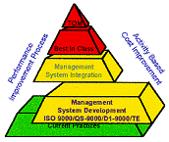
Empowerment means let employees decide themselves Vinamilk should consider empowerment as its tool to reach Total Quality Management. With empowerment, employees do better the job, especially for the sellers because they are people have face-to-face conversation with customers. By building strong culture, Vinamilk make its employees to focus on customer value, responsible for their work to customer and keep thinking about customers. By empowerment and strong culture, Vinamilk can create competitive advantage because they are factors very difficult to copy.

Build Vinamilk’s structure around its process to increase flexibility
Development teams should become the primary organisational units. The mission of functional department should be redefined. Budget should be done by process instead of department. This is the new concept for manufacturer that IBM, Owens Corning are applying to reduce 80% of time to launch new products. The key point of this concept is in the new process enterprise, the key structural issue is no longer centralisation versus decentralisation; it’s process standardisation versus process diversity. To do that work, Vinamilk should, firstly, train employees, change the old thinking of managers about structure, rebuild it standard criteria and empowerment.

REFERENCES

- Arie de Geus – “The living company” – Havard Business review, March - April 1997.
- Dibb, Simkin, Pride, Ferrell – Marketing, 3rd European edition – Houghton Mifflin Company, 1997.
- Eric Abrahamson – “Change without pain” – Havard Business Review, July - August 2000.
- Niraj Dawar and Tony Frost – “Competing with giants. Survival strategies for local companies in Emerging Markets” – Havard Business Review, March - April 1999
- Peter Leadley – Marketing, the primer – University of Lincolnshire and Humberside

