University of Lincolnshire and Humberside
Master in Business Administration

ASSIGNMENT OF HUMAN RESOURCE MANAGEMENT



Student: Nguyen Trung Thanh

Enrolment number: 008022000

E-mail: nguyentrungthanh@hotmail.com
DEVENTER 20/10/2000
INDEX

INTRODUCTION | 2
FPT – THE ROAD TO SUCCESS | 3
1. Difficult beginning | 3
2. Success come with slogan “Total solution, excellence service” | 3
FPT’s HUMAN RESOURCE MANAGEMENT ANALYSIS | 5
1. Focus on young talent and innovative | 5
2. Innovative reward system | 6
3. Planning, training and development | 6
4. Building a different culture to motivate employees | 7
5. Encouraging employee relationship by sport activities and others. | 8
Critical analysis in FPT’s human resource management | 9
1. Problem in hiring approach. FPT should change the way to hire employee, not only depends on education, IQ or working history. | 9
2. Flattening company structure, move to project structure. | 9
AS A CONCLUSION | 11
REFERENCES | 12

INTRODUCTION

Food and Processing Technology Corporation (FPT) is known as number one IT company in Vietnam with the revenue of VND 516 billion in 1998 and 543 billion in 1999. FPT has the largest number of employees which is nearly 400 people positively participating in information technology and other project. Its products are development of computer software; designing and installing information network system; distribution of information products; Internet service, training information science; technology transfer; warranty and maintenance. FPT started doing business in 1988 with 13 members only, and it now has representative in Europe, North America, Japan and India with 459 staff. The average growth is around 70% and capital increases 80% per year (Source: FPT annual report 1998). In 1997, company built the first WAN called Vietnam Intelligence. In 1998, FPT was the first Internet Service Provider and Internet Content provider. The company also achieved the second labour medal from government and award of the most trusted IT company in Vietnam. Its famous software – smartbank - was the golden-medal software in Computer WorldExpo 1998. FPT received awards from the Ministry of Trade for accomplishment in exporting software in 1998

The success of FPT includes excellence human resource management with empowerment, unique culture, employee involvement, remuneration and reward, training; marketing strategy, and focus on quality and prestige by applying International standard ISO 9001. This assignment includes 3 parts:
- Part 1: FPT- The road to success introduces more detail what they did to success.
- Part 2: FPT human resource management Analysis brings insight aspects of human resource management in FPT.
- Part 3: Critical analysis in FPT’s human resource management gives some critical analysis current FPT’s approach to human resource management and describe what should be changed.

Deventer 20/10/2000
Nguyen Trung Thanh

FPT - THE ROAD TO SUCCESS

“… FPT deeply believes that only turn round and round with the practice, working to the fullest, top-level create is able bring about products with real value…FPT bring to its customers not only computers but also high quality total solution that they need…”
Prof. Dr. Truong Gia Binh - FPT President and CEO

- Difficult beginning

Food and Processing Technology Corporation (FPT) was established in 1988 by 13 members. At first, they produced pineapple powder, chilly shrimp-chips, H.V. (Quinua) nutritious powder, and popcorn. Although its H.V nutrition powder was awarded Golden Medal in Giang Vo Exhibition and Fair but they found it was hardly to launch in the market. Then, they gave up the direction of Food and Processing Technology. Since the first personal computer was born in 1985, the computer technology had been rapidly growed. Members of FPT corporation who almost graduated from technology school realised that technology field is the most appropriate for them. But at the beginning, they did not success. The two first softwares are Auto Character Recognition and professional printing program TYPO4 that consumpted a lot of time, effort and money had gone to oblivion. The company felt into financial problem. To save the company, every one worked enthusiastically with even very little salary or did not accept the salary, foreign company failed to have FTP employee even in high salary 2000$ per month.

- Success came with slogan “Total solutions, excellent services”

They did not have to wait so long. In 1989, the first significant computer contract is with Soviet Union Academy of Sciences and Office. The first informatics solution of FPT is to informationalized Vietnam Airlines' International Ticket Office. In 1991, it announced the Informationalized Banking Business solution and since then, FPT becomes a famous IT solution provider in Vietnam. Its major clients are World Bank Vietnam, Eximbank, Vietcom Bank, Agricultural Bank, Bank of Tokyo, Bank of Cuu Long Delta housing Development, UNDP, Coca-cola, Denmark Embassy, Ford, British Petro, Bimson Cement Company. “…Support and post-sale service is FPT's important strategy. In 5 years ago, we separated Service Center into one independent in order to guarantee the quality of maintenance and repair with the principle of settlement the breakdown will not later than 24 hours since informed…” said Prof. Dr. Truong Gia Binh - FPT President and CEO.
FPT created an excellent system of maintenance, preservation, repair, upgrade and supply replaceable spare parts is one of the most important factors to attract customers to FPT. FPT pledge to serve Customers within 3 hours, if they are in Ha Noi capital or Ho Chi Minh city, within 48 to 72 hours in the other regions when FPT received require from customers.

FPT prepared for Internet strategy by building the first WAN called “Tri Tue Viet Nam” (Vietnam Intelligence) and provided WAN service for free in the first year. Till now, the price for using FPT WAN service is still quite cheap so that a lot of people are using FPT WAN “Tri Tue Viet Nam”. The WAN successes because it is quite interactive, easy-to-use and cheap. Moreover, later in 1997, Vietnam officially connected to Internet, FPT becomes one of the first three Internet service providers and quickly gain significant market share because of well-known “Tri Tue Viet Nam” which later achieved award of the software that has the biggest number of user in Vietnam.

In year 1998 and 1999, FPT receive award “Most trusted IT company” in Vietnam and four golden medals In Computer Expo99. Advantages of FPT are prestige, quality and a significant number of excellence programmer. When a company has transferable assets, it can extent local advantage abroad. Thus, FPT strategy now focuses on keeping number one position of IT company in Vietnam and software exporting. “In new period FPT strive to reach the revenue of US$ 50 million in 2000, become the area scaled technology corporation in 2005 and worldwide scaled in 2010. We will take active part into domestic software market. Our object of exporting software is USD 10 million in 2005” Prof. Dr. Truong Gia Binh - FPT President and CEO said. The difficulty for FPT is lack of professional programmer. The company is preparing human resource by participating into establishing Hoa Lac High-Tech Park Project, opening two international IT training centres, holding Vietnam Intelligence Software contest, granting to students who are excellence in maths and computer science. To improve the quality of products, FPT is the first IT company that applied International standard ISO 9001.

“…The 21st century is coming with an uncountable amount of challenges, challenges for Vietnam, challenges for FPT, and challenges for each of us. FPT will continue going, as it is our aspiration and responsibility…”
Prof. Dr. Truong Gia Binh - FPT President and CEO

FPT’s HUMAN RESOURCE MANAGEMENT ANALYSIS

“ When some one ask us, if we have to pack FPT 10 years technology, or 10 years FPT's activities into a few words, what are they? Man, that is the word. Man is the essence in FPT 10 years technology.”
Prof. Dr. Truong Gia Binh - FPT President and CEO

The manager of a living company must let people grow within a community that is held together by clearly stated values. The manager, therefore, must place commitment to people before assets, respect for innovation before devotion to policy, the messiness of learning before orderly procedures, and the perpetuation of the community before all other concerns. (Arie de Geus – “The living company” – Havard Business Review March-April 1997).

Derek Torrington and Laura Hall described the difference between Human Resource Management (HRM) and Personnel Management in the book of Personnel Management is: Personnel Management is workforce-centred, directed mainly at the organisation’s employees, finding and training them, arranging them to be paid, explain management’s expectations, justifying management’s actions, satisfying employee’s work-related needs, dealing with their problems and seeking to modify management action that could produce unwelcome employee response. HRM is resource-centred, directed mainly at management needs for human resource to be provided and deployed. Demand rather than supply is emphasised. There is greater emphasis on planning, monitoring and control rather than mediation. By these instructions, we will see how FPT approach and apply Human Resource Management.

- Focus on young talent and innovative
In 1999 FPT has 459 members and staff, among them there are 31% female and 69% male. FPT members’ knowledge level is very high, 7.1% personnel are post graduated, 78.8% have finished University and 13.8% have finished high school or secondary school. FPT is regarded to be one of the biggest young companies in Vietnam for the average age of the company is 28.61 in 1998. Persons who have abilities and desires to study are created good conditions to study to enrich knowledge as well as working abilities.

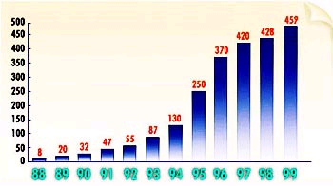

Diagram 2-1: Number of employee in FPT during period 88-99. Source: FPT official web-site http://www.fpt-soft.com

- Innovative reward system

In FPT, promotion is fairly open for everyone who has ability and desire to develop. I give here some true examples about young talent employees moved to higher rank in FPT when they worked hard to contribute their effort and lead company to success.

Truong Dinh Anh, graduated from Touring Economic Department, National Economy University, went to FPT in 1993. He is a person of indulgence. He indulges in working and success. Through the last 5 years, he has worked 12 hours a day, almost no Sunday and on average one years, he created one application software. Dinh Anh has quickly become first-rate software expert, took part in programming interbank payment, saving transaction allowing send and draw in multiple places, data transmission, security system... In 1997, he was promoted the manager of FPT Online Exchange, which is FPT Internet Center now.

Duong Dung Trieu came to FPT to practice when he was a student, and when he graduated from Information Technology Department in Hanoi University of Technology in 1995; he joined FPT with the position of first-rate expert on network and Internet. He successfully aided Truong Dinh Anh in building “Tri tue Viet Nam” network. He is 25 years old and promoted to be the manager of a very important group in company: Informationizing FPT.

Phan Van Hung, 24 years old, came to FPT in 1996. He is now building Office Management program (Little Girl) and promoted to manage software export in FPT.

Chu Thanh Ha was an excellent student with two international scholarships, graduated from National Economy University. Entering FPT in 1995, she had proved her striving ability. She is leading very successfully marketing business in FPT Internet Center now.

Looking after the cadre is FPT’s first care. For last 10 years, salary increase on average 35% per year. Company encourages Research and Development with annual technology program, in which everyone can register to get sponsor for researching ideas, the products can be competed and received award when they are commercialized. Company will find the satisfactory solution that the talents who have a great contribution for company's development are rewarded worthily.

- Planning, training and development

Training and development keep a very important role in FPT strategy because the pursuit of quality strategy requires high task skill of staff, the flexibility of company need “flexible staff”. There are more than 25.000 children following this program until now. More than 100 textbook, programs of FPT Training Center are being used by tens thousand people in the acquaintance with the IT FPT also train its staff inside or outside country because “FPT also wishes to build a young, active and integrated, highly professional staff force, suitable to the market economics which is one of the main factors reaching to successes…. Learning and studying is most encouraged. Company often cooperates with Hanoi School of Business, Hanoi National University organizes informatics classes for cadres and staffs, as well as supports them to go studying abroad by company's financial aid.” said Prof. Dr. Truong Gia Binh - FPT President and CEO. In FPT, the task of the predecesors for the new comers is to spend 50% of time and efforts on the youth and have confidence in them.

- Building a different culture to motivate employees

R.Ritti and G.Funkhouser said that in any organisation, there are the ropes to skip and the ropes to know. That is organisation culture. Organisation culture is a common perception held by the organisation’s members, a system of shared meaning. (Stephen P.Robbins – Organisational Behaviour). “FPT is one of a few companies which intent to build their own style. This is the remark that we are most satisfied with. It is also the aspiration of FPT's founders. We wish to be not only a "new style" corporation but to have a lifestyle at work- which is unique, looking toward the good, and in accordance with the new society.” said Prof. Dr. Truong Gia Binh - FPT President and CEO.

FPT establishes weekly magazine called “Chung ta” which reflects all kinds of activities in FPT systematically and frequently, lead out new matters and forums that all FPT members could discuss. Chung ta is a place that FPT members express their innermost feelings and aspiration, a place that FPT people show literature talent, compose poetry and stories Chung ta magazine enrich spiritual FPT’s life. It expresses very special culture of FPT people. FPT is most important piece of life of Chung ta; “FPT is a place we express ourselves. And the best way to express innermost feelings and aspiration is expression through intramural magazine. Intramural magazine is just a place where we express our sentiment more romantically, more broadly, more creatively and more faithfully,” said Dr. Truong Gia Binh, FPT President and CEO. Another magazine is “You and me” reminds employees of the memory and builds the new historical notes.
- Encouraging employee relationship by sport activities and others.

FPT tries to create favourable conditions for its members to fully develope their potentials. Emplyees understand that the company is not the addition of individuals but the collection of them. It is like a living entity, not a specific person but all together. FPT suppose that the individual-individual relationship essentially must be based on human heartiness. “A culture can only be formed if we show heartiness in dealing with one another. We should share equally our last crust, show our self-denial in our mutual dealings, and take ourselves challenges. It is easy for people to behave finely as there is no interest conflict. Waiting for a late comer to start a meal means more than patience. Sometimes an action is less important than the way people do it. Managers have to give higher priority to difficulties that staff members are facing than to the difficulties of the company.” said Dr. Truong Gia Binh, FPT President and CEO.

Annual sport evens are bicycle racing, Football Cup "Flowers Champion", Football Cup "10 years FPT", Olympic 98, Running "Healthy for FPT", Trade-union literature and art competition, literature and art performance, history Writing... As the result, FPT have four books, two films, one CD-ROM about itself. All these above activities in FPT are assorted to company's Culture by the name “Sang Tac Ca”.

CRITICAL ANALISIS in FPT’S human resource management

“… At the doorstep of 21st century, we are facing to new and greater challenges and opportunities, which have the focus in developing and exporting software. We will be going with new willingness, new energy and the firm belief in success, because we have the secrets for these successes…”
Prof. Dr. Truong Gia Binh - FPT President and CEO

We are living in the changing world in which three most important changes heavily affect to FPT are the change in technology, change in demand and change in workforce. The question is if the current situation (strategy and philosophy in Human Resource Management) can adapt to the new environement and develop the competitive advantage of flexible and high-skill workforce.

- Problem in hiring approach. FPT should change the way to hire employee, not only depends on education, IQ or working history.

IT company is a flexible one. It relies much on teamwork, teambuilding and project. FPT coporation relies on its culture as well. Thus, the teamwork skill is very important. Before, writing job description for the empty position, FPT should record some requirements from “core” colleages. If it is not made by “core” colleages, the job description that is very long and unrealistic. Claudio Fernandez-Araoz in “Hiring without Firing (Havard Business Review – July August 1999) said unrealistic specification could be fullfiled only by Batman, Spiderman or Superman. For example the candidate should be forceful leader, team player, high energy, ambitious, thoughtful and strategic analyst.

FPT still ignore Emotional Intelligence in job description. According to the research conducted by Daniel Goleman, author of the book “Working with Emotional Intelligence”, the components of emotional intelligence are twice as important for excellent performance as pure intellect and expertise. Goleman’s research also found that for very senior leaders, close to 90% of success could be attributed to emotional intelligence competencies.

- Flattening company structure, move to project structure.

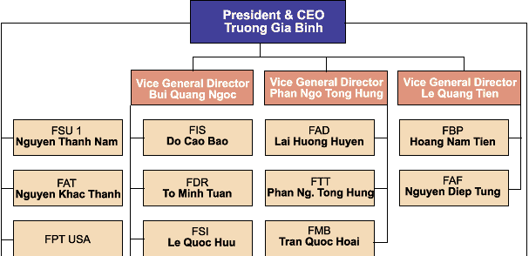
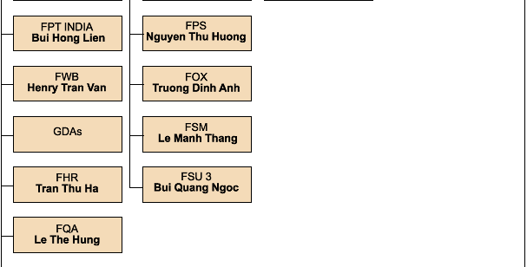
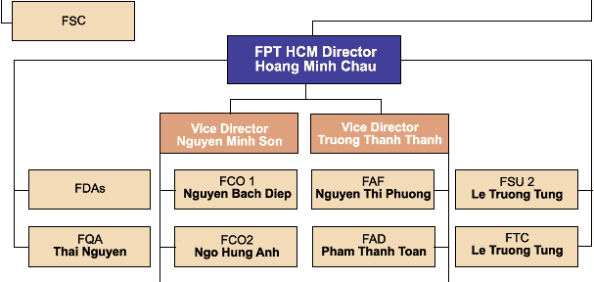
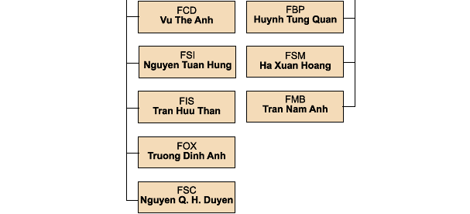

Diagram 3-1:Structure of FPT corporation. Source: FPT official website http://www.fpt-soft.com
IT company must be flexible and should target to project structure. The reason is that software exporting is FPT strategic decision. Softwares cannot be stored like tangible products. They come by projects that appear after signing a contract.
Team 1
Team 2
Team 3

Team management leaders

Diagram 3-2 – project structure for FPT corporation

Team 1, team 2 and team 3 are functional team such as marketing, fianancial, software development or installation. With this model, FPT can complete a lot of project in short time. The reason is in the previous structure, when a project comes and it has to be examined by all the departments. In each department, the project have to wait for time of assigning responsility for someone else. In the new model, when a project comes, it is automatically assigned responsibility for a limited persons. It is also clear that in project model, FPT coporation can re-evaluate its human resource quantity for planned projects. How many programmers are still required, hired more or outsourcing?

AS A CONCLUSION

The right approach to Human Resource Management bring to FPT amazing achievements number one IT company in Vietnam, the most trusted IT company, the company that has the best-sale and best-used software, an image of prestige and fame. But like other giants, when the company is bigger, it will face a lot of inevitable problems: how flexible it should be, diversification or not diversification, … But for me, I believe that FPT corporation will achieve more and more. I come to the end with the last quote from Truong Gia Binh, president and CEO of FPT Corporation “No success can be easily achieved. We can build FPT's style. With sparkling thoughts and excitement, we can gain success. We will lose all if we satisfy with what we have acchived. We have already gained some but there are much more that we have not.”
REFERENCES

- Arie de Geus – “The living company” – Havard Business review, March - April 1997.
- Claudio Fernandez-Araoz – “Hiring without firing” – Havard Business Review, July-August 1999.
- Chris Pike and Mary Grenham – Human Resource Management, The primer – University of Lincolshire and Humberside.
- Derek Torrington and Laura Hall – Personnel Management, a new approach, second edition – Prentice Hall 1991
- Eric Abrahamson – “Change without pain” – Havard Business Review, July - August 2000.
- FPT official website – http://www.fpt-soft.com
- Ian Beardwell and Len Holden – Human Resource Management, a contemporary perspective, second edition – Prentice Hall 1997.
- Mary Grenham – Human Resource Management, The primer – University of Lincolshire and Humberside.
- Morten T.Hansen, Nitin Nohria and Thomas Tierney – “What’s your strategy for managing knowledge?” – Havard Business Review, March-April 1999.
- Niraj Dawar and Tony Frost – “Competing with giants. Survival strategies for local companies in Emerging Markets” – Havard Business Review, March - April 1999
- Stephen P.Robbins – Organizational behaviour, sixth edition – Prentice-Hall International Editions 1993.
- Truong Gia Binh - Recapitulative report FPT 10 years Technology.

