CMPR121 - Exam2 - UMLs

Base/Parent Class
MyUnit
- value: unsigned short
- description: char[100]
+ MyUnit()
+ setValue(int) : void
+ getValue() : int const
+ setDescription(string) : void
+ getDescription() : string const

friend ostream& operator<<(ostream&, const MyUnit&

Derived/Child from (MyUnit)
MyScheduleDate
- Type : char
- description: string
+ MyScheduleDay()
+ setType(newType: char)
+ getType() : char const
+ setDescription(desc: string): void
+ getDescription(): string
+ clearDescription(): void
+ clearDate(): void

friend ostream& operator<<(ostream& , const MyScheduleDay&

Aggregated Class
MyCalendar
- currentYear : unsigned short
- currentMonth : unsigned short
- currentDay : unsigned short
- scheduleDays[12][31] : MyScheduleDay

+ MyCalendar()
+ setCurrentMonth(m: int): void
+ getCurrentMonth(): unsigned short
+ setCurrentYear(y: int): void
+ getCurrentYear(): unsigned short
+ setCurrentDay(d: int): void
+ getCurrentDay(): unsigned short
+ getSDay(m: int, d: int): MyScheduleDate
+ getDaysInMonth(): unsigned short
+ getDaysInMonth(month: int): unsigned short
+ yearToWords(): string
+ getMonthName(): string
+ getMonthName(month: int): string
+ getDayOfWeek(): string
+ updateDaySuffix(): string
+ getSystemDate(): int*
+ updateDaysInMonth(): int
+ isLeapYear(): bool
+ operator++(): MyCalendar
+ operator++(int): MyCalendar
+ operator--(): MyCalendar
+ operator--(int): MyCalendar
+ jumpForward(days: int): void
+ jumpBackward(days: int): void
+ scheduleDate(day: int, month: int,
description: const string&, type: char):
MyScheduleDate
+ unscheduleDate(day: int, month: int):
MyScheduleDate
+ getScheduleDate(month: int, day: int):
MyScheduleDate&
+ getMonthSchedules(month: int):
vector<MyScheduleDate>
+ getScheduleDate(): MyScheduleDate&
+ updateToSystemDate(): void
+ saveToFile(filename: string&): bool
+ restoreFromFile(filename: string&): bool
friend ostream& operator<<(ostream& , const MyCalendar&
Work assignments:
Armando:
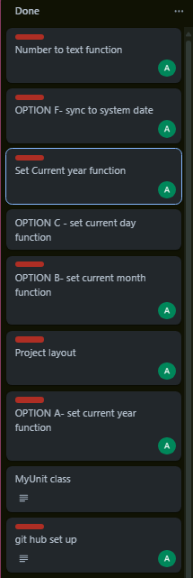
Gemma:
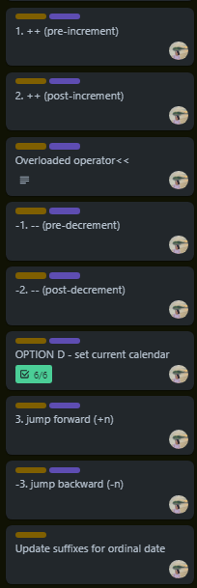
Chris:
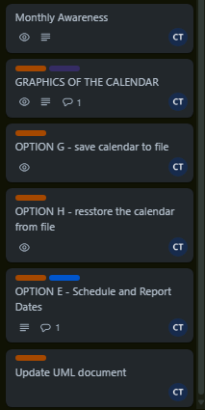

Testing and Debugging:
All 3 contributors

