

**ADDIS ABABA UNIVERISITY**

**ADDIS ABABA INSTITUTE OF TECHNOLOGY**

**CENTER OF INFORMATION TECHNOLOGY AND SCIENTIFIC COMPUTING**

**DEPARTMENT OF SOFTWARE ENGINEERING**

**Musica – Ethiopian Music Service**

Project Proposal

**PREPARED BY:** -

1. Eyosias Samson
2. Gemechu Mohammed
3. Henok Akanaw
4. Immanuel Alemtena
5. Kaleab Belete
6. Kalid Sultan

**ADVISOR**: Mr. Fitsum Alemu

**21/03/2018**

**ACKNOWLEDGMENT**

**TABLE OF CONTENTS**

**ACRONYMS** v

**ABSTRACT** vi

**1.** **INTRODUCTION** 1

**1.1** **Background of Musica** 1

**1.2** **The Existing System** 2

**1.3** **Statement of the Problem** 2

**1.4** **Objective of the Project** 3

**1.4.1** **General Objective** 3

**1.4.2** **Specific Objective** 3

**1.5** **Proposed System** 3

**1.6** **Feasibility Study** 4

**1.6.1.** **Economic Feasibility** 4

**1.6.1.1.** **Developmental cost** 4

**1.6.1.2.** **Operational Cost** 4

**1.6.2.** **Technical Feasibility** 5

**1.6.3.** **Schedule Feasibility** 5

**1.7** **Scope**  5

**1.8** **Methodology** 6

**1.9** **Project Management plan** 7

**1.9.1.** **Time Management plan** 7

**1.9.2.** **Quality Management Plan** 8

**1.9.3.** **Communication Management Plan** 8

**APPENDIX** ix

**REFERENCE** x

# **LIST OF TABLES**

Table 1 – Developmental Cost ………………………………………………………………………………

Table 2 - Operational Cost …………………………………………………………………………………..

Table 3 - Time Table Chart (Gant Chart) …………………………………………………………………………..

Table 4 - Organizational Structure …………………………………………………………………………………..

# **ACRONYMS**

CD: Compact Disk

EIPO: Ethiopian Intellectual Protection Office

CBE: Commercial Bank of Ethiopia

# **ABSTRACT**

It’s not worth noting that Music is a fabric of our lives. It is the universal language that can trigger the feelings of happiness, nostalgia, or even sorrow by speaking to the soul. Not only does Music bring people together it also brings us closer to ourselves and others in that it creates an avenue for empathy and understanding. Music is engraved into human society so much in that it is apparent in every significant event from weddings and funerals to graduation ceremonies formal inaugurations and birthdays.

Now at the 21st century, Ethiopian music is gaining popularity and mixing with cultures around the world. Today’s artists like Teddy afro, Jackie Gossaye, Zeritu Kebede and Jano band are gaining popularity even outside of Ethiopia. Teddy Afros’ new album was ranked #1 on Billboard’s “World Music Charts” on 2017. As these artists grow and become more famous around the world, their songs are getting more valuable in the market. Thus creating a need for stronger methods of copyrighting their works.

# **INTRODUCTION**

## **Background**

Ethiopian music is a reflection of its historical and social episodes. Before the second world war, Ethiopia’s culture was influenced by Muslim countries around its port. Therefore, Ethiopian music before the war was religious and secular which traced back to Saint Yared during the reign of Gabra Masqal. However, during the 20th century, Ethiopia became highly influenced by European culture and thus a whole new genre of Ethiopian music was born. A genre that moved by a free spirit was flirting with Rock and Roll and twist from that era without losing its roots. Swinging Addis, was a very popular during the 1960s and 1970s with the azmari-bets in Addis Ababa. This paved the way for prominent artists like Mahmoud Ahmed (The Ethiopian Elvis), Mulatu Astatke (king of Ethio-jazz) and Tilahun Gessesse (The Voice) to cease the opportunity and revolutionize the Ethiopian music forever.

The fundamental idea behind establishing a copyright law is the encouragement of creativity and protection of an individual’s or a company’s right to ownership of a product. The law gives the owner the exclusive right to sale, rent, transfer, communication and reproduction of the work to the public.

In Ethiopia, intellectual property copyright is a very recent development compared to that of the rest of the world. The origins of copyright protection date back to the Civil Code of 1960. It is the first law that deals with copyright issues in Ethiopia. It discusses about protection of Literary and artistic ownership. However, the code wasn’t thinking of the future. As time went, the need for a specific law dealing with copyright became crucial. [1]

So the Ethiopian Intellectual Property Office(EIPO) was established as an autonomous institution in 2003 to solve the problem. Soon after, the Copyright and Neighbouring Rights Protection Proclamation No.410/2004 was enacted in 2004. It introduced new rights for owners, widened the scope of copyright and related rights, and provided a better mechanism of enforcement and protection of copyright. [2]

However, a study conducted by Ethiopian Intellectual Property Office(EIPO) on the level of copyright infringement at a national level indicates that the infringement rate was 58.6% for the year 2014. Out of this, the infringement rate on musical works was 80.33% far higher than that of films, which was at 49.05%. This constant infringement of intellectual property rights in the music industry affirms that Ethiopia’s music sector is prone to piracy and corruption. [3]

## **The Existing System**

As is the case in most countries, the music industry in Ethiopia uses a system by which it follows these steps. First the artist and the recording studio sign a deal to produce the music. This deal allows the artist to get involved in the production of its music while the studio handles the distribution. To distribute the music, the studio uses various methods like Street to Street sellers, Vehicle stand sellers and other studios. The music is distributed through Compact Disks (CDs) due to their cheapness and availability. Upon release, pirated digital versions of songs spring up in various sites on the internet, partially emanating from the absence of platforms with which users can legally acquire them.

Figure 1 - Existing System

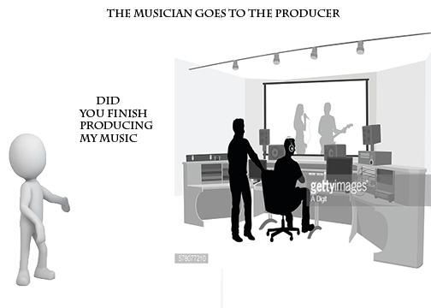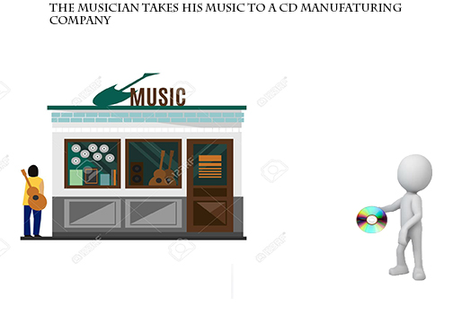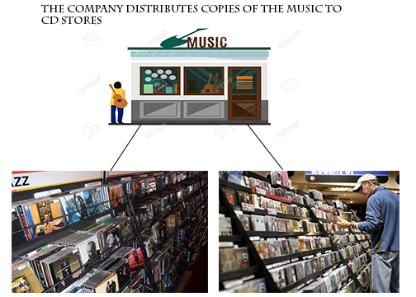

## **Statement of the Problem**

From what we have observed from the existing system the main problem was that the existing system experiences uses CDs. When artists produce a music and the studio releases it through CDs, customers will usually either copy the music to their phones or flash drives by themselves or by local computer stores. These customers will most likely then distribute the copyrighted music to their friends for free without any regard to the copyright laws. This will definitely cause the studio and the artist to lose money every time the customers distribute the songs for free. In addition, the CDs currently in service are getting outdated. There is not enough CD-players that can play the CDs. Also they are vulnerable to become unusable after a period of time the CDs start playing to get scratched.

## **Objective of the Project**

### **General Objective**

The General objective of the project is to develop a system that allows clients to purchase music products and to protect the copyright of the music.

### **Specific Objective**

In order to achieve the general objective, the following specific objectives must be attained:

* Provide a safe environment where copyright laws are protected.
* Establish a transaction space based on the geographical area.
* to reduce the money lost as a result of copyright.
* D

## **Proposed System**

The system we propose tries to circumvent the problems that exist in the current existing system. This project is intended to eliminate the above problems by letting the user have access to the music via his/her mobile phone. This will make the process faster and better. The process will go as follows.

First the user downloads and install the application on the mobile phone. Then the user is required to setup his account by filling in his/her personal information. Soon after, the user is shown the wide variety of music currently available in the system. To download a music, the user is asked to give the password for the bank account in his account. When confirmed, the application downloads the music and the user can now play the music he/she downloaded.

## **Feasibility Study**

## **Economic Feasibility**

### **Developmental cost**

Table 1 – Developmental Cost

|  |  |
| --- | --- |
| **Operation** | **Cost** |
| Employees | 0 br |
| Interviews | 200 br |
| Internet Research | 300 br |
| Food | 400 br |
| Transportation | 800 br |
| Other | 300 br |
| **Total** | **2000 br** |

### **Operational Cost**

Table 2 - Operational Cost

|  |  |
| --- | --- |
| **Operation** | **Cost** |
| Deployment | 0 br |
| Bug fixes (App maintenance) | 677br |
| Web hosting | 1,400 br |
| **Total** | 1500 br |

## **Technical Feasibility**

This system requires a Mobile device running an Android Operating system. This is currently widely available and can even be obtained with ease. Second the system requires a bank account to purchase the music products. Users can use this system with ease because a user only needs to have a technical knowledge of inputting some personal information and browsing for music like any android application.

## **Schedule Feasibility**

As for the schedule, the system is destined to get delivered at the end of the semester. Even if there are several other projects that may hinder our progress, we intend to finish up the project at the designated date by following the proper stages and goals.

**1.7 Scope**

This platform is aimed solely at providing a legal digital music marketplace for the Ethiopian people. Consumers that wish to abide by national copyright laws will be able to legally possess digital formats of their favorite songs. However, this proposed system does not take into account piracy that results from the desire to have a free access to intellectual property. This problem lies in the arena of digital law enforcement and thus not relevant to our proposal. This system is supposed to fulfill these features:

* Allow users to purchase music with Ethiopian currency.
* Allow artists to receive payment for their works.
* Create an ecosystem where both users and artists are both happy.
* By utilizing the new online payment systems developed by the Commercial Bank of Ethiopia, it will create a mobile application that allows for digital music purchases.

## **Methodology**

This project follows a spiral model for the development of the system. We use this model because of the high risk of banking and intellectual property of music. It provides an early indication of unforeseen problems and changes to eliminate errors.

Is the project risky?

Does the customer seek involvement?

What’s the life time of this project?

Size of the project?

Is the requirement dynamic or static?

are our group members experienced?

Do you have a risk expert?

* Customer Communication Stage: -
  + To collect the necessary data for the system, we plan to interview a select number of individuals not more than 2 currently active in the music industry to get a sense of the backroom working mechanism of the music industry. Other than that, there are multiple posts and websites that try to show the problem after conducting multiple interviews. So we can gather some data from those posts.
* Planning Stage: -
  + The data we gathered will include a sense of the cost of distribution of the music products of the existing system. This helps us design a system which can economically benefit the artist and the developers of the system. In addition, we will also perceive an understanding of the level of encryption the system should implement for the money transaction and also for the music after it is downloaded to prevent the sharing of the music through Bluetooth, Universal Serial Bus(USB) and third-party applications like Xender and Zapya.
* Risk analysis Stage: -
  + Because the system is dealing with banking systems and intellectual properties, we will be assessing the risks at every loop of the process. We will list and document the quality assurance to cross check with every product and for ensuring good quality.
* Engineering and Construction Stages: -
  + For the system to be achieved, the team will use a mobile platform architecture i.e. Android to support it. And to insure the copyright is protected we use an algorithm which encrypt the downloaded music not to be found on file manager.
* Testing Stage: -
  + Since we are implementing a spiral model for the development of the system, testing will be made at each loop, there will be a close interaction with the customer to provide a feedback. 

Figure 2 Gant Chart

## **Project Management plan**

## **Time Management plan**

1. **Quality Management Plan**

The quality assurance of this project focuses on the processes used in the manufacturing of the application. In order to assure quality, an iterative quality process will be used throughout the project life-cycle. This iterative process includes assessing and evaluating risk, repeated testing and continuous feedback gathering from users. Quality is planned for and managed through the “Plan-Do-Check-Act” cycle for project execution.

**1.9.2.1. Organization and Responsibilities**

Table 4 - Organizational Structure

|  |  |  |
| --- | --- | --- |
| **Name** | **Role** | **Quality Responsibility** |
| Kaleab Belete | Project Manager  Project Delivery Team | * Documenting customer expectations * Utilizing the expertise of the Project Delivery team to determine the necessary procedures. * Delivering a quality product |
| Kalid Sultan | Project Delivery Team | * Performing an active role in ensuring the customer’s quality objectives are clearly articulated and that the customer understands the professional standards, laws and codes which must be incorporated into the project. * Monitoring the quality of their work. * Keeping the commitment for the completion of their project |
| Eyosias Samson |
| Immanuel Alemtena |
| Gemechu Mohammed |
| Henok Akanaw |

**1.9.2.2. Quality Assurance**

The final system will be reviewed to ensure that the mobile application adheres to the following standards:

* It conforms to the application guidelines stipulated by Google’s play store
* It does not exhibit any errors or crash unexpectedly
* It does not exhibit any user interface glitches
* The user experience is consistent throughout the entire application.
* All graphical assets are aesthetically pleasant and catered to devices with high resolution
* It executes all financial transactions flawlessly and with complete accuracy

**1.9.2.3. Risk Management**

We will list and document the quality assurance to cross check with every product and for ensuring good quality.

Some examples of risk management approaches

* Requirements complete and clear
* Quality assurance approach
* although this risk item will depend on the quality of the software quality assurance itself, the fact that a documented approach exists should limit this risk factor to a Medium rating

1. **Communication Management Plan**

Table 5 Communication plan

| **Type of Communication** | **Method / Tool** | **Frequency/Schedule** | **Information** | **Participants / Responsible** |
| --- | --- | --- | --- | --- |
| **Internal Communication:** | | | | |
| Project Meetings | Telegram, Trello, physical meeting | Twice a week and on events | Project status, problems, risks, changed requirements | Project Mgr. Project Team |
| Sharing of project data | Git | When available | All project documentation and reports | Project mgr.(s)  Project Team |
| Milestone Meetings | Physical meeting | Once a week | Project status (progress) | Project mgr. Sub-project mgr. |
| Final Project Meeting | Physical meeting | Monday | Wrap-up Experiences | Project mgr. Project Team |
| **External Communication and Reporting:** | | | | |
| Project Report | Excel sheet | Monthly | Project status - progress - forecast - risks | Project Manager Sub-Project Managers |
| SteCo Meetings | Teleconference | Monthly |  | Project Manager, SteCo |

# **APPENDIX**

# **REFERENCE**

[1] [3] Music In Africa , <https://www.musicinafrica.net/magazine/copyrights-royalties-and-music-piracy-ethiopia> , 06/03/2018

[2] Addis Standard , <http://addisstandard.com/copyright-protection-in-ethiopia-shining-law-zero-effect/> , 06/03/2018