

**Department of Transportation**

**The Honey Badgers:**

*Marcus Shannon, Will Hicks, Adam Mitchell,   
Jarred Wynan, and Kyle Pirnie*

**Abstract:**

The department of transportation associated with the University of Louisiana at Lafayette has requested a software application be developed. Overall, what has been requested is a smartphone application that will inform users about how many parking spaces are available inside any specifically given parking tower. This application should be available for free so any student may download it from the app store to learn more about parking information on campus. It’s also been requested that all development resources be well developed in such a way that a future development team may also iterate and build on to the existing software.

**Table of Contents:**

* **Introduction**
  + *Scope*
  + *Application Usage*
  + *Capabilities*
  + *Overall Structure of the Software Application(s)*
* **Project Organization**
  + *Project Lead*
    - *Marcus Shannon*
  + *Mobile Application Developers*
    - *Will Hicks*
    - *Adam Mitchell*
  + *Server Side Developers*
    - *Jarred Wynan*
    - *Kyle Pirnie*
* **Lifecycle Model Used**
  + *Hybrid of Agile and Waterfall methodologies*
* **Risk Analysis**
* **Hardware and Software resource requirements**
* **Deliverables - Schedule**
* **Monitoring - Reporting - Controlling Mechanisms**
* **Professional Standards**

**Introduction:**  
 As stated in the abstract above, the department of transportation associated with the University of Louisiana at Lafayette has requested a software application to be developed. The original problem that the software application is to resolve is about getting the number of available parking space(s), in the parking tower, to the user and/or students. After much consideration and a few meetings, the conclusion or solution to this problem would be to develop smart-phone applications for android and iphone. This conclusion was reached due to numerous reasons but the big reason being it’s the cheapest, yet most efficient way of giving this information to the user. It should well noted that this will the initial development of this application and should be well documented for any future development team working on this project.

* **Scope:** For the scope of this project, we will only be concerning ourselves with one specific parking garage but the application will be developed in such a way that it may later be modified to include or have multiple garages.
* **Application Usage:** The core/ideal usage of this application that we will develop would go as follows. Assuming the user has the application installed for his/her device, the user would be in some way, shape, or form needing to park on the University of Louisiana at Lafayette campus. That user would like to not park at Cajun Field and take the bus back to campus. They would prefer to park near their classes to avoid the bus or walking far to class. So the user would open this application real quick to check the current availability of the parking tower(s) on campus. The application would simply display:
  + Name of the parking garage
  + Total number of parking spots in the garage
  + Available number of parking spots in the garage
* **Capabilities:**
  + Be compatible with most modern versions of Android
  + Be compatible with the latest iterations of the iPhone
  + Able to display the relevant information the user is looking for
  + Quickly connecting and synchronizing the relevant information

**Overall Structure of the Software Application(s)**

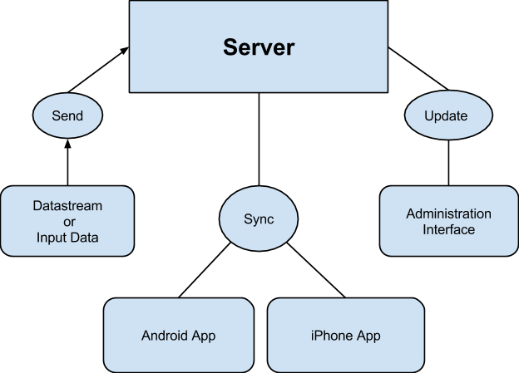

**Project Organization:**

* Marcus Shannon (Lead Developer)
  + Marcus’s main role is to communicate with the customer and lead the rest of the team into coming with a suitable solution for the given problem. This entails drawing up the initial design for the software application, pro’s/con’s of different algorithmic usage, making prediction type calculations on memory/clock-cycle costs, minimizing usage of processor for a robust program, creating & documenting all code based documents, assigning tasks to each individual member in the group to maximize workflow effectiveness, ensuring deadlines are being met by all group members, and will also handle integrating different part of the project. The rationale on why Marcus is designated this position is primarily based on experience. He has lead a number of software development projects while in the Computer Science program for the University of Louisiana at Lafayette. He has experience doing all of the tasks detailed above except for communicating with the customer.
* Will Hicks (Mobile App Developer)
  + Will’s main roles are to help Marcus communicate with the customer and work on the Mobile Application part of the project. This entails researching into the networking aspects of mobile development, GUI’s, IDE’s, documenting all logical/algorithmic parts of the code, and communicating any questions to Marcus about network - communication details with the server.
* Adam (Mobile App Developer)
  + Adam’s main role is to work alongside Will and focus on developing the Mobile Application part of the project. This entails most of what was stated above in Will’s part of the documentation.
* Jarred Wynan (Server Side Developer)
  + Jarred’s main role is to work alongside with Kyle in the development of the server. This entails researching on what is the best way for setting up the server, all coding in dealing with incoming connections, how to handle the queries for information on those connections, and the administrative interface that will be used by the company management to modify/view stored information on the server.
* Kyle Pirnie (Server Side Developer)
  + Kyle’s main role is to work along side with Jarred in the development of the server. This entails all of the details as stated above in Jarred’s part of the documentation. He’ll also liase with the necessary people in order to secure the hardware environment requirements and platform requirements for the software to run on.

**Life Cycle Model:**

* **Hybrid of Agile and Waterfall methodologies:**
  + The lifecycle model we will be using for this project is a hybrid of Waterfall and Agile methodologies. The reason/rationale for making this choice is firstly, based on the experience level of the development team. Most members of the development team do not have experience in mobile application development or server side development. Therefore this methodology was chosen so we can have a higher overview of the project by using some of the base idea’s behind the waterfall method. However most people on this team do have a wide variety of programming/ development experience hence we don’t need to document into too deep of detail before we start the implementation of the application. Therefore we will be using most of the methodologies that agile offers like iterative development and showing the customer step-by-step(weekly) of what’s going on with the product. Though one major idea from the waterfall methodology we will be making use is the idea of deep documentation inside the code documents. The reason for this is because a future development team may/possibly be building/iterating on the code base we are building from scratch. Therefore it will be beneficial to write well explained/documented code so they may understand the full extent of the code base and application.

**Risk Analysis:**

Risks associated with our project include:

1. Risk: Team member absentism for various reasons or losing a team member entirely.

Probability: low

Mitigation: Crosstraining were necessary/possible. Regular communication between functional areas and good documentation.

1. Risk: There is a change requested by the client which comes late and has wide ranging implications.

Probability: medium

Mitigation: Appropriately frequent updates and contact with client to ensure that no surpises come our way.

1. Risk: We take on more work than we can do in the time allotted.

Probability: medium

Mitigation: Careful management of expectations of both the client and the team. Prioritization of project goals into must haves and stretch goals.

**Hardware and Software Resource Requirements:**

Hardware:

* Development machines - CMPS 106 lab + personal pcs.
* Production machines - new virtual server environment or a directory on existing fileserver.

Software:

* IDEs for phone apps development
* small SQL server or potentially even JSON or text files.

**Deliverables, Schedule:**

|  |  |  |
| --- | --- | --- |
| **What** | **Who** | **Time Estimate** |
| Server Side components - datastore, interfaces with input/output, and a web frontend/reporting functionality. | Jarrod / Kyle | 2-3 weeks |
| Mobile app development | Will / Adam | 2-3 weeks |

**Monitoring, Reporting, and Controlling Mechanisms:**

Reporting will be via informal reports to the project manager and other team members as necessary and the team will also have formal meetings regularly. Logs by all team members will be kept as we progress through project checkpoints and goals.

**Professional Standards**

Professional conduct regarding treatment of fellow team members will be adhered to at all times. The following guidelines for professional standards will be used:

* On the first occurrence of unacceptable behavior, determine the circumstances involved, resolve the problem, and document the event in the meeting minutes.
* On a second occurrence, notify the instructor of the problem. A meeting will be set up to evaluate the situation and resolve the problem.
* On a third occurrence, again notify the instructor of the problem. A meeting will be set up to evaluate the situation and resolve the problem. At this point, the team will have the *option* of removing the team member. If removed, then the team member receives a pro-rated grade based on the number of weeks they have participated in the group.

Examples of unacceptable behavior may include not delivering on time, delivering poor quality work, missing team meetings, being unprepared for team meetings, disrespectful or rude behavior, etc. Reasons such as "too busy" or "I forgot", or "my dog ate my design model" are unacceptable.

Valid reasons that must be considered include those listed for obtaining an incomplete standing in a course (illness, death in the family, travel for business or academic reasons, etc.)