Timed Final State Machine

Abstract syntax
In this section we explain how a DSL made in Ecore can be equipped with the Timed Final State Machine (TFSM) Model of Compuation (MoC). First, the abstract syntax of the DSL must contain the information needed by the MoC. Here we consider one possible metamodel of TFSM. A TFSM is composed of set of States among which an initial state. Each state can have a set of Transitions, which owned a Guard. A guard can be specified by a FSMEvent reception (EventGuard) or by a duration relative to the entry in the incoming state of the transition (TemporalGuard). The duration of a temporal guard is measured on the reference clock owned by the TFSM (FSMClock). A transition can also generate a set of events.
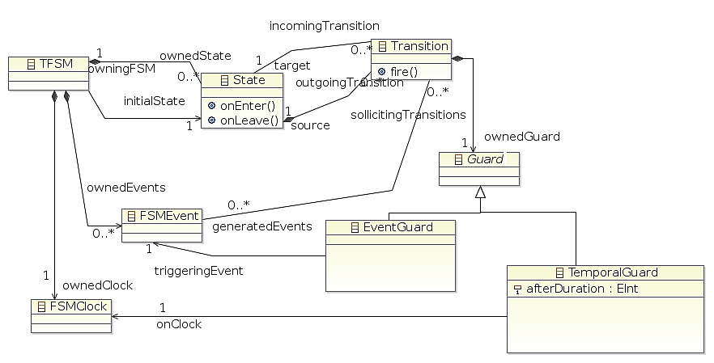Figure 1: One possible metamodel for TFSM

Model of Computation
A model of computation specifies the order under which the actions and events of a DSL are considered as correct. Here the terms “actions and events” are used in a broad sense.
TFSM MoC is based on FSM whose informal description is the following:
A state is a description of the status of a system that is waiting to execute a transition. A transition is a set of actions to be executed or of events to send when a condition is fulfilled or when an event is received. We say a transition to be fired when its condition is respected and when its source state is the active state. When a FSM is started, the initial state is active. Then the active state is the target of the last fired transition. In some finite-state machine representations, it is also possible to associate actions with a state:
- Entry action (onEnter()): performed when entering the state,
- Exit action (onLeave()): performed when exiting the state.

The Timed FSM model of computation just specify that a possible condition on a transition is the relative time elapsed since the entry in its source state. Of course it can also be the reception of an event like in FSM.
This description has many drawbacks. First it is difficult to find it in a reference document so that it is a version based on FSM that has been extended by me to reflect as much as possible my understanding of the TFSM semantics. Second, the description is clearly informal and lack many choices, mainly concerning the fine synchronization. For instance, what append if an event occurs at the exact same time than the entry into a state ? Should the transition be fired or not ? This means that different tools can implements different semantics of TFSM depending on the language, the developper afinity, etc. To make this MoC explicit, we use ECL.
The first step consists in equipping the DSL with meaningful events, possibly related to some DSL concepts. These events are the ones whose relative evolutions is restricted by the MoC. In the TFSM case, we need to explicit the events presented in Figure 2.

Plutot mettre du CallEvent
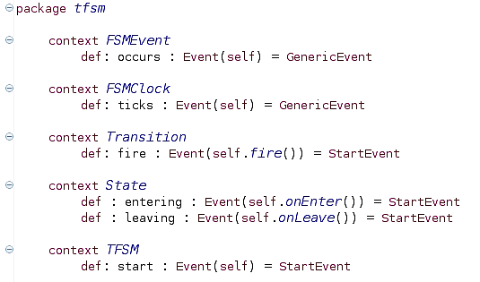Figure 2: Explicit definition of the events used by the MoC on the DSL metamodel
First, we add two intuitive events: an FSMEvent occurs and an FSMClock ticks. The reader can note that, it is not because a metaclass is called event that we should assume it automatically have an “occurs” semantic event attached. Here, this association is explicit. Such specification means that each instance of the FSMEvent and FSM Clock metaclass will be respectively equipped with the occurs and the ticks event. These events are directly linked to the instance of the metaclass. Finally this event has no unformal meaning (i.e. it is a generic event). All Transition instances are equipped with a fire event. This event is linked with the fire() operation of the metaclass. Additionally, the event is unformally a CallEvent, meaning that the occurrence of such event is expected to call the linked operation.

