1. open MS SQL.

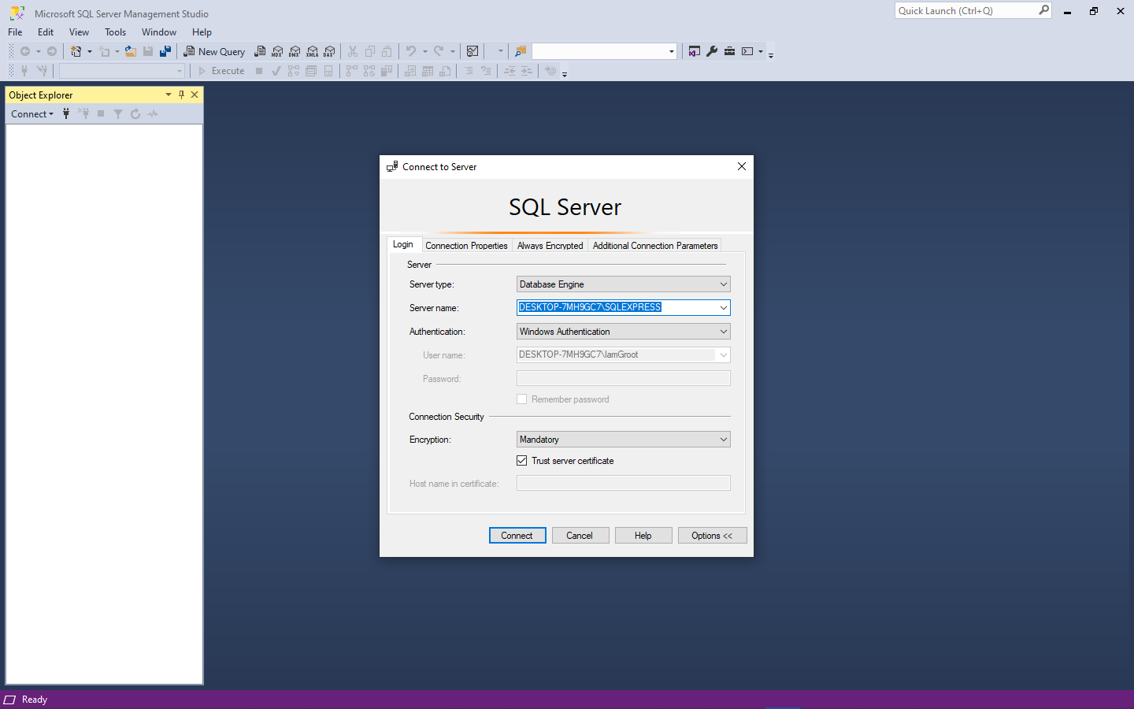

copy the server’s name for later use.

2. add database name it "InventoryDB".

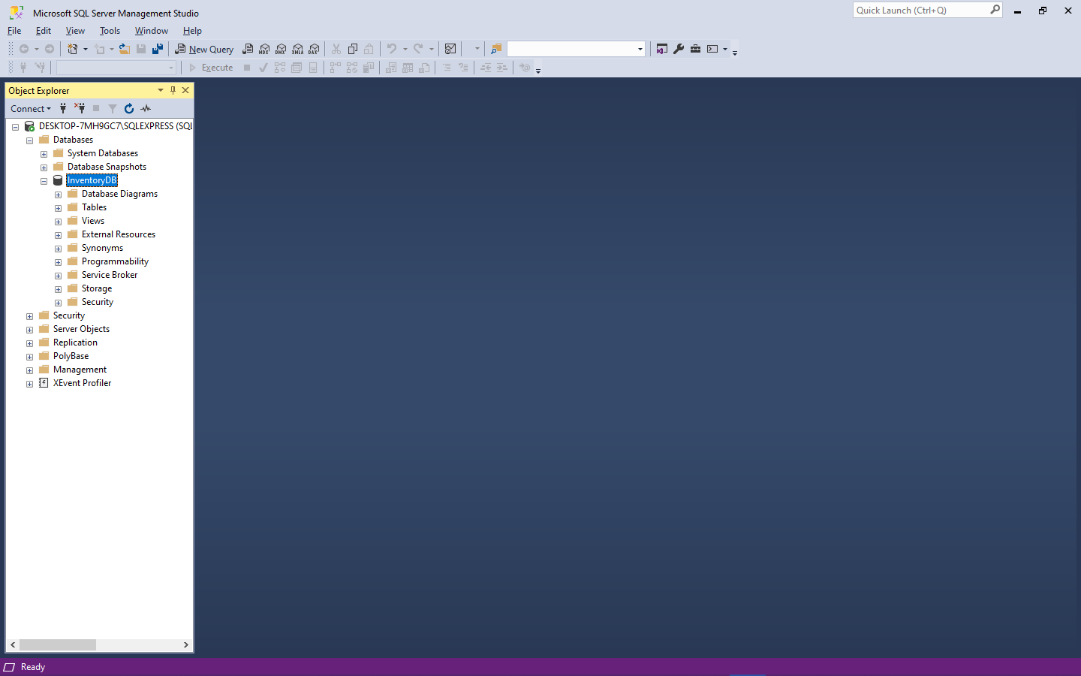

3. create new query and copy paste the DB.sql and execute it.

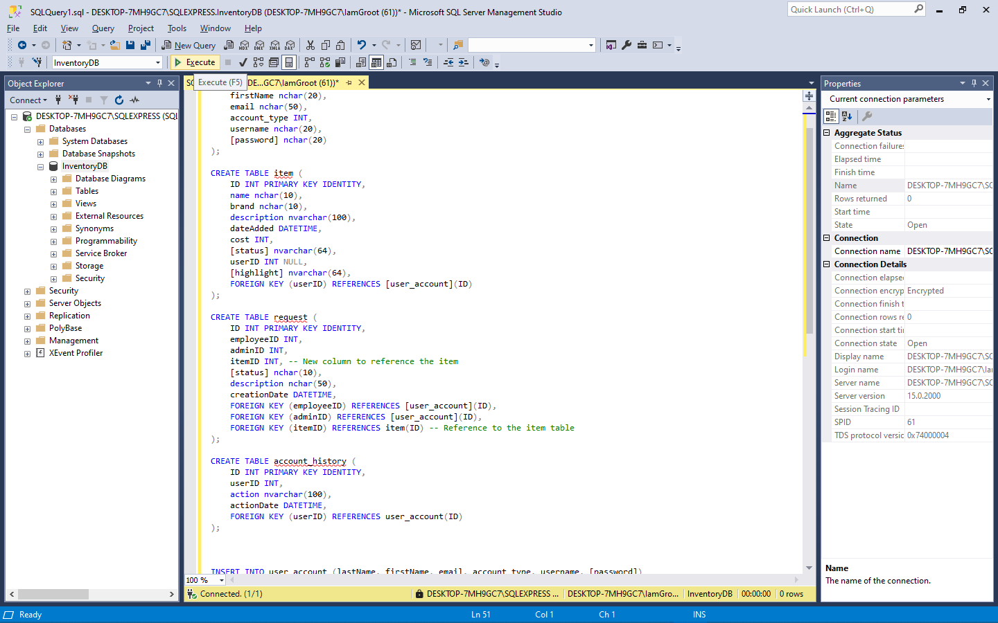

4. go to the visual studio 2022 and load the .sln file.

5. after loaded of the project go to view option and click server explorer.

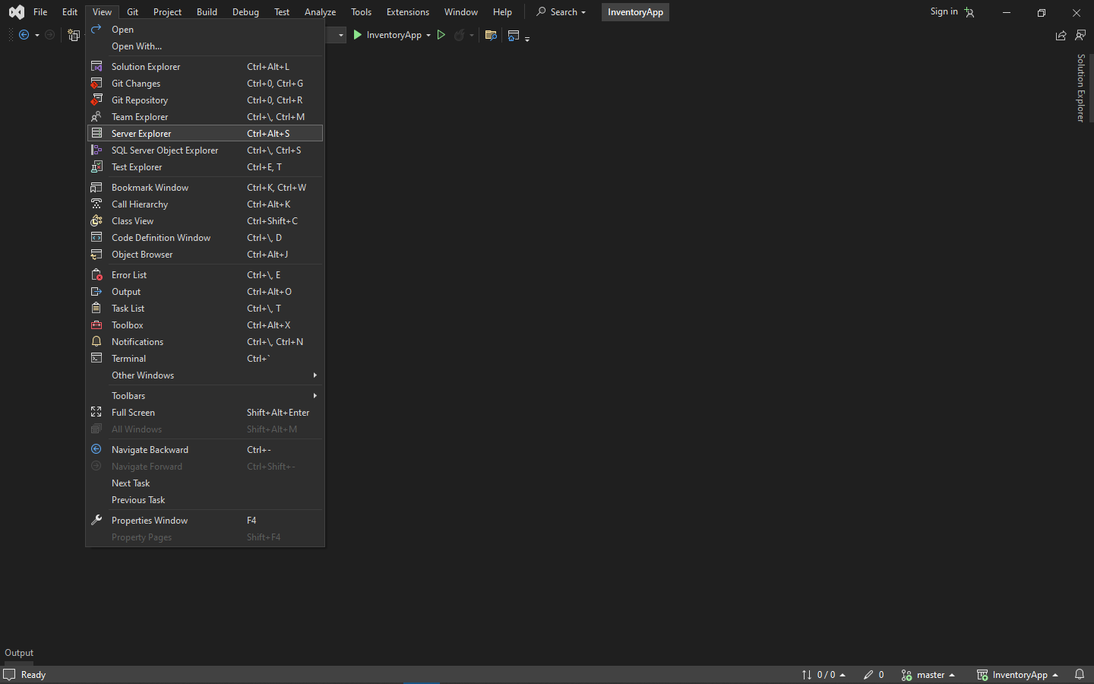

6. click the “connect to database” get the server name of ms sql.

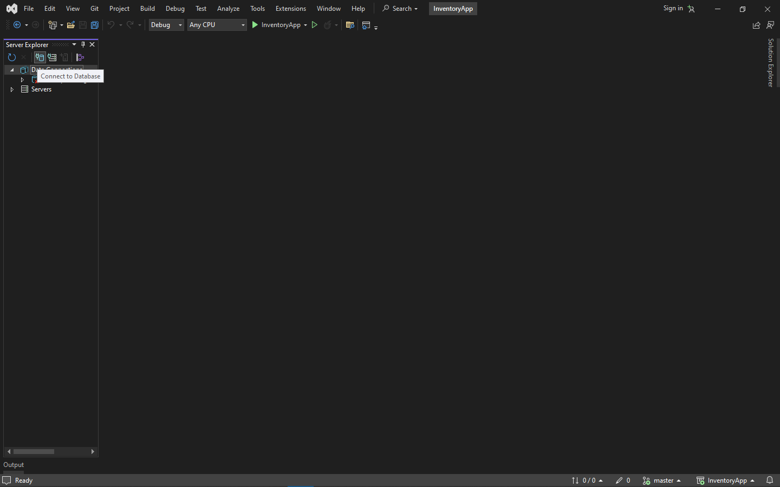

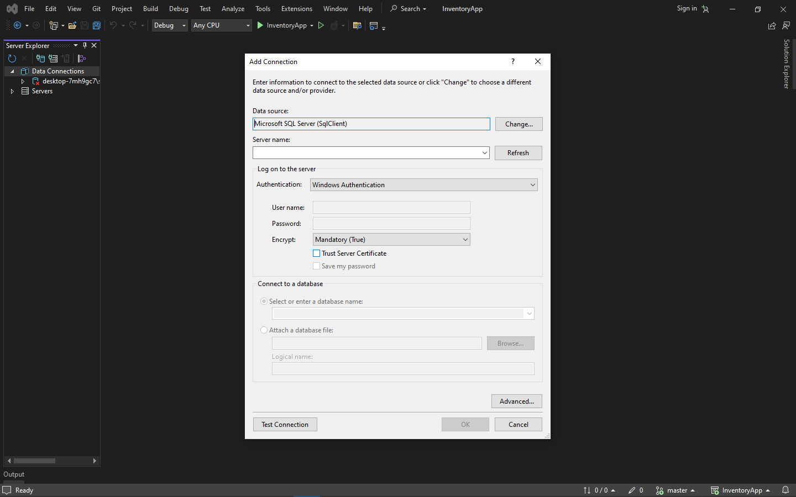

7. copy and paste the server name and check the Trust server certificate and select your database “InventoryDB”.

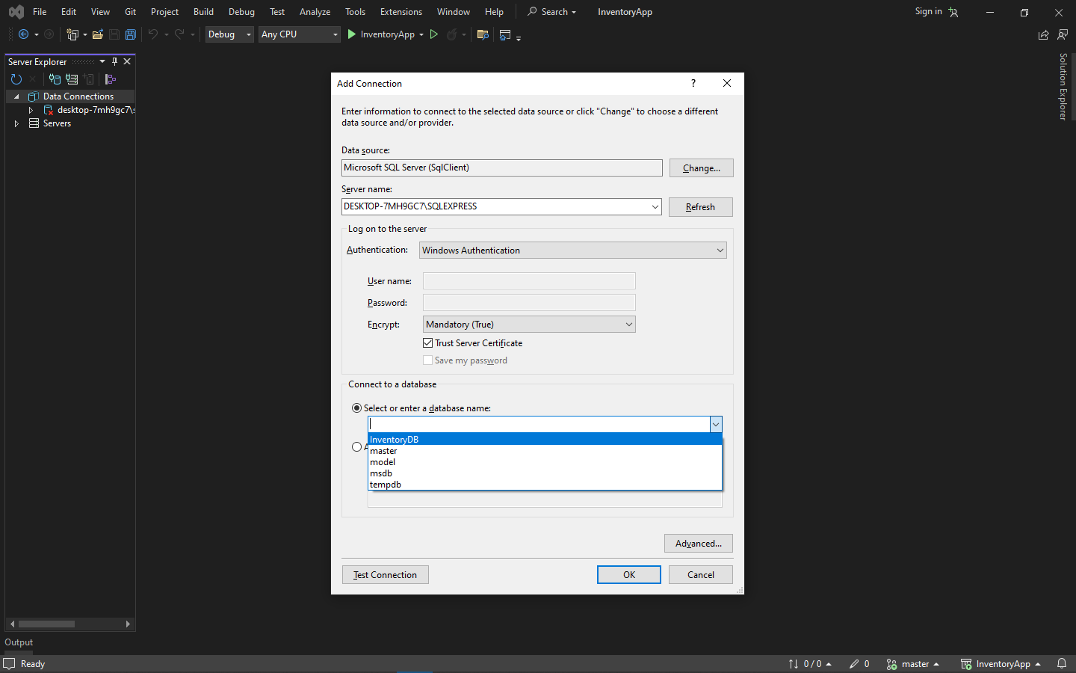

Test Connection if goods all work. Then click ok.

8. Right click to the server and click properties.

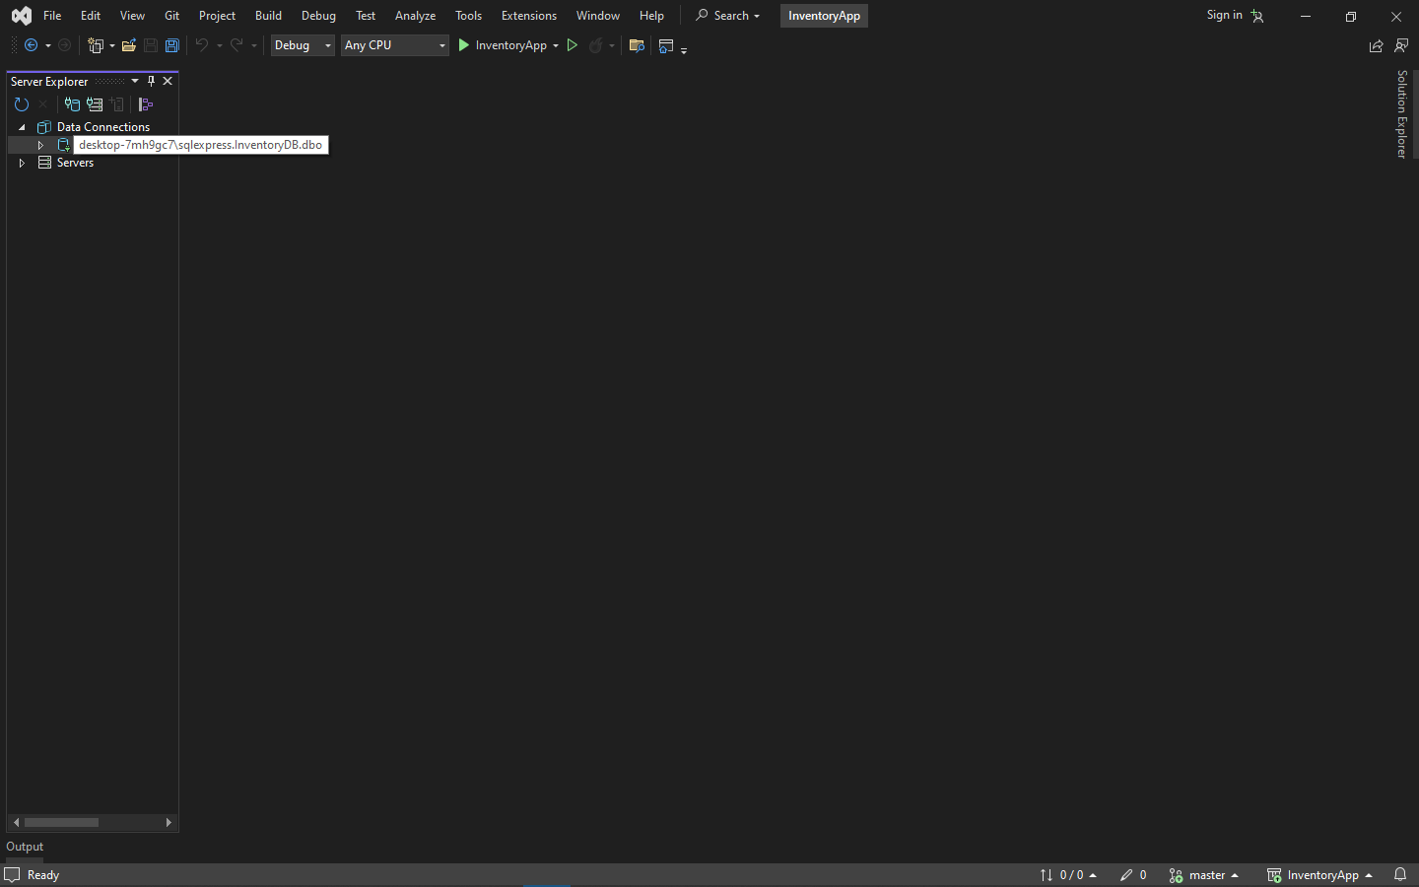

9. Copy the connection string

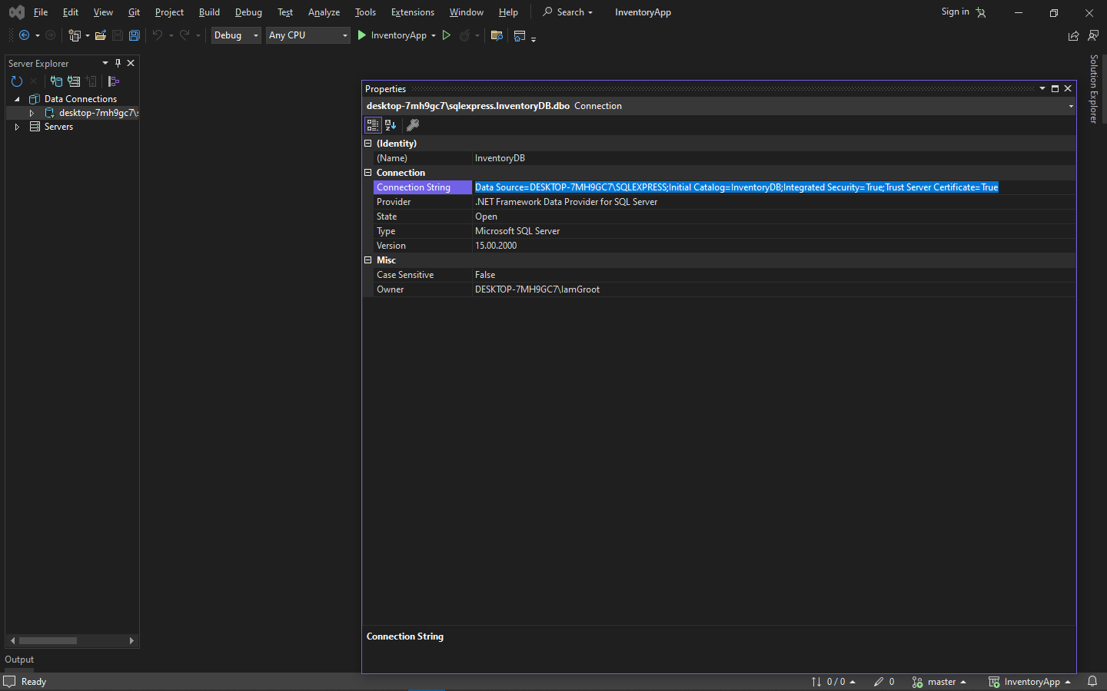

10. go to solution explorer and navigate to DAL folder and click the DatabaseManager.cs

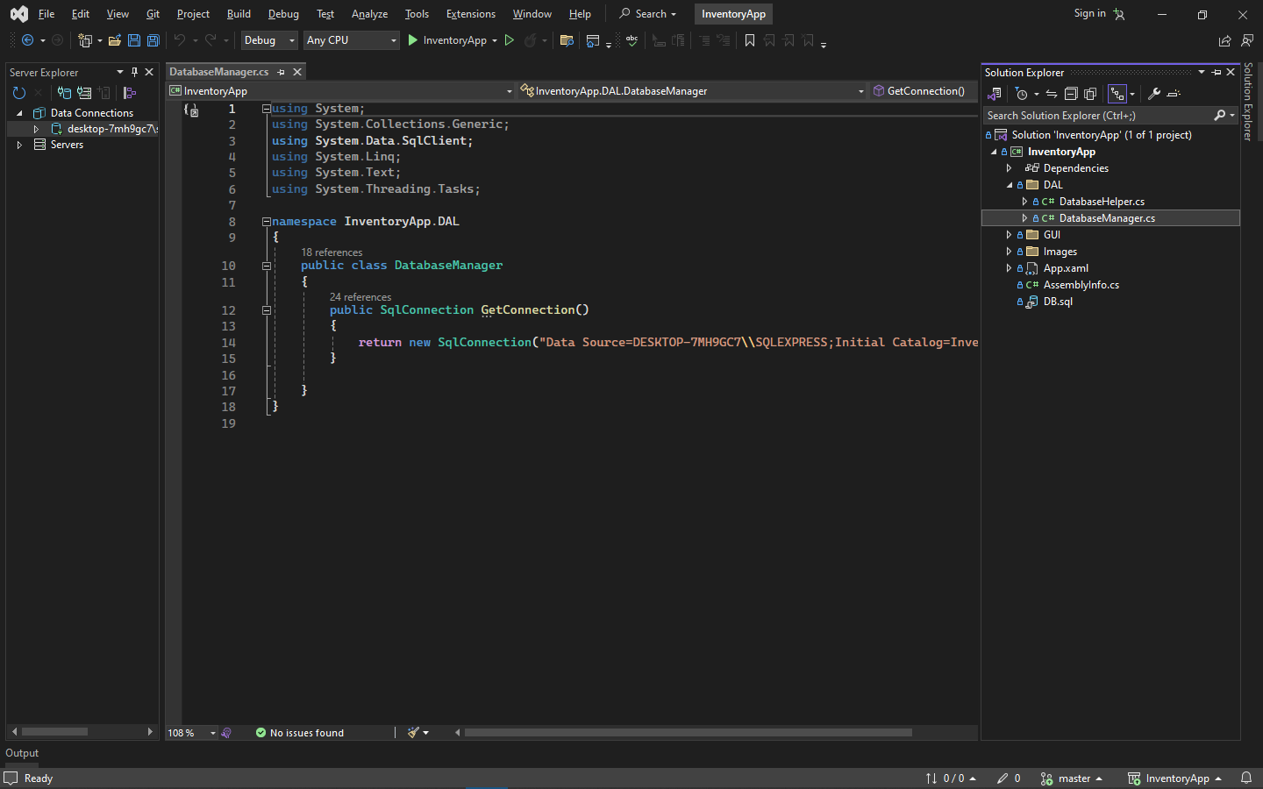

11. Copy the connection string in the sqlConnection.

