Towards Software Rejuvenation
via a Multi-Agent Approach

Heliomar K. da R. Santos João F. N. Pimentel Viviane T. da Silva Leonardo G. P. Murta
Instituto de Computação (IC) – Universidade Federal Fluminense (UFF)
Rua Passos da Pátria, 156, Bloco E, 3º andar
São Domingos, Niterói, RJ 24210-240 – Brazil
Phone: +55 (21) 2629-5665/5666
{hkann, jpimentel, leomurta, viviane.silva}@ic.uff.br

ABSTRACT
Usually, development teams devote a huge amount of time and effort on maintaining preexisting software features. However, because many of these maintenances are not planned, the software tends to degrade over time, causing side effects mainly on its non-functional requirements, such as reusability, understandability, and maintainability. Thus, this paper proposes the continuous monitoring of some quality attributes of the software through metrics and the execution of automatic perfective maintenance (i.e., refactorings) to promote its rejuvenation in response to previously detected anti-patterns or bad smells. Our approach was evaluated through an experimental study. This study found evidences that automatic software rejuvenation is possible and that some refactorings are better suited to specific quality attributes..
Categories and Subject Descriptors
D.2.7 [Software Engineering]: Distribution, Maintenance, and Enhancement – enhancement, Restructuring, reverse engineering, and reengineering.
I.2.11 [Artificial Intelligence]: Distributed Artificial Intelligence - Coherence and coordination, Intelligent agents, Multiagent systems
General Terms
Management, Measurement, Design.
Keywords
Software Aging, Refactoring, Metrics, Multi-Agent Systems.
- INTRODUCTION
Software development is different from the development of other products [13]. For instance, to manufacture software, it is necessary just a CD burn or a deployment procedure on a server. This is certainly cheaper and simpler than the manufacture of cars, houses, and agricultural products. However, due to the easiness of the software manufacturing process, software evolution and maintenance tend to be more frequent if compared to physical products.
This scenario lead to a challenge: how to conceive robust software architectures that are able to embrace change, supporting consecutive evolutions, requirements changes, and other modifications? Although there are several guidelines in this direction [8][40][7][37], it is still difficult to foresee software architectures that can be easily adapted due to the evolution of software requirements. Several factors make software evolution difficult or expensive, such as:
- Changing technologies: The cost for team training and infrastructure maintenance of legacy technologies may become too high if compared to learning and adopting new technologies, due to the size, complexity, and lifetime of the software.
- Labor turnover: During the lifetime of a successful software, people get retired, fired, hired, and, in some situations, the original development team is completely replaced by a brand new team, leading to loss of organizational memory.
- Tight Schedule: when software is being developed and maintained under pressure, usually due to poorly estimated deadlines, time to market suppresses quality, causing technical debts [18] in the product.
These factors altogether, among others, contribute over time to degenerate software architectures, even if best practices are in place. The resulting effect is that after patching a software product for a long time, the incorporation of new features becomes harder [33]. This is the most visible result of software aging [32].
The usual strategy to fight software aging, besides applying the previously cited guidelines during construction, is performing perfective maintenance from time to time. As defined in [17] “Perfective maintenance provides enhancements for users, improvement of program documentation, and recoding to improve software performance, maintainability, or other software attributes.” However, perfective maintenance usually demands high product knowledge and high effort to be performed, and cannot be performed in parallel with other development activities due to difficulties in merging structural changes [25]. These requirements for performing perfective maintenance go against the above-mentioned factors (i.e., labor turnover and tight schedule), forcing companies to postpone perfective maintenance indefinitely.
Therefore, the goal of this work is to alleviate the precocious aging of software, improving the status of software quality attributes. To reach this goal, we propose a novel approach, named Peixe-Espada, which adopts a Multi-Agent System (MAS) during idle development time to autonomously perform perfective maintenance in the software product without burdening the development team. It is important to notice that our approach is intended to companies that adopt a usual work cycle of, for example, eight hours per day, leaving the computational resources available during the rest of time. Our approach exploits this fact as an opportunity of using idle computational park to perform perfective maintenance. This strategy also contributes to the previously discussed problem of merging structural changes because in this context there is no parallelism with development tasks. The use of computational resources during idle periods is not new. For example, initiatives like World Community Grid [16] aim at finding cure for diseases in a distributed way, running on idle PCs of regular users. However, the exploitation of this opportunity in Software Engineering is rare (among the few exceptions we can cite the Hudson [39] continuous integration software). Usually scripts are scheduled to run overnight on servers, but the development PCs are shutdown during this period.
An additional motivation is the possibility of extract knowledge about refactorings and quality attributes as also show the changes of metric values about each particular project. In the end, make patterns among these properties in different contexts of software environment development.
PARÁGRAFO SOBRE O ESTUDO
The rest of this work is organized as follows: Section 2 presents the background of our work. Section 3 introduces our approach, showing in depth how we can reduce the premature aging of software via the adoption of a MAS. Section 4 shows some experimental studies performed to evaluate our work. Section 5 describes the related work, contrasting and comparing to our work. Finally, Section 6 concludes the paper summarizing the contributions of our approach and discussing some limitations and future works.
- BACKGROUND
This session presents the routine practices of development teams, contextualizing the reader to specific terms used throughout this work regarding some key concepts about: (1) Software Configuration Management, more specifically Version Control System; (2) Refactorings and some Design Patterns;

Software Configuration Management
Software Configuration Management (SCM) is an important subarea of Software Engineering, which intends to provide some level of control over software evolution [10]. To reach its goal, SCM is divided into three complementary systems [28]: (1) Version Control System (VCS); (2) Issue Tracking System; and (3) Build and Release Management Systems. These systems can be supported by tools or run manually.
The use of SCM is indispensable to professional software development. It can be observed in maturity models, such as CMMI [8] and MPS.BR [40], which introduce this requirement in their initial levels, respectively, level two and level F. For this reason, our approach assumes that at least VCS are in place. Therefore, the definition of some basic concepts regarding VCS is necessary.
The usual working cycle performed by development teams that use VCS (more specifically, a centralized VCS) comprise the following tasks:
- A developer arrives at work and needs to make changes in a specific project, but the most recent version of the source code is in a VCS repository. Hence, the developer has to populate a local workspace with a specific version from the repository (checkout operation).
- The developer performs the desired changes in the local workspace and decides to share it with the rest of the team. Thus, the developer has to send the current workspace version to the VCS repository (checkin operation). This operation is also known as commit in many VCS tools.
- Finally, other developers that are working in the same project may want to update their workspace with the current version of the VCS repository. To do so, they can use the update operation, which merges the repository version into their local workspace.

Refactoring
As defined by Martin Fowler [12]: “Refactoring is the process of changing a software system in such a way that it does not alter the external behavior of the code yet improves its internal structure”. The main motivations to perform refactorings are to improve the understandability, the flexibility, and, consequently, the maintainability of a source code [18]. Due to that, the process of refactoring consists of removing duplicate codes, simplifying conditional logic, and making the source code cleaner [12]. Other 12 motivators are discussed by Yi Wang [47] where 6 intrinsic motivators (Responsibility with Code Authorship, Self Esteem, Self Efficacy, Achievement Needs, Social Norm and Unconscious Habit) and other 6 external motivators (Threats of Punishment, Perceived Value, Estimated Efforts, Recognitions from Others, Refactoring as Assigned Tasks and Other Organization Related Factors) are found in a research with professional developers and managers.
A refactoring can be as small as renaming a method or as big as unifying two hierarchies in an object-oriented software, demanding from seconds to months or even years to complete. Design patterns [14] are frequently used to support refactoring, but refactorings are not necessary guided by design patterns. In this sense, Kerievsky [18] emphasizes that a refactoring should complete itself at the time the source code met the project needs and not when a design pattern is achieved.
Methodologies as XP [5] and methods as Test-Driven Development [6] preach the constant need of refactoring. A common procedure in these methodologies and methods is: (1) write a test case for a specific requirement; (2) write a source code which is compliant to the test; (3) refactor the source code keeping it compliant to the test; (4) continue the cycle according to new requirements to be implemented, returning to step “1”. Thus, refactoring is increasingly becoming a fundamental activity in software development.
Several researches [21][2][15][19] indicate that specific characteristics in the source code may accuse the need of some refactoring. These characteristics are usually called bad-smells [12]. According to this definition, it is possible to notice that a refactoring is closely related to a symptom, which is usually a bad smell. For example, in the case of the “Encapsulate Field” refactoring [12], a public attribute is searched throughout the source code and when detected, it triggers the transformation of the public attribute into private, introduces getter and setter methods, and changes the read and writes references into calls to the getter and setter methods. 1 shows this refactoring divided into two phases: (1) in the search phase the symptoms and the transformation targets are found; and (2) in the apply phase the transformation is performed and the references are updated.
In this context, suppose that at the end of the day a developer realizes that an attribute is public needlessly, and decides to encapsulate it. Currently, most integrated development environments (IDE) help to encapsulate fields, but even this simple refactoring raises the following question: (1) Are there other public attributes in the source code that may need the same refactoring? (2) Are there other symptoms in the project that may lead to other kinds of refactorings? (3) Should the developer spend time and effort solving such kinds of non-functional problems? 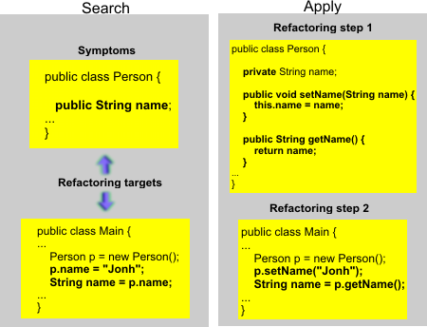
Figure 1: Refactoring pattern
The answers to these questions motivate the development of an automatic approach for source-code refactoring. This approach would be more effective in finding other attributes with the same problem and fixing the problem, finding other kinds of refactoring symptoms, and performing the correspondingly refactorings, and preserving the developer time to other more noble activities related to the problem domain.
- Peixe-espada Approach
Our work proposes the use of a distributed multi-agent system to manage idle machines and use their computational power to perform improvements over the existent source code. Thus, we use quality attributes to allow managers specify how the software should be improved. An orchestrator agent is created for each quality attribute. The main goal of an orchestrator agent is to improve its respective quality attribute for a particular project. To do so, orchestrator agents delegate tasks to worker agents, which are responsible to execute the necessary operations to obtain the source code, detect refactoring symptoms, perform the refactorings in the source code, and evaluate the changes. The orchestrator agents run on a server while the worker agents run on the developers’ computers during idle time, usually at night. Figure 2Figure 2: Approach. summarizes our approach. It shows the workflow to complete a successful rejuvenation cycle. We consider a cycle successful when the Current Configuration is improved in terms of the chosen quality attribute at the end of the cycle. Otherwise, the cycle is considered unsuccessful and the Chosen Configuration is discarded.
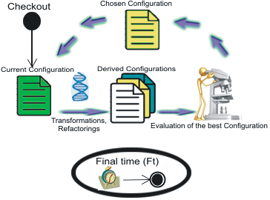
Figure 2: Approach.
As discussed before, the work agents are scheduled to execute during idle periods of the developers’ computers. During their execution, they communicate with the orchestrator agents to receive instructions about their tasks. The steps to complete a successful work cycle are: (1) Initially, a worker agent has to checkout the source code, materializing the Current Configuration in its workspace; (2) after that, they ask to a orchestrator agent a sequence of refactorings and perform these refactorings in the Current Configuration, generating Derived Configurations; (3) subsequently, the Derived Configurations are evaluated and the best Derived Configuration is chosen; and (4) finally, if the best Derived Configuration is better than the Current Configuration, it replaces the Current Configuration and the cycle resumes.
At the end of each cycle, the work agents inform the results (i.e., success, failure, or indifference) to the orchestrator agent, who stores this knowledge to support the multi-agent system in further refactorings. It is important to notice that this knowledge represents the learning ability of the multi-agent system. It allows relating which refactorings have higher probability to improve each specific quality attribute, alleviating the generation of useless Derived Configurations in subsequent executions.
If no refactoring improves the Current Configuration in terms of a specific quality attribute, the work cycle ends. Moreover, if the developers’ computers are not idle anymore (i.e., the Final Time is achieved), the worker agents report the performed changes to the orchestrator agent and finish their work. All changes are committed to a branch in the VCS repository, thus the development team can incorporate the changes they judge relevant.
The next subsections detail the multi-agent system structure (section 3.1), the roles and goals of each agent type (section 3.2), and how the agents reach their goals (section 3.3).

Multi-Agent System Structure
As previously discussed, the orchestrator agent runs on a remote server and the worker agents run on the developers’ computers. The orchestrator agent is bound to a quality attribute and to a software project. On the other hand, each worker agent is created on a different developer’s computer, is configured with a specific allowed running period (i.e., the computer idle time), and is bound to an orchestrator agent that it should obey.
One of the key aspects of our approach is how the agents collaborate as a distributed system to reach their goal. Due to the complexity of the steps involved in the software rejuvenation, parallel work is fundamental. Our MAS allow three different strategies for parallel work: improve different projects in parallel, improve different quality attributes in parallel, and speed up the improvement of a specific quality attribute of a specific project.
Usually a software house develops different products. With our approach it is possible to improve different projects at the same time, spending part of the total idle computation power for each project. For example, in a setting with 5 developers’ computers, up to 5 projects can be improved in parallel. Each project will have an individual orchestrator agents running on the server, bound to at least one worker agent running on each developers’ computer.
On the other hand, a Project can be improved according to different quality attributes. In our approach, different worker agents can work in parallel to improve different quality attributes of the same project. In other words, this strategy dedicates part of the total idle computation power to improve each quality attribute of a given project. For example, in a setting with 5 developers’ computers, up to 5 orchestrator agents can be configured to improve different quality attributes, and at least one worker agent can be bound to each orchestrator agent.
Finally, different worker agents can work for the same orchestrator agent. In this strategy, each group of worker agent receives a distinct refactoring sequence, but all the sequences aim at improving the same quality attribute of the same project. At the end, the improvements of each group are committed in separated branches. For example, in a setting with 5 developers’ computers, an orchestrator agent can be configured to improve a specific quality attribute of a specific project, and 5 worker agents can be bound to this orchestrator agent.
It is important to notice that these strategies can be combined to meet specific software rejuvenation goals. For example, a company with 32 developers responsible of 4 mainstream products can configure Peixe-Espada with 8 orchestrator agents. Each pair of orchestrator agent can be responsible for improving two different quality attributes of the same project. Moreover, 4 worker agents may be bound to each orchestrator agent. This way, 32 worker agents will be working in parallel to improve 2 quality attributes of 4 different projects.
Every agent is composed by roles, plans, and goals. To achieve a specific goal the plans are composed by actions. The next sections show in depth our multi-agent system, explaining the plans of the agents, how they are organized in actions, and how the communications among agents occurs.

Agents Roles and Goals
As previously discussed, our multi-agent system is composed by orchestrator agents and worker agents. However, the worker agents are in turn specialized into four roles: local manager, measurer, refactoring, and configuration manager. Thus, each worker agent role is responsible of a pre-determined group of cohesive actions, respectively, the local coordination of the remaining agents in the developers’ computer, the measurement of quality attributes, the application of refactorings, and the interaction with the VCS repositories.
As shown in Error: Reference source not foundError: Reference source not found the agents follow a predefined hierarchy. The only worker agent role allowed to communicate with the orchestrator agent is the local manager. The orchestrator agent works as a global manager of the whole MAS, while the local manager agent works as a local coordinator in a specific developer’s computer. Orchestrator agents are located on the remote server, and their goals are to improve the previously registered quality attribute (i.e., Reusability, Flexibility, Understandability, Functionality, Extendibility, or Effectiveness) of a project. They also manage the knowledge about the relationship among refactorings and quality attributes. This allows a better refactoring sequence suggestion to worker agents because it prioritizes the refactorings that have proven to be more successful to improve a specific quality attribute.
In contrast, local manager agents are the interface between other agents and the orchestrator agents. They locally manage others worker agents, acting as a local coordinator. Their goal is to keep other worker agents harmoniously collaborating on a specific developer’s machine. The measurer agents are responsible for measuring the quality attribute of specific configurations of the project. They are employed before and after a specific refactoring is performed, to allow deciding in keeping or discarding the results of a refactoring. The refactoring agents are specialized in finding symptoms related to each automated refactoring and applying the refactoring. Their goal is to apply refactorings without breaking the project source code. Finally, the configuration manager agents are responsible for interacting with the VCS repository. Usual actions of this agent include checkin, checkout, create branch, and revert modifications.

Agents Plans and Actions
According to the BDI architecture [34], agents have roles, plans, actions, beliefs, and goals. Based on this architecture each agent role of our MAS has its own plans and actions. The Error: Reference source not found allows the general accompaniment of each action described in this section. This figure presents the interaction among these five agents represented in a UML activity diagram. This is not a full diagram, it is only the summary to show the minimum work cycle in Peixe-Espada.
In an usual operation cycle, the orchestrator agent performs the following actions: (1) to register the worker agents; (2) to choose the project repository URL to checkout; (3) to provide the metric tools to calculate each quality attribute; (4) to choose the execution order of the refactorings; and (5) to store information about success, failure, or indifference regarding each performed refactoring.
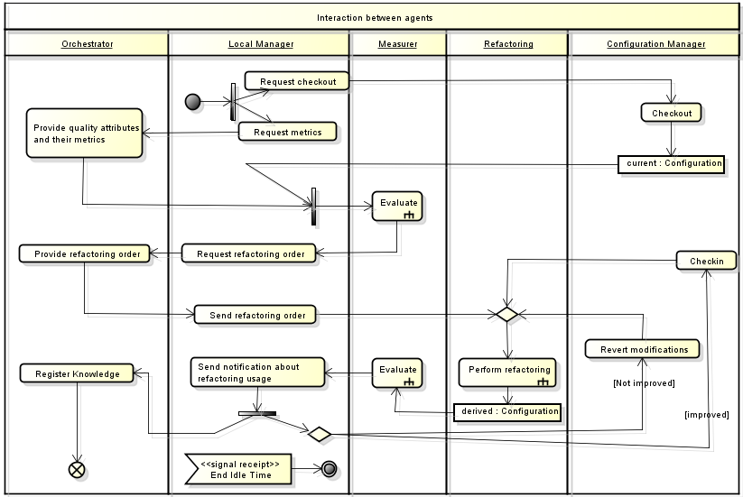
The local manager agent is responsible of the following actions: (1) to request the configuration manager agent to checkout the Current Configuration; (2) to request the metric tools from the orchestrator agent to calculate the quality attribute that should be improved; (3) to request the measurer agent to calculate a specific quality attribute of Current Configuration; (4) to request the refactoring order from the orchestrator agent; (5) to request the refactoring agent to perform a sequence of refactorings; (6) to request the measurer agent to measure the same quality attribute in the Derived Configurations; (7) to inform the orchestrator agent about improvement, decreasing or indifference of quality attributes for each refactoring; (8) to request the project branch URL from the orchestrator agent; and (9) to request the configuration manager agent to commit the Chosen Configuration in a specific branch.
Figure 3: Activity diagram, interaction among agents
The measurer agent also follows a plan in response to requests of the local manager agent. This plan is composed of four specific actions: (1) to extract design metrics from a specific configuration, (2) to normalize the values from design metrics previously extracted, (3) to calculate quality attributes from these metrics and (4) to compare configuration’s improvement according to quality attributes measured . The first evaluate, present in Error: Reference source not foundError: Reference source not found, this agent does the measurement from the current configuration and registered these values to normalize the next measurements. The second evaluate this agent does all the actions describe in (1), (2), (3) and (4) relative to derived configurations. Currently, the measurer agent is working with design metrics, quality attributes and normalization defined by Bansiya and Davis [2]. However, its design allows future extensions to accommodate additional metrics and quality attributes, if necessary. The current set of metrics available in Peixe-Espada is listed in Table 1: Design Metrics for Design Properties [3], and Table 3: Computation Formulas for Quality Attributes [3] presents the formula to calculate a quality attribute, according to Bansiya and Davis [3][2].
The refactoring agent employs the following actions during its work: (1) to request the ordered list of refactorings; (2) to apply each refactoring over a specific configuration; and (3) to inform the local manager agent about the success or failure while applying a specific refactoring. As some refactorings are not automatable [30], this agent is currently working with the refactorings presented in Error: Reference source not found. However, the design of the refactoring agent also allows future extensions to accommodate additional refactorings, if necessary. As previously discussed, this agent divides the refactoring in two main phases: search and apply. The search phase searches for elements that can be refactored. This search results in sets of programming elements (i.e., packages, classes, methods, attributes, etc.) that are inputs to a particular refactoring; and the apply phase transforms the elements of the source code according to some specific rules, as presented in Table 5.

Table 1: Design Metrics for Design Properties [3]
Design Property | Derived Design Metric
Design Size | Design Size In Classes(DSC)
Hierarchies | Number of Hierarchies (NHO)
Abstraction | Average Number of Ancestors (ANA)
Encapsulation | Data Access Metric (DAM)
Coupling | Direct Class Coupling (DCC)
Composition | Measure of Aggregation (MOA)
Inheritance | Measure of Functional Abstraction (MFA)
Polymorphism | Number Of Polymorphic Methods (NOP)
Messaging | Class Interface Size (CIS)
Complexly | Number of Methods (NOM)

Table 3: Computation Formulas for Quality Attributes [3]
Design Property | Derived Design Metric
Reusability | ( -0.25*DCC + 0.25*CAM + 0.50*CIS + 0.50*DSC )
Flexibility | ( +0.25*DAM - 0.25*DCC + 0.50*MOA + 0.50*NOP)
Understandability | ( -0.33*ANA + 0.33*DAM - 0.33*DCC + 0.33*CAM - 0.33*NOP - 0.33*NOM - 0.33*DSC )
Functionality | ( +0.12*CAM + 0.22*NOP + 0.22*CIS + 0.22*DSC + 0.22*NOH )
Extendibility | ( +0.50*ANA - 0.50*DCC + 0.50*MFA + 0.50*NOP )
Effectiveness | ( +0.20*ANA + 0.20*DAM + 0.20*MOA + 0.20* MFA + 0.20*NOP )
Finally, the configuration manager agent performs the following actions to achieve its plain: (1) to request the project repository URL from the local manager agent; (2) to checkout the Current Configuration and to manage the workspaces; (3) to request the project branch URL from local manager agent; (4) to create a new branch; (5) to commit the Chosen Configuration to the branch; and (6) to revert modifications in response of an inefficient or faulty refactoring.
Table 5: Automatic Refactorings and serach symptoms
Refactoring | Search Phase | Apply Phase
Encapsulate Fields [12] | Symptoms: Public attributes. Targets: public attributes and its use. | Change attributes’ access modifier to private; create getters and setters methods; and update references to the use created methods.
Pull Up Methods [12] | Symptoms: Method whose class should have a superclass that does not belong to an external library. This method should not overwrite any method of the superclass hierarchy. Targets: methods and their classes/superclasses. | Move the method to the superclass or move only its signature; change methods’ access modifier to public, protected, or remove this modifier.
Pull Up Fields [12] | Symptoms: Field whose class should have a superclass that does not belong to an external library. No other field from the superclass must have the same name of searched field. Targets: fields and their classes/superclasses. | Move the field to super class; change fields’ access modifier to public, protected, or remove this modifier.

Implementation details
Our approaches’ implementation is divided into web and desktop applications. At web application, we can register the software projects under the Configuration Management and create an orchestrator agent via the bond between a software project and a pre-registered quality attribute. After to create an orchestrator agent, we can invoke a desktop application through of the java-web-start technology [24]. So, in a desktop application we can schedule the idle time of the current machine how showed in Figure 3Figure 4: Scheduling idle time of a development machine.
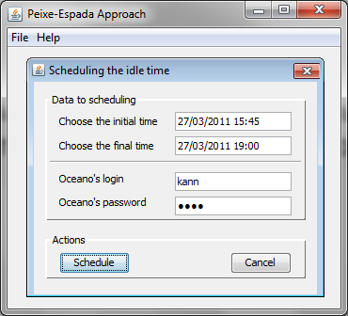
Figure 3: Scheduling idle time of a development machine

After we click in “Schedule” we can choose a specific orchestrator agent, in other words, we choose the quality attribute to be improved in the software project. This is presented inError: Reference source not found Figure 4.
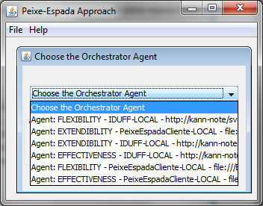
Figure 4: Orchestrator choose
The monitoring of local manager agents can be done in the web application how showed in Figure 5 . It shows all orchestrator agents, theirs local manager agents and information about improvement, decreasing or indifference of quality attributes for each refactoring applied.
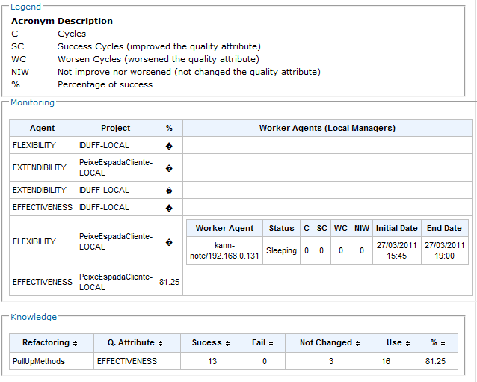
Figure 5: Agents Monitoring
In each machine where agents are making improvements the local managers have an output, thus the steps of work are evidenced in brief. The Figure 6Figure 6 shows a little output where the agents are getting metrics to calculate the quality attribute, getting refactoring order and start the refactoring with the first refactoring of the suggested order.
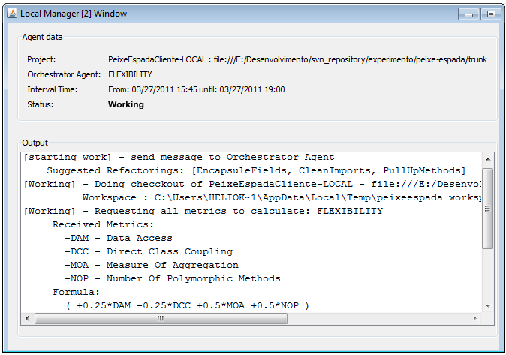
Figure 6: Output Agents in the desktop application

Finally, at the end, the worker agents make a resume of the performed changes and send to the orchestrator agent, for example: “branch created in http://.../branches/efectiveness_1”
, “Fields Encapsulate: field br.ic.uff.model.Person.name,” , “Method moved from br.uff.ic.model.Employ.getName to br.uff.ic.model.Person.getName”, etc.

- Evaluation
It is common to find many development teams that suffer with the precocious aging of software, but, each team had different methodologies, architectures and experiences. So, it is necessary to make experiments in different environments in order to evaluate if our approach is be able to alleviate the precocious aging of software. In evaluation process we can also analyzing patterns between refactorings and quality attributes as also show the changes of metric values about each particular project.
There are many ways to assess this approach, so we choose to separate in some steps: (1) to get data of real development team in software design process; (2) to use some periods to apply we approach; (3) to make a quantitative and qualitative study.
Our experiments were made with our approach Peixe-Espada and one of its dependencies, an open-source and a real project. In order to facility, we realized the experiments only with the HEAD version to each projects. The analyzed refactorings were PullUpMethods and EncapsulateFields. The measured quality attributes were Flexibility, Extendibility and Effectiveness.

Projects
The limiting factors to the choice of projects were the following restrictions: a maven project; under Subverion version control; distinct sizes; different teams; at least a real project. The data about the experimented projects are obtained from StatSvn. Below we describe the choose projects, their used snapshots to this experiment has the properties listed in Table 7.
Peixe-Espada (PE) is the implementation of this approach, in other words, we are using we project to improve itself. The mainly dependencies is the Oceano-Core (OC) where are implemented concerns about SCM, metrics, quality-attributes and other concerns to other academic researches.
Administrative System from UFF (IDUFF) is a real system responsible to manage the academic information and offers features online as request subjects, regularity declaration to students, release student’s notes, a lot of features to functionaries, course coordinator, professor and other academic roles. This system is released since 2008 and it is in constant evolution.
The Byte Code Engineering Library (BCEL) is intended to give users a convenient possibility to analyze, create, and manipulate (binary) Java class files (those ending with .class). Classes are represented by objects which contain all the symbolic information of the given class: methods, fields and byte code instructions, in particular. BCEL is already being used successfully in several projects such as compilers, optimizers, obfuscators, code generators and analysis tools as some metric tools.

Legend: M.D. – Measurement Date; C.L. – Code Line, all line from text files; C. – Committers; T.F. – Total Files; T.J.C. – Total Java Class, including test classes; J.C.L. – Total Class Line, all line from java files, including test classes.
Table 7: Properties from used projects
 | PE | OC | IDUFF | BCEL
M.D. | 2011/04/06 | 2011/04/06 | 2011/03/30 | 2011/04/06
C. L. | 8119 | 27554 | 241818 | 142832
C. | 2 | 6 | 27 | 5
T.F. | 79 | 290 | 1746 | 504
T.J.C. | 65 | 266 | 1037 | 405
J.C.L. | 6636 | 26375 | 163913 | 58010

General Analysis
As previously discussed, to this work we used only two refactorings (PullUpMethods and EncapsulateFields) and three quality attributes (Flexibility, Extendibility and Effectiveness).
 | PE | OC | IDUFF | BCEL
M.D. | 2011/04/06 | 2011/04/06 | 2011/03/30 | 2011/04/06
C. L. | 8119 | 27554 | 241818 | 142832
C. | 2 | 6 | 27 | 5
T.F. | 79 | 290 | 1746 | 504
T.J.C. | 65 | 266 | 1037 | 405
J.C.L. | 6636 | 26375 | 163913 | 58010

Table 8: Successful Encapsulate Fields refactoring
 | PE | OC | IDUFF | BCEL
Effectiveness |  | 0,0%
Extensibility |  | 0.0%
Flexibility |  | 33,33%

Table 9: Successful Pull Up Methods refactoring
 | PE | OC | IDUFF | BCEL
Effectiveness |  | 39.29%
Extensibility |  | 39.29%
Flexibility |  | 39.29%

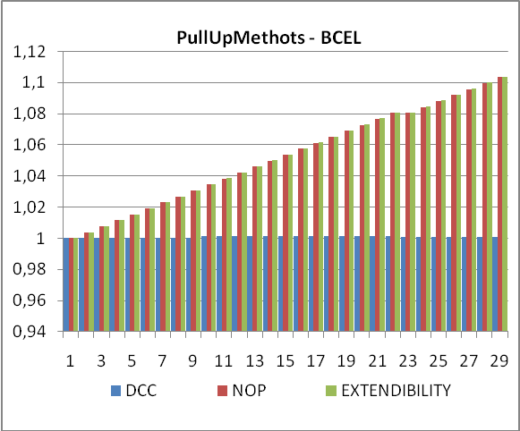

- Related Work
In the contexts of automatic approaches, it is found a lot paper to automatic refactorings [27][31][35][1], refactoring suggestion [38][44][9][45], bad smells detection [20][26][38], some of reengineering [23][38][26][11] and other that treat of specific refactorings [46][43][11]. But, in result found, few works are closely connected, for example, O'Keeffe and Cinneide [29] present an approach of automatic refactoring of software whose evaluations are based on some heuristics from literature. These heuristics focus on maximizing or minimizing metrics and for this, the authors list an order of priority among them.
In a later work, O'Keeffe and Cinneide [20] based on measures of Bansiya, J. and Davis [3], which provides a set of metrics and quality attributes to perform search aiming to improve the software quality. The three quality attributes used in this work were flexibility, reusability, and understandability. In order to do search what would be refactored, the authors used four techniques: one that stops refactoring when detects the first improve; one that stops when finds the better improving; one that is the merge among the first and the second; and a heuristic.
Seng et al. [36] also present an approach to perform automatic refactorings. The refactoring Move Methods was used and applied in an open source project. To make transformations, they use a structure which combines refactorings (genotype) and data models (phenotype). With this structure, they apply the genotype of a source (structure genotype plus phenotype) to other two and generate, extensively, possible permutes. To analyze the results, the authors use an evaluation function. At the end of process, it offers a list of possible refactoring, so this process is semi-automatic.
A representative approach from reengineering area was created by Tahvildari and Kontogiannis [41]. They developed a framework of automatic design improve by detection of design flaws via key class [4] heuristic, applied meta-pattern transformations [42], evaluated these transformations with maintainability metrics using Laguë and April [22] and performed experiments with four open-source.
The biggest difference between these works is that they treat of specifics problems inside automatic improves universe, of course that if we made a lot expansions some approaches became in a robust approach. Our approach was developed to offers a robust tool kit to solve complex problems as the software aging. In other words, we created an expansible framework with solutions of: metrics and evaluation; refactorings and symptoms search; monitoring of evolution and management of projects over version control systems and; parallel execution to optimize the IO tasks and use idle time of development machines.
From another point of view, our approach allow to perform a lot research like patterns between refactorings and quality attributes, search base, reengineering and multi-agent problems.

An important point of our work is related to the advantages provided by multi-agent systems. A multi-agent system is composed of a set of software agents that are autonomous, adaptive, interactive, and oriented by goals [16]. Due to that, agents are able of running without the need of human or other agents intervention, and can adapt their behavior to changes in the environment where are inserted.
- Conclusion
What are the results?
What is importance of each result in industry?
What and how were the ratings?
This approach solved problems describing in Introduction?
What are vantages to use SMA?
Which was the gain of having used Manage Configuration?
- References

1. Abdeen, H., Ducasse, S., Sahraoui, H., e Alloui, I. Automatic Package Coupling and Cycle Minimization. Proceedings of the 2009 16th Working Conference on Reverse Engineering, IEEE Computer Society (2009), 103–112.
2. Antoniol, G., Fiutem, R., e Cristoforetti, L. Using Metrics to Identify Design Patterns in Object-Oriented Software. Software Metrics, IEEE International Symposium on, IEEE Computer Society (1998), 23.
3. Bansiya, J. e Davis, C.G. A Hierarchical Model for Object-Oriented Design Quality Assessment. IEEE Transactions on Software Engineering 28, 1 (2002), 4-17.
4. Bauer, M. e Karlsruhe, F. Analyzing Software Systems by Using Combinations of Metrics. PROCEEDINGS OF THE ECOOP WORKSHOP ON EXPERIENCES IN OBJECT-ORIENTED RE-ENGINEERING (LECTURE NOTES IN COMPUTER SCIENCE 1743, (1999).
5. Beck, K. e Andres, C. Extreme Programming Explained: Embrace Change. Addison-Wesley Professional, 2004.
6. Beck, K. Test Driven Development: By Example. Addison-Wesley Professional, 2002.
7. Bosch, J. Design and Use of Software Architectures: Adopting and Evolving a Product-Line Approach. Addison-Wesley Professional, 2000.
8. Chrissis, M.B., Konrad, M., e Shrum, S. CMMI(R): Guidelines for Process Integration and Product Improvement. Addison-Wesley Professional, 2006.
9. Czibula, I.G. e Czibula, G. Clustering Based Automatic Refactorings Identification. Symbolic and Numeric Algorithms for Scientific Computing, 2008. SYNASC \uc0\u8217{}08. 10th International Symposium on, (2008), 253-256.
10. Dart, S. Concepts in configuration management systems. ACM (1991), 1-18.
11. Ferber, M., Hunold, S., Krellner, B., Rauber, T., Reichel, T., e R\ünger, G. Reducing the Class Coupling of Legacy Code by a Metrics-Based Relocation of Class Members. (2009).
12. Fowler, M., Beck, K., Brant, J., Opdyke, W., e Roberts, D. Refactoring: Improving the Design of Existing Code. Addison-Wesley Professional, 1999.
13. Frederick P. Brooks, J. No Silver Bullet Essence and Accidents of Software Engineering. Computer 20, 4 (1987), 10-19.
14. Gamma, E., Helm, R., Johnson, R., e Vlissides, J.M. Design Patterns: Elements of Reusable Object-Oriented Software. Addison-Wesley Professional, 1994.
15. Harman, M. e Tratt, L. Pareto optimal search based refactoring at the design level. Proceedings of the 9th annual conference on Genetic and evolutionary computation, ACM (2007), 1106–1113.
16. IBM. World Community Grid. 2010. http://www.worldcommunitygrid.org.
17. ISO - International Organization for Standardization. ISO - International Organization for Standardization. 2010. http://www.iso.org/iso/iso_catalogue/catalogue_tc/catalogue_detail.htm?csnumber=39064.
18. Kerievsky, J. Refactoring to Patterns. Addison-Wesley Professional, 2004.
19. Kessentini, M., Sahraoui, H., Boukadoum, M., e Omar, O.B. Search-based model transformation by example. Software & Systems Modeling, (2010).
20. Khomh, F., Vaucher, S., Guéhéneuc, Y.-G., e Sahraoui, H. A Bayesian Approach for the Detection of Code and Design Smells. Quality Software, International Conference on, IEEE Computer Society (2009), 305-314.
21. Kramer, C. e Prechelt, L. Design recovery by automated search for structural design patterns in object-oriented software. Reverse Engineering, 1996., Proceedings of the Third Working Conference on, (2002), 208–215.
22. Laguë, B. e April, A. Mapping of Datrix™ software metrics set to ISO 9126 Maintainability sub-characteristics. the Proceedings of Software Engineering Standards Issues (SES’96), Montreal Canada, (1996).
23. Mancoridis, S., Mitchell, B.S., Rorres, C., Chen, Y., e Gansner, E.R. Using Automatic Clustering to Produce High-Level System Organizations of Source Code. Proceedings of the 6th International Workshop on Program Comprehension, IEEE Computer Society (1998), 45–.
24. Marinilli, M. Java Deployment with JNLP and WebStart. Sams, 2001.
25. Mens, T. A State-of-the-Art Survey on Software Merging. IEEE Trans. Softw. Eng. 28, 5 (2002), 449-462.
26. Meyer, M. Pattern-based Reengineering of Software Systems. Proceedings of the 13th Working Conference on Reverse Engineering, IEEE Computer Society (2006), 305–306.
27. Moore, I. Automatic inheritance hierarchy restructuring and method refactoring. ACM SIGPLAN Notices, ACM (1996), 235–250.
28. Murta, L.G.P. e Werner, C.M.L. Gerência de Configuração no Desenvolvimento Baseado em Componentes. 2006.
29. O’Keeffe, M. e Ó Cinnéide, M.O. Proceedings of the Workshop on Directions in Software Engineering Environments. (2004).
30. O’Keeffe, M. e Ó Cinnéide, M. Search-based refactoring for software maintenance. Journal of Systems and Software 81, 4 (2008), 502-516.
31. O’Keeffe, M. e Ó Cinnéide, M. Search-based refactoring for software maintenance. Journal of Systems and Software 81, 4 (2008), 502-516.
32. Parnas, D.L. Proceedings of the 16th international conference on Software engineering. IEEE Computer Society Press (1994), 279-287.
33. Pressman, R. e Pressman, R. Software Engineering: A Practitioner’s Approach. McGraw-Hill Science/Engineering/Math, 2004.
34. Rao, A.S. e Georgeff, M.P. BDI agents: From theory to practice. Proceedings of the first international conference on multi-agent systems (ICMAS-95), (1995), 312–319.
35. Sagonas, K. e Avgerinos, T. Automatic refactoring of Erlang programs. Proceedings of the 11th ACM SIGPLAN conference on Principles and practice of declarative programming, ACM (2009), 13–24.
36. Seng, O., Stammel, J., e Burkhart, D. Proceedings of the 8th annual conference on Genetic and evolutionary computation. ACM (2006), 1909-1916.
37. Shaw, M. e Garlan, D. Software Architecture: Perspectives on an Emerging Discipline. Prentice Hall, 1996.
38. Simon, F., Steinbrückner, F., e Lewerentz, C. Metrics Based Refactoring. Proceedings of the Fifth European Conference on Software Maintenance and Reengineering, IEEE Computer Society (2001), 30–.
39. Smart, J.F. Continuous Integration with Hudson. O’Reilly Media, Inc.
40. Softex. Mps.Br - Melhoria de Processos do Software Brasileiro. 2009. http://www.softex.br/mpsbr/_home/default.asp.
41. Tahvildar, L. e Kontogiannis, K. Improving design quality using meta-pattern transformations: a metric-based approach: Research Articles. Journal of Software Maintenance and Evolution: Research and Practice 16, (2004), 331–361.
42. Tahvildari, L. Quality-Driven Object-Oriented Re-Engineering Framework. Proceedings of the 20th IEEE International Conference on Software Maintenance, (2004), 479–483.
43. Taneja, K., Dig, D., e Xie, T. Automated detection of api refactorings in libraries. Proceedings of the twenty-second IEEE/ACM international conference on Automated software engineering, (2007), 377–380.
44. Tourwe, T. e Mens, T. Identifying refactoring opportunities using logic meta programming. Software Maintenance and Reengineering, 2003. Proceedings. Seventh European Conference on, (2003), 91-100.
45. Tsantalis, N. e Chatzigeorgiou, A. Identification of refactoring opportunities introducing polymorphism. Journal of Systems and Software 83, 3 (2010), 391-404.
46. Vikram Jamwal. Automated refactoring of objects for application partitioning. Software Engineering Conference, 2005. APSEC \uc0\u8217{}05. 12th Asia-Pacific, (2005), 8 pp.
47. Yi Wang. What motivate software engineers to refactor source code? evidences from professional developers. Software Maintenance, 2009. ICSM 2009. IEEE International Conference on, (2009), 413-416.

, (2009), 413-416.

Peixe-Espada (belt fish in Portuguese) is a fish species that has nocturne habits, similarly to our approach that works at the idle time of software development, mainly at night.

