**Provenance in Games**

Troy C. Kohwalter Esteban W. G. Clua Leonardo G. P. Murta

Universidade Federal Fluminense, Instituto de Computação, Brazil

**Abstract**

Serious games have been used to aid the understanding of concepts that are taught in theoretical classes. These games provides game sessions allowing the player to make decisions in order to solve the addressed concept. Nevertheless, mistakes are commonly made by players which may result in failing to complete the objects or reaching the final goal. These mistakes sometimes are difficult to spot and when the game is replayed the player might try a trial and error approach until finding out which mistake was the cause of his failure. However, depending on the game dynamic, to reproduce a game state might be a difficult task. In order to solve this issue, this paper presents a framework which will record all useful gameplay data to be later used for analysis. This analysis will allow the player to identify his mistakes by visual representation of an oriented graph using provenance rules, containing all actions and decisions made during the game session, aiding in his understanding of his mistakes and learning through them.

**Keywords**: serious games, education, game analysis, provenance, action flow.

**Authors’ contact**:

{tkohwalter, esteban, leomurta}@ic.uff.br

# Introduction

Games have been used for some time to the purpose of aiding students to learn and comprehend concepts taught in classrooms. However, these serious games are limited in terms of analysis, which do not allow the player to analyze decisions made throughout the game to detect symptoms of the problems which occurred due to wrong decision making. The player would require to play the game again and make different decisions trying to figure out which one was not apt to the situation. Although, depending on the dynamic of the game, reproducing the same state can be problematic, making it difficult to replay it and try new solutions.

Neural studies have been made about the capability of learning from the human brain (CHIALVO; BAK, 1999) (CLARK, 1950). It has been stated that the process of learning by correcting past mistakes are more efficient, which also increases the ability to adapt to new situations due to the rule of *changing synaptic strengths*, which ensures that synaptic changes occur only at neurons involved in wrong outputs. But in order to correct mistakes made, it is important to know which mistakes were made.

For this purpose, a method to analyze a game flow was informally proposed by (WARREN, 2011), which aims to analyze by a flow graph which maps actions. More formal ways were also proposed (CONSALVO; DUTTON, 2006) which the analysis is done by metrics collected during the game session, creating a gameplay log to identify events caused by player choices. Another method is by *Playtracer* (ANDERSEN *et al.*, 2010), which offers a method to visually analyze play traces, providing detailed visual representation of the paths taken by the player through the game. The first one is an open idea which can be applied for players, but the other two methods are developer-oriented, meaning they aim to improve the quality of the game. That is not the kind of game analysis we desire.

For this purpose, this paper introduces a framework which will collect the necessary information from the game session while it is played. Then this collected data will pass through a series of process to create an oriented graph which maps the actions flow made during the session, using provenance techniques for inference. This graph will then be visible to the player, allowing him to analyze and identify critical nodes which influenced the game outcome. Doing so will permit him to understand how the outcome came to be and the reason behind it. This will aid in the identification of mistakes, allowing for the player to reflect upon them for future interactions.

This paper is organized as follows: Section 2 gives an introduction to the Open Provenance Model, explaining some of key definitions that can be used by the proposed method in order to create the action graph which will be visible to the player for analysis. Section 3 presents a framework to integrate provenance into games, explaining how the structure should be organized and giving some examples to the game-provenance mapping. Section 4 presents an usage of the proposed framework on an education game developed previously, pointing to the changes made in order to adapt it to permit provenance. Finally, Section 6 presents the conclusions of this work and future work.

# Open Provenance Model

Provenance is well understood in the context of art or digital libraries, where it respectively refers to the documented history of an art object, or the documentation of processes in a digital object's life cycle. In 2006 at *International Provenance and Annotation Workshop* the participants were interested in the issues of data provenance, documentation, derivation and annotation. As a result, the Open Provenance Model (MOREAU *et al.*, 2011) was created from the Provenance Challenge that was held in that workshop.

## Definition

In Open Provenance Model, it is assumed that provenance of objects are represented by an annotated causality graph, which is a directed acyclic graph, enriched with annotations capturing further information pertaining to execution. In (MOREAU *et al.*, 2011), a provenance graph is a record of a past or current execution, and not a description of something that could happen in the future.

## Requirements

Open Provenance Model is a model of provenance that was designed to meet the following requirements:

1. Allow provenance information to be exchanged between systems;
2. Allow developers to build and share tools to operate on such provenance model;
3. Define provenance in a precise, technology-agnostic manner;
4. Support digital representation of provenance;
5. Allow multiple levels of description to coexist;
6. Define a core set of rules that identify the valid inferences that can be made on provenance representation.

## Nodes

The Open Provenance Model is in essence a directional graph in which express dependencies between nodes. As such, the nodes can represent *Artifacts*, *Processes* and *Agents*. *Artifacts* are an immutable piece of state that can represent a physical object or a digital representation in a computer system. *Processes* are actions or a sequence of actions performed or caused by artifacts and results in new artifacts. *Agents* are contextual entities acting as a catalyst of a process that can enable, facilitate, control or affect its execution.

The Open Provenance Model is a model that represents artifacts in the past, explaining how they were derived, including processes that occurred in the past as well as are still in running.

## Dependencies

Since one of the goals of the Open Provenance Model is to capture the causal dependencies between the artifacts, processes, and agents, the provenance graph is defined as a directed graph, whose nodes are artifacts, processes and agents as described earlier. The edges on the graph belong to one of the categories described in Figure 1, representing a causal dependency between its source, denoting the effect, and its destination that denotes the cause.

The first two edges says that a process used an artifact and that artifact was generated by a process. The letter "R" represents the roles under which these artifacts were used since a process may have used several artifacts. Likewise, many artifacts may have been generated by a process, and each would have a specific role. Roles are only meaningful in the context of the process where they are defined, and they are not defined by OPM, but by the application domains. Roles are used on OPM just to distinguish the involvement of artifacts in processes.

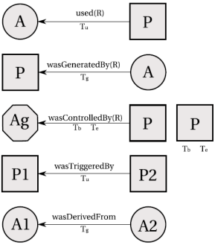

Figure : Edges and Usage of Timestamps in Open Provenance Model. Adapted from (MOREAU *et al.*, 2011).

The edge *was controlled by* express that a process was caused by an agent, essentially acting as a catalyst or controller. Since a process may have been controlled by several agents, it is also identified their roles as controllers. This type of dependency represents a control relationship and not a data derivation. The edge *derived from* assert that artifact A2 was derived from another artifact A1, giving us a dataflow oriented view of provenance. In contrast to the edge *was derived from*, an edge *was triggered by* allows for a process oriented view of past executions. Below are some important definitions in the Open Provenance Model.

**Causal Relationship**: *Represented by an arc and denotes the presence of a causal dependency between the source of the arc (effect) and the destination of the arc (cause).*

**Artifact Used by a Process**: *A "used" edge from process to an artifact is a causal relationship intended to indicate that the process required the availability of the artifact to be able to complete its execution. When several artifacts are connected to a same process by multiple "used" edges, all of them were required for the process to complete.*

**Artifacts Generated by Processes**: *A "was generated by" edge from an artifact to a process is a causal relationship intended to mean that the process was required to initiate its execution for the artifact to have been generated. When several artifacts are connected to a same process by multiple "was generated by" edges, the process had to have begun for all of the to be generated.*

**Process Triggered by Process**: *An edge "was triggered by" from a process P2 to a process P1 is a causal dependency that indicates that the start of process P1 was required for P2 to be able to complete.*

**Artifact Derived from Artifact**: *An edge "was derived from" from artifact A2 to artifact A1 is a causal relationship that indicates that artifact A1 needs to have been generated for A2 to be generated. The piece of state associated with A2 is dependent on the presence of A1 or on the piece of state associated with A1.*

**Process Controlled by Agent**: *An edge "was controlled by" from a process P to an agent Ag is a causal dependency that indicates that agent Ag controlled the start and end of process P.*

**Role**: *Designates an artifact or agent's function in a process.*

## Temporal Constraints

Open Provenance Model allows for causality graphs to be used with time information. In this model, time is not to be used for deriving causality, but to be used as a way of validating causality claims, since if the same time clock is used to measure the time for both the effect and cause, then the time of an effect should be greater than the time of its cause.

In addition, time may be associated to *instantaneous occurrences* in a process. There are four types of this occurrences: for artifacts they are *creation*  and *use*, whereas for processes are *starting* and *ending*. Given that time is observed by someone, its accuracy is limited by the clock and the notion of time. In this way, the model allows for an interval of accuracy to support the granularity used to represent time. With this, it is possible to state that an artifact was used no earlier than time t1 and no later than time t2, as an example.

For a process, it is analogous. indicate how time information can be expressed in the model. For "used" edges and "was generated by" one timestamp can be used to express when the event happened. For "was controlled by" edge two timestamps marks when the process started and terminated. For "was derived from" and "was triggered by" edges, one timestamp to indicate when the artifact was used. Despite using timestamp, the time of occurrence in itself is not to be used to imply causality. If process P1 happened before P2 is not enough information to infer that P1 caused P2 to happen.

## Completion and Inferences

The Open Provenance Model has defined the notion of a graph based on a set of syntactic rules and topological constraints. The provenance graph captures causal dependencies that can be summarized by means of transitive closure. Because of this, a set of completion rules and inferences can be used in the graph.

For completion rules, there is the artifact elimination, also known as forward transformation. In such transformation is shown. The edge "was triggered by" can be obtained from the existence of "used" and "was generated by" edges. Also in the same figure, there is another completion rule, artifact introduction, which establish that the "was triggered by" edge is hiding the existence of an artifact used by P2 and generated by P1. The completion rules allows the establishment of the existence of some artifact but it does not tell us what their id is. This is the consequence of using "was triggered by", which is a composition of "used" and "was generated by".

In , there is only one completion rule, which is referred to as *process introduction*. The edge "was derived from" hides the presence of an intermediary process. However, the converse rule does not hold since without any internal knowledge of P, it is impossible to ascertain if there is an actual dependency between A1 and A2.

When users want to find out the causes of an artifact or a process, their interest is in indirect causes that involve multiple transitions. For this purpose of expressing queries or expressing inferences about provenance graphs, a set of new relationships were created.

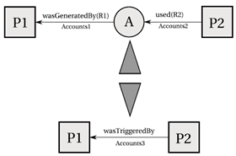

Figure : Artifact introduction and elimination. Adapted from (MOREAU *et al.*, 2011).

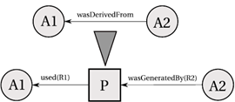

Figure : Process introduction. Adapted from (MOREAU *et al.*, 2011).

**Multi-step "wasDerivedFrom"**: *An artifact a1 was derived from a2 (possibly using multiple steps), written as a1 🡪* a2, if a1 "was derived from" an artifact that was a2 or that was itself derived from a2 (possibly using multiple steps). In other words, it is the transitive closure of the edge \was derived from". It expresses that artifact a2 had an influence on artifact a1.*

**Secondary Multi-Step Edges**:

* *Process p used artifact a (possibly using multiple steps), written p* 🡪*\* a, if p used an artifact that was a or was derived from a (possibly using multiple steps).*
* *Artifact a was generated by process p (possibly using multiple steps), written a* 🡪*p, if a was an artifact or was derived from an artifact (possibly using multiple steps) that was generated by p.*
* *Process p1 was triggered by process p2 (possibly using multiple steps), written p1* 🡪 *p2, if p1 used an artifact that was generated or was derived from an artifact (possibly using multiple steps) that was itself generated by p2.*

Multi-step edges can be inferred from single step edges by eliminating artifacts that occur in chains of dependencies. The relationships described above are illustrated in .

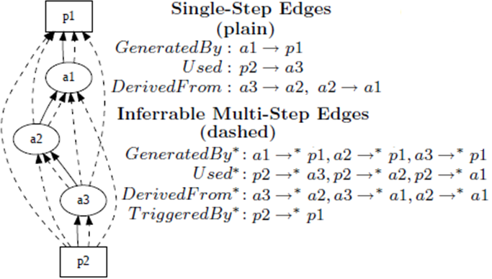

Figure : Inference. Adapted from (MOREAU *et al.*, 2011).

# Provenance in Games

~~How nice it would be to use provenance in games. And for storytelling as well! Something similar is the Replay in an RTS or race game.~~

~~Speak about the benefits a provenance graph can bring to games, such as help the player understand why the game took a different path from the one the player imagined.~~

## Proposed Model

To use provenance in games, it is necessary to map each type of node in a provenance graph to something that can be represented in the game context. As was mentioned earlier, the Open Provenance Model have three types of nodes: *Artifacts*, *Process* and *Agents*. In order to map then, it is necessary to find similarities in a game context.

Starting with *Artifacts*, their provenance definition states that they are "*an immutable piece of state that can represent a physical object* […]". Its definition already give a clue on which role they can represent during a game, which is objects. The object can be anything used in the game, for example in the case of an RPG, the type Artifact cam represent weapons, potions, legendary artifacts, magical objects and such. It can represent anything meaningful to the development of the game history.

For *Agents*, its definition states that they "*are contextual entities acting as a catalyst of a process that can enable, facilitate, control or affect its execution*". In a game context, agents can be mapped as people represented in the game, monsters and players.

Lastly, *Process* according to its definition is "*actions or a sequence of actions performed or caused by artifacts* […]". So, in a game context, the Process can be viewed as actions or events made by living or intelligent entities that are present in the game. Note that it was made a difference between living and intelligent. This difference is important to mention because imagine in an RPG environment where a sword can be expressed as an agent because this sword is not a normal one. It has an intelligence on its own, which is called Intelligent Items in a *Dungeons and Dragons* nomenclature. Despite being an object (sword), it can think and by an extent act, therefore it cannot be considered only as an object. It can also be as complex as being both an object and an agent at the same time.

Now, with all three types of nodes mapped into a context common in games, it is also necessary to map their causal relations to create the provenance graph. The Open Provenance Model defines a few causal relations which can be used similarly to their original context, but can be extended to be more suitable in a game if necessary. Also, the Open Provenance Model can deal well with the aspect of time, which can be heavily explored in games, especially on games which focus on storytelling, recording when each event happened and use that information to generate other events.

Following this framework, it is possible to create a provenance graph for games. Section 4 introduces a game where this framework was implemented to generate a provenance graph. However, before that, the next subsection will suggest what information to store from actions, events, objects and agents.

## Information to store

Actions can be represented by a series of attributes to describe it and the context it was involved so later can be used to create the provenance graph. Every action needs to have a reason for its existence, why the action was performed, what the triggered it, and who performed the action. In addition, the time of its occurrence can be important depending of the reason of using provenance. The reason in this paper is to produce a graph containing details that can be tracked to determine why something occurred the way it did. Therefore, with this assumption, the time of the action, the person who did it, what the action produced and what it affect are recorded for further analysis.

Events also work in a similar way as action, with the difference in who did it, because events are not necessary tied to persons. Some of these attributes are not necessary depending of the way the data will be stored. If you store actions in a list, and each agent has an action list, then it is not necessary to replicate information regarding who did the action.

For objects, its name, type, location, importance and events that are generated by it can be stored to aid in the construction of the graph. Lastly, agents can record its name, attributes it has, goals and current location.

All these attributes illustrated on this section are just suggestions on how the information can be stored to generate a provenance graph. It can be changed depending on how you store the information. If the information is already stored in an oriented graph or desires to generate the provenance graph on the fly, instead of a post-analysis, some of these attributes can be inferred by the structure.

## Decision tree

Decision trees (MORET, 1982) are a visual tool used to model decisions and their consequences, including possibilities of occurrence of events, resource costs, and usefulness of a particular outcome. This model can be considered as a deterministic algorithm to decide which variable to test based on the variables already tested and the results of its evaluation. Decision trees are represented by oriented tree format graphs composed of three distinct node types: decision; uncertainty; and terminal.

Decision trees can be used to control actions for non-playable characters (NPCs) in the game or trigger events. For this purpose, each important NPC will require a decision tree that is consulted to determine which action to execute. Similar to a estate diagram modeling. However, using decisions tree will allow for a greater variety of possible actions to be executed to reach the same goal, differencing the way to reach it, which is only limited by its size and complexity.

With the usage of decisions trees, it is added a variety of actions and creates a diversity of possible outcomes in games, which can easily be traced to the reasons behind the outcomes by following the decision tree graph for each action. This information derived from decisions tree can be used for provenance.

## Information Structure

In order to store all the necessary data to be used later for provenance, there is a need for a storage structure. Depending on the information structure, it is possible to use the structure itself for inference in provenance, simplifying some unnecessary information.

Consider the generation of actions, which are executed by an entity. These action information can be stored in a list. Each entity will then have a list of actions that contains all executed actions. Doing so, will allow inferring who executed each action just by looking at whose list it belongs to, without the need to explicitly say who executed the action. It is analogous for events. In case there was an external influence that resulted in the triggering of an action, then link the generated action to the influence, which also has links to the actions that generated the influence. Since actions belongs to lists that are linked to entities, then it is possible to infer who or whom influenced the outcome of the action by following the links.

For places, or scenes, it can be done in a similar way to represent entities present. Each scene will have a list of entities that belongs to it. To represent a world, then create a list of scenes, which in turn will contain list of entities that are in the scene, where these entities will have a list of performed actions, which will have links to influences. Using this structure, it is possible to simplify some inferences in the provenance model, such as show only relevant actions, which has external influences, to evaluate the outcome of a game session. An example of such structure is giving at Figure 5, where the world has a list of scenes, each scene a list of all entities in it, and lastly each entity with a list of actions performed.

Figure : Example of structure

## Using information for provenance

The purpose of collecting information during a game session is to be able to use provenance techniques to analyze and infer the reasons of the outcome. In the previous section it was set a framework to store such information. If the game does not support a provenance framework or have appropriate tools, it will be necessary to export the information to be used externally for analysis. However not all stored information will be used or necessary for the analysis, containing replication of actions that did not provoke any significant change. These can be simplified or omitted during provenance by using completion and inference rules.

With the aim of finding actions that had an impact in the story, the actions that did not cause any dramatic change can be omitted using multi-step inference rules. As an example, the player is in combat with an enemy and only after a few rounds it fell under the player's attacks. With the proposed framework, every round will create a node to represent the action taken by the player, which normally is attacking the enemy. This will cause replication of data that is unnecessary for analysis, so it is possible to reduce all these attack nodes to simply one node.

However, that is not always true. The player could have made other actions against the enemy, which are also considered a form of attack, such as casting a spell, or a special attack maneuver, or even healing himself in order to survive. These actions are not duplicates, but can still be encapsulated for analysis. Since provenance is an analysis from the present to the past, the outcome of the battle is already known and can be used to decide how to encapsulate the combat actions. If the player was victorious with minor challenge, did not suffer severe wounds, or barely used any resources at his disposal, then the entire combat can be simplified to just one node saying that the player attacked the enemy and was victorious. However, if the combat was challenging or the player lost, it will be interesting to preserve the action nodes for analysis so the player can analyze the combat and decide what and when something went wrong.

# Evaluation

To implement the proposed provenance framework for games, the authors decided to use a Software Engineering education game known as *Software Development Manager* (SDM), proposed by (KOHWALTER *et al.*, 2011), for its code familiarity and past experiences. In SDM, the player has a team of employees which are used to develop software according to contracts made with customers.

The gameplay and game mechanics are modeled presenting possibilities to the player to decide strategies for development and define the roles for each staff member. As any contract, the software may have requirements that must be followed during development. From a gameplay point of view, these requirements help to balance the mechanics and rules. When the software is completed and delivered to the customer, there is a quality assessment of the software and a project completion payment accordingly to the product quality.

Since SDM focus in people management, the main element of the game are the employees, which represent the player’s labor force. Since employees take a very important role, several features are used in the game. These features include changes in possible roles that an employee can perform and the attributes used to calculate the employee’s performance. Another element present in the game is specialization, used to define the employee working competence. With the specialization system, it is possible for employees to undergo training to learn new sets of skills. Also the concepts of working hours, morale, and stamina are used to modify the employee’s productivity.

Figure 6 show a simplified version of SDM’s class diagram focusing on the employee, showing his human attributes, types of specializations and the possibility of training to acquire specializations, and that the employee is affect by other employees that belong to the staff team. In small details, it also illustrates the project and its characteristics and requirement.

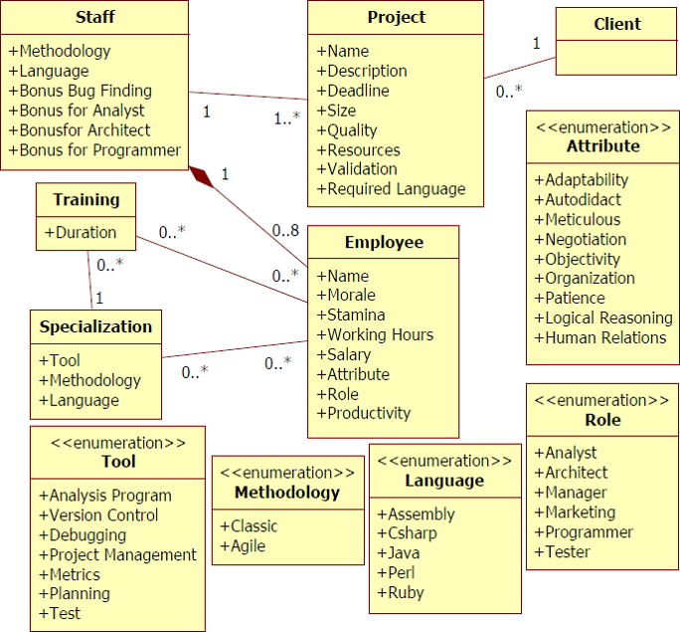

Figure : SDM's simplified class diagram. Adapted from (KOHWALTER *et al.*, 2011).

## Adapting SDM for the proposed framework

To introduce decision trees and a way to record all actions made by the player's employees for usage on provenance later on, some changes were made in the roles presented in the game. With these changes, it is possible to create an oriented graph representing the flow of actions performed by each employee during the development of the software. The purpose of this graph is to use provenance techniques, presented earlier in this paper, allowing the player to view all the actions made during the playing session. With this information, the player can analyze the flow of the game and reach to conclusions about why the game session ended the way it did.

The role of an Analyst now has three different tasks to perform: Elicitation and validation; Requirements specification; and the creation of acceptance test cases. Another change was the way the analyst role works. Now with the tasks of elicitation and specification separated, it is necessary to discover the system requirements by the process of elicitation and then create the model that the staff uses by the task of specification. The new tasks for the analysis is illustrated at Figure 8.

For the role of an Architect, new tasks were introduced which is responsible for creating integration and system test cases, generating prototypes to be used by the analyst and his task of aiding programmers by working the software architecture.

The manager role was revised and changed as follows: He has the task of managing the staff and decides which role each will perform; Decide the development focus, which can be from four types (Analysis, Development, Quality and Balanced); Decide the staff working hours; and manage the hiring of new employees.

The roles of Programmer and Tester had suffered changed that affect each other. Now, it is not the tester's responsibility to fix bugs as well as find them. The tester will only report bugs found so the programmer can fix them. Because of that, the programmer's tasks are as follow: Software Repair; Software Development; Code Refactoring. Moreover, the tester only task is to report bugs found by the usage of test cases.

With the new programmer's task of refactoring, a new aspect was introduced in the software development, which is the quality of the code. This quality influences the probability of removing and introducing bugs in the software. Also, the quality of the code is directly affect by how the programmer is working, which now has three different ways: Ad hoc; Draw-Code; and Test-Driven. Only the first one affects quality, and in a negative way. To increase the code quality it is necessary to do refactoring of parts in the software already implemented.

The Draw-Code mode of programming is the default one and equivalent to the one in the previous version of the game. Test-driven allows the programmer to develop the software with minimal chances of introducing new bugs because the programmer is taking his time to create unitary test cases, check the code for bugs and repair.

With these changes in roles, other changes were made in the structure of the game to accommodate them. The first change was related to test cases and software bugs. Because of the different test cases available and performed by different roles, it was necessary to expand the way bugs are represented in the game. As such, there are now four categories of bugs: Acceptance, system, integration and unitary.

illustrates the changes made in each role and allows the player to configure the tasks of each employee. The decisions trees for each role use all options presented in that screen. Note that some options were not mentioned. The staff manager uses those in order to decide the staff configuration in case the player does not want to micromanage the game, giving some of the responsibility to the staff manager.

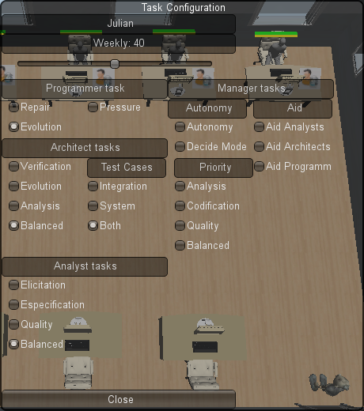

Figure : Task Configuration window

Another side change made in the game is to allow an employee to perform up to two roles simultaneously, having a primary and secondary role. When an employee has both roles filled, the player or the staff manager decides the rates for each role. In other words, how many hours of his time that employee will dedicate for each role. All rules for the primary role apply to the secondary role, and the productivity of the primary and secondary roles are multiplied by their rate factor. The staff manager also can use this feature for assigning roles.

With the revised roles and their respective tasks, decision trees were made to allow for a task selection and create a diversity on the game flow. Each decision tree corresponds to a role, obeying their respective tasks. However, the way these tasks are performed may vary depending on the situation. As such, the decision process is influenced by internal reasons, generated by the employee himself, and external reasons, decisions made by the player or staff manager. Figure 8 illustrates an example of such decision tree, belonging to the analyst role and illustrates the external reasons.

The introduction to decision trees allows for the variety of actions performed by each role. These actions, which are the result of a path from root to leaf in the decision tree, are stored for future provenance analysis, along with the path taken. Other tasks can also produce actions for storage, such as hiring and firing an employee, training, player choices and decisions.

Figure : Analyst Decision Tree Example. Orange boxes represent end nodes, in this case tasks. Red boxes are value evaluation. Green lines represent probabilistic paths and blue lines are decision paths.

## Information Structure

The information structure used on SDM is similar to the one explained in section . As such, each project is a scene, which contain a list of all entities that participated in it. These entities are employees that worked in the project and the player. Each employee has a list of actions made and each action containing its details, including links to other actions in case of external influences. Figure 9 illustrates the action nodes generated during the game. These actions have details about who performed it, when it was performed, which task generated it, if there was any external influences, and a description of the decision tree path taken to generate the action.

As said, all actions are grouped in the owner list, meaning at each employee will have a list of actions. The player will also have a list of all actions performed. illustrates the information organization for one project, showing all the employees involved in it and the details of the project.

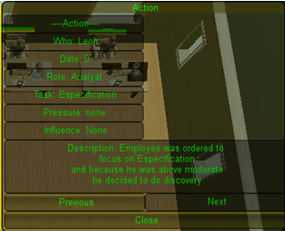

Figure : Action details

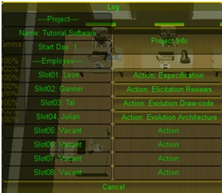

Figure : Information Organization

Each employee slot in the picture is a list of all employees that belonged to that slot and in the left side of each slot is the action list, showing the last action performed. By selecting the action, it will allow to see its details, as shown in and transverse the list by the buttons Previous and Next. It is analogous for the employee list.

## Using the information for provenance

With the adaptations and storage structure for relevant information on SDM, it is now possible to use the collected data for provenance. However, due to limitation on Unity3D, the data will be exported for an external tool for visualization and analysis. However, the data will need to pass through some changes to remove unnecessary information, duplicate actions or similar ones. For the purpose of the game, the only interesting actions are the ones which influences or is influenced by other actions, like player and manager decisions or tasks that generate interference on other roles like architecture task from an architect.

Action which don't generate influence or does not influence other actions are not relevant for the analysis, due to the fact the action did not change the state of development, negatively or positively. Nevertheless, it is important to not forget that even if they are not relevant for the analysis, they are relevant for the development of the software in the game. Without such actions the game would stagnate and not progress. The problem is not these actions, but the decisions made for the execution of these actions.

After cleaning the data, the information will be more adequate for analysis and provenance inferences. This way, the player will be able to trace actions that had an impact during development and study if the course of action taken was an adequate one. Identifying these actions are essential for the understanding why something happened the way it did. This refined action graph can be displayed for the player by external tools designed for graph display, aiding visually the analysis.

Understanding the reasons of the outcome, the player will be able to learn from his decisions and analyze more efficient ways to develop future projects. In addition, it allow for the perception of mistakes made that should be avoided in the future.

# Conclusion

This paper proposes a framework for provenance in games, allowing for post game analysis to discover divergence points in the game that contributed to the end result of the gaming session. This framework can be well used on serious games to improve understanding by analyzing game flow and identifying sections that influenced the outcome, aiding the player to understand why it happened the way it did.

This paper also show a game in which this framework was used, collecting the necessary information for post analysis using provenance. However, due to time constraints, the usage of provenance and data mining were not executed, but they are planned as future work to export all the collected information, generate a graph and apply provenance techniques for the game analysis.

# Acknowledgements

The authors would like to thank (omitted) and (omitted) for the financial support of this work. Also for (rest is omitted because I did not write it yet).

# References

ANDERSEN, E.; LIU, Y.-E.; APTER, E.; BOUCHER-GENESSE, F.; POPOVIĆ, Z. **Gameplay analysis through state projection**. . [S.l.]: ACM Press. , 2010

CHIALVO, D. R.; BAK, P. Learning from mistakes. **Neuroscience**, v. 90, n. 4, p. 1137–1148, jun 1999.

CLARK, G. The organization of behavior: A neuropsychological theory. **The Journal of Comparative Neurology**, v. 93, n. 3, p. 459–460, 1950.

CONSALVO, M.; DUTTON, N. Game analysis: Developing a methodological toolkit for the qualitative study of games. **In: Game Studies**, 2006.

KOHWALTER, T.; CLUA, E.; MURTA, L. **SDM – An Educational Game for Software Engineering**. . Salvador: In: X SBGames. , 2011

MOREAU, L.; CLIFFORD, B.; FREIRE, J. *et al.* The Open Provenance Model core specification (v1.1). **In: Future Generation Computer Systems**, v. 27, n. 6, p. 743–756, jun 2011.

MORET, B. Decision Trees and Diagrams. **In: ACM Computing Surveys (CSUR)**, v. 14, n. 4, p. 593–623, dez 1982.

WARREN, C. **Game Analysis Using Resource-Infrastructure-Action Flow**. **ficial**. [S.l: s.n.]. Disponível em: <http://ficial.wordpress.com/2011/10/23/game-analysis-using-resource-infrastructure-action-flow/>. , 2011