Enhancing Software Engineering Education through Provenance applied to Serious Games

Troy C. Kohwalter

Esteban G. W. Clua

Leonardo G. P. Murta

Instituto de Computação

Universidade Federal Fluminense  
Niterói – RJ Brazil

{tkohwalter, esteban, leomurta}@ic.uff.br

**ABSTRACT**

Software engineering is focused on practical and theoretical aspects of the software production. Teaching software engineering is traditionally done by theoretic classes with few practical exercises. To circumvent this problem, a raising approach consists on the adoption of games and simulators, where decisions and interactions become key factors to transmit and acquire knowledge. However, mistakes made by wrong decisions may jeopardize the learning process, especially when reproducing its effects might not be a viable option. With this in mind, we propose a novel approach based on provenance concepts in order to present the decisions and effects of such decisions when learning via games. We extract provenance using our software engineering game and generate a provenance graph that can be used for a broader range of analysis. We validate our results with experiments and detailed statistics analysis.

**Categories and Subject Descriptors**

K.3.0 [**Computer Uses in Education**]: General; K.8.0 [**Personal Computing**]: General - *Games*

**General Terms**

Design, Experimentation.

**Keywords**

Software Engineering, Serious Game, Provenance, Education, Game Flux.

# INTRODUCTION

Traditional Software Engineering teaching process consisted of lectures and a course project, which has the intent of applying the theory learned during lectures in order to aid understanding. Moreover, these projects are restricted to the length of the course, which limits the opportunities for the students to practice and comprehend all the concepts taught in classrooms. Also due to the limited time, most course projects provide guidelines for a linear execution that leaves little room for experiencing the many facets of the software process. Lastly, these course projects typically focus on project deliverables, which usually do not stimulate the student’s interest. In order to solve this problem, games [1] have been used for helping students to learn and understand concepts taught in classrooms [3–6, 12, 20, 21, 23, 24, 26, 27] by stimulating curiosity and providing motivation for learning [14].

However, the conclusion of a digital game session derives from a series of decisions and actions made throughout the game. In many situations, analyzing and understanding the events, mistakes, and fluxes of a concrete game play may be useful for understanding the achieved results. This game flux analysis is also fundamental for detecting symptoms of problems that occurred due to wrong decision-making and to better understand if the student learned the concepts presented by the game.

Without a game flux analysis, the student would be required to play the game again and induced to make different decisions to intuitively guess which actions were incorrect. Similarly, the tutor would be required to watch the game being played in order to identify the mistakes made by the player. However, depending on the game dynamics and its complexity, reproducing the same state can be unviable, making it difficult to try new solutions.

With this in mind, the goal of this paper is to improve the software engineering learning process by making the tacit knowledge explicit as insights on how the game session progressed. This is achieved by analyzing the game flux data using provenance[1]. The provenance analysis process collects data and generates a provenance graph, relating actions, decisions, and events that occurred throughout the game in a high level model, allowing a broader range of analysis from both the student and the teacher. For instance, the provenance graph allows the student and the tutor to browse the data, identifying actions that influenced specific outcomes. It also helps to understand how events were generated and which decisions contributed to them. This process also aids in the identification of mistakes, allowing the student to reflect upon them for future interactions or for the tutor to know which concepts students are having difficulties.

In our previous work [9], we introduced the usage of digital provenance [7] in games. The main goal of the previous work was to propose a conceptual framework that collects information during a game session and maps it to provenance terms, providing the means for a post-game analysis. The present paper applies the conceptual framework introduced in the previous paper in a serious game named SDM [10] for teaching Software Engineering. The provenance support in SDM allows a broader range of analysis by using collected gameplay provenance information to generate a provenance graph. This provenance information can be used by the student and the tutor to identify the cause-and-effect relations between actions during a game session in order to understand the outcomes. The provenance graph is displayed for analysis by using a provenance visualization tool named *Prov Viewer*, which was customized to SDM and uses provenance visualization features detailed at another previous work [8].

The SDM game focuses on introducing Software Engineering concepts and skills to undergraduate students. The provenance gathering and visualization presented in this paper allows students and tutors to visualize the game flux and identify steps that lead to successful or unsuccessful outcome. Experiments were made with different undergraduate classes to access the viability of analyzing a game session by using provenance. The goals of these experiments were to known if the provenance analysis is faster and more efficient than analyzing the game by re-watching the session, trying to observe if it has a higher identification rate of the cause-and-effect relations between the actions and their outcomes.

The rest of the paper is organized as follows: Section 2 presents the related work. Section 3 presents the SDM with provenance support and provenance visualization. Section 4 discusses the experiment with two undergraduate classes and our findings about using provenance analysis to understand the game session. Section 5 concludes and presents future works.

# RELATED WORK

In Navarro [12], the authors created a Software Engineering simulation digital game called SimSE. The purpose of this game is to address the gap in the traditional techniques of Software Engineering teaching where students are exposed to various concepts and theories, but have few opportunities to apply these ideas into practice. In SimSE, the player assumes the position of a project manager who has a team of developers and manages the software development by making hiring and firing decisions, monitoring development progress, assigning tasks and buying new tools. The fundamental goal of the SimSE project is to allow the customization of the simulated process model and therefore to be used by professors during the presentation of content related to the software life cycle.

The SimSE has an explanatory tool for analysis available to the player that goes beyond what is being presented at the game. These features include plotting graphics showing game values and actions details, such as when an action started and ended, the participants (employees, tools, and documents) involved with the action (*i.e.* creating requirement document), and game rules associated with it. It also shows all triggers and destroyers for the each action, displaying what could have caused the action to start and end. The explanatory tool is a powerful analysis tool that shows details during each clock-tick in the game. However it does not show details about how each participant of each action contributed to it, nor their respective contribution values.

Dantas et al. [4] presents a simulation based digital game for teaching Software Engineering, named The incredible Manager. The focus of this game is project management, where the player has the job of manager in a company. The player main tasks are to plan and manage software development projects. As a project manager, the player establishes a development plan for the project and has the options of forming a development team to estimate the duration of each task, assign tasks to developers, make project plans, negotiate with stakeholders, control how many hours the team will work per day and determine the effort spent on quality assurance. One important limitation reported by players was related to been unable to trace and explain each action and their consequences during the game in order to evaluate their own performance after playing the game.

Another Software Engineering simulation digital game was developed by Drappa [5] named SESAM. In SESAM, the student assumes the role of a project manager by hiring, firing, or designating tasks to employees. The game uses a text interface where the student writes in natural language for interacting with his employees, being their reply in the form of statements. These statements are the only form available for the player to gauge his decisions during development.

At the end of the SESAM game session, it is displayed the player’s score, detailing the developments statistics, such as the number of days to finish the project, human effort, cost, and requirements coverage. Previously hidden attribute values from the customer requirements are also displayed to the player. However, the students made the same mistakes when replaying a session due to not having any learning effect to help avoid such mistakes by just looking at the scores. Also due to the score output format, students were failing to reflect on the details of the game session and were doing a trial-and-error approach. When their final score was fairly good, they kept the same approach in the next simulation. Otherwise they would try a different approach.

Other digital games were made for teaching Software Engineering, such as MO-SEProcess and Groupthink [26] which are add-ons for the multiplayer online game Second Life, being both games a multiplayer style. The first game, MO-SEProcess is based on SimSE but focusing on the waterfall approach where each player is a member of the development team. The second game, Groupthink, is also an add-on for Second Life and is based on a software specification exercise developed by M.I.T., where players form teams and answers questions related to software development. In both games, a final score is displayed at the end of the session to the teams.

Finally, the Pex4Fun [23] is a digital game for teaching Software Engineering that focuses on code duels, where the player’s goal is to implement a puzzle method that follows defined specifications and is equivalent to the hidden puzzle method. The only decision that needs to be made is related to the code that will be written since there is no interaction with other entities. Thus Pex4Fun and the remaining Software Engineering games [3, 6, 21, 24], which are either board or card games, are not compatible with our approach.

# USING PROVENANCE IN GAMES FOR ENHANCING SOFTWARE ENGINEERING TEACHING

A typical digital game architecture is mainly composed of game objects and the game loop. All objects present in a game, from environment objects to characters, are inherently game objects. Game objects by themselves do not add characteristics to the game. Instead, they are containers that hold components that implement actual functionality, such as scripts (*i.e.* artificial intelligence, player controller), meshes (the object structure or “body”), physics, textures, animations, and audio. Meanwhile, the game loop is responsible for the sequence of events that occur in a game, allowing the game to keep running regardless of the user’s input. The game loop keeps the game alive, updating game object states and executing their actions. Each script in a game object has a function called Update, which is called by the game loop in order to execute the specific game object functionalities. Every time the game loop is ticked, it executes the Update function from all scripts that belongs to the game objects present in the scene.

In a previous work [9], we proposed a novel usage for provenance in the game field. In order to adopt provenance for the context of games, we mapped each type of vertices of a provenance graph into elements typically found in games. Using the PROV [15] notations, an *entity* was mapped to static game objects present in a game, such as weapons, equipment, and furniture. *Agents* were mapped to dynamic game objects, such as characters, event controllers, and plot triggers. Lastly, *activities* were mapped to actions or events executed throughout the game, such as interactions with other *agents* and *entities*. The causal relations, which are the edges of a provenance graph, were mapped to influences occurred during the game. illustrates this mapping process of provenance concepts into the game context, outlining important information of each element type to be collected during game execution for a provenance analysis.

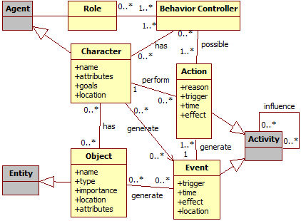

Figure : Data model diagram. Gray classes represent generic provenance classes.

This provenance analysis infrastructure, which uses the proposed framework presented in [9], was instantiated in a Software Engineering educational game we developed, named SDM (Software Development Manager) [10]. The goal of SDM is to allow undergraduate students to understand the existing cause-effect relationships in the software development process. Thus, the adoption of provenance becomes an important instrument to better support knowledge acquisition, allowing tracking mistakes made during a game session or identifying concepts that are not well understood by the students.

## SDM

In SDM the player manages a team of employees that is used to develop software according to contracts made with customers. The gameplay and game mechanics are modeled presenting possibilities to the player, who decides strategies for development and defines the roles for each staff member. As in any contract, the software has requirements that must be followed during development. From a gameplay point of view, these requirements help to balance the mechanics and rules. When the software is completed and delivered to the customer, there is a quality assessment of the software and a project completion payment accordingly to the product assessment. presents a screenshot of SDM in action, with the bottom corner illustrating the software’s development status.

Since SDM focuses in people management, the main elements of the game are the employees, which represent the player’s labor force. Employees can perform different roles (analyst, architect, manager, marketing, programmer, and tester), which use the employees’ human attributes to calculate their performance depending on the respective roles. Employees’ names and roles are displayed in the staff menu at the top corner of . Another attribute present in the game is specialization, which is used to define the employee working competence. With the specialization system, it is possible for employees to undergo training to learn new sets of skills. Also the concepts of working hours, morale, and stamina are used to modify the employee’s productivity. The left corner of illustrates the status of morale and stamina for each employee in the staff, as well as the player’s expenses.

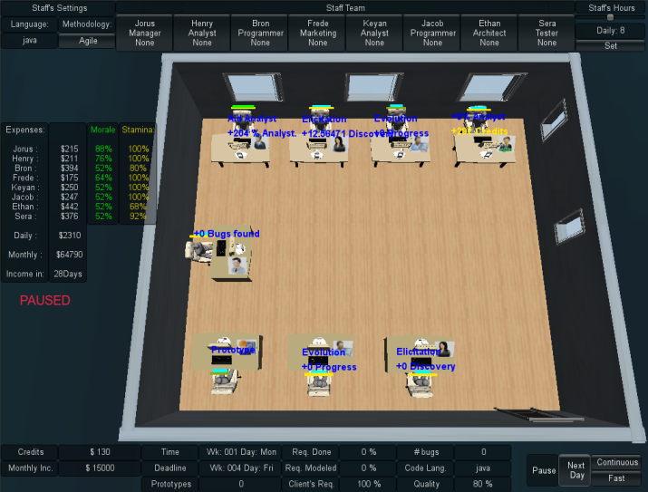

Figure : Screenshot from a game session in SDM

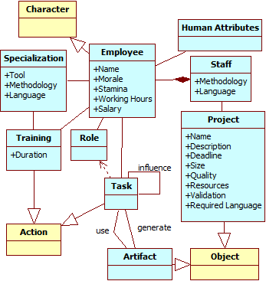

Figure : SDM simplified class diagram. Yellow classes represent generic classes showed in . Blue classes represent SDM classes.

These features are illustrated in , which shows a simplified version of SDM’s class diagram focusing on the employee. Each employee is defined by his human attributes (adaptability, autodidact, human relations, logical reasoning, meticulous, negotiation, objectivity, organization, and patience), can have specializations categorized in three different types (with a total of 14 different specializations), and can be put for training in order to acquire new specializations.

Each employee can have up to two different roles at the same time, among six possible roles available. Each role has a different set of tasks, which are administered by decisions trees[11] that considers internal (attributes, morale and stamina status) and external (player or staff) influences to determine how these tasks are executed. Tasks can influence and be influenced by other tasks from another employee and can also generate artifacts, which can represent prototypes, used to validate software requirements with the client, or test cases (unit, integration, system, and user acceptance). Lastly, employees belong to the player’s staff and develop the software for a customer, respecting the customer’s requirements and deadlines.

## Provenance Gathering in SDM

The data structure used in SDM to collect provenance information was adapted and mapped to be suitable with the proposed provenance structure presented in [9], which is as follows: Each project contains a list of the employees involved in its development. In turn, each employee has a list of his actions executed throughout the development. If any action had an external influence during its execution, then the action also has a pointer to the action that influenced it. Throughout the game, when actions are executed or triggered, the information about these events is collected at runtime and stored for later usage. Executed actions go to their respective employee lists while new employees are added to the project list, creating their own list of actions. Each day at the game universe stores the state of the software development at the end of that day.

Since the information collected is used for the generation of the provenance graph, its content is mapped to the three possible types of provenance vertex: *activities*, *agents*, and *entities*. This mapping is made according to the data model explained at [9] and previously mentioned at the beginning of this section: *activities* are actions or events, *entities* are static game objects (prototypes, test cases, software development state), and *agents* are dynamic game objects (employees and clients).

The majority of the provenance gathering, which is related to *activities*, is administrated by decisions trees and occurs at leaf nodes of the tree, which is where the action is executed. The information gathered varies with each type of element, as can be seen by Figure 4. *Activities* provenance information (c) is taken directly from the decision tree, getting the execution information and retracing the tree path from the leaf to the root. *Agents’* information (b) is gathered when they first interact in the game. *Entities* information gathering varies due to having different types. For the software *entity*, distinguished as Project at Figure 4 (a), the information is gathered in a daily basis, recording the current state of development. Prototypes and test cases *entities* information is gathered when they are created.

Moreover, the causal relationship between elements is also gathered. For instance, when an *activity* is influenced by another *activity* or generates an influence to an *entity*. Examples of influences can be from an employee aiding another employee or when a task changes the state of the software under development.

## Provenance Visualization

With the adaptations for provenance gathering made in the original SDM [9], it is now possible to use the collected provenance data to generate a provenance graph for analysis. The collected game data, known as *game flux log*, is exported to *Prov Viewer*, which is a provenance graph visualization tool based on our previous work [8], related to provenance visualization and adapted for usage in SDM. In the *Prov Viewer*, the data is processed and used to generate a provenance graph of the game session to aid the analysis process.

After the *game flux log* is processed and the graph is generated, our system draws the graph on the screen so the user can analyze it. Figure 5 illustrates the graphical user interface (GUI) of *Prov Viewer* and the displayed provenance graph from a gameplay session generated by SDM. Using the visual notations defined at [8], square vertex represents an *activity*, while circle represents an *entity* and an octagon represents an *agent*. The provenance graph is displayed at the center of the screen but only part of it is visible due to the graph size. However it is possible to zoom in or out and navigate through the graph. The graph layout is set to be similar to a spread sheet, where each “line” represents the *activities* of each *agent* and each “column” represents a day in the game. The layout can be customized by creating new layouts or using existing ones available at JUNG. The filters, specifically defined for SDM, are located at the lower region of the interface. The “CollapseAgent” button collapses all the *agent’s* vertices into the *agent* itself. It is useful to detect if an *agent* had any influence throughout the game, instead of looking vertex by vertex. The “Collapse” button allows the user to collapse selected vertices, creating a meta-vertex that summarizes edges (influences) by type. The “Extend” button removes the last collapse made to generate the selected meta-vertex.

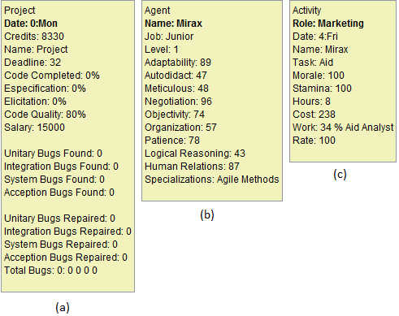

Figure : Provenance information gathered from the game for software development (a), employee (b), and actions (c).

The “Display Edge” is an important aspect during analysis, allowing for the identification of types of influences in the graph, filtering influences that are not relevant for the desired analysis. The displayed graph only shows the edges types selected, omitting unselected types. For example, in the edge types “Neutral” and “Aid” are selected, thus showing all positive (green) and negative (red) influences of the “Aid” type and all “Neutral” (dotted-black) type edges, which in this case are association edges.

The “Attribute Status” changes the vertex color according to their values from the selected attribute. In SDM they can be: Morale, Stamina, Hours (short for Working Hours), Weekend (highlighting “Saturday” and “Sunday” vertices), Credits, and Role. The vertex color does not change if it does not have the selected attribute. The default mode shows common activities with a shade of gray and uncommon activities with different colors. Common activities in SDM are normal tasks executed by employees during their roles, while uncommon activities are activities that do not happen frequently. For instance, in SDM the uncommon activities are: Idle (red color), Training (purple color), Fired (brown color), Promotion (green color), Hired (“cornsilk” color), and Negotiation (“honeydrew” color). This color difference between vertices is useful to quickly identity non-ordinary events. For example, by looking at the graph shown in Figure 5 it is possible to quickly identify that an employee trained (purple vertices) during one week and was idle (red vertices) for several days after the training was complete just by analyzing the vertices color. This type of visualization, based on the evaluation of attributes, is useful to quickly identify particular sections in the graph.

# EVALUATION

The main motivation of this work is related to the following research questions:

1. Does provenance analysis help to understand events that emerged during the game?
2. Is provenance analysis faster than only watching a replay of the game session?
3. Is provenance analysis more accurate than only watching a replay of the game session?

To assess the possibility of using provenance analysis for improving understanding, we generated a replay of a game session and compared it with provenance analysis using a provenance graph. This comparison was conducted through a questionnaire containing specific questions about events that occurred during the game session. Volunteers were divided into two groups: with and without provenance. Both groups watched the replay of the game session. The group with provenance also had access to the provenance graph. At the end, both groups answered the same questionnaire.

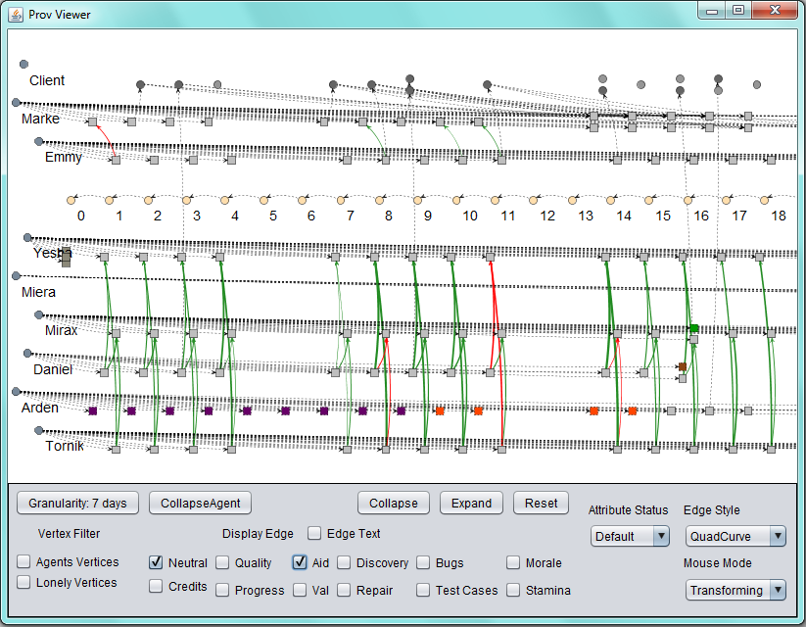

Figure 5: Prov Viewer’s GUI

Lastly, we used two metrics to compare the results obtained by both groups: precision and time. The precision metric, has the intention to verify the correctness of the answers provided by both groups. The time metric is used to measure the time each volunteer took to answer all questions, thus allowing to know which method (with or without provenance) is faster.

## Experiment Planning

We opted for a controlled environment in order to reduce independent variables that were beyond our control. Instead of playing the game, volunteers watched a recorded game session played by a third person. Thus, the questionnaire can be customized to the game session, allowing to ask specific questions about events that occurred in that particular session. Also, the questionnaire is designed to measure the precision of the answers provided by both groups (with and without provenance) and the time volunteers took to finish it. Precision [2] is a traditional metric for information retrieval and can be seen as a measure of correctness, which is the percentage results that are relevant. Time is measured in minutes taken to complete the questionnaire.

Before filling the questionnaire, volunteers are required to read and watch tutorials due to the unfamiliarity with the game and the *Prov Viewer* tool. Furthermore, we ran a pilot of the experiment in order to determine the experiment structure, which was initially structured as follows: volunteers were divided into two groups and start the experiment by watching the SDM tutorial, then the *Prov Viewer* tutorial (only for the group with provenance) and the replay of the game session video. Lastly, they receive the questionnaire.

This order was later changed for the experiment due to the fact that volunteers were reviewing the *Prov Viewer* tutorial while answering the questionnaire. This happened because they were forgetting how to operate the tool after watching the replay of the game session video, which takes around seven minutes. Another change made for the experiment was related to the questions in the questionnaire. Some questions were allowing different interpretations, which caused too many mistakes on both groups. Thus, we decided to create a new scenario (and video) with a different set of questions.

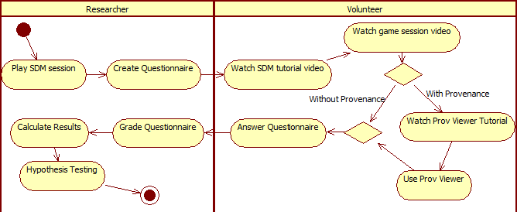

Figure 6: Experiment Execution activity diagram

With the changes made after the pilot, the experiment plan is illustrated by Figure 6 and is divided in three stages: Generating the questionnaire, running the experiment with volunteers (students), and analyzing the results. According to the plan shown in Figure 6, the first stage (Create Questionnaire) is executed before running the experiment with volunteers. We created the replay of a recorded game session from SDM that narrates the player’s decisions throughout the game.

The next stage is to run the experiment with volunteers. The volunteers watch a tutorial video from SDM, which explains details about the game interface, and read a written document summarizing key features. Subsequently, they watch the replay video and are divided in two groups: those that will use provenance and those that will not. After watching the replay video, the volunteers are handed the questionnaire. However, the group with provenance watches another tutorial video for the tool before receiving the questionnaire. This stage also has a time limit to avoid fatigue. The game session is available in GEMS[2], along with the provenance graph. Lastly, we performed a statistical analysis over the results by means of hypothesis test in order to compare the obtained results from both methods (with and without provenance).

Another important factor for the design of the experiment concerns the definition of the significance level to be used during statistical analysis. For the experiments performed in this work we used a confidence interval of 95%, which translates to α = 0.05 where α is the maximum probability of incorrect rejecting the null hypothesis (Type I error). The following subsections describes the game session used for the experiment, the proposed questionnaire, and execution details.

### Game Session Scenario

For this experiment we created the following scenario [3]: Starting the game, the player has at his disposal four employees: Yesha, Tornik, Mirax, and Emmy. The first thing he does is to assign roles for each employee. Yesha is assigned as the staff’s manager and has the task of aiding analysts. Tornik is assigned as an analyst, Mirax as marketing (which aids analysts and provides a cash income to the player by making deals), and, lastly, Emmy is assigned as programmer to develop the software. Then the player asks Yesha to hire tree new employees: Arden, which is placed in training, Marke, an architect, and lastly Daniel, an analyst that will work for 14 hours a day. Almost two weeks passed before Arden finished his training and was allocated to work as programmer.

Starting the third week in the game, the player begins to have financial problems and runs out of cash. Daniel, due to the extra hours, is tired and quits. The game continues with a few rearrangements in task. Tornik is assigned to do both elicitation and specification tasks as analyst and Arden begins to work as a programmer. Mirax is later promoted at the third week. At the fourth week, Marke’s role is changed to programmer, focusing on repairing reported bugs, and as a tester. Nearing the end of the week, Arden and Marke resign the staff due to lack of payments since the player was having financial problems. At the start of the next month, and after receiving cash from achieving a milestone from the contract with the client, the player hires another employee (Miera) as a programmer to replace Arden. At the same week, the player sets Mirax to negotiate with the client, asking to extend the project’s deadline by one extra week, since the deadline was ending. Because of the deadline extension, the staff manages to complete the software in time, delivering the software to the client.

The software delivered still had one reported and unfixed bug, plus another twenty five unknown bugs that were not identified by the staff. Aside from the bugs, the coding quality of the software was mediocre with a rate of 75.84. This rate can vary from 10 to 120, where 10 is the maximum negative modifier and above 100 provide a positive modifier. Thus the value 75.84 is near the average (65.0). Concerning the player’s financial status, the player started the game with 40,000 credits and at the end he had 5,969 credits and gained another 8,335 credits (out of 34,335) for delivering the software. The difference in payment is due to the number of bugs left in the software (26 bugs). Also, the player’s reputation did not increase because of the poor quality of the delivered software (number of bugs). Concerning the staff, the player kept all starting employees, but lost three, out of four, hired employees. Three of the remaining employees have lost morale during the development and one is fatigued. At the end of the session, the *game flux log* was generated by using the collected information from the game (employees, actions, and the project daily progression).

### Questionnaire

The questionnaire was designed based on the video, consisting of ten questions. The first and the last questions are related to time measurements: the times when the volunteer started and finished the questionnaire. The second question is designed to identify the group of the volunteer: with provenance, which uses *Prov Viewer* while answering the questionnaire, or without provenance, which answers the questionnaire only based on the video footage. The other seven questions are related to events that emerged during the game and have the same weight with values varying from 0 (wrong) to 1 (correct), depending on the answer provided. A value of 0.5 means the answer was partially correct, meaning that only one item was correctly identified. These questions explore different aspects from the game, and some questions require a deeper knowledge of the game.

The third question in the questionnaire asks one reason that made the employee Arden to quit the staff. The forth question is the same as the third, but related to the employee Daniel, since their motives for quitting the staff were different. Arden left because of lack of payment (morale decreased due to lack of payment) while Daniel left due to overworking and lack of payment (morale decreased due to low stamina and lack of payment). Either answer was acceptable because we only asked one reason. The fifth question asks why Tornik had made no progress during a certain period of time. The sixth question asks why Daniel’s productivity had a sudden drop from one day to another. The seventh question asks the most contributing factor that allowed finishing the software in time. The eighth question asks the two most contributing factors that caused financial problems after day eleven. The ninth, and last, question asks which employee was idle for a period of time.

### Experiment Execution

After the pilot and making the appropriate changes in the plan, we applied the experiment in two different undergrad classes [22], composed of 18 and 19 volunteers each. From those 37 volunteers, only 32 were able to finish the experiment in the allocated time, thus 5 partially answered questionnaires were discarded. After running the experiment on both classes, the questionnaires were analyzed.

## Statistical Analysis

A fundamental part of the statistical analysis of an experiment is the hypothesis test [25]. In the hypothesis test, two hypotheses are proposed and used to validate the collected data. However, hypothesis testing involves two types of error: Type-I and Type-II. The Type-I error refers to the rejection of the null hypothesis even when it is true, while the Type-II error refers to the acceptance of the null hypothesis when it is false. These errors depend on the power of the test C, which is the probability of 1 - β that the test is true if H0 is false and β is the probability of committing the error Type-II. Moreover, the hypothesis test can be parametric or non-parametric. Parametric tests have a greater power C, thus produces more accurate and precise estimates. However, parametric tests can only be used if the samples follow a normal distribution. Nevertheless, non-parametric tests do not require normality and are recommended when samples are small [25].

The statistical analysis was performed with the intention of checking the obtained results and verifying if they have any significant difference. The main idea is to compare the results obtained from the questionnaire and the elapsed time of both groups. All tests were done in the open source software *R* [17], which is commonly used for statistical analysis and graph construction, within the IDE *RStudio* [18].

On a normality test the null hypothesis H0 states that the collected data follows a normal distribution. The alternative hypothesis, H1, states that the collected data does not follow a normal distribution. Given this, a normality analysis from the obtained data decides between using parametric or non-parametric tests. Thus, we used the Shapiro-Wilk test [19] with the following hypotheses:

$$\begin{matrix}H_{0}:Sample x_{1}{, x}_{2},…,x_{n}have a normal distribution \\ H_{1}:Sample x_{1}{, x}_{2},…,x_{n} does not have a normal distribution\end{matrix}$$

The normality test was executed in *R* by applying the Shaphiro method at vector *x*, where *x* is the vector containing the data to be analyzed. It is provided as output the statistical value *W*[4] from the Shapiro-Wilk test and its *p-value*[5]. The null hypothesis is rejected if *p-value* is lower than the significance level α, thus concluding that the data do not have a normal distribution.

The normality assumption was violated for all obtained results from the experiment because *p-value* < 0.01. It is possible to verify that *p-value* < α since α = 0.05 and *p-value* < 0.01, thus rejecting the null hypothesis. Therefore, non-parametric tests were used for statistical analysis. The non-parametric test used to compare the means was Mann-Whitney, which is also known as Wilcoxon rank-sum [16] test. There are other non-parametric tests, such as Chi-2 and Kruskal-Wallis, however Mann-Whitney was chosen because it compares two means from two different samples against the same alternative hypothesis, which fits to our experiment design. The next subsection presents the results obtained from Mann-Whitney test to verify if the group results, with and without provenance, are the same.

### Comparison of Means

We adopted the following hypothesis in our tests, naming prov as the group that used the tool and replay the group that did not:

$$\begin{matrix}H_{0}: μ_{prov}=μ_{replay} \\ H_{1}: μ_{prov}≠μ_{replay}\end{matrix}$$

The mean is calculated for each question from the questionnaire and for the duration that each volunteer took to finish it. Table 1 illustrates the mean and the standard deviation of each question for both methods, with green values representing the group with higher mean at each question from the questionnaire.

Table 1: Mean and Standard Deviation for each question

|  |  |  |  |  |  |  |  |  |  |
| --- | --- | --- | --- | --- | --- | --- | --- | --- | --- |
|  | | **Q3** | **Q4** | **Q5** | **Q6** | **Q7** | **Q8** | **Q9** | **Duration** |
| **With Prov** | **Mean** | **0.5** | **0.9375** | 0.1875 | 0 | **0.375** | **0.1562** | **0.8125** | **23.1875** |
| **Standard Deviation** | 0.5164 | 0.25 | 0.4031 | 0 | 0.5 | 0.3010 | 0.4031 | 4.2461 |
| **Without Prov** | **Mean** | 0.0625 | 0.875 | 0.1875 | 0 | 0.25 | 0.0938 | 0.5 | 28.9375 |
| **Standard Deviation** | 0.25 | 0.3416 | 0.4031 | 0 | 0.4472 | 0.2015 | 0.5162 | 10.5797 |

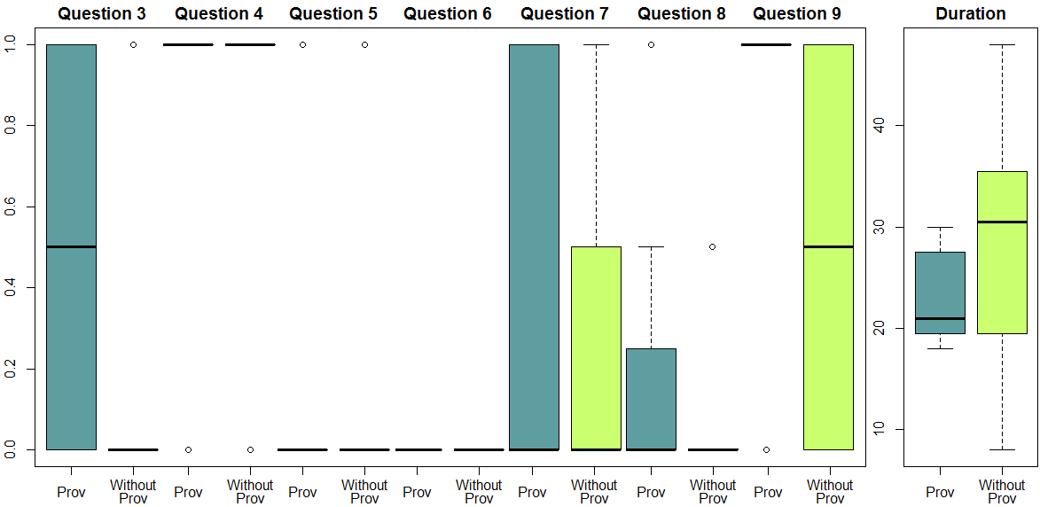

Figure 7: Boxplots from the experiment

Table 2: Results obtained from the Mann-Whitney test

|  |  |  |  |  |  |  |  |  |
| --- | --- | --- | --- | --- | --- | --- | --- | --- |
| **α = 0.05** | **Q3** | **Q4** | **Q5** | **Q6** | **Q7** | **Q8** | **Q9** | **Duration** |
| **p-value** | **0.007259** | 0.5757 | 1 | 1 | 0.467 | 0.6371 | 0.07049 | **0.03595** |

The *boxplots* shown in Figure 7 summarizes the distributions of both approaches (with and without provenance methods). In these graphs, the boxes represent part of the central distribution, which contains 50% of data. Thus, the data scattering is proportional with the box’s height. The median is represented by a black line inside the box. This way, 25% of data is between the box’s edges and the median. The median location indicates if the distributions are symmetrical in the experiments. Lastly, circles indicate outliers.

It is possible to assert that there is a difference in mean if the null hypothesis is rejected. The Mann-Whitney test was performed in R by the Wilcox function applied to *x, y* and computing the confidence interval, where *x* and *y* are vectors to be tested. As default, the *wilcox.test* paired attribute is set to false, representing the Mann-Whitney test, with the default α value of 0.05.

The null hypothesis is not rejected if *p-value* is greater than significance level α. In other words, there is not enough evidence to assert a difference between results. When the null hypothesis is rejected (*p-value* < α), it is necessary to identify which method is superior by analyzing the confidence interval *CI*. If *CI* – α < 0, then $μ_{prov}>μ_{replay}$. Otherwise $μ_{prov}<μ_{replay}$. By analyzing the *p-values* from Table 2, the usage of provenance analysis provided better results in question 3 and in the time required to finish the questionnaire (duration), while there is not enough evidence to assert difference between results for the other questions (*p-value* > α). Even though both questions 3 and 4 asked about the reason that an employee quit the staff, only one volunteer that answered the questionnaire without provenance identified that the lack of payment was the reason for it.

By comparing the *boxplots* in Figure 7 and the statistical results, it is possible to infer that question 3 yielded better results by using provenance while questions 4 and 5 had equal results. Meanwhile, questions 7 and 8 results were similar but with varying scattering. Even though results are matching with Mann-Whitney test data, question 9 has a different behavior due to the small difference from *p-value* to α (*p-value* = 0.07 against α = 0.05). By analyzing the *boxplot* for question 9, the results for using provenance are greater than without provenance. While without provenance’s data is scattered around the maximum and minimum values with the median at the middle, the provenance’s median is located at the maximum value.

Lastly, as shown by the Mann-Whitney test, using provenance for analysis provides faster answers than analyzing the game session’s replay. This is clearly seen by comparing the medians between both methods and the box’s scattering (height) position. The next section details existing threats to the experiment.

## Threats to Validity

Despite the care in reducing the threats to the validity of the experiment, there are factors that can influence the results. In relation to internal validity, the selection for both groups (with provenance and without provenance) can affect the results because of the natural variation in human performance. Furthermore, the experiment was executed with volunteers, which generally are more motivated for executing tasks. Anyone from the class could choose to be dismissed from the experiment and be released earlier. Lastly, the experiment was the first contact of the volunteers with both the game mechanics (by watching the video) and the tool. Thus, the lack of experience can affect the results, even when minimized by the usage of tutorials. For external validity, to level the experience of volunteers, they were from two different classes of the same discipline (Introduction to computer programming), which occurs in the first period of undergraduate course in Computer Science at *Universidade Federal Fluminense*.

Regarding construct validity, the questionnaires were composed of several questions to reduce threats related to a lack of knowledge from the game, thus exploring different aspects from it. Another risk is related to people being afraid of being evaluated, thus trying to “look better” by lying. This is the case of how long they took to finish answering the questionnaire. To minimize this, we had a strict timetable for each activity, stating the exact time they began answering the questionnaire and verifying the time they finished and delivered the questionnaire.

A threat related to conclusion validity is the reliability of measures. This is dependent on factors like question wording, which may allow for different interpretations, and the graph layout. To minimize the threat, we answered any doubts voiced by volunteers related to the questions in the questionnaire or regarding the tool (*Prov Viewer*). Another threat is related to the fact that volunteers examined a video of the gameplay session instead of playing it. In a real situation, they would play the game then proceed to the game flux analysis with provenance, making the provenance analysis more efficient due to the fact that the concepts and situations were experienced by the player himself, instead of analyzing a gameplay video from another player.

# CONCLUSION

This paper introduces new perspectives on software engineering learning, leveraging the current state of the art, based on game, to a level where the game provenance can produce and consolidate knowledge. This knowledge can help on (1) confirming the hypotheses formulated by students, (2) supporting tutors for a better guidance, (3) motivating practical exercises around some case studies, and (4) extracting behavior patterns from individual sessions or groups of sessions.

The provenance visualization allows the discovery of issues that contributed to specific game fluxes and results achieved throughout the gaming session. This analysis can be used on serious (digital) games to improve understanding of the game flux and identifying actions that influenced the outcome, aiding the student to understand why they happened the way they did. It can also be used by the tutor to analyze a game session to verify the student’s progress by checking his decisions and their consequences in the outcome, identifying concepts that might not be clear to the student.

The results from the experiment demonstrate that analyzing the game session with provenance provides equal or greater results than watching a replay of the session. Furthermore, analyzing the game flux with provenance is faster than only watching a replay of the game session. In relation to correctly identifying the causes of the events in the game, using provenance provided better statistical results in at least one case (question 3, related to lack of payment), and slightly better results in another (question 9, related to identifying the idle employee). The other cases were not statistically different with the current sample size, even when their mean (values) were greater than analyzing by watching a replay of the session.

Currently, we do not make automatic inferences to the user in the provenance graph, but let the user decide what he wants to infer. Studies in this area can be made in order to identify information that can be omitted from the user without affecting the overall analysis. Another interesting research is to automatically identify patterns in the game flux and points of interest for the student and tutor. For future work, we plan to work on different graph visualization layouts, introduce the provenance support in other education games, and run more experimental studies on the usage of provenance in educational games to evaluate the aspects of learnability. We also believe that the ideas discussed in this paper can open a wide range of research in the field of behavior patterns data mining of the learning sessions.

# ACKNOWLEDGMENTS

We would like to thank CNPq, FAPERJ, and CAPES for the financial support.

# REFERENCES

[1] Abt, C.C. 1987. *Serious Games*. University Press of America.

[2] Baeza-Yates, R.A. and Ribeiro-Neto, B. 1999. *Modern Information Retrieval*. Addison-Wesley Longman Publishing Co., Inc.

[3] Baker, A., Navarro, E. and van der Hoek, A. 2003. Problems and Programmers: An Educational Software Engineering Card Game. *International Conference on Software Engineering (ICSE)*. (2003), 614–621.

[4] Dantas, A., Barros, M. and Werner, C. 2004. A Simulation-Based Game for Project Management Experiential Learning. *Software Engineering and Knowledge Engineering (SEKE)*. 19, (2004), 24.

[5] Drappa, A. and Ludewig, J. 2000. Simulation in software engineering training. *International Conference on Software engineering (ICSE)*. (2000), 199–208.

[6] Fernandes, J.M. and Sousa, S.M. 2010. PlayScrum - A Card Game to Learn the Scrum Agile Method. *Games and Virtual Worlds for Serious Applications (VS-Games)*. 0, (2010), 52–59.

[7] Freire, J., Koop, D., Santos, E. and Silva, C.T. 2008. Provenance for Computational Tasks: A Survey. *Computing in Science Engineering*. 10, 3 (Jun. 2008), 11 –21.

[8] Kohwalter, T., Clua, E. and Murta, L. 2013. Game Flux Analysis with Provenance. *Advances in Computer Entertainment (ACE)*. (2013).

[9] Kohwalter, T., Clua, E. and Murta, L. 2012. Provenance in Games. *Brazilian Symposium on Games and Digital Entertainment (SBGAMES)*. (2012).

[10] Kohwalter, T., Clua, E. and Murta, L. 2011. SDM – An Educational Game for Software Engineering. *Brazilian Symposium on Games and Digital Entertainment (SBGAMES)*. (2011), 222–231.

[11] Moret, B. 1982. Decision Trees and Diagrams. *ACM Computing Surveys (CSUR)*. 14, 4 (1982), 593–623.

[12] Navarro, E.O. and van der Hoek, A. 2004. SimSE: an educational simulation game for teaching the Software engineering process. *Innovation and technology in computer science education (ITiCSE)*. 36, 3 (2004), 233–233.

[13] PREMIS Working Group 2005. *Data Dictionary for Preservation Metadata*. Implementation Strategies (PREMIS).

[14] Prensky, M. 2001. Fun, Play and Games: What Makes Games Engaging. *Digital Game-Based Learning*. (2001), 1–31.

[15] PROV Model Primer: 2010. *http://www.w3.org/TR/prov-primer/*. Accessed: 2013-03-21.

[16] R Documentation: Wilcoxon Rank Sum and Signed Rank Tests: *http://stat.ethz.ch/R-manual/R-patched/library/stats/html/wilcox.test.html*. Accessed: 2013-03-26.

[17] R: *http://www.r-project.org/*. Accessed: 2013-03-26.

[18] RStudio: *http://www.rstudio.com/*. Accessed: 2013-03-26.

[19] Shapiro, S.S. and Wilk, M.B. 1965. An Analysis of Variance Test for Normality (Complete Samples). *Biometrika*. 52, 3/4 (1965), 591.

[20] Sharp, H. and Hall, P. 2000. An interactive multimedia software house simulation for postgraduate software engineers. *International Conference on Software Engineering (ICSE)*. (2000), 688–691.

[21] Smith, R. and Gotel, O. 2008. Gameplay to Introduce and Reinforce Requirements Engineering Practices. *Requirements Engineering Conference (RE)*. (2008), 95–104.

[22] Svahnberg, M., Aurum, A. and Wohlin, C. 2008. Using students as subjects - an empirical evaluation. *Empirical software engineering and measurement (ESEM)*. (2008), 288–290.

[23] Tillmann, N., De Halleux, J., Xie, T., Gulwani, S. and Bishop, J. 2013. Teaching and learning programming and software engineering via interactive gaming. *International Conference on Software Engineering (ICSE)*. (2013), 1117–1126.

[24] Von Wangenheim, C.G., Savi, R. and Borgatto, A.F. 2012. DELIVER! - An educational game for teaching Earned Value Management in computing courses. *Information and Software Technology*. 54, 3 (Mar. 2012), 286–298.

[25] Wohlin, C., Runeson, P., Höst, M., Ohlsson, M.C., Regnell, B. and Wesslén, A. 2000. *Experimentation in software engineering: an introduction*. Kluwer Academic Publishers.

[26] Ye, E., Liu, C. and Polack-Wahl, J.A. 2007. Enhancing software engineering education using teaching aids in 3-D online virtual worlds. *Frontiers In Education (FIE)*. (2007), T1E–8–T1E–13.

[27] Zhu, Q., Wang, T. and Tan, S. 2007. Adapting Game Technology to Support Software Engineering Process Teaching: From SimSE to MO-SEProcess. *International Conference on Natural Computation, 2007. ICNC 2007*. 5, (2007), 777–780.

1. Provenance refers to the documented history of an object's life cycle and is generally used in the context of art, digital data, and science [13].
2. The videos and the *Prov Viewer* with the provenance graph used during the experiment are available at http://gems.ic.uff.br/  
   ping/.
3. Available at http://gems.ic.uff.br/ping/.
4. The W statistic checks if the sample is from a normal distribution. Data normalization is shown by low values.
5. *p-value* is the lowest level of significance at which the null hypothesis could be rejected for the given observations.