Specular Fading over Distance on Wrinkled Surfaces
Applied for Game Engines

Troy C. Kohwalter
Esteban W. G. Clua
Leandro A. F. Fernandes

Instituto de Computação
Universidade Federal Fluminense
Niterói – RJ, Brazil
{tkohwalter, esteban, laffernandes}@ic.uff.br

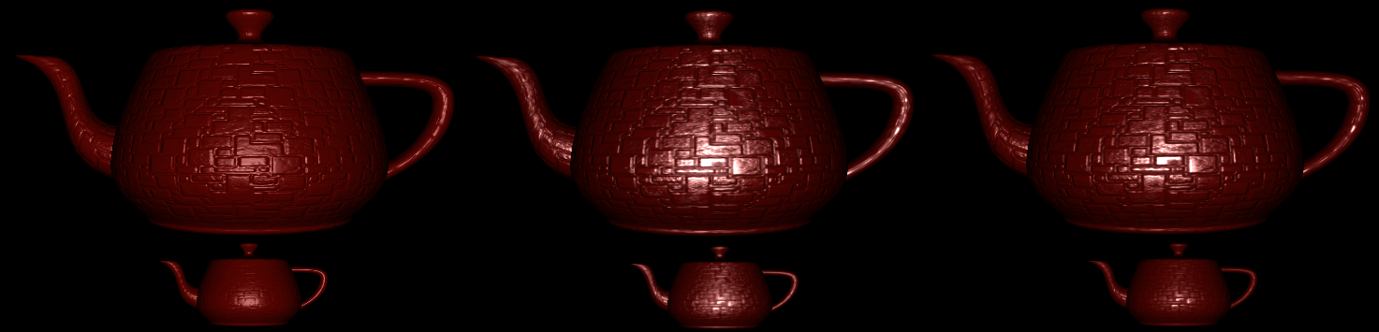
Figure 1: Bump mapping with Blinn-Phong, LEAN Mapping and Specular fading on a teapot.

Abstract— Blinn’s illumination model is commonly used in real time graphics. This model allows a rich visual experience without the usage of highly detailed meshes when used with normal maps. However, when the observer is far from the surface, the bumped regions may become blurred and disappear, thus making the surface duller than it is. To fix this issue, a new approach was developed recently and the result is satisfying. However, in that approach the specular highlight intensity made by the small bumps is unaffected by the distance. One way to reduce the specular effect is by using traditional fog techniques, where most algorithms change only the alpha factor, maintaining the same specular shape. To correct this issue, this paper proposes an alternative and efficient approach that solves this specular highlight intensity by applying a fog-like term during the calculation of the specular component.
Keywords— bump-mapping, normal-mapping, lean mapping, specular ilumination, fog.

Introduction
To create the illusion of details in surfaces or surface structures, artists usually create bump maps. In many cases these bump maps contain random bumps to better simulate rough surface materials at close range. The surface of these perceived roughnesses should be the same when displayed at different distances to the viewer. However, the shading of these bumps, which are mapped to surfaces, are often inconsistent across different levels of detail and distance, because the shading model at the coarsest level of detail does not correspond to the mapped bumps at finer level of detail. As a result, the bump map is not consistent with the shading model.
Bump mapping was originally introduced by Blinn [1]. He demonstrated how to simulate wrinkled surfaces by only perturbing the normal vector without changing the underlying surface itself. The new perturbed normal is used for lighting calculations instead of the original normal. For about thirty years, the bump mapping introduced by Blinn has been an effective method for adding apparent detail to a surface. Programmable GPUs made this technique available for real time rendering, being a common feature in almost any 3D game.
Unfortunately, bump mapping has serious drawbacks with filtering and antialiasing. When the bumps are viewed at a distance, the standard MIP mapping technique for bump map can work well for diffuse shading [2]. However, it fails to capture changes in specularity. When looking far away, the result will be a shiny and bump-less surface, appearing as if it were duller. Many techniques that tries to solve the highlight aliasing problem were proposed, but they require too many pre-computation, such as [3][4][5]. To correct this issue, a new mapping approach was developed [6]. With this approach, the bumps are preserved at high distances. Nevertheless, the specular highlights produced by these small bumps are also visible, making the surface artificially shiny.
This paper proposes an improvement of the LEAN mapping by introducing a fog-like effect in order to reduce the specular highlight according to the distance of the object. For this aim, we use the LEAN mapping in order to avoid the blurring of the bump surface and propose a modification to make the necessary change in the specular highlight, reducing the shiny effect. Note that this only affects the specular term, so it can be used in conjunction with fog algorithms, making so that with the increase of distance, the object will suffer light scattering and gradually lose the specular highlight.
On this paper, we use the term bump mapping to refer to the original deformation texture that defines surface normal perturbation for the shading calculation. This paper is organized as follows: Section 2 presents some ground basement of previews works in the area, as well as an overview of the proposed method. Section 3 presents our modified method. Section 4 show the results of the method and Section 5 show some implementation details. Finally, Section 6 presents the conclusion of this work.

Related Work
There are many approaches to represent bumps in an object's surface. One of the first well established models originated from Blinn [7], which uses a simple shading equation based on microfacets. That model is a modification of the Phong model [8], enhancing its visually appealing for small wrinkled materials. After this proposal, many other ways to represent surface bumps were developed with better and more flexible results. One of such is the storage of the surface normal in texture maps [9] [10] to render diffuse and specular reflections from the small bumps in the surface. Another model that is based on microfacets is Cook-Torrance [11], which also adds shadowing and a Fresnel term to make it more realistic. Ward [12] introduced an anisotropic BRDF model that is based on an anisotropic Gaussian microfacet distribution and Ashikhmin [13] have developed a way of generating reflection models from arbitrary normal distributions.Lastly was the Linear Efficient Antialiased Normal Mapping (LEAN) model, in which this work was based on. Since this paper proposes an improvement of the LEAN model by adding an effect similar to fog, we will also briefly present the Distance Fog, a technique used to enhance the perception of distance by simulating fog and light scattering, causing distant objects to appear with lower contrast.

Lean Mapping
As previously observed, Bump Mapping has a highlight problem, which is caused by filtering. When viewed from distance, the sampled surface will be filtered and result in changing the normal to the average value computed that as a result make the bumps no longer visible, which causes the impression of a duller surface. To deal with it, a new technique was developed called LEAN mapping [6]. The LEAN mapping is a simple model that is compatible with existing diffuse bump filtering. It has a low pre-computation and run-time cost while also being compatible with existing shading models based on Blinn-Phong [7] or Beckmann-distribution [14]. In addition, LEAN mapping allows for several approaches to combine multiple bump layers.
The LEAN mapping bump specularity is a modification of the Ward shading model [12], which assumes perfectly reflective micro facets that are randomly distributed around the overall surface normal. The LEAN mapping model requires one additional MIP [15] texture lookup per shading evaluation and also manages to capture antialiasing of the highlight shape and the transition of anisotropic bumps into an anisotropic highlight. For the computation, the LEAN mapping uses an existing height or normal map [16] to generate the LEAN map on GPU [6].
LEAN mapping can be used in game arts due to its simplicity, low computational overhead and compatibility with Blinn-Phong. To use LEAN mapping with existing Blinn-Phong-based game assets, it is necessary to use the equivalence of the Blinn-Phong model with the symmetric Ward model using a Beckmann distribution. Given a bump normal map (1), the LEAN map textures are computed as:
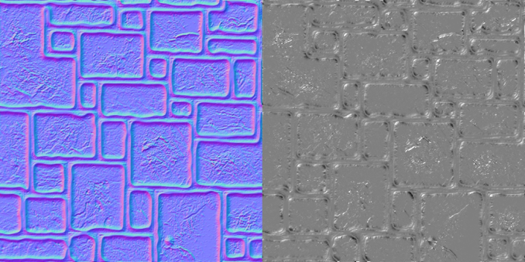
(1)
(2)
(3)
Figure 2: First texture generated by LEAN. The first three values from the texture (RGB) represents the bump normal, and the last one (Alpha) M.z.
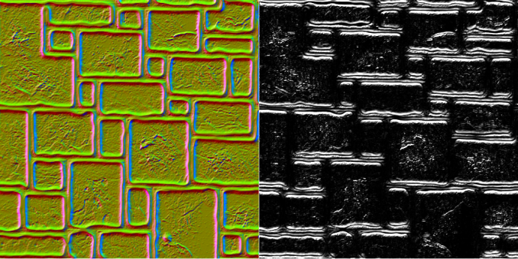
Figure 3: Second texture generated by LEAN. The first two values (RG) represent B while the last two (BA) M.x and M.y.Where b is the Bump Normal and a division of the coefficient by b.z. Equation (2) and (3) are used to generate both LEAN maps with their respective values. The textures sampling of these five values obtained by (2) and (3) gives an anti-aliased, filtered blend of the bumps and specular shading for any view. To store five values in textures, it is required the usage of two textures, which enables the possibility to store eight values. The remaining three values can be used to store the Bump Normal in order to save computation and improve the quality of the diffuse filtering, instead of reconstructing it. Figure 2 and Figure 3 illustrates the RGBA from both generated LEAN textures. Storing the Bump Normal also allows for the usage of diffuse filtering with a non-normalized normal after the texture filtering, as observed by [2].
Given the LEAN textures values, B and M from (2) and (3), it is possible to reconstruct the covariance ∑ with (4) by using MIP levels and any linear filtering. The covariance controls the size and shape of the highlight center. With the covariance, it is possible to compute ∑⁻¹ to use calculate the LEAN specular term in (5).
To use LEAN mapping with Blinn-Phong specularity, it is necessary to add the 1 / s term in the final shading when constructing the covariance ∑, adding it in the M.x and M.y terms [6]. Doing so will result in the effect of baking the Blinn-Phong specularity in the texture. Figure 4 shows the difference between the techniques of LEAN mapping and Bump mapping.
(4)
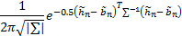 (5)
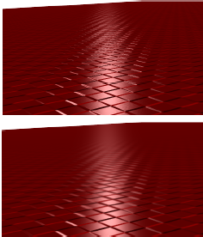
Figure 4: Bump Mapping versus LEAN Mapping: First picture is generating an ordinary bump map. Second picture was using LEAN mapping with trilinear MIP filtering. Figure adapted from [6].

Distance Fog
Distance Fog, also referred as true fog or range fog, tints the screen according to the distance that a given pixel is from the camera. Objects further away will appear to fade into the fog. To do this, distance fog need to check distances every frame, and as a result can have an impact on performance. Some limitations can be set to reduce this impact, like rejecting objects beyond a certain distance. The resulting effect of distance fog simulates light scattering, which causes objects that are more distant to appear in lower contrast. This technique can also be used to obscure objects with a fog gradient by haze and aerial perspective. Figure 5 illustrates an example of the fading effect from distance fog.
The range-based fog approach is a more accurate way to determine the fog effects. In method, it is used the actual distance from the viewpoint to a vertex for its fog calculations, increasing the effect of fog as the distance between the two points increase, rather than the depth of the vertex within in the scene, thereby avoiding rotational artifacts.
Graphic APIs, such as Direct3D or OpenGL, have three interpolations for fog: One linear and two exponential. The Linear fog equation (6), known in Direct3D as D3DFOG_LINEAR, and the Exponential fog equations (7) and (8), also known as D3DFOG_EXP and D3DFOG_EXP2:
The system stores the fog factor in the alpha component of the specular color for a vertex. If the application performs its own transformation and lighting, it is possible to insert the fog factor values manually during the rendering process. When the fog effects are calculated, the fog factor from one of the previews equation is used in a blending process. The blending equation (9) effectively scales the color of the current polygon C by the fog factor f, and adds the product to the fog color C, scaled by the bitwise inverse of the fog factor. The resulting color value is a blend of the fog color and the original color, as a factor of distance.
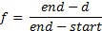 (6)
(7)
(8)
- start is the distance at which fog effects begin.
- end is the distance at which fog effects no longer increase.
- e is the base of natural logarithms (approximately 2.71828).
- density is an arbitrary fog density that can range from 0.0 to 1.0.
- d represents depth, or the distance from the viewpoint. For range based fog, the value for d is the distance between the camera position and a vertex. For non-range based fog, the value for d is the absolute value of the Z-coordinate in camera space.
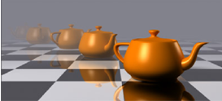
Figure 5: Distance Fog representation. Note that the teapot begins to vanish when camera distance increases. Even so, the specular highlight is identical to the original model, minus the change in alpha to make the model transparent. Figure adapted from http://en.wikipedia.org/wiki/.
(9)

Specular Fading
The proposed shading model in this paper is a variation of the LEAN mapping technique proposed by [6]. As was presented on section 2, LEAN mapping is used to deal with the highlight aliasing and the blurred drawback generated from bump mapping when the object is viewed from certain distances. LEAN solves this issue very well, maintaining the clarity of the bumps in the surface. However, the specular shininess is also maintained, even on huge distances, as shown in Figure 6. As the figure illustrates, the ocean highlights caused from the bump deformations to simulate ocean waves are still present even on huge distance near the island's coastal. This happens because LEAN preserves the bump surface as well as the bump specularity, which is based on the Ward model. The Ward model assumes perfectly reflective microfacets that are randomly distributed around the overall surface normal.
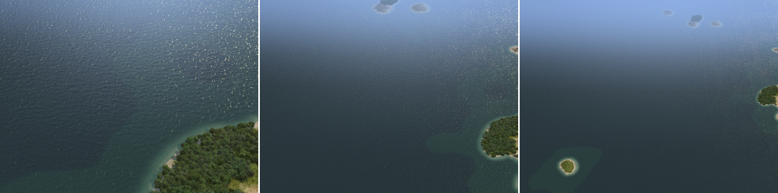
Figure 6: LEAN mapping specular highlight is present on huge distances. Notice the highlight at the upper right corner of the picture. Figures extracted from [6].
To deal with this problem, we propose a modification of the shading specular component, similar to the effect of distant fog, but affecting only the specular highlight intensity, reducing it gradually up to a minimum accepted value defined by the user. This specular fading term varies according to the camera distance from the object. Both the minimum and maximum highlight specular intensity is configurable, and viewed on close range is identical to LEAN. This new configurable empirical specular fading term is added as a power of the dot product between Normal and Light vectors.
This new term allows the specular control over distance, which is made during the shading process without too much computational overhead. In addition, unlike fog that changes the alpha according to the distance and thus preserving the specular highlight, this term actually reduces it without interfering with the alpha component. Equation (10) is the specular fading control (sf).
(10)
Where V is the view vector, Fade is a parameter to configure the fading rate, which can also be used to adjust to the world scale, and maxP is the maximum specular fade desired by the user. This term is applied as shown by (11), where Ks is the material specular component, sf the specular fading, and spec is the LEAN specular term.
(11)

Results
While comparing LEAN map with our proposed model, it is possible to notice the difference on specular highlight when the distance between the camera and the object changes. Figure 1 and Figure 7 illustrates the specular fading, LEAN and bump mapping. Figure 8 and Figure 9 shows the difference between normal LEAN technique and LEAN with specular fading. As shown in it, the farther the object is from the camera, lower the specular highlight is. This also corrects the specular highlight from fog algorithms, which changes the alpha component making it transparent over distance. Notice that this method only reduces the specular highlight, so it can be used in conjunction with distance fog without problems, allowing the fog algorithm to fade the object while changing the specular highlight, unlike shown in Figure 5, which maintains the highlight while fading.
Tests were made in order to compare the new model with the traditional LEAN technique. The computer that ran the tests uses a geforce GTX550Ti, Windows 7 64-bit. The recorded frames per second were ranging over 1000 to 1600 FPS for both methods, which varies with the camera range and the object, The difference with only of 10 FPS between the two techniques. The model used on these tests had 256 triangles and 200 vertices. With a teapot model containing 79600 triangles and 44366 vertices, the frame rates were around 570 to 790 FPS depending on the range with minimal difference of 5 FPS.

Implementation
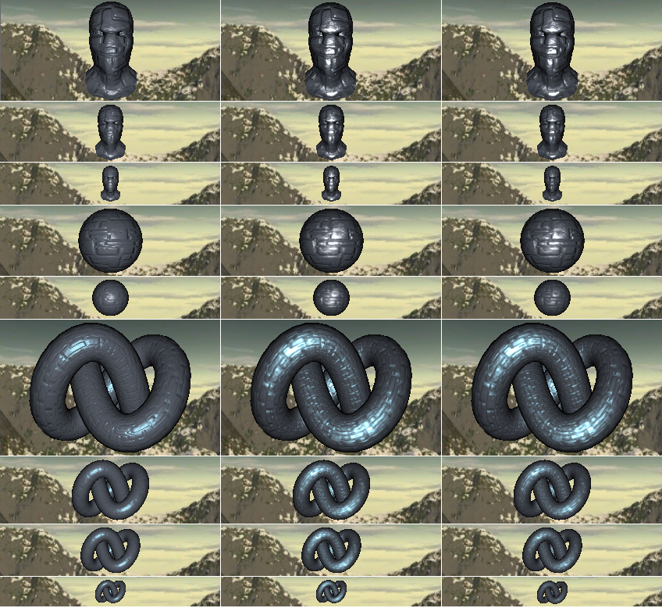
Figure 7: Comparison between Bump Mapping (left column), LEAN mapping (center), and Specular Fading (right column) using three different models: ninja head, sphere and a torus. Notice the difference specular highlights as the distance increases.
The implementation in this section shows only the application of the equation in the LEAN shader. For LEAN, generate lean maps textures normally and unpack N, B, M terms from the texture. Then, convert M to ∑ and compute the specular term. After this process, compute the specular fading and the final color, as shown by Figure 10.

Conclusion
This paper presented an improvement technique for LEAN mapping for its inherent problems with the specular highlight over distances, as well as how distance fog algorithm try to solve it. As a result, an improvement was developed and presented in order to affect the highlight according to the object’s distance. Since this only affects the specular term, it can also be used in conjunction with fog to increase the visual appeal. Because this approach is based on LEAN, a performance comparison was made between both approaches. It was concluded that the performance cost of the modification does not have noticeable impact on calculation speed. Also this approach can be used in real time applications because it uses LEAN mapping in its core.
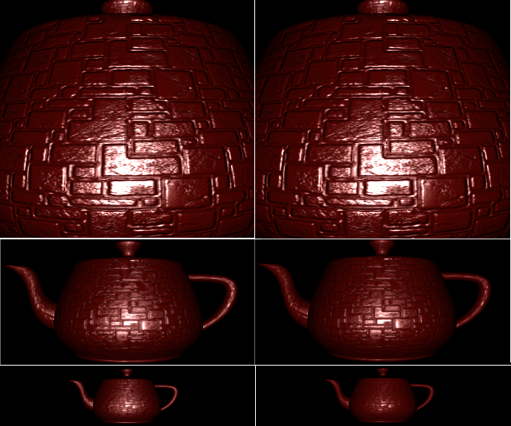
Figure 8: Comparison between LEAN and our proposed improvement using a teapot model. In the left is the traditional LEAN technique and in the right the proposed improvement. As shown in the figure, at close range they are identical, however the farther the camera is from the object, less specular highlight.
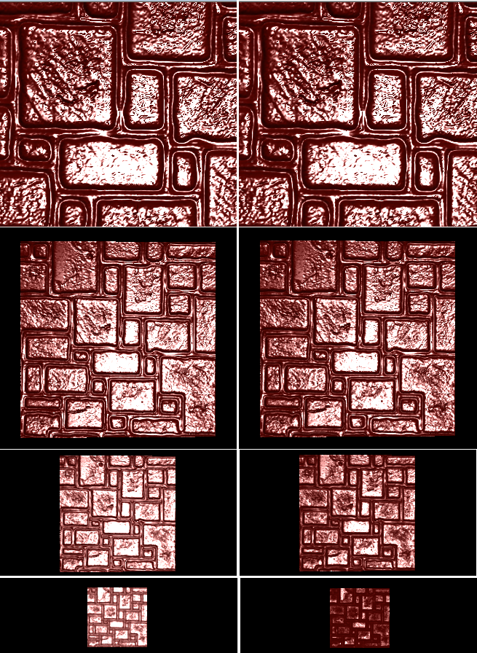

Figure 9: Another comparison between LEAN and our proposed improvement using a square model. In the left is the traditional LEAN technique and in the right is LEAN with specular fading.Acknowledgements
We would like to thank CNPq, FAPERJ and CAPES for the financial support.
vec4 t1 = texture2D(Lean1, gl_TexCoord[0].st);
vec3 Normal = vec3(t1.xyz) * 2.0 - 1.0;
// Equivalence for the Blinn-Phon is 1 / s, where s is the specular expoent. This is done here to remove the dependancy on the lean map creation.
float power = 1.0 / MaterialShininess;
// Unpack B and M
vec4 t2 = texture2D(Lean2, gl_TexCoord[0].st);
vec2 B = (t2.xy * 2.0 - 1.0) * scaleFactor;
vec3 M = vec3(t2.zw + power, t1.w * 2.0 - 1.0) * scaleFactor * scaleFactor;
//Convert M to E
vec3 E = M - vec3(B * B, B.x * B.y);
float Det = E.x * E.y - E.z * E.z;
// Compute LEAN Specular term
vec2 h = Half.xy / Half.z - B;
float e = (h.x * h.x * E.y + h.y * h.y * E.x - 2.0 * h.x * h.y * E.z);
float spec = (Det <= 0.0) ? 0.0 : exp(-0.5 * e / Det) / sqrt(Det);
// Normal dot LightDirection
float NdotL = clamp (dot (Normal, fvLightDirection , 0.0, 1.0);
fvTotalDiffuse = fvMaterialDiffuse * NdotL;
// Spec Fading Computation
float specFading = 1.0 + (pow(ViewDirection.z * SpecFadeRange, 2.0) );
specFading = clamp(specFading, 1.0, maxPower);
// Add specFading to Specular component
fvTotalSpecular = fvMaterialSpecular * pow(NdotL, specFading) * spec;
// Compute Fresnel
float fFresnel = clamp(FresnelBias + (FresnelScale * pow(1.0 - dot(Normal, fvViewDirection), 5.0)), 0.0, 1.0);
fvTotalSpecular *= fFresnel;
// Final Color
color = (fvTotalDiffuse + fvTotalSpecular).xyz * LightColor.xyz;
Figure 10: GLSL pseudo code for specular fading applied in LEAN shader in tangent space.

References
[1] J. F. Blinn, “Simulation of wrinkled surfaces,” SIGGRAPH Comput. Graph., vol. 12, no. 3, pp. 286–292, Aug. 1978.
[2] M. Kilgard, “A practical and robust bump-mapping technique for today’s GPU’s,” In: GDC 2000, 2000.
[3] B. Cabral, N. Max, and R. Springmeyer, “Bidirectional reflection functions from surface bump maps,” SIGGRAPH Comput. Graph., vol. 21, no. 4, pp. 273–281, Aug. 1987.
[4] B. G. Becker and N. L. Max, “Smooth transitions between bump rendering algorithms,” presented at the Proceedings of the 20th annual conference on Computer graphics and interactive techniques, New York, NY, USA, 1993, pp. 183–190.
[5] S. H. Westin, J. R. Arvo, and K. E. Torrance, “Predicting reflectance functions from complex surfaces,” presented at the Proceedings of the 19th annual conference on Computer graphics and interactive techniques, New York, NY, USA, 1992, pp. 255–264.
[6] M. Olano and D. Baker, “LEAN mapping,” presented at the Proceedings of the 2010 ACM SIGGRAPH symposium on Interactive 3D Graphics and Games, New York, NY, USA, 2010, pp. 181–188.
[7] J. F. Blinn, “Models of light reflection for computer synthesized pictures,” SIGGRAPH Comput. Graph., vol. 11, no. 2, pp. 192–198, Jul. 1977.
[8] B. T. Phong, “Illumination for computer generated pictures,” Commun. ACM, vol. 18, no. 6, pp. 311–317, Jun. 1975.
[9] W. Heidrich and H.-P. Seidel, “Realistic, hardware-accelerated shading and lighting,” presented at the Proceedings of the 26th annual conference on Computer graphics and interactive techniques, New York, NY, USA, 1999, pp. 171–178.
[10] J. Kautz and M. D. McCool, “Interactive rendering with arbitrary BRDFs using separable approximations,” presented at the ACM SIGGRAPH 99 Conference abstracts and applications, New York, NY, USA, 1999, p. 253–.
[11] R. L. Cook and K. E. Torrance, “A Reflectance Model for Computer Graphics,” ACM Trans. Graph., vol. 1, no. 1, pp. 7–24, Jan. 1982.
[12] G. J. Ward, “Measuring and modeling anisotropic reflection,” SIGGRAPH Comput. Graph., vol. 26, no. 2, pp. 265–272, Jul. 1992.
[13] M. Ashikhmin, S. Premoze, and P. Shirley, “A Microfacet-based BRDF Generator,” In: Proceedings SIGGRAPH ’00, pp. 65–74, 2000.
[14] P. Beckmann and A. Spizzichino, The Scattering of Electromagnetic Waves from Rough Surfaces. Pergamon Press, 1963.
[15] L. Williams, “Pyramidal parametrics,” SIGGRAPH Comput. Graph., vol. 17, no. 3, pp. 1–11, Jul. 1983.
[16] J. Cohen, M. Olano, and D. Manocha, “Appearance-preserving simplification,” presented at the Proceedings of the 25th annual conference on Computer graphics and interactive techniques, New York, NY, USA, 1998, pp. 115–122.

