Similarity Collapse: Reducing the Provenance Graph by clustering similar states
Troy C. Kohwalter Esteban G. W. Clua Leonardo G. P. Murta
Instituto de Computação
Universidade Federal Fluminense
Niteroi – RJ, Brazil
{tkohwalter, esteban, leomurta}@ic.uff.br

ABSTRACT
Paste the appropriate copyright/license statement here. ACM now supports three different publication options:
- ACM copyright: ACM holds the copyright on the work. This is the historical approach.
- License: The author(s) retain copyright, but ACM receives an exclusive publication license.
- Open Access: The author(s) wish to pay for the work to be open access. The additional fee must be paid to ACM.
This text field is large enough to hold the appropriate release statement assuming it is single-spaced in TimesNewRoman 8 point font. Please do not change or modify the size of this text box.

Winning or losing a game session is the final consequence of a series of decisions and actions made during the game. The analysis and understanding of events, mistakes, and flows of a concrete game play may be useful for different reasons: understanding problems related to gameplay, data mining of specific situations, and even understanding educational and learning aspects in serious games. In a previous work we introduced a novel approach based on provenance concepts in order to model and represent a game flow. The resulting provenance graph allows developers and designers to identify possible mistakes and failures in gameplay design by analyzing the collected gameplay data. However, due to game dynamics, the resulting provenance graph can be overwhelming in size, making it difficult to identify sections of interest in the game session. To solve this problem, we propose a similarity collapse, which cluster nearby vertices that have similar values in order to reduce graph’s size. We also provide a Prolog implementation and analyses examples explaining the semantic reason of each collapse.

Author Keywords
Game Analysis; Provenance; Graph; Inference; Game Flux; Clustering.

ACM Classification Keywords
E.1. Data Structures. E.2. Data Storage Representations. I.5.3. Clustering. K.8.0. General

INTRODUCTION
The conclusion of a game session derives from a series of decisions and actions made throughout the game. In many situations, analyzing and understanding the events, mistakes, and fluxes of a concrete gameplay experience may be useful for understanding the achieved results. A game flux analysis may also be fundamental for detecting symptoms of problems that occurred due to wrong decision-making or even bad gameplay design.
Besides that, without any formalized process, this type of analysis may be subjective and, depending on the game dynamics and its complexity, it would require playing the game successively, making the same decisions, to intuitively guess which ones were responsible for generating the observed effects. Thus, reproducing the same state can be unviable, making it difficult to replay and identify, in a trial and error approach, the source of the problem. In addition, examining the game flux might allow for the identification of good and bad attitudes made players. This knowledge can be used in future game sessions to avoid making the same mistakes or even to adjust gameplay features.
The analysis process for detecting gameplay issues is done nowadays in an artisanal way by using a popular beta testing [3] approach. The beta test phase is an indispensable source of data for the developers about technical issues or bugs found in the game. Normally, beta testers are volunteers who were recruited to play the game in an early, pre-release, build of the game where they can provide information about technical issues and provide feedback about the gameplay mechanics. Thus, beta testing is a crucial part of the development to identify important issues in the game. However, developers have little control over the beta testers’ gameplay experience or the environment because they can play at home.
In our previous work [10], we were the first to introduce the usage of digital provenance [5] in games. The main goal of the previous work was to propose a framework that collects information during a game session and maps it to provenance terms, providing the means for a post-game analysis. This was the first time that the provenance concept and formalization was used in the representation of game flux.
Following that work, we published another work [9] based on the conceptual framework that was introduced in the previous paper. However, while the first one focused on the provenance gathering, our second work focused on the provenance graph construction and manipulation to support analysis. This provenance analysis is useful to support advanced game flux analysis, such as gameplay design and balancing, data mining, and even for storytelling due to its rich data extraction capabilities. In that work, we aimed to improve the game designer’s understanding of the game flux by providing insights on how the gameplay progressed and influences in the outcome. In order to improve understanding, we provided the means to analyze the game flux by using provenance using our conceptual framework. We also demonstrated in [11] that such analysis helps to understand the events that occurred during a game session.
The provenance analysis described requires processing the collected gameplay data and generating a provenance graph, which relates the actions and events that occurred during the game session. This provenance graph allows the user to identify critical actions that influenced the game outcome and helps to understand how events were generated and which decisions influenced them. The game’s provenance analysis can be used in conjunction with the beta testing in order to aid in the identification of gameplay or technical issues, allowing the designer to analyze the tester’s feedback report and the gameplay data from the game session.
However, depending on the game style, a game session might take several hours or days to be completed. This makes the size of the provenance graph overwhelming, making it difficult for the developer to analyze the game’s provenance data due to the sheer number of collected information. Thus, in this paper we propose an automatic inference based on similarity in order to reduce the graph size and quickly identify sections in the graph that had significant changes during the game.
This paper is organized as follows: The first section provides related work in the area of game flux analysis. The following section provides a background on the provenance in games framework and the third section presents our approach for reducing the generated provenance graph through similarity inferences. Then we present the inference implementation and integration in the Prov Viewer tool, followed by examples. Finally, the last section concludes this work and points out some future work.

Related Work
In the digital game domain, Warren [6] proposes an informal method to analyze the game flux using a flux graph, mapping game actions and resources into vertices. By his definition, resources are dimensions of the game state that are quantifiable, while actions are rules of the game that allowed the conversion of one resource into another. Consalvo [2] presents a more formal approach based on metrics collected during the game session, creating a gameplay log to identify events caused by player choices. Playtracer [1] allows the user to visually analyze play steps, providing detailed visual representation of the actions taken by the player through the game.
These three approaches are developer-oriented, meaning that they aim to improve the quality of the game by providing feedback to the development team. However, Consalvo [2] presents a template for analysis, acting as guidelines to how the analysis should be done. Meanwhile, Playtracer [1] focuses on identifying the player’s strategies by visually analyzing play traces instead of using queries.
Lastly, the Game Analytics [7] from Unity3D [14] allows visualizing game data as heat maps directly on the scene. This identifies bottlenecks and hotspots, and underused and overused areas of the game. It also measures the game retention rate, where players are stopping playing, and how the game progression develops.

Provenance In Games Framework
In order to adopt provenance for the context of games, it is necessary to map each type of vertices of the provenance graph into elements that can be represented in games. The PROV model uses three types of vertex: Entities, Activities, and Agents. In order to use these vertex types, it is first necessary to define their counterparts in the game context.
In the context of provenance, entities are defined as physical or digital objects. Trivially, in our approach they are mapped into objects present in the game, such as weapons and potions. In provenance, an agent corresponds to a person, an organization, or anything with responsibilities. In the game context, agents are mapped into characters present in the game, such as non-playable characters (NPCs), monsters, and players. It can also be used to map event controllers, plot triggers, or the game’s artificial intelligence overseer that manages the plot. Thus, agents represent beings capable of making decisions, while entities represent inanimate objects. Lastly, activities are defined as actions taken by agents or interactions with other agents or entities. In the game context, activities are defined as actions or events executed throughout the game, such as attacking, dodging, and jumping.
With all three types of vertex mapped into the game context, it is also necessary to map their causal relations to create the provenance graph. The PROV model defines some causal relations that can be used similarly to their original context. However, it also provides rules to extend these relationships or to create new ones. For instance, it is possible to create relationships to express the damage done to a character or relationships that affect specific core mechanics from the game, like attack rolls, healing, and interactions with NPCs or objects. Also, the PROV model deals well with the aspect of time, which can be heavily explored in games, especially on games focused on storytelling.
Each NPC in the game should explicitly model its behavior in order to generate and control its actions, providing an array of behavior possibilities. For example, decision trees [12] can be used to model the NPC’s behaviors. With this explicit model, a behavior controller can register information about the action when it is executed. Actions can be represented by a series of attributes that provide a description and the context of the action, allowing the creation of a provenance graph. As illustrated by Figure 1, every action needs some information: a reason for its existence, why the action was performed, what triggered it, and who performed the action. In addition, the time of its occurrence can be important depending of the reason of using provenance. The main reason of using provenance is to produce a graph containing details that can be tracked to determine why something occurred the way it did. Therefore, with this assumption, the time of the action, the person who did it, and the effects of the action can be recorded for future analysis.
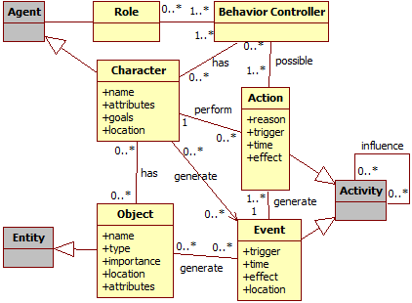
Figure 1: Data model diagram. Gray classes represent generic provenance classes.Events also work in a similar way as actions, with the difference in who triggered them, since events are not necessary tied to characters. For objects, its name, type, location, importance, and the events that are generated by it can also be stored to aid in the construction of the graph. Lastly, agents can have their names, attributes, goals, and current location recorded. The information collected during the game is used for the generation of the game flux log, which in turn is used for generating the provenance graph. In other words, the information collected throughout the game session is the information displayed by the provenance graph for analysis. Thus, all relevant data should be registered, preferentially at fine grain. The way of measuring relevance varies from game to game, but ideally it is any information that can be used to aid the analysis process.

Graph Reduction
Depending on the game style, a game session might take several hours or days to be completed. This makes the size of the provenance graph overwhelming, even when making pre-filtering during the generation of the game’s provenance data. One way to avoid such situations is to show the provenance graph with some filters selected instead of its full extension.
For example, before showing the graph to the user, it is possible to collapses less relevant vertices to reduce the graph’s size. For instance, combat stages can be identified and collapsed into a single vertex for each instance. Places visited in the game can also be collapsed into a single vertex, containing all interactions made in that location. It is also possible to collapse collapsed vertices, having different levels of detail. In this case, a collapsed combat inside a collapsed area visited by the player may contain other actions aside from the combat, such as interactions with the ambient. This gives an impression of a map from the player’s journey, showing vertices for each location visited by the player, while allowing the developer to expand only the situations he desires to analyze.
Instead of collapsing all combats and locations, filters can be used to decide which combats or locations were not relevant to the story, or had no noticeable impact in the player’s journey, while keeping important events visible to the developer. This is possible because provenance is analyzed from the present to the past. This way, combat outcomes are known and can be used to decide if they are relevant or not. If the player was victorious with minor challenge, did not suffer severe wounds, or barely used any resources at his disposal, then the entire combat can be simplified into just one vertex representing the combat with the enemy.
However, if the combat was challenging or the player lost, it may be interesting to display all actions for a correct analysis, allowing the player to identify important facts that influenced the combat outcome. Note that this type of filter is heavily dependable of the game context, so a specific set of filters should be implemented for each individual game. However, some types of inferences are not domain specific and can be used in a variety of games or generic graphs.
Considering the amount of game data collected, it is bound to have multiple instances that belongs to the same game state or that represent stagnant sections during the game. For example, if we are interested in analyzing the player’s prowess during tough fights or monsters, then we are only interested in combats that the player suffered or struggled to win. Thus, all instances that his hit point did not change or barely fluctuated are not relevant to the analysis. These occasions can represent the time the player was exploring, traveling, talking with other non-playable characters or doing easy battles. Since the analysis is focused on tough situations, then all these occasions can be omitted during the graph visualization. Therefore, we can omit all vertices in the graph that have a similar value with its neighbor by doing a collapse based on similarity.
In order to omit similar instances in the graph, it is necessary to compare each vertex with its neighbor. If their values are similar then they can be collapsed into a single vertex. Since the objective is to omit all similar instances, then it is necessary to go beyond the vertex direct neighbor. If both vertices are similar, then add them to the collapse group and start checking for neighbors of the group, not only of the original vertex. Thus, the collapse group will keep growing until a significant change of state is detected.
Note however that these comparisons cannot be made only with the original vertex’s value. They need to be done with the entire group due to the small variations that each vertex can have in its value without causing a change of state. This threshold that determines when a state changes must verified every time when trying to increase the collapse group by checking the group’s minimum and maximum values. If by adding a new neighbor makes the difference between values greater than the threshold, then it marks a change of state and the vertex is not added to the group. The following section explains in more detail how this similarity collapse works.

Similarity Collapse
Let G = (V,E) be a directed graph comprising a set V of vertices together with a set E of edges. Let p(S,u) be a directed path of length one between u to any of the vertices in S. In order words, u is a direct neighbor of at least one vertex in S. Furthermore, each vertex v contains at least one numeric value coupled with a label, which represents the value semantic or type. For example, v is a vertex in V that has two values, one representing hit points and another representing mana points. Finally, let S be a similarity collapse set of connected vertices that evaluates one type of value.
For each vertex v in V, create a collapse set S as following:
- Initialize S as an empty set then add v in it. Since S contains only one element, update the maximum and minimum values of the desired numeric value from S to be equal to the value from v;
- Get a vertex u, where u is a vertex in V, such as p(S,u) exists. If none exists, return S if S contain more than one vertex. Otherwise return null.
- Check if u’s value, of the same type considered by S, is between the maximum and minimum values from S;
- If u’s value is between the maximum and minimum values, then add u to S and return to step 2;
- If u’s value is greater than S’s maximum value, then calculate the difference between u and maximum value. Otherwise calculate the difference between u and minimum value.
- If the difference is lesser than the established threshold (defined by the user), then add u in S. Otherwise return to step 2;
- Update S’s maximum and minimum values.
- Return to step 2.
This procedure returns multiple collapse sets since it runs for each vertex v in V. Furthermore, all vertices from the same set have a difference between values lesser than the established threshold. For example, consider G = (V,E) where V contain vertices v₀ to v₄ and E contain edges that connects v_{i+1} to v_{i}. Moreover, consider that each v in V is associated with a value. All vertices have the same value with the exception of v₂, which has double the value from other vertices. Figure 2 illustrates this G graph.
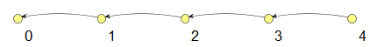
Figure 2: Example of a directed Graph
For the example, let us define the threshold to be one standard deviation for the v values. By running the algorithm, it will return two disjoint sets: S₁ = {v₀,v₁} and S₂ = {v₃,v₄} since v₂ is outside the defined threshold. First it considered v₀ then added v₁ to S₁. When trying to add v₂ to S₁, the difference between values was greater than the established threshold. Thus, v₂ is not added to S₁. Since v₁ has no incoming neighbor besides v₂ then it returns S₁ as a collapse set. Furthermore, since v₁ only has v₂ as incoming neighbor and the difference between their values is greater than the threshold, then the algorithm does not return v₁ as another collapse set. The same thing happens when evaluating v₂ with v₃. When starting with v₃, the algorithm will insert v₃ to S₂ and evaluate v₄. Since the difference between v₄ and v₃ is lesser than the threshold, then v₄ is added to S₂. When considering v₄, since it has no neighbor, the algorithm ends and returns both S₁ and S₂.
On the given example, both collapse sets were disjoint. But what would happen if they were not? Let us consider the same graph but with all vertices having equal values. Since all vertices have the same values, then every time the neighbor is evaluated, their difference will always be lesser than the standard deviation, thus added to the current collapse set. As such, the solutions obtained are S₁ = {v₀,v₁,v₂,v₃,v₄}, S₂ = {v₁,v₂,v₃,v₄}, S₃ = {v₂,v₃,v₄}, and S₄ = {v₃,v₄}. As can be seen, those solutions sets are not disjoint. In truth, all of those solutions are sub-sets of S₁.
This is just an example of overlapping collapse sets. Another example would be a bigger sequence of vertices that slightly increases or decreases values in such a way that you cannot put the entire sequence in the same collapse set. This also results in multiple overlapping sets. Our objective is to reduce the graph by collapsing sequences of vertices that have similar values or did not vary or change much between states. Considering this, then how do we select the best collapse sets in order to maximize the number of collapsed vertices when there are overlapping sets?
One possible way would be to treat it as an optimization problem where we want to maximize the number of collapsed vertices. For such, it is needed to select disjoint collapse sets that maximize the number of vertices to be collapsed. One simple approach would be to use a greedy heuristic, sorting the collapse sets by size in a decreasing order and select the largest one that is disjoint to the ones already selected. Another way to avoid overlapping sets is to keep a memory of all collapsed vertices. Thus, when selecting the next set, discard all vertices that were collapsed in previous sets. This will transform all sets in disjoint sets, since we are dynamically removing the overlapping sections. However, this alone does not guarantee that we will have the best collapse selection.
To ensure we have the best collapse selection, we can add an extra step to check if the largest set chosen is still larger than the second one after removing all vertices that were already collapsed in the first set. If the first set is still the largest one, then collapse the set. However, if it is not, then remove all collapsed vertices in the second set and compare the second with the first and the third sets. If either the first set or the second is the largest one, then collapse it. Otherwise repeat this process with the by comparing with the next set until finding the largest collapse set. This heuristic updates the collapse candidates on demand and spare the processing time used for updating all sets when a new collapse is made.
By using the proposed algorithm, nearby vertices in the graph that have similar values will be collapsed into a single vertex, reducing the graph’s overall size. This is useful to reduce the graph size by omitting vertices with similar values to quickly identify sections or vertices that are different from its neighbors or the expected behavior. In game terms, those vertices that were not collapsed represent drastic changes in the game state and are worth displaying then for analysis, while all collapsed ones fluctuates around the same state and did not caused a change of state.

Prov Viewer’s Automatic Inference
The Prov Viewer [9] is a provenance graph visualization tool originally made for displaying provenance gathered from games that uses the Provenance in Games conceptual framework [10]. In Prov Viewer, the game flux data gathered during a gaming session is processed and automatically used to generate an interactive provenance graph of the session to aid during the analysis process.
With the available features provided by Prov Viewer, which were presented at [9], users can manipulate the graph by deciding which type of edges and color schemes will be displayed on the provenance graph. Furthermore, he can navigate in details through the graph, exploring different sections of the game session or zoom out for a broader view. It is also possible to collapse sections of the graph in order to reduce its size and thus omitting vertices that might not be relevant for the current analysis. All graph manipulations done in Prov Viewer can be reverted and no information is lost during the process.
However, Prov Viewer had no previous feature for automatic inference in the provenance graph, thus it displayed the entire graph for the user. Nonetheless, the tool had the necessary features to allow the user to decide what he wanted to infer. With the addition of the inference presented in the previous section, Prov Viewer can now automatically reduce the graph size by collapsing sequences of vertices that did not generated any relevant change in the game state.

Graph Notation
Before explaining the similarity inference available in Prov Viewer, it is necessary to explain how the graph data is structured in order to understand some of the inference possibilities offered by the tool. Currently, one of the available input formats in Prov Viewer for the gathered provenance data extracted from an application is a simple XML Schema (input.xsd). This provenance data XML contains the list of vertices and edges that represent the provenance data. An example using the input schema is as follows:
<vertex>
<id>ag01</id>
<type>Agent</type>
<label>Joao</label>
<date>0</date>
<attribute>
<name>Level</name>
<value>1</value>
</attribute>
<attribute>
<name>Job</name>
<value>Senior</value>
</attribute>
<details></details>
</vertex>

<vertex>
<id>ac01</id>
<type>Activity</type>
<label>Action</label>
<date>1</date>
<attribute>
<name>Role</name>
<value>Manager</value>
</attribute>
<attribute>
<name>Morale</name>
<value>100</value>
</attribute>
<attribute>
<name>Hours</name>
<value>8</value>
</attribute>
<details></details>
</vertex>

<edge>
<id>e01</id>
<type>Neutral</type>
<label>wasAssociatedWith</label>
<value>0</value>
<sourceid>ac01</sourceid>
<targetid>ag01</targetid>
</edge>
For both vertex and edge, the “id” is a unique identification name and “type” represents the vertex’s category (activity, entity, or agent) and for edges it represents the name of the relationship. The “label” is a human-readable representation that can also be used for sub typing. The “date” is related to temporal information, “attribute” is used to register vertex attributes aside from label and date that are accessed by color schemes, and “details” is used for additional information about the vertex. Note however that an attribute description contain a name and a value. For the edge, “value” represents a numerical value associated to the relationship and is used to determine the edge’s color and thickness. Lastly, “sourceid” and “targetid” represents the relationship members. As the name implies, the vertex that is the source of the edge and the vertex that is its target. Prov Viewer uses this information to generate the graph’s vertices and edges.
As previously mentioned, the graph vertices represent provenance concepts which are classified in Prov Viewer as agents, activities, and entities. Although PROV allows sub typing, Prov Viewer always treats provenance concepts via their respective super classes. However, Prov Viewer allows vertices of the same type to contain different characteristics (in terms of extra attributes) without generating conflicts in the graph. Each vertex type has established characteristics, as described earlier, such as color and shape, which are defined by their type. However their extra attributes can be different even when they belong to the same type, with the exception of the only two fixed attributes: label and date. This introduces greater flexibility and allows for storing more information during the provenance gathering that can be used during analysis.

Inference implementation
Taking into account the graph data format used by Prov Viewer, we implemented the inference algorithm presented in the previous section in Prolog. For the inference in Prov Viewer, we restricted to only one type of edge for determining neighbors. Thus, two vertices X and Y are neighbors if and only if there is an edge from Y to X that is from the desired type.
We also adopted the convention that the edge’s direction must be from Y to X to minimize the number of possibilities, reducing the number of duplicate sets. If we considered both ways then the number of resulting collapse sets would be much higher with the majority being duplicates. Also, by restricting the edge type instead of using all possible types, the collapsing sets will follow the edge’s semantics and avoid creating confusing collapses that groups similar vertices regardless of their semantic connection.
Besides the edge type, we also restrict the inference to one vertex attribute. For example, we can evaluate how the player’s hit point is throughout the game, collapsing all vertices in which his hit point did not change beyond the established threshold. Or we can evaluate the player’s mana points to identify sections of the graph that he used spells. Below is a section of the Prolog code used in the implementation for the threshold, path, and inference functions.
threshold(X,Y,VAL) :- abs(X - Y) =< VAL.
path(X, Y, TYPE) :-
edge(_, _, _, TYPE, _, _, Y, X),
vertex(_, _, X, T, _, _, _),
vertex(_, _, Y, T, _, _, _).
similarity (_, ATT, TYPE, MIN, MAX, [ ]).
similarity (Lant,ATT, TYPE, STD, MIN, MAX, [X|Lresp]) :-
first(Lant, Y),
path(Y, X, TYPE),
vertex(_, _, X, _, _, _, IDATTRIBUTE2, _),
attribute(_, IDATTRIBUTE2, ATT, VALUE2),
atom_number(VALUE2, W2),
max(W2, MAX, NEW_MAX),
min(W2, MIN, NEW_MIN),
threshold(NEW_MAX, NEW_MIN, STD),
similarity ([X|Lant], ATT, TYPE, STD, NEW_MIN, NEW_MAX, Lresp).
The threshold function is a simple one that compares the difference between two values with a third value, which is the defined threshold. Currently, we are using the standard deviation of the desired attribute used for the collapse. As mentioned, the inference uses a neighbor function to group vertices together. This neighbor function is the “path” function, which returns a vertex that is connected to the current one by the desired edge type.
The inference function is the “similarity”, which is recursive in Prolog. The first function is the base of the recursion while the second is the one that creates the collapsing sets. In the first line, we take the newest element added to the collapsing set so we can find new elements to collapse. The second line, “path”, searches for a neighbor of the selected vertex, while the third and fourth line gets the neighbor’s value for the attribute that is being evaluated.
The fifth and sixth lines update the minimum and maximum values in the current collapse set and the seventh line checks if the neighbor’s value is below the threshold. If by adding the neighbor in the collapsing set does not break the threshold limitation, then the vertex is added and in the last line calls the “similarity” function recursively to try to add more vertices. Note however that this implementation collapses only paths. In order to change this, the function in the first line, “first(Lant, Y)”, need to be changed, since it only returns the newest element added to the set.
Prov Viewer executes this inference when changing display modes by calling the Prolog implementation. It uses the display mode’s attribute to make the inferences and one type of edge selected by the user. The Prolog counterpart returns all possible collapse sets to Prov Viewer, which in turn sorts the collapsing sets by decreasing order and execute the collapses by using the greedy heuristic, updating the list of vertices already collapsed to remove vertices from overlapping collapses.

Case of Study
For the purpose of providing an example of usage with a rich context, we adapted the software engineering serious game named SDM. With the adaptations for provenance gathering made in the original SDM [10], it became possible to use the collected provenance data to generate a provenance graph. We also configured Prov Viewer to be compatible with SDM semantics.
In SDM the player manages a team of employees that develop software according to contracts made with customers. The gameplay and game mechanics are modeled presenting possibilities to the player to decide strategies for development and defines the roles and tasks for each staff member. As in any contract, the software has requirements that must be followed during development. From a gameplay point of view, these requirements help to balance the mechanics and rules.
When the software is completed and delivered to the customer, there is a quality assessment of the software and a project completion payment accordingly to the product assessment. Since SDM focuses in people management, the main elements of the game are the employees, which represent the player’s labor force. Employees can perform different roles (analyst, architect, manager, marketing, programmer, and tester), which use the employees’ human attributes to calculate their performance depending on the respective roles.
Another attribute present in the game is specialization, which is used to define the employee working competence. With the specialization system, it is possible for employees to undergo training to learn new sets of skills. Also the concepts of working hours, morale, and stamina are used to modify the employee’s productivity.
These characteristics are illustrated in Figure 3, which shows a simplified version of SDM’s class diagram focusing on the employee. Each employee is defined by his human attributes (adaptability, auto didacticism, human relations, logical reasoning, meticulousness, negotiation, objectivity, organization, and patience), can have specializations categorized in three different types (with a total of 14 different specializations), and can be allocated for training in order to acquire new specializations.
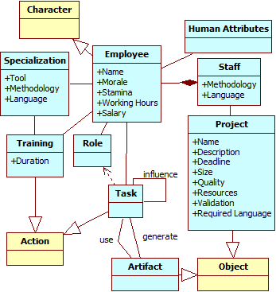
Figure 3: Mapping of SDM game and Software Engineering domains. Yellow classes belong to the game domain, showed in Figure 1. Blue classes belong to SE domain (SDM game).Each employee can have up to two different roles at the same time, among six possible roles available. Each role has a different set of tasks, which are administered by decisions trees [12] that considers internal (attributes, morale, and stamina) and external (player or staff) influences to determine how these tasks are executed. Tasks can influence and be influenced by other tasks from another employee and can also generate artifacts, which can represent prototypes, used to validate software requirements, or test cases (unit, integration, system, and user acceptance). Lastly, employees belong to the player’s staff and develop the software for a customer, respecting the customer’s requirements and deadlines.

Graph Visualization and Inference Examples
Figure 4 displays the Prov Viewer interface using the SDM configuration schema (presented in the previous section) as a test bed. The display edge feature is represented by a list instead of checkboxes, thus allowing more flexibility (in quantity) and easier selection of edges to be displayed. It is possible to observe that the graph of Figure 4 only displays the selected edge types: “Neutral”, “Credits”, and “Aid”. Furthermore, notice that vertices colors are matching PROV’s colors for easier identification. The only difference is the pink activity vertices in Figure 4 because they were flagged as uncommon activities for easier identification (activity vertex, Attribute: Task, Value: Idle). Besides the default color scheme, vertex shapes are still used to identify types. Circles represent entities, squares represent activities, and pentagons represent agents. This notation is similar to the one presented in PROV-LAYOUT [13].
The graph layout shown in Figure 4 is the Temporal Layout introduced by Prov Viewer. In this layout, each line groups activities of the same agent or entity, where each column represents passage of time. This makes easier to know the entity or agent responsible for executing each activity. By looking at Figure 4 we can easily identify all activities executed by each agent, by just looking at the agent’s line. This layout also has a configurable backbone, which in this case is a sequence of a specific type of entity that represents the project’s daily development status. The numbers represent temporal data, such as day 0, day 1, and so on. It is also possible to change the graph layout in the tool to use any other JUNG [8] layout.
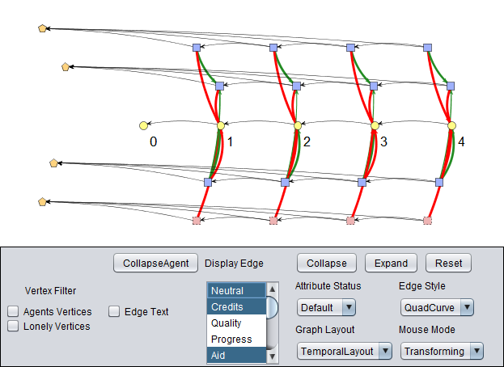

Figure 4: Prov Viewer GUI customizable for different applications presenting a graph using PROV notations. In this example, it is customized for the SDM game.
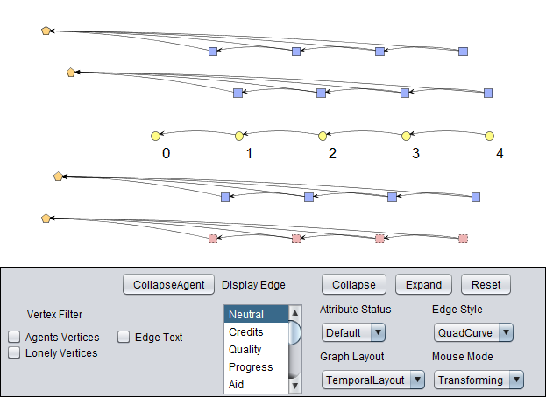
Figure 5: Graph from Figure 4 but displaying only “Neutral” type edges.Figure 5 shows the same graph from Figure 4 but filtering edges to display only the ones from the “Neutral” type, which will be the edge type used for inference. As can be seen in Figure 5, all vertices at the same line are connected in sequence and they do no connect other vertices from different lines, unlike Figure 4. The reason for this is because the “neutral” edge type in SDM has the semantic of association, while all other types are influences generated during the game session.
In Prov Viewer, the similarity inference is tied with the attribute display views and automatically collapse vertices that have similar values or that do not change more than the defined threshold. Using the same graph from Figure 5 and changing the display view to evaluate the player’s financial status, which is show by the yellow vertices, Prov Viewer changes the graph from Figure 5 to Figure 6. As can be seen in Figure 6, the vertices color changed from yellow (default color) to green (status color) due to the change of the display view, which also changed the color scheme. However, the interesting thing is that the number of vertices reduced from 5 to 3.
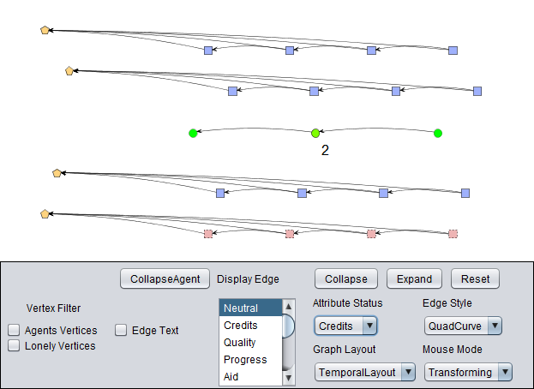
Figure 6: Credits display view.By looking closely to the graph, we can see that vertices 0 and 1 collapsed into a single vertex and vertices 3 and 4 into another vertex. Only vertex 2 did not collapse. Thus, we can quickly surmise that there was a significant change in the financial state between vertices 1, 2, and 3even if the color remained the same (green). If there was no significant change from vertex 1 and 2, then vertex 2 would be collapsed along with vertices 0 and 1. Following the same reasoning, the same can be said to vertex 2 and 3. If we analyze each vertex value in Figure 7, we can indeed see this is the case, since each vertex value is around 40.000 while vertex 2 (id: ent2) is around 30.000.
In Figure 8 we can see another example of graph reduction by collapse. In this case, the display view is set for working hours, which is the amount of hours that each employee worked each day. By selecting this view, we can see that three employees had all their daily activities collapsed into a single vertex, while the upper-most employee in the graph retained all the original vertices. By analyzing the collapsed graph, we can quickly surmise that three employees worked roughly the same amount of hours each day.
However, one employee worked erratically since the amount of hours done each day was drastically different, as can be seen by the lack of collapses. His erratic behavior is also reflected by the different colors in each vertex. The vertex coloration is based on traffic light scale [4], which indicates the status of the variable using gradient colors ranging from red to green. If we analyze each vertex of the employee, we can indeed see that his working hours were erratic: at the first day he worked 8 hours, on the second day 12 hours, on the third day 16 hours, and the last day only 4 hours.
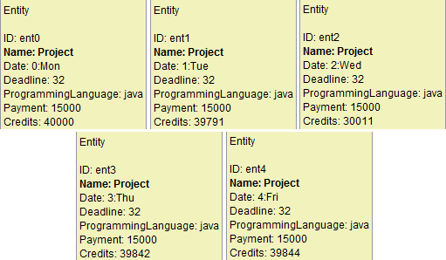
Figure 7: Entity vertex details from Figure 5.
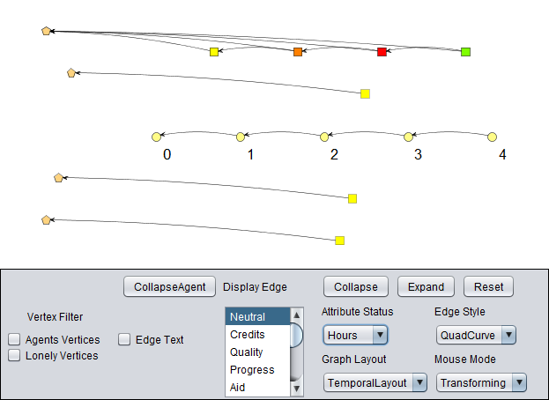

Figure 8: Hours display view.Conclusion
This paper introduces new perspectives on gameplay analysis through graphs, leveraging the current state of the art based on gameplay analysis. The game’s provenance graph can aid in the detection of gameplay issues and sections of the game session that suffered significant changes. This is accomplished by the usage of inferences in order to reduce the overall graph size and hide sections in the graph that were static or stagnant and did not offer any useful information for analysis.
By using the similarity collapse, it is possible to omit irrelevant or similar game states in the provenance graph for easier identification of noteworthy regions of the game session or the states transitions. Non-collapsed vertices represent states that suffered changes outside the expected margin. Even when there are two consecutive collapses, which happens when a value slowly changes incrementally, tell us of a change in game state that happened in a slow fashion. Otherwise both groups would be collapsed into a single group.
Currently, Prov Viewer only does one automatic inference to the user by collapsing sequences of vertices that have similar values. However, Prov Viewer also allows the user decide what needs to be inferred by providing the necessary tools to omit information in the graph, such as filters and collapses (both for vertices and edges). Studies in this area can be made in order to create more types of inferences that omit information from the user without affecting the overall analysis. Another interesting research is to automatically identify patterns in the graph and the player’s behavior.

ACKNOWLEDGMENTS
We would like to thank CNPq, FAPERJ, and CAPES for the financial support.

REFERENCES
[1] Andersen, E., Liu, Y.-E., Apter, E., Boucher-Genesse, F. and Popović, Z. 2010. Gameplay analysis through state projection. Foundations of Digital Games (FDG). (2010), 1–8.
[2] Consalvo, Mi. and Dutton, N. 2006. Game analysis: Developing a methodological toolkit for the qualitative study of games. Game Studies. 6, 1 (Dec. 2006).
[3] Davis, J., Steury, K. and Pagulayan, R. 2005. A survey method for assessing perceptions of a game: The consumer playtest in game design. Game Studies. 5, 1 (2005).
[4] Diehl, S. 2007. Software Visualization: Visualizing the Structure, Behaviour, and Evolution of Software. Springer.
[5] Freire, J., Koop, D., Santos, E. and Silva, C.T. 2008. Provenance for Computational Tasks: A Survey. Computing in Science Engineering. 10, 3 (Jun. 2008), 11 –21.
[6] Game Analysis Using Resource-Infrastructure-Action Flow: 2011. http://ficial.wordpress.com/2011/10/23/game-analysis-using-resource-infrastructure-action-flow/. Accessed: 2012-10-19.
[7] GameAnalytics For Game Developers Know the facts Improve and Monetize: http://www.gameanalytics.com/. Accessed: 2013-05-30.
[8] JUNG: Java Universal Network/Graph Framework: 2010. http://jung.sourceforge.net/.
[9] Kohwalter, T., Clua, E. and Murta, L. 2013. Game Flux Analysis with Provenance. Advances in Computer Entertainment (ACE). (2013).
[10] Kohwalter, T., Clua, E. and Murta, L. 2012. Provenance in Games. Brazilian Symposium on Games and Digital Entertainment (SBGAMES). (2012).
[11] Kohwalter, T., Clua, E. and Murta, L. 2014. Reinforcing Software Engineering Learning Through Provenance. Simpósio Brasileiro de Engenharia de Software (SBES). (2014).
[12] Moret, B. 1982. Decision Trees and Diagrams. ACM Computing Surveys (CSUR). 14, 4 (1982), 593–623.
[13] PROV-LAYOUT: 2012. http://www.w3.org/2011/prov/wiki/Diagrams. Accessed: 2013-03-21.
[14] Unity - 3D Game Engine: 2010. http://unity3d.com/. Accessed: 2011-05-05.

https://raw.github.com/gems-uff/prov-viewer/master/src/ main/resources/input.xsd

