SDM – An Educational Game for Software Engineering

Troy C. Kohwalter Leonardo Murta Esteban W. Clua

Instituto de Computação
Universidade Federal Fluminense

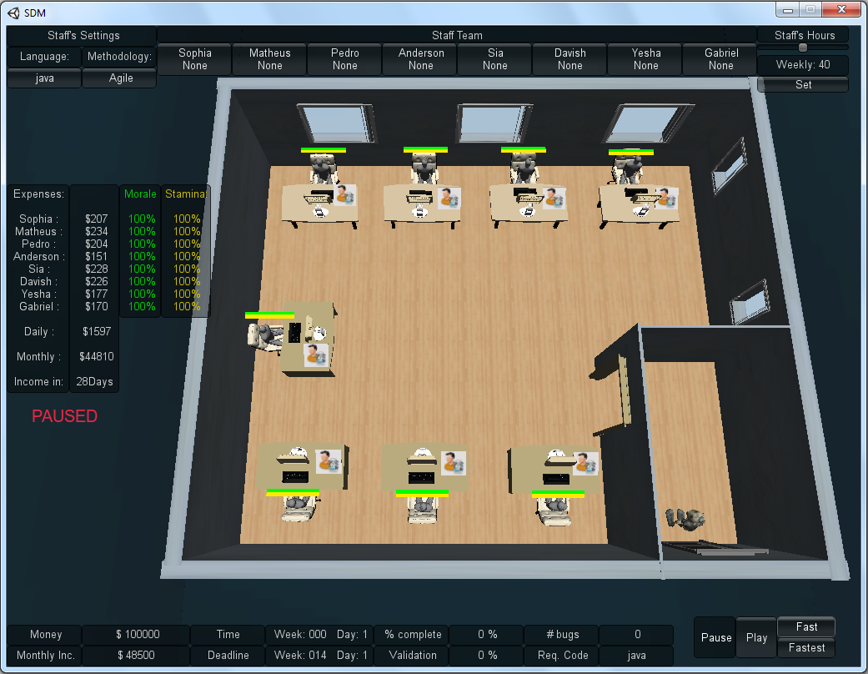
Figure 1: SDM

Abstract

Software Engineering is a subject area of computing that focuses on practical aspects of the software production. The Undergraduate courses of Computer Science have disciplines of Software Engineering, but they are shown usually in theoretically way and with only a few implementation jobs using the techniques and tools learned. The practical approach of the concepts learned during the teaching of Software Engineering aids in determining the content featured in understanding and the reason for using the techniques presented. Based on this, this work proposes the modeling and development of an educational game that allows the user to determine the knowledge of Software Engineering, specifically people management, involving the training, workload and role played by members of the development team. The intention is to familiarize the player with the difficulties encountered during software development, leading him to understand the motivation of using the techniques of Software Engineering. This work also presents the Software Development Manager, a novel simulation game where the player owns a software development company that counts with the help of a team, which is administered by the player, to develop products desired by customers. The purpose of this game is to assist in learning the knowledge of Software Engineering in a way that takes advantage of the benefits of fun and entertainment.

Keywords: games, software engineering, people management.

Authors’ contact:
tkohwalter@gmail.com
{esteban, leomurta}@ic.uff.br

1. Introduction

Learning can and should be a fun process. Given this, one option to make learning fun is by using games with the aim to stimulate curiosity and provide motivation for learning. Prensky (2001b) gives twelve reasons for the fact that computer games are the most potentially attractive pastime in the history of mankind:

1. Games are a form of fun. That gives us enjoyment and pleasure.
2. Games are form of play. That gives us intense and passionate involvement.
3. Games have rules. That gives us structure.
4. Games have goals. That gives us motivation.
5. Games are interactive. That gives us doing.
6. Games are adaptive. That gives us flow.
7. Games have outcomes and feedback. That gives us learning.
8. Games have win states. That gives us ego gratification.
9. Games have conflict / competition / challenge / opposition. That gives us adrenaline.
10. Games have problem solving. That sparks our creativity.
11. Games have interaction. That gives us social groups.
12. Games have representation and story. That gives us emotion.

There are other means that can provide some of these characteristics, for example, movies and books. However, games are the only process that conveys all these aspects at the same time (Prensky 2001b).

In the area of Software Engineering, the traditional teaching consists of lectures and some practical work with the intent of using the theory learned in class. However, these practical works, for the most part are small and do not stimulate the student’s interest.

The reason these students do not show much motivation in these types of proposed work is because they belong to another type of generation. This generation, called “Digital Natives” by Prensky (2001a) is accustomed to receive lots of information in a short period of time, like to do parallel tasks and prefer graphics or visual interactions instead of text explanations.

Prensky (2002) identified that one of the problems in learning is the lack of motivation from the student. To learn any subject it is necessary to make an effort, something that is rarely done without a reason. While the goal of educators is to convey the content, they do not bother to keep the student involved. Computer games, on the other hand, have the main goal to keep the user involved and make him want to devote more and more time playing.

Considering these facts, in this paper we present a modeling of Software Engineering process using the gameplay and game mechanics theory, in order to present a possible game based approach for teaching and simulating Software Engineering. Based on our theory, we describe how we created a new educational game focusing at teaching Software Engineering. The game, called Software Development Manager, or SDM for short, is primarily intended to assist in learning the concepts of people management, involving training, assigning tasks and workload. These concepts are taught in theoretical lectures of Software Engineering and can use the SDM to assist, keeping the students interested in the subject through the fun offered by the game.

The game SDM convey the importance of the management of the development team and each possible role that a member of the team can undertake. However, the most distinct factor of this game is the use of human characteristics to determine if the employee is qualified to perform a certain role.

This paper is organized as follows: Section 2 presents related works of other education games for Software Engineering. Section 3 presents the modeling concept and approach of the game SDM. Section 4 presents the experiments made for the game. Finally, Section 5 presents the conclusions of this work.

2. Related Work

In Software Engineering, students are exposed to various theoretical concepts and end up having little opportunity to apply all concepts learned in class. Due to this problem, educational games were developed to address the concepts that are taught in theoretical lectures, as well as assist in understanding the content. Many educational games for Software Engineering were developed addressing different concepts.

In (Navarro 2002), the authors created a simulation game of Software Engineering called SimSE. The purpose of this game is to address the gap in the traditional techniques of Software Engineering teaching where students are exposed to various concepts and theories, but have few opportunities to apply these ideas into practice.

In SimSE, the player assumes the position of a project manager who has a team of developers. As the player manages the software development, he can make hiring and firing decisions, monitor progress, assign task and buy tools. This game counts with a graphical interface that transmits all the necessary information to the player by dialogues or information windows. Figure 2 shows SimSE’s graphical interface. The fundamental goal of the SimSE project is to allow the customization of the simulated process model and therefore be used by professors during the presentation of content on the software life cycle.

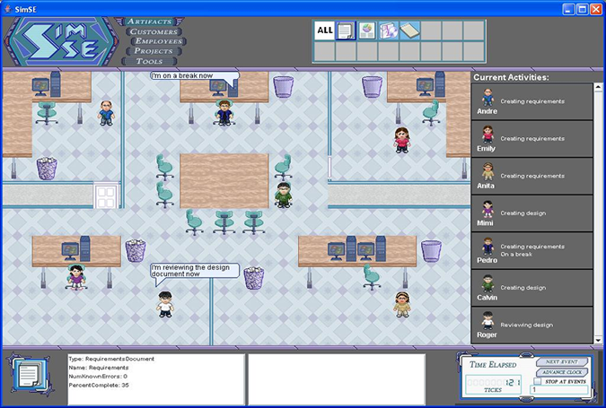
Figure 2: SimSE graphic interface

In (Baker et al. 2003), the authors created a card game. The main focus of this card game, called Problems and Programmers, is the teaching of Software Engineering. Through a simulation of a software development process, from conception to completion, the players learn tactics to avoid problems during the development of the product.

In this game, players are project managers who work in the same company. The goal is to compete with each other in order to complete their projects in less time. However, players who adopt strategies to minimize the time or make risk decisions will be affected negatively, while players who choose to follow the concepts of Software Engineering will be rewarded. For this, the game depends on different types of card for each situation. Figure 3 show some of the cards in the game.
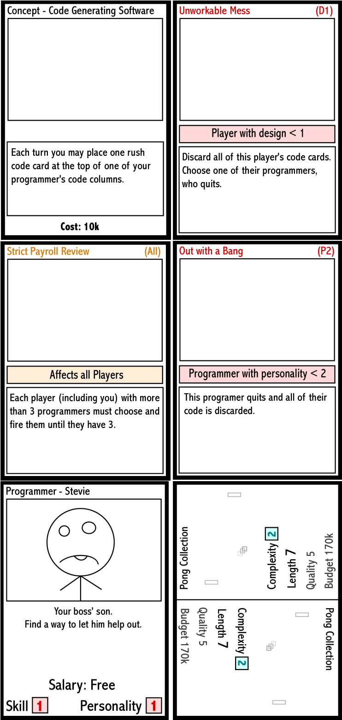
Figure 3: Problems and Programmers cards

Despite showing important phases of software development, such as documentation, implementation, inspection and testing, the game Problems and Programmers is lacking in some aspects, such as the card’s structure and rules that make the game difficult to play with several people and unable to be played alone. With these shortcomings in the dynamics, the game ends up being compromised.

In (Dantas et al. 2004), the authors created a simulation game for teaching Software Engineering named The incredible Manager, or in short TIM. The focus of this game is project management, where the player has the job of manager in a company where he should plan and manage software development projects.

As project manager, the player makes up a development plan for the project to be used to develop of the project and has the options of forming a development team to estimate the duration of each task, assign tasks to developers, make project plans, negotiate with stakeholders, control how many hours the team will work per day and determine the effort spent on quality assurance. All these options are available through the graphical interface, as shown in Figure 4.

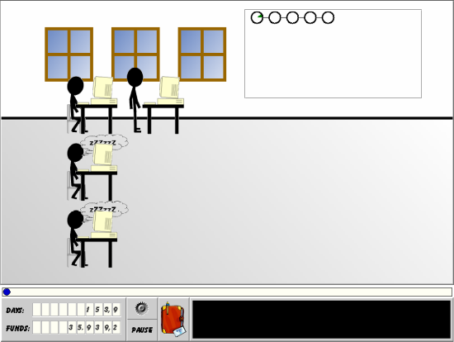
Figure 4: TIM's graphical interface

However, as in the SimSE game, it is only presented two types of roles that can be performed during the development of the project: the manager, that is the player himself, and developers, that are the employees of the team. However, these are not the only roles that are played in the development of software. There are others which were not mentioned, but equally important, such as system analysts and software architects.

While the mentioned works are modeled having in mind the Software Engineering concepts as a first requirement, there are other works that are mainly focused at the entertainment and gameplay aspects, such as Gamedev Story (Games 2010). Our work has a novel approach, since tries to model the architecture having the fun theory since the beginning of the concept, but also pretending to stay very close to the Software Engineering theory and literature.

3. SDM Architecture

In the game SDM, proposed in this paper, the player has a team of employees who are used to develop software that are required by customers. The gameplay and game mechanics are modeled presenting possibilities to the player to decide strategies for development and define the roles for each staff member. The software required by customers may have requirements that must be respected during development. From a gameplay point of view, this requirement helps to balance the mechanics and rules. When the software is completed and delivered to the customer, there is a quality assessment of the software and a project completion payment.

Since SDM focus is people management, the main element of the game are employees, which represents the player’s labor force. Since employees take a very important role, several existing features where expanded or added. Starting with the changes in possible roles that an employee can perform and then the new attributes system used to calculate the employee’s performance. Another element added is specialization, used to define the employee working competence. With the specialization system, it is possible for employees to undergo training to learn new specializations. Also the concepts of working hours, morale and stamina are used to modify the employee’s productivity. Figure 5 show a simplified version of SDM’s class diagram.

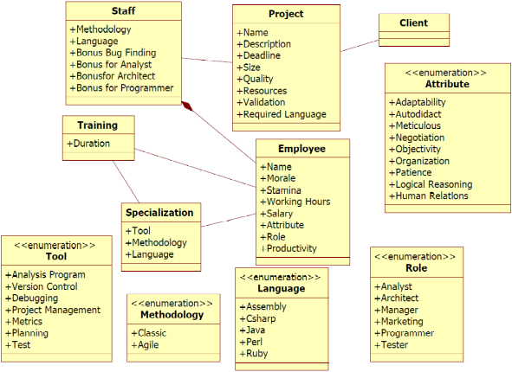
Figure 5: SDM's Simplified Class Diagram

3.1 Employees

In SDM the employees represent the player’s workforce. They perform planning tasks and develop the software through the roles that are assigned by the player. In addition to the tasks that can be assigned, employees have certain characteristics that are used to determine the affinity to perform each possible task.

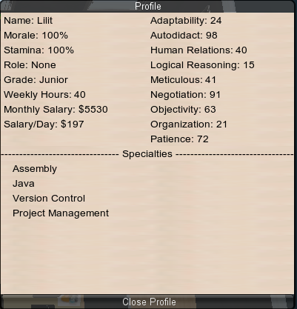
Figure 6: Employee's sheet

3.2 Roles

The above-mentioned tasks are performed by the roles that an employee can play in the game. When a role is chosen for an employee, he will devote all his working time performing the desired function.

In the design of the SDM, six different types of roles were chosen and can be assigned to an employee. These roles are analyst, architect, manager, marketing, programmer and tester. The purpose of using these six roles is to expand the scope of functions that can be performed by staff members. Each of these roles has a specific function that contributes to the development of software, which is described below.

- The systems analyst serves as a translator between the user’s needs and the architect’s model that is used by the programmers during development. For this, the analyst must have a comprehensive knowledge of the business area in which the system will be developed in order to properly implement the business rules.
- The software architect is the professional responsible for design and development of the system architecture. He is responsible for creating testing procedures to ensure the software quality is at the desired level proposed by the customer. In addition, he is responsible for generating prototypes for the customer.
- The manager is the individual responsible for planning and controlling the execution of the work of team members every day. The manager, in the proposed approach, also manages the team’s human resources and is responsible for hiring new employees. In addition to this task, the manager assists indirectly in almost all functions performed by other roles during the project’s development.
- The role of marketing is to negotiate the contract with the customer. The marketing can also influence in the request made by the customer to the system analyst, managing to convince the customer that an initially unwanted functionality is acceptable.
- Codes do not generate alone. For this, it is needed programmers to develop the software. Therefore, the programmer is responsible for generating the software’s code lines. However, the programmer is also responsible, inadvertently, to put bugs in the software during development. These bugs affects the final quality of the project and the amount of bugs introduced is influenced by the programmer’s experience with the programming language used and his capacity of working with the methodology adopted by the team.
- The tester is the person responsible for carrying out the software verification to provide information about its quality. This responsibility includes the act of using the project in order to find bugs and correct them. As mentioned earlier, the tester works with the team’s architect.
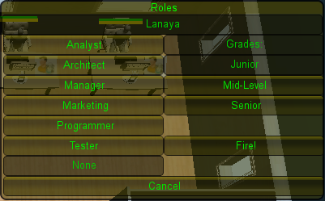
Figure 7: Roles window

3.3 Attributes

The employees have attributes that influence their job performance. However, these attributes are not directly related to each role, such as an attribute to be used for the role of manager and another for programmer. To make the SDM more realistic and have a distinction of the other games, the system adopted for attributes is the usage of human characteristics of a person. These human characteristics, called human attributes in our work, are the attributes visible to the player so he can consult and formulate a performance evaluation in which an employee will have for a certain role. However the mapping of these human attributes to the performance attributes is not informed to the player. With that, the player needs to use the common sense and make some experiments to be able to discover which attributes are more important for each role.

After performing a detailed study on employee’s profiles (Santos 2005; Russo 2007) that plays certain roles in software development, we selected nine human attributes to represent the characteristics of the employee. The attributes are:

- Adaptability: the ability to react to changes. This attribute, specifically in our proposal reflects the employee’s ability to adapt to changes in scope and planning of the software. This attribute is widely used by analysts and architects and is also important for manager.
- Autodidact: responsible for the ability of learning without having an instructor. The individual makes their own search and research on the material needed for learning. This attribute is important for the programmer. Besides being used to determine the performance, this attribute is also applied when an employee is training, chanting the length of time needed to complete the training.
- Meticulous: used to measure the employee’s ability to pay attention to details of the problem, point to point checking the level of detail of the activities. This attribute is heavily used by testes and is also important for analysts and architects.
- Negotiation: used to determine the employee’s ability to perform replacement persuasions, or persuade the other part showing the most relevant benefits of a point of view. This attribute, as its name implies, is essential during negotiations and is heavily used by marketing, but alone it does not determine the final performance of the negotiations.
- Objectivity: the ability to be objective. Serves to seek the simplest functional solution, especially during the software implementation. Therefore, it is a good attribute for programmers.
- Organization: the attribute responsible for the structuring of work and combination of individual efforts to make collective efforts. It is also useful for planning and creating schedules, thus making it a good attribute for managers.
- Patience: the virtue to maintain a balanced emotional control, without losing his cool over time. It consists basically on the tolerance to errors or unwanted events. The ability to endure discomfort and difficulties of every kind, from any time or anywhere, to persist in a difficult task. This attribute is important for testes, but no less important for other roles.
- Logical Reasoning: define the ability to seek a solution to a problem when data is available as a starting point, but no one is quite sure how to achieve the goal. It identifies errors intuitively, understand the logic behind the problem and make mathematical calculations. This attribute is very important for programmers and testers.
- Human Relations: responsible for the interpersonal characteristic and communications skills of persuasion. Being able to explain ideas and to distinguish the technical vocabulary of the business. This attribute is heavily used by employees who perform the role of analysts, manager and marketing.

The weight of the human attributes for the performance of each role proposed for this work is presented in Table 1.

Table 1: Human attributes weight for each role
An = Analyst Ar = Architect Ma = Manager
 | An | Ar | Ma | Mar | Prog | Tes
Adaptability | 20% | 25% | 10% | 5% | 5% | 5%
Autodidact | 5% | 5% | 10% | 5% | 20% | 5%
Meticulous | 10% | 15% | 5% | 5% | 5% | 25%
Negotiation | 5% | 5% | 10% | 25% | 5% | 5%
Objectivity | 10% | 10% | 5% | 5% | 15% | 10%
Organization | 5% | 10% | 25% | 5% | 10% | 10%
Patience | 10% | 10% | 10% | 20% | 10% | 15%
Logical Reasoning | 10% | 15% | 5% | 5% | 25% | 20%
Human Relations | 25% | 5% | 20% | 25% | 5% | 5%
Mar = Marketing Prog = Programmer Tes = Tester

3.4 Specializations

Another important topic in our modeling is that each employee has specializations. These specializations can be from three types: programming languages which reflect the language that the employee is able to work; techniques that are used to determine if the employee is familiar with certain methodologies adopted by the develop team; and tools that is used to assist the employee to perform its task.

Programming language and techniques specializations are used to determine if the employee is able to work with the methodology and the programming language adopted by the staff, giving negative modifiers in case the employee don’t meet the team’s development setting. The tools specialization is used only to aid the employee, having no drawback for the lack of it.

3.5 Training

We propose a model where it is possible to train an employee so that he can acquire new specializations. The type of specialization to be trained can be chosen by the player at any time and have a duration of several days, influenced by the autodidact attribute. During the training period, the employee will devote his entire time on training and will not be allowed to exercise other functions simultaneously, such as working. Only when the training is completed the employee may resume his daily duties at the company.

With the possibility of training, the player can see that it is necessary, before starting the development or when adding a new member in the staff, to train his employees. In case no training is made to meet the requirements of the project, the employee’s performance will be reduced and the software quality will negatively be affected. Another learning that the player can get from the training aspect is that if an employee already belongs to the player’s staff since older projects, it is very likely that he will need less and less training for new projects.

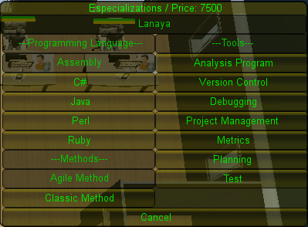
Figure 8: Training Window

3.6 Working hours, morale and stamina

The number of working hours is another factor that influences the performance of an employee and directly affects the employee’s salary and his stamina. Morale and stamina models the employee’s behavior that he will have at work and is directly related to performance.

Stamina, as mentioned before, is affected by working hours. In case the employee is doing overtime work, his stamina will start to decrease, thus causing a drop in his performance due to exhaustion and if he is working less hours, his stamina will increase.

With this relationship of working hours and stamina, it is possible to conclude that when an employee is working overtime, his productivity will be higher in a short term and then will begin to drop because of his exhaustion. After a few days his overtime productivity will be negated by his exhaustion and if it continues his productivity will fall beyond his normal productivity levels.

Morale also affects the employee performance, although not by fatigue but by the will to work. Morale is responsible for the employee’s desire to stay in business. If his morale is low, the employee may resign voluntarily from the team. Failure in payment is an example that affects negatively the morale.

This system of morale, stamina and working hours provide the player another possibility of strategic development for the software. It is up to the player to balance the benefits and drawback of using such aspects.

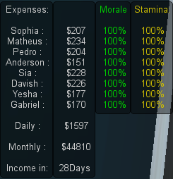
Figure 9: Staff summary window

3.7 Differential

The SDM, in relation to the works that were cited on section 2, has many new aspects as a game. Employees now are an essential part of the development and as such they were expanded in terms of complexity.

In SDM the employees have human characteristics that determine his performance on the tasks, instead of a performance attribute directly related to each task. Besides attributes, the employees have specializations that affect their performance and making it necessary to do training in the initial phase of the development. Aside from attributes and specializations, the roles that an employee can play have also been increased from two to six, adding new important roles that are used during the development of the project.

4. Experiment

In order to evaluate the game developed, different students, with different profiles, were selected to play the SDM. The purpose of this experiment was to investigate what would be the student perception with the game and evaluate the contents of Software Engineering presented. For this, we exposed the selected people to a SDM gameplay session of thirty minutes and gave them a questionnaire that we designed which was divided into two parts: participant characterization and game evaluation.

Among the selected people, 89,3% are undergrad, 3,57% master’s and 3,57% making PhD. In this group, 17,9% has had a course of Software Engineering and 60,7% had no previously contact. All evaluated participants enjoyed playing the game. Regarding the gameplay, 10,7% found it easy, 25% felt that the game was too complicated and the rest said it was normal in terms of gameplay. Referring to learning the contents of Software Engineering, 75% of the participants said they learned something new with the game. When asked if they would like to play the game again, 85,7% responded positively, explaining it that is was possible to apply the knowledge that they knew about Software Engineering and by the way the game handled the staff management. After having experienced the game, 82,1% said that the SDM sparked an interest in Software Engineering. These questions and data are presented in Table 2 and Table 3 at the end of this paper.

Table 2: Simplified Questionnaire
Question | Answers
Education? | Doctorate | PhD | Master’s | Master | Grad.
SE experience? | Never | Read | Studying | Studied | Course
Liked playing? | Hated | Didn’t like | Indifferent | Liked | Liked very much
Gameplay? | Incompre-  hensible | Complicated | Normal | Easy | Very Easy
Learned anything new? | No | Yes | - | - | -
Want to play again? | No | Yes | - | - | -
Aroused Interest? | No | Yes | - | - | -

Table 3: Questionnaire's answers
Question | Answers
Education | 0% | 3,57% | 0% | 3,57% | 89,3%
SE experience? | 60,7% | 14,3% | 3,57% | 17,9% | 0%
Liked playing? | 0% | 0% | 3,57% | 60,7% | 32,1%
Gameplay? | 0% | 25% | 60,7% | 10,7% | 0%
Learned anything new? | 17,9% | 78,6% | - | - | -
Want to play again? | 10,7% | 85,7% | - | - | -
Aroused Interest? | 14,3% | 82,1% | - | - | -

5. Conclusion

In this paper we have shown a new proposal of modeling and implementation of an educational game for Software Engineering that can be used to aid the students to understand the various concepts that are taught on theoretical classes. We described our game SDM showing its aspects and differences on the other educational games presented in literature.

In our experiment, a game session of thirty minutes game experience in conjunction with a questionnaire was given to the volunteers. The analysis of this experiment shows that the game helps the player to understand Software Engineering concepts that are shown in the game while enjoying the playing experience.

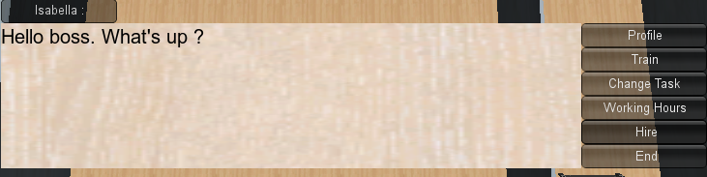
Figure 10: Dialog in SDM

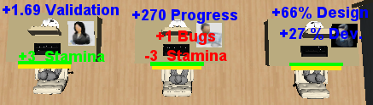
Figure 11: Employee's working. Show changes on Stamina due to different working hours

While developing this game, many other possibilities emerged, such as include a system of affinity between the player’s employees. This system would affect the integration of new employees in the team, causing the player to reflect on the decision to replace an employee in the middle of the software development. The new member would need, besides going through training, meet the team’s requirements and interact with other members to know how the team works on a daily basis.

A weakness of our game is that in the current version of the game, it is not possible to define iteration. Every day the player is given a feedback of the performance of each employee, but because of the sheer number of information shown, the player may be disoriented in relation to assessing the pace of the project development. To work around this problem, one option could be implemented that allows the player to choose the size of iterations, in which would inform the team’s performance and each individual employee performance within the chosen period.

We consider that our goals where achieved with our current implementation of the game, as we analyzed the results of the experiments that shows the game as a enjoyable way to help understand some concepts of Software Engineering, especially about people management.

Acknowledgements

Section omitted for Blind Revision.

References

Baker, A., Navarro, E.O. & Hoek, A. van der, 2003. Problems and Programmers: An Educational Software Engineering Card Game. In In: ICSE, pp. 614-621.
Dantas, A., Barros, M. de O. & Werner, C.M.L., 2004. Treinamento Experimental com Jogos de Simulação para Gerentes de Projeto de Software. In In: SBES.
Games, F., 2010. Game Dev Story. Available at: http://itunes.apple.com/us/app/game-dev-story/id396085661?mt=8 [Accessed May 5, 2011].
Navarro, E.O., 2002. SimSE: A Software Engineering Simulation Environment for Software Process Education. In In: ICS.
Prensky, M., 2001a. Digital Natives Digital Immigrants. In In: On the Horizon.
Prensky, M., 2001b. Fun, Play and Games: What Makes Games Engaging, In: Digital Game-Based Learning.
Prensky, M., 2002. The Motivation of Gameplay. In In: On The Horizon.
Russo, R. de F.S.M., 2007. Tendência empreendedora do gerente. In In: Gest. Prod., pp. 581-593.
Santos, S.C.G., 2005. Psicologia em Estudo - The information technology professionals and their personality analyzed by Rorschach technique. In In: Psicol. estud.

