Bloody Hell! Why did this happen?

Troy C Kohwalter

tkohwalter@ic.uff.br
Esteban G W Clua
Universidade Federal Fluminense
Instituto de Computação, Passo da Patria, 156, bloco E, Niterói - RJ Brasil
esteban@ic.uff.br
Leonardo G P Murta

leomurta@ic.uff.br

ABSTRACT
The analysis and understanding of events, mistakes and flows at a concrete game play may be very useful in many aspects: understanding problems of gameplay, data mining of specific situations and even understanding educational results in serious games. We introduce a novel and efficient methodology based on provenance concepts in order to model and represent a game flow. We model the game data and map it to provenance in order to generate a provenance graph, which is then used for analysis. We also instantiated the framework and graph generation in a Software Engineering game as a proof of concept, allowing the player to identify his mistakes and learn through them by analyzing the generated provenance graph from collected gameplay data.
Categories and Subject Descriptors
J.1 [Administrative Data Processing]: Education. I.7.5 [Document Capture]: Document Analysis. H.3.2 [Information Storage]: File organization and record classification. E.1 [Data Structures]: Graphs. D.2.12 [Interoperability]: Data mapping.
General Terms
Documentation, Design, Human Factors, Theory.
Keywords
Provenance, education, game analysis, action flow, graph, storytelling.

INTRODUCTION
Games have been used for aiding students to learn and understand concepts taught in classrooms [4, 20] due to their stimulating curiosity characteristic and for providing motivation for learning [23]. This type of games are called serious games [1], which are games used for purposes other than entertainment while still providing pleasure. Traditional, serious games are limited in terms of analysis of the obtained results, and do not allow the player to deeply comprehend decisions made throughout the game after finishing it. In many cases, this analysis is fundamental for detecting symptoms of problems that occurred due to wrong decision-making. The player would be required to play the game again and make different decisions to intuitively guess which ones were not adequate to the situation. However, depending on the dynamics and the complexity of the game, reproducing the same state can be unviable, making it difficult to replay it and try new solutions.

Neural studies about the learning capability of human brain [7, 9] state that the process of learning by correcting past mistakes can be very efficient. This process increases the human ability to adapt to new situations due to the rule of changing synaptic strengths, which ensures that synaptic changes occur only at neurons involved in wrong outputs. Nevertheless, in order to correct mistakes, it is fundamental to know which mistakes are.
The goal of this paper is to improve the player’s understanding of the game flow, how the story progressed and influences in the outcome. In order to improve understanding, we provide the means to analyze the game flow by using a provenance graph. Provenance refers to the documented history of an object's life cycle and is generally used in the context of art or digital data [22]. This is the first time that the provenance concept and formalization is used in the representation of game flow.
In our previous work [16], it is introduced the usage of digital provenance [12] in games by using the proposed framework. The framework provides the means to use provenance techniques for analysis by collecting information during a game session and mapping to provenance terms, thus allowing a post-game analysis.
The proposal of the present paper is based on that framework presented at [16], using the collected data for a post-game provenance analysis. The provenance analysis is done by processing the collected gameplay data and generating a provenance graph, mapping the actions and events made during the game session. This provenance graph allows the player to identify critical actions that influenced the game outcome and helps to understand how events were generated and which decisions influenced them. This process also aid in the identification of mistakes, allowing the player to reflect upon them for future interactions.
The provenance in games framework were previously instantiated in the SDM game [17] as a proof of concept. The SDM game focuses on introducing Software Engineering concepts and skills to undergraduate students. The new and improved version of SDM presented in this paper includes provenance support and analysis, allows students to analyze their actions and identify steps that lead to successful or unsuccessful outcome. While the main application of provenance in this paper is applied at serious games analysis and education, our novel concept may be used in many other aspects in games, allowing in the future studies of gameplay balancing, events and behaviors data mining and even storytelling enhancements.
This paper is organized as follows: Section 2 provides related work in the area of game flow analysis. Section 3 provides some background on the Provenance Model, explaining key definitions that are used in the provenance graph, as well as the framework used to bring provenance to games. Section 4 presents the provenance analysis by using a provenance graph and some features to aid in the analysis. Section 5 presents a proof of concept usage of the analysis in the SDM game. Finally, Section presents the conclusions of this work and points out some future work.

RELATED WORK
[25] proposes an informal method to analyze the game flow using a flow graph, which maps actions. [10] presents a more formal approach based on metrics collected during the game session, creating a gameplay log to identify events caused by player choices. Another method, called Playtracer [2], offers a way to visually analyze play steps, providing detailed visual representation of the actions taken by the player through the game.
Besides [25] proposal, which is superficially described in a blog, the other two methods are developer-oriented, meaning they aim to improve the quality of the game by providing feedback to the development team. Due to that, we could not find any concrete solution to provide feedback to the player.
Another method that analyzes a story in the field of interactive storytelling [6] was presented in [21]. This method organize the story using PNF networks [21], representing the temporal structure of the events that make up the plot. This structure can also be used in the generation of new events to the story, but is restricted to temporal coherence between the game events.

PROVENANCE
Provenance is well understood in the context of art or digital libraries, where it respectively refers to the documented history of an art object, or the documentation of processes in a digital object's life cycle. In 2006, at the International Provenance and Annotation Workshop, the participants were interested in the issues of data provenance, documentation, derivation and annotation. As a result, the Open Provenance Model (OPM) [18] was created from the Provenance Challenge that was held in that workshop. Recently another provenance model was developed, named as the PROV Model Primer [15], which can be viewed as a continuation of the OPM, since the later fell into disuse. Both models aim to bring provenance concepts to digital data.
In the Provenance Model, it is assumed that provenance of objects is represented by an annotated causality graph, which is a directed acyclic graph enriched with annotations capturing further information pertaining to execution. According to [18], a provenance graph is a record of a past or current execution, and not a description of something that could happen in the future.
The causality graph is composed of nodes that can represent Artifacts, Processes and Agents. Artifacts are an immutable piece of state that can represent a physical object or a digital representation in a computer system. Processes are actions or a sequence of actions performed or caused by artifacts and results in new artifacts. Agents are contextual entities acting as a catalyst of a process that can enable, facilitate, control or affect its execution. The edges of the graph belong to one of the categories described in Figure 1, representing a causal dependency between its source, denoting the effect, and its destination that denotes the cause. Below are some important definitions in the Open Provenance Model according to [18].
Causal Relationship: Represented by an arc and denotes the presence of a causal dependency between the source (effect) and the destination (cause).
Artifact Used by a Process: A [used] edge from process to an artifact is a causal relationship intended to indicate that the process required the availability of the artifact to be able to complete its execution. When several artifacts are connected to a same process by multiple [used] edges, all of them were required for the process to complete.
Artifacts Generated by Processes: A [was generated by] edge from an artifact to a process is a causal relationship intended to mean that the process was required to initiate its execution in order to generate the artifact. When several artifacts are connected to the same process by multiple [was generated by] edges, the process must begin for all of them to be generated.
Process Triggered by Process: An edge [was triggered by] from a process P₂ to a process P₁ is a causal dependency that indicates that the start of process P₁ was required for P₂ to be able to complete.
Artifact Derived from Artifact: An edge [was derived from] from artifact A₂ to artifact A₁ is a causal relationship that indicates that artifact A₁ should have been generated for A₂ to be generated. The piece of state associated with A₂ is dependent on the presence of A₁ or on the piece of state associated with A₁.
Process Controlled by Agent: An edge [was controlled by] from a process P to an agent Ag is a causal dependency that indicates that agent Ag controlled the start and end of process P.
Role: Designates an artifact or agent's function in a process.

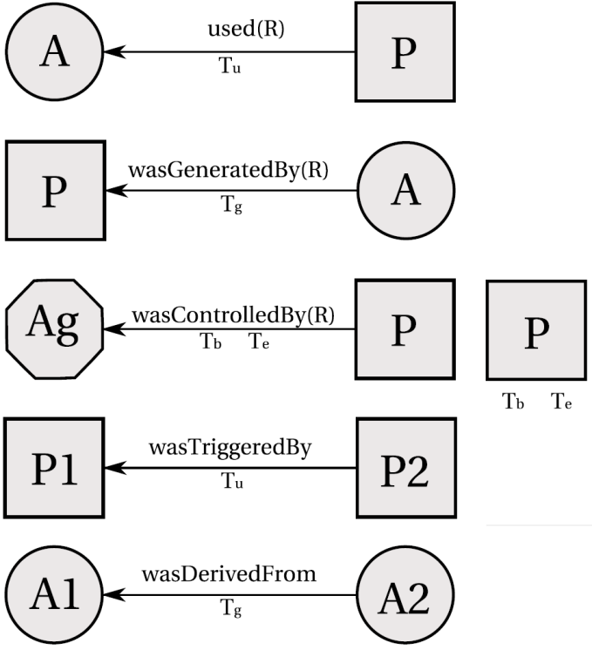
Figure 1. Example of edges and timestamps in OPM. Source: [18].
In Figure 1, the edge [used] means that a process used an artifact, while the [was generated by] edge an artifact was generated by a process. The letter "R" represents the roles under which these artifacts were used since a process may have used several artifacts. Likewise, many artifacts may have been generated by a process, and each would have a specific role. Roles are only meaningful in the context of the process where they are defined, and they are not defined by the OPM itself, but by the application domains. Roles are used on OPM to distinguish the involvement of artifacts in processes.
The edge [was controlled by] means the process was managed by an agent, essentially acting as a catalyst or controller. Since a process may have been controlled by several agents, their roles are also identified as controllers. This type of dependency represents a control relationship and not a data derivation. The edge [was derived from] assert that artifact A₂ was derived from another artifact A₁, giving an oriented dataflow view of the provenance. In contrast to the edge [was derived from], an edge [was triggered by] allows a process to have an oriented view of past executions. Figure 2 illustrates the provenance class diagram with edges types.
Moreover, the Provenance Model allows causality graphs to be used with time information. In this model, time is not used for deriving causality, but to validate causality claims, since if the same time clock is used to measure the time for both the effect and cause, then the time of an effect should be greater than the time of its cause.
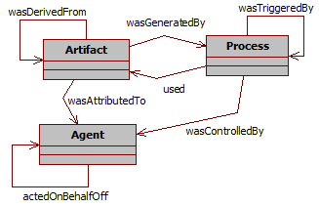
Figure 2. Provenance Class Diagram
In addition, time may be associated to instantaneous occurrences in a process. There are four types of this occurrences, being denoted as creation and use for artifacts and starting and ending for processes. Given that time may be observed by someone, its accuracy is limited by the clock and the notion of time. This way, the model allows for an interval of accuracy to support the granularity used to represent time. With this, it is possible to state that an artifact was used no earlier than time t₁ and no later than time t₂, as an example. This rationale is analogous for processes.
Figure 1 indicates how time information can be expressed in the model. For [used] and [was generated by] edges, one timestamp can be used to express when the event happened. For [was controlled by] edge two timestamps marks when the process started and terminated. For [was derived from] and [was triggered by] edges, one timestamp to indicate when the artifact was used. Despite using timestamp, the time of occurrence itself is not enough to imply causality. The fact that process P₁ happened before P₂ is not enough information to infer that P₁ caused P₂ to happen.
Finally, the Open Provenance Model has defined the notion of a graph based on a set of syntactic rules and topological constraints. The provenance graph captures causal dependencies that can be summarized by means of transitive closure. Because of this, a set of completion rules and inferences can be used in the graph. When users want to find out the causes of an artifact or a process, their interest is in indirect causes that involve multiple transitions.

Provenance in Games
To use a provenance methodology for game flow analysis, it is necessary to map provenance nodes to their game counterpart. We first proposed in [16] an adoption of provenance in the context of games, mapping each provenance node type to elements typically present in games. At such mapping, Artifacts, which provenance definition states as "an immutable piece of state that can represent a physical object […]" were mapped to game objects. In such a way, artifacts can be anything used in the game, such as weapons, potions, legendary artifacts, magical objects, etc, in a typical RPG game. In essence, it can represent anything meaningful to the development of the game history or the scenery.
Agents, which in provenance "are contextual entities acting as a catalyst of a process that can enable, facilitate, control or affect its execution", were mapped as characters present in the game, as non-playable characters (NPCs), players, and other entities, which can also be plot-managing entities.
Lastly, Processes by its definition of "actions or a sequence of actions performed or caused by artifacts […]" were mapped to actions or events made by entities in the game. In [16], the generation of actions and events are controlled by decision trees [19]. However, any decision making algorithm can be used instead to control actions and behaviors. These generated actions and events are represented as processes nodes in the provenance graph.
Moreover, in [16] we proposed a data model for provenance in games, which illustrates the provenance mapping and information examples that can be used for analysis, as shown by Figure 3. Besides this, [16] also presented an information structure to store collected game data for provenance analysis.
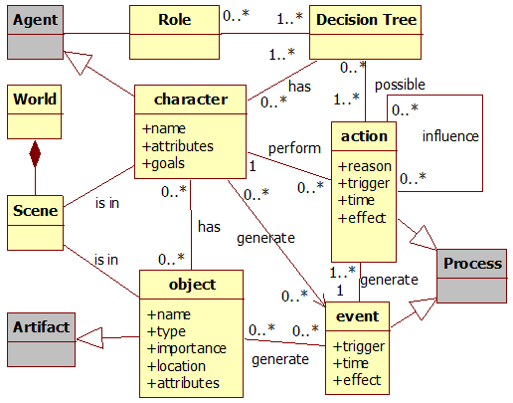
Figure 3. Data model diagram. Gray classes represent provenance classes. Source: [16].

PROVENANCE ANALYSIS
The purpose of collecting information during a game session is to be able to generate a provenance graph and use provenance techniques in order to analyze and infer the reasons of the outcome. However, not all collected information is relevant for every type of analysis. Thus, the provenance graph might contain actions that did not provoke any significant change. These elements act as noise and can be omitted during analysis.
The collected game data is used by a novel graph visualization tool, which is based on JUNG [14]. In this application, the data is processed and used to generate a provenance graph for analysis. After processing the data, the application creates the graph’s edges and nodes following our defined rules and according to their types. These data are written in separated files and used to generate the provenance graph. This graph is a representation of the game flow and is available for the user to interact and analyze, reaching his own decisions about how events occurred during the game and the outcome. The user will be able to see the consequences of each action and how they influenced other actions and the outcome, as well as manipulate the graph by omitting facts and collapsing chains of action for a better understanding and visualization process. No information is lost in this process, so the player can undo the changes.
A small example of a generated provenance graph from exported data is illustrated by Figure 4. Following the provenance notation specification, each node shape is related to its type. Square nodes represent process nodes, circles are artifacts nodes and an octagon represents agent nodes, as indicated by Figure 5. Other features present in the graph are explained below.
In order to better analyze graph data, some features are available in the graph application. As previously mentioned, it is possible to collapse nodes in order to reduce the graph size by changing the information display scale, grouping nearby nodes together and thus changing the graph granularity. Another usage of collapse is to group processes from the same agent, making easier to see all influences and changes that the agent did throughout the game. Figure 6 illustrates a collapse by grouping an agent’s processes with the agent.
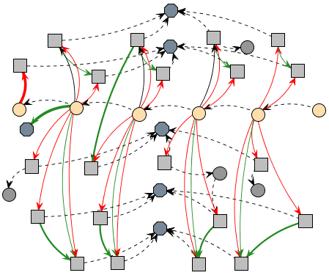
Figure 4. Example of a generated provenance graph.

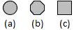
Figure 5. Node shapes by type. Figure (a) is an artifact node. Figure (b) an agent node and (c) a process node.
Another feature defined and implemented is the edge filter. An edge in the provenance graph represents a relationship between nodes. Depending on the context, it is possible to have multiple types of relations: positive, negative and even neutral.. Neutral relations are those that did not improved nor prejudice other processes or artifacts. Besides this, the context of the edge may vary. In the application it is possible to filter edges by context and the type of relationship.
The application also uses shapes and colors to distinguish information. As noted previously, nodes have different shapes according to its type. However, it is also possible to differentiate a node from another with different borders and color. As an example, processes that did not interact with other processes, or special types of processes, can be dotted. Borders can also be used on edges. The thickness can be interpreted as an estimative of how strong the relationship is. If the edge represents a low influence on the process, it will be a thin edge. If the influence is high, then it will be thicker. Another resource present on edges is color. For each type of relationship (positive, negative and neutral) is used a different color. Green is used for positive influences, red for negative, and black for neutral. To emphasize neutral relationships lack of impact, they can also be dotted. These edge types are illustrated in Figure 7.
Another filter present is the status filter. When selecting the desired status all nodes with the specified filtered status will change their colors according to their respective values. As an example, imagine that we desire to analyze the player’s hit points (HP) value throughout the game. When filtered by player’s HP, all nodes that contain a player HP value will have their colors changed by green if the value is above 75%, yellow if value is between 40% and 75%, and red if below 40%. Activating this type of filter allow the user to see the player’s HP throughout the game, making easier to identify situations where he might have had trouble. Section 5 provides more examples of those features used for analysis. Lastly, selecting a node will highlight its neighbors.
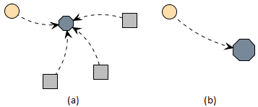
Figure 6. Collapsing Nodes. Figure (a) is the normal graph, containing an artifact, an agent, and three processes. Figure (b) is the grouping of all agent processes with the agent. Note the node size difference.
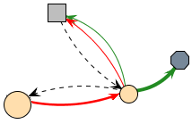
Figure 7. Edge types. A dotted edge is used for neutral relationships, and straight lines for influences. Note different colors and thickness for influences. Red is used for negative influence and green for positive. The thicker the edge, the more it is influenced.
Using these features for graph manipulation and visualization, the user is able to interact with the provenance graph and identify relevant actions that had an impact in the story or is relevant to the desired type of analysis and hide information that might not be relevant to the desired analysis.
Irrelevant information can be omitted in the graph or grouped together by features presented in the application. As an example, we may be in a situation that the player is in combat with an enemy and only after a few rounds it falls under the player's attacks. With the framework proposed in [16], every interaction creates a node to represent the action taken by the player, which is attacking the enemy. This may generate data that is unnecessary for analysis, so it is possible to reduce all the individual attack nodes to simply one node. Another case should be if the combat did not generates any impact in the story outcome, where it may be completely omitted.
However, the player could have made other actions against the enemy, which are also considered a form of attack, such as casting a spell, or a special attack maneuver, or even healing himself in order to survive. These actions are not duplicated, but can still be encapsulated for a superficial analysis, and if necessary can be expanded for a detailed analysis. Note that all collected information is preserved and the only change made is on how it is displayed.
Since provenance is an analysis from the present to the past, the battle outcome is already known and can be used to decide if it was relevant or not. If the player was victorious with minor challenge, did not suffer severe wounds, or barely used any resources at his disposal, then the entire combat can be simplified to just one node representing that the player attacked the enemy and was victorious. However, if the combat was challenging or the player lost, it is interesting to show all action nodes for analysis so the player can analyze the combat and identify important facts that influenced the combat outcome.
Note however that this application does not provide inference for the user, only the means necessary to infer. The player himself will need to decide which information is relevant for analysis. The reason we do not provide a generic inference strategy is due to its complexity. To infer something and decide if it is relevant or not for analysis is a complex process, which happens to be domain sensitive. This type of decision making also involve other areas of research [5, 8, 11, 13, 26].
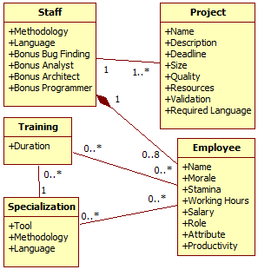
Figure 8. SDM's simplified class diagram. Source: [16].
APPLICATION
The provenance analysis using the proposed framework presented at [16] was instantiated and improved upon in a Software Engineering educational strategy game named Software Development Manager (SDM) [17]. The goal of SDM is to allow undergraduate students to understand the existing cause-effect relationships in software development process. As so, the adoption of provenance becomes an important instrument to better support knowledge acquisition, allowing the possibility of tracking mistakes made during a game session.
In SDM, which was developed using the game engine Unity3D [24] and had some elements influenced by [3], the player has a team of employees that are used to develop software according to contracts made with customers. The gameplay and game mechanics are modeled presenting possibilities to the player to decide strategies for development and define the roles for each staff member. As in any contract, the software has requirements that must be followed during development. From a gameplay point of view, these requirements help to balance the mechanics and rules. When the software is completed and delivered to the customer, there is a quality assessment of the software and a project completion payment accordingly to the product quality.
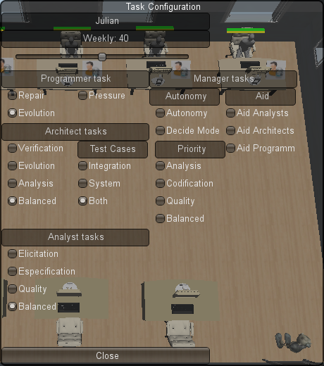
Figure 9. Task Configuration window. Source: [16].Since SDM focuses in people management, the main elements of the game are employees, which represent the player’s labor force. Employees can perform different roles (analyst, architect, manager, marketing, programmer and tester), which uses employee’s attributes to calculate his performance. Another element present in the game is specialization, used to define the employee working competence. With the specialization system, it is possible for employees to undergo training to learn new sets of skills. Also the concepts of working hours, morale, and stamina are used to modify the employee’s productivity. Figure 8 shows a simplified version of SDM’s class diagram focusing on the employee, showing his human attributes, types of specializations, the possibility of training to acquire specializations, and how the employee is affect by other employees that belong to the staff team. It also illustrates the project, its characteristics and requirements. We included in [16]edifferent changes in the game, introducing new concepts and expanding employee behaviors and actions, including some significant role responsibilities changes illustrated at Figure 9.

Information Storage
The information structure used on SDM is similar to the one explained in [16]. As such, each project contains list of employees that were involved in its development. Each employee has a list of actions executed as well as links to other actions in case of external influences. Throughout the game, when actions are executed, information is collected and stored for post-game analysis and for generating the provenance graph. Since provenance graphs contains three types of nodes (processes, agents, and artifacts), the collected information is mapped to each type, according to the data model explained in [16] and illustrated by Figure 3. Each node contains different information according to its type.
For the processes nodes, which represents actions executed during the game by employees, it is stored when it occurred, who executed it, which task was executed, which role was he occupying, the employee’s current morale and stamina stats, how many hours he worked that day, how much credits was spent to execute the action, the progress made in his task and a description of the action, explaining his decision making process. Besides those, if the action had any external influences or if used or altered an artifact, a link to the action that affects its execution and the artifact is included.
Agent nodes, representing employees, stores the employee’s name, his current staff grade, his level, human attributes which are used in the game, and specializations.
Artifact nodes vary according to its type. In SDM we use three types of artifacts: Prototypes, produced by architects and consumed by analysts; Test Cases, produced by analysts, architects and programmers and consumed by testers; and Project, which represents the software development progress and is considered the main artifact for analysis.
For project type artifact, it is stored the name of the project, the day of its instance, the project’s deadline, how much credits the player have, how much coding was produced, the code overall quality, the clients requirements identified and modeled by analysts, how many credits is paid each month to the player and the state of each type of bugs found and repaired. Figure 10 illustrates an example of the data shown in the provenance graph according to the node’s type.
After the data is collected and extracted, a provenance graph corresponding to that scenario is generated and displayed for analysis, similar to the one presented by ..

Provenance Graph
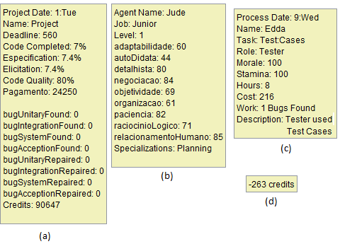
Figure 10. Information data in the provenance graph. (a) is the main artifact node data (Project). (b) is an agent node data (Employee). (c) is a process node data (actions) and (d) an edge data (influences).
With the adaptations made in the original SDM concepts [16], it is possible to use the collected data for provenance analysis. The collected game data is exported for an external graph visualization tool, which uses JUNG. In that application, the data is processed and used to generate a provenance graph for analysis.
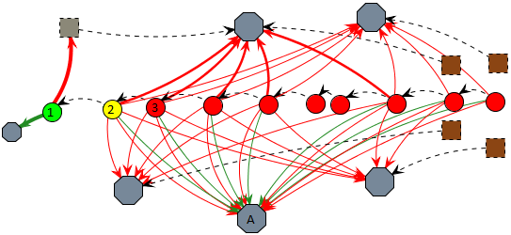
Figure 11. An example of credits status filter.
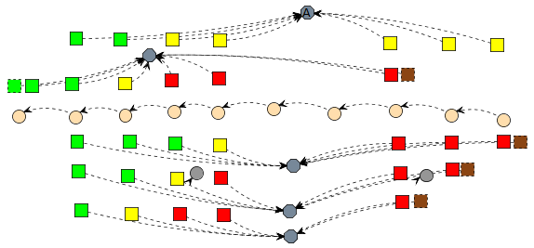
Figure 12. Morale Filter on non-collapsed graph from Figure 11.By analyzing the graph it is possible to reach some conclusions of why the story progressed the way it did. As an example, Figure 11 illustrateryscenery where the player had credits problem. Credits are the monetary coin in the game. To simplify the picture, some collapses were made, omitting most of the agent’s processes. The artifactn represent instances of the development stage, including the player’s credits value. The processes present in the picture represent hiring actions for gray and resignations for brown.
In Figure 11 it is already applied credits filter, both in the edges and nodes. In (1), the project had a substantial credits income and a new employee was hired, as marked by the thick green edge for an agent and thick red edge for a gray dotted process. The player’s credits are also in a green zone as marked by the project’s node color. However, due to the hiring fee paid in (1) and the resources used by the staff in (2), the player’s credits changed to a yellow zone, even with the minor income from agent (A). In (3) the player’s credits changed to red zone due to payments process, meaning that his resources are almost empty and will not have enough credits to keep paying his employees. When that happens, employee’s morale is lowered due to the lack of payment and if it reaches red zone, they can resign, as shown by brown processes.tObserving Figure 12 we can see each employee’s morale getting lower by lack of payment and why they asked their resignation. Without the credits to hire new employees and without a staff, the player lost the game.
Another example of analysis is by checking employee productivity and understanding why variations occurred. In SDM, productivity is defined by the task executed, if had any outside help, employee’s job (junior, mid-level, and senior), working hours, and stamina and morale stats. Figure 13 illustrated an example. To simplify graph visualization due to size limits, we will focus only in two agents and the main artifact known as “project”. Those agent’s roles are programmer and manager, with the manager acting as a supporting role for the programmer.
Analyzing the picture we can see that the programmer’s productivity fluctuated throughout (1) to (7). We can also see that this fluctuation was not caused by the manager, since his aid bonus did not have much variation. The variation from (1) to (2) in the programmer’s productivity was because he performed different tasks. In (1) he did a test-driven approach, which reduces his productivity. There are three different types of tasks in the picture for the programmer: Test-driven, which has reduced productivity for more quality, design-code, which is treated as the default type of programming, and ad hoc, which increases productivity at the cost of quality.
In (2) he did an ad hoc approach, which maximizes his productivity at the cost of quality. The change in (3) can be identified by looking at his working hours, which can be done by looking at each individual node or by adding a filter, as shown by Figure 14.
At Figure 14, we can see that the programmer’s daily hours were increased by the change from yellow to red. There are three different colors to this filter, green for under-working, yellow for default, and red for over-working in a daily basis. Since the process node in (3) is red, it means the employee is doing extra hours, which increases his productivity. From (3) to (7), his working hours remained unaltered. So the change from (2) to (3) was mainly due the change on his daily working time. But if we look at (4), we can see a drop in his productivity.
The task performed at (4) was design-code, but even so there was a subtle decrease due to changes in his stamina and morale. In (5) the change is more visible, especially because he was in ad hoc mode, same as (3). His working hours had not decreased, as noted by Figure 14. This drastic change occurred because the programmer was getting tired, meaning his stamina was dropping because of the extra hours he was doing.
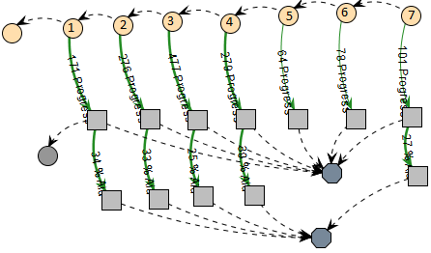
Figure 13. Example of a provenance graph analysis.
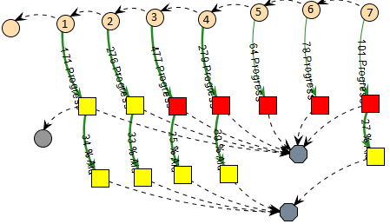
Figure 14. Graph from Figure 13 using filter: working hours.

By changing the filter again to show stamina levels, we can see in Figure 15 that in (3) his stamina indeed dropped to yellow because of the extra hours and in (4) it reached red due to exhaustion. Another side effect of his exhaustion was the change on the programmer’s morale, which also reached the red zone in (5), as illustrated by Figure 16. With both the morale and stamina at lowest levels, the extra hours were not compensating his productivity. As shown previously, if his morale levels don’t increase the programmer might resign. Lastly, the small variation from (5) to (7) is due to a random range modifier during productivity computation, since the programmer is already working at minimal levels at the current configuration.

CONCLUSION
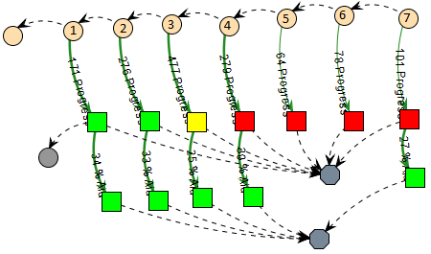
Figure 15. Graph from Figure 13 using filter: stamina. 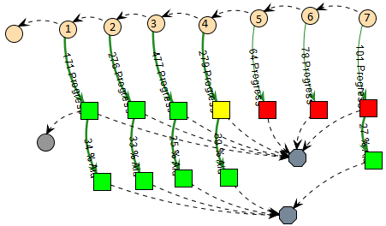
Figure 16. Graph from Figure 13 using filter: morale.

This paper proposed a new type of game flow analysis by using provenance in games framework, allowing post game analysis to discover points that contributed to specific game flows and results achieved throughout the gaming session. This analysis can be used on games to improve understanding and analyzing game flow and identifying actions that influenced the outcome, aiding the player to understand why it happened the way it did. It can also be used to analyze a game story development, how it was generated and which events affected it.
In this paper we presented a tool to visually aid the analysis by manipulating the generated provenance graph from collected data. It also showed a game in which our proposed provenance analysis was instantiated, with some flow and elements examples. During the game session, information is collected generating a game flow log, which is used in a post analysis to generate a provenance graph. We also explained some analysis features that can be done in the provenance graph to aid or refine the analysis.
However, there are still some limitations. If the provenance graph is too large, by the order of thousands of nodes, even using the granularity filter, there will be some visualization limitations, not to mention a lower performance when executing filters. Due to the graph size, information contained in collapsed nodes will also have visualization issues. This happens because the collapsed node is actually a graph, and the information displayed is a list of all nodes contained in it with their respective information. One way to deal with this problem is to filter the displayed information from the graph-node to only a few, more important or relevant ones, or to display a summary as if it was only one node and provide the possibility of viewing the collapsed graph in a separated window.
Another limitation is that we do not make inferences to the user, but let the user decide what he want to infer. Studies in this area can be made in order to identify information that can be safely omitted from the user without impacting in the overall analysis. Another interesting research is to automatically identify patterns in the game flow. Lastly, we plan on working in different graph visualization layouts and run experiments to evaluate the aspects of learnability of using the provenance graph in order to understand better the story.

ACKNOWLEDGMENTS
We would like to thank CNPq, FAPERJ and CAPES for the financial support.

REFERENCES
[1] Abt, C.C. 1987. Serious Games. University Press of America.
[2] Andersen, E. et al. 2010. Gameplay analysis through state projection. In: ACM Press. (2010), 1–8.
[3] App Store - Game Dev Story: 2010. http://itunes.apple.com/us/app/game-dev-story/id396085661?mt=8. Accessed: 2011-05-05.
[4] Baker, A. et al. 2003. Problems and Programmers: An Educational Software Engineering Card Game. In: ICSE. (2003), 614–621.
[5] Bristol, E.H. 1977. Pattern recognition: An alternative to parameter identification in adaptive control. Automatica. 13, 2 (Mar. 1977), 197–202.
[6] Cavazza, M. et al. 2002. Character-based interactive storytelling. IEEE Intelligent Systems. 17, 4 (Aug. 2002), 17 – 24.
[7] Chialvo, D.R. and Bak, P. 1999. Learning from mistakes. Neuroscience. v. 90, 4 (Jun. 1999), 1137–1148.
[8] Cios, K. et al. 1998. Data mining methods for knowledge discovery. Kluwer Academic Publishers.
[9] Clark, G. 1950. The organization of behavior: A neuropsychological theory. The Journal of Comparative Neurology. v. 93, 3 (1950), 459–460.
[10] Consalvo, M. and Dutton, N. 2006. Game analysis: Developing a methodological toolkit for the qualitative study of games. In: Game Studies. v. 6, (2006).
[11] Fayyad, U. et al. 1996. From Data Mining to Knowledge Discovery in Databases. AI Magazine. 17, 3 (Mar. 1996), 37.
[12] Freire, J. et al. 2008. Provenance for Computational Tasks: A Survey. Computing in Science Engineering. 10, 3 (Jun. 2008), 11 –21.
[13] Han, J. and Kamber, M. 2006. Data Mining: Concepts and Techniques. Morgan Kaufmann.
[14] Joshua O’Madadhain et al. 2010. JUNG: Java Universal Network/Graph Framework. Open-source.
[15] Khalid Belhajjame et al. 2012. PROV-DM: The PROV Data Model. Working Draft.
[16] Kohwalter, T. et al. 2012. Provenance in Games. (Brasilia, 2012).
[17] Kohwalter, T. et al. 2011. SDM – An Educational Game for Software Engineering. (Salvador, 2011).
[18] Moreau, L. et al. 2011. The Open Provenance Model core specification (v1.1). In: Future Generation Computer Systems. 27, 6 (Jun. 2011), 743–756.
[19] Moret, B. 1982. Decision Trees and Diagrams. In: ACM Computing Surveys (CSUR). 14, 4 (Dec. 1982), 593–623.
[20] Navarro, E. 2002. SimSE: A Software Engineering Simulation Environment for Software Process Education. In: ICS. (2002).
[21] Passos, E.B. et al. 2009. Hierarchical PNF Networks - A Temporal Model of Events for the Representation and Dramatization of Storytelling. 2009 VIII Brazilian Symposium on Games and Digital Entertainment (SBGAMES) (Oct. 2009), 175 –184.
[22] PREMIS Working Group 2005. Data Dictionary for Preservation Metadata. Technical Report #Final Report of the PREMIS Working Group. Implementation Strategies (PREMIS).
[23] Prensky, M. 2001. Fun, Play and Games: What Makes Games Engaging. In: Digital Game-Based Learning. (2001).
[24] Unity - 3D Game Engine: 2010. http://unity3d.com/. Accessed: 2011-05-05.
[25] Warren, C. 2011. Game Analysis Using Resource-Infrastructure-Action Flow. Ficial.
[26] Witten, I.H. and Frank, E. 2005. Data Mining: Practical Machine Learning Tools and Techniques, Second Edition. Morgan Kaufmann.

