Part 5. Multisite mixing models built-in functions in GEM-Selektor v.3.3 code

Treatment of condensed symmetric non-electrolyte solutions in GEM-Selektor code is based on the default expression for the chemical potential of a j-th end member:
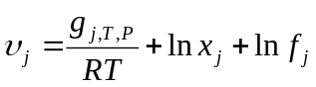 (5.1-1),
where g_{j,T,P} is the molar apparent Gibbs energy function at T,P of interest; 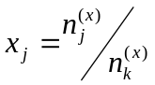is the end member mole fraction (n_{j} is the primal mole quantity of j-th species and n_{k} = ∑ x_{j} , j ∈ L_{k} is the total mole quantity of the k-th phase), and f_{j} is a ‘real’ activity coefficient.
If all f_{j} = 1 at any composition then eqn (5.1-1) reduces to the Raoult’s law of simple ideal mixing, where the activity of j-th end-member equals its mole fraction. This definition of ideal mixing, corresponding to the configurational entropy of random mixing on a single type of structural sites, is rather narrow. In a broader sense, ideal solutions can be defined as having zero excess entropy, zero enthalpy and zero volume of mixing (Oates, 1966; Price, 1985; Anderson and Crerar, 1993). Microscopic moieties (usually ions or atoms) can substitute each other independently on one or several types of structural sites, often called ‘sublattices’ (Hillert, 1998; Lucas et al., 2007). Sublattices formally represent long-range ordering (LRO).
Eq (5.1-1) corresponds to the simplest case where two or more moieties substitute each other on one site type, and there is one moiety per formula of end member. This is the case e.g. for carbonate (A,B,…)CO₃ or sulfate (A,B,…)SO₄ solid solutions, but it is clearly insufficient for most of rock-forming silicate or oxide minerals where mixing occurs on several sublattices simultaneously, and can be complicated by short-range ordering (SRO) effects. In such ideal ‘multisite mixing’, the activity a_{j} of j-th end member is not simply its mole fraction x_{j}, but a more complex function of ‘site fractions’ y_{s,m} of m-th substituting moiety on s-th site type in k-th solution phase. This corresponds to a more complex form of the configurational entropy, and causes the ‘reciprocal’ relations between end members and their standard-state properties.
Here we need to introduce a set Ξ_{k} of indexes of sublattices (structural site types) in the k-th phase, where n(Ξ_{k}) is the number of site types indexed with s ∈ Ξ_{k}. Further, we introduce a set Μ_{s} of indexes of n(Μ_{k}) moieties that can appear on s-th site in k-th phase structure; moieties will be indexed with m ∈ Μ_{k}. Let η_{j,s,m} be a ‘moiety-site multiplicity’, i.e. the number of moles of m-th moiety on s-th site in one mole of j-th end member at standard state ( j ∈ L_{k}), and η_{s} be the number of s-th sites in one formula unit of any end member of the k-th phase (s ∈ Ξ_{k} ) (‘site multiplicity’). Note that the same species (e.g. ion M+), if it appears on two different sublattices, must be considered as two different moieties; the same applies to vacancies.

5.1. Ideal part of the end-member activity term
Now, the approximation of chemical potential of j-th end member of k-th phase takes the form
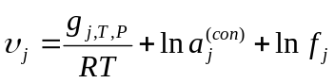 j ∈ L_{k} (5.1-2),
where λ_{j} is the ‘macroscopic’ end member activity coefficient, and 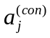 is the ideal part of activity related to the partial molar configurational entropy:
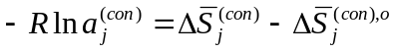 (5.1-3).
Following the derivation in (Price, 1985),
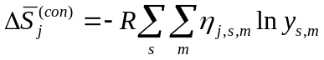 m ∈ Μ_{k} s ∈ Ξ_{k} j ∈ L_{k} (5.1-4),
where the site fraction of m-th moiety on s-th site in k-th phase is
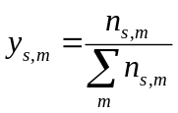 m ∈ Μ_{k} (5.1-5).
here n_{s,m} is the number of moles of m-th moiety on s-th sublattice sites in the ‘real’ state.
At standard state, the s-th site fraction of m-th moiety in j-th end member is
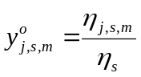 (‘site multiplicity’ 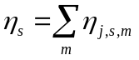) (5.1-6),
and the end member has a configurational entropy term itself:
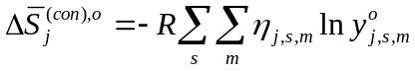 (5.1-7)
Combination of eqs (5.1-4, 5.1-7 and 5.1-3) yields
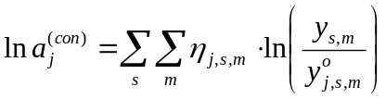 m ∈ Μ_{k} s ∈ Ξ_{k} j ∈ L_{k} (5.1-8)
The site fraction y_{s,m} (eq 5.1-5) in the k-th phase can be expressed through mole fractions of end members x_{j} because
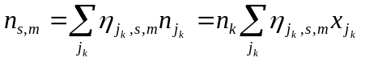 j_{k} ∈ L_{k} (5.1-9),
where n_{jk} is the primal mole amount of j_{k}-th end member, and 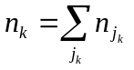(here, summations run over all end members in k-th phase). Using , eq (5.1-5) takes the form:
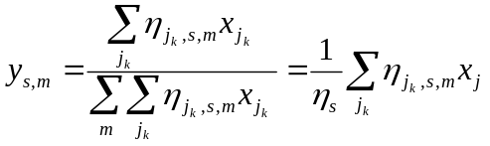 j_{k} ∈ L_{k} m ∈ Μ_{k} s ∈ Ξ_{k} (5.1-10).
Substituting this and eq (5.1-6) into eq (5.1-8) results in the ideal activity of j-th end member
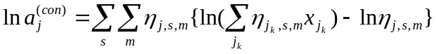 j_{k} ∈ L_{k} (5.1-11).
Now, eq (5.1-2) for the end member chemical potential takes a more general form:
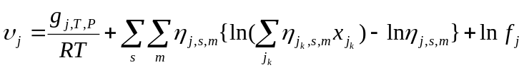 (5.1-12).
At n(Ξ) = 1 and all η_{j,s,m} numbers equal to unity, eq (5.1-11) reduces to ln x_{j} – the simple ideal single-site mixing activity contribution - and eq (5.1-12) reduces to eq (5.1-1). In principle, any multi-site mixing model can be put on top of the ln x_{j} term in eq (5.1-1) by introducing a ‘configurational entropy’ term λ_{j}, also called ‘fictive activity coefficient’:
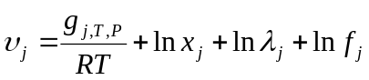 (5.1-13)
where
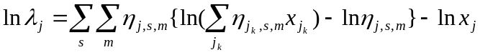 (5.1-14).
In earlier versions of GEMS, this could be done only in Phase definition scripts which contained all the specific η_{j,s,m} numbers for a particular sublattice mixing model. This slowed calculations down and precluded such phase definitions from being used in GEMS3K kernel and, thus, in any reactive mass transport or other coupled codes. This work represents an extension that enables built-in ideal or non-ideal multi-site mixing models also in GEMS3K. For this extension in TSolMod class, it is necessary to use an array of η_{j,s,m} numbers arranged as a sequence of n(L_{k}) matrices 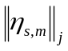, each having n(Ξ_{k}) rows and n(Μ_{k}) columns. These matrices will be arranged in (part of) a MoiSN array (to be created in the MULTI data structure) then passed as a pointer into TSolMod class instance. The moieties will be arranged in a common list (without duplicate entries) for the solution phase. If the same cation or anion occurs in different sublattices then it must be considered as a different moiety on each sublattice site. For example, in ferrites, divalent and trivalent cations may be redistributed between tetrahedral and octahedral sites, e.g. in Ni-ferrite: (Ni_{1-z}Fe^{III}_{z})_{Tet}(Ni_{z}Fe^{III}_{2-z})_{Oct}O₄, where 0 < z < 1 is the extent of inversion which depends on temperature. At given temperature, e.g. setting z = 0.8, the Fe-Ni ferrite system may be represented using two end members: (Ni_{0.2}Fe^{III}_{0.8})_{Tet} (Ni_{0.8}Fe^{III}_{1.2})_{Oct}O₄ and (Fe^{II}_{0.2}Fe^{III}_{0.8})_{Tet} (Fe^{II}_{0.8}Fe^{III}_{1.2})_{Oct}O₄. Note that Ni cation on the Tet sublattice is not the same moiety as Ni cation on the Oct sublattice. If vacancies are considered on different sites, the same applies to vacancies.
The most versatile way of providing the information about moieties occupancies on sites in the Phase definition seems to be through the formulae of end members. To do this, the formulae syntax needs to be extended. For example, the usual formulae of feldspar end members are
KAlSi3O8 (microcline); NaAlSi3O8 (albite); CaAl2Si2O8 (anorthite) etc.
This format does not contain information about sites and moieties that substitute on them. However, this information can be incorporated e.g. in the following way:
{K}:{Al}{Si}3:O8 {Na}:{Al}{Si}3:O8 {Ca}:{Al}2{Si}2:O8
Essential feature here is that each moiety (incl. vacancy Va ) is taken in the {} braces; the colon ‘:’ separates sublattice sites which must follow the same order in all end members. The η_{j,s,m} numbers appear just as stoichiometry coefficients after moieties. Upon parsing the formula, the number of sublattices is counted by encountered colons ‘:’ (two in the above example), and the moieties are collected in a list along with their site-moiety multiplicity η numbers and the site index. This list can then be merged into the overall list of n(M_{k}) moieties for the phase, and the η numbers then assigned to tables, the sequence of which forms the MoiSN array. The same ion can be represented as different moieties by adding the moiety index after species name. In the above example of ferrite with cation inversion, the formulae of end members will look like this (default valence of IC Ni is 2 and that of IC Fe is 3):
{Ni}0.2{Fe}0.8:{Ni}0.8{Fe}1.2:O4
{Fe|2|}0.2{Fe|3|}0.8:{Fe|2|}0.8{Fe|3|}1.2:O4
In the former end member, Ni is present on both sites, so the program creates two moieties: [Ni]0 and [Ni]1; it also creates two moieties for divalent Fe: [Fe]0 and [Fe]1. By analyzing the latter end member, [Fe|3|]0 and [Fe|3|]1 will be added to the list of moieties, and so on.

Chemical formulae of DCs are parsed in GEM-Selektor using the syntax that is now extended, as shown below in boldface:

<formula> ::= <fterm> | <fterm> <charge>
<fterm> ::= <icterm> | <fterm> <icterm> |
<site_term> : | <fterm> <site_term> :
<site_term> ::= <moiety> | <site_term> <moiety>
<moiety> ::= {<elem>} | {<elem>} <elem_st_coef>
<icterm> ::= <elem> | <elem> <elem_st_coef>
<elem> ::= (<fterm>) | [<fterm>] |
<isotope_mass><icsymb><valence> |
<isotope_mass><icsymb> |
<icsymb><valence> | <icsymb>
<charge> ::= +<real> | -<real> | + | - | @
<elem_st_coef> ::= <real>
<icsymb> ::= <Capital_letter> | <icsymb><lcase_letter>
| <icsymb>_ | Va
<valence> ::= |-<integer>| | |+<integer>| | |<integer>|
<isotope_mass> ::= /<integer>/
<integer> ::= <num>
<num> ::= <digit> | <num><digit>
<digit> ::= 0 | 1 | 2 | 3 | 4 | 5 | 6 | 7 | 8 | 9
<real> ::= <num>.<num> | <num>. | .<num> | <num>

In the <elem> term, up to three levels of nesting is allowed. The vertical bar "|" means "or", i.e. one selection from several possible values or terms. The “Va” in <icsymb> means “vacancy” and should be ignored everywhere except where moieties and site terms are analyzed. When the formula parser is called for checking the DComp or ReacDC formulae, all the { and } brackets must be replaced with ( and ) respectively, and colons : removed.

Otherwise, the site index should be incremented upon encountering the colon ‘:’. The newly encountered moieties (including Va) is put into square brackets, appended with the sublattice index, and then added to the list of moieties, if not already present there, and the moiety index and site index are then used for inserting the respective occupancy number (if given after ‘}’, 1 by default) into the occupancy table, which must exist for all end members in the phase. The strict order of site terms is essential. The total of moiety occupancies (the site multiplicity) for a given site is checked to be the same for this site term in all end members (see eq 5.1-6).

5.2. Non-ideal site-interaction part of the end-member activity term
after T.Wagner 21.06.11
To represent intra-site non-ideal interactions for substitutions of moieties on sublattices, the approach of Berman and Brown (1984), Berman (1990) is applied because of its relative simplicity and compatibility with ‘petrologic’ style of defining end members with more than one moiety on a sublattice site. So far, this approach ignores cross-site interactions (which at least partially can be accounted for using the reciprocal terms).
In our notation, the ideal contribution to the end member activity used in Berman’s models,
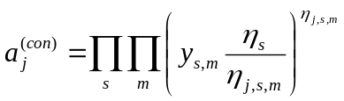 m ∈ Μ_{k} s ∈ Ξ_{k} j ∈ L_{k} (5.2-1)
is shown to be equivalent to eq (5.1-8) because from eq (5.1-6), 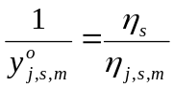.
The non-ideal contribution to end-member activity (see eq 5.1-2) is defined as the sum of
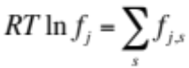 s ∈ Ξ_{k} j ∈ L_{k} (5.2-2)
Furthermore,
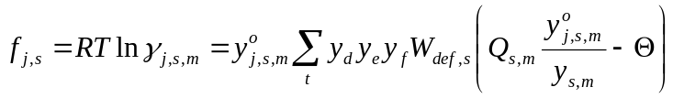 t ∈ W_{s} (5.2-3)
where the index m refers only to moieties that are present on s-th site in j-th end member; Q_{s,m} is the number of _{d}, _{e}, _{f} subscripts equal to m (0, 1 or 2); Θ is the order of interaction (symmetric: 1; asymmetric: 2); and W_{s} is the subset of indexes p of entries in the list of interaction parameters that refer to s-th sublattice. The _{d}, _{e}, or _{f} subscript can be an index m of any moiety that exists on the s-th site. Hence, W_{def,s} is the interaction parameter for a particular combination of moieties substituting each other on the s-th site. The T,P dependence of the interaction parameter is represented, as usual, by three coefficients a, b, and c (J,K,bar):
W = a - b⋅T + c⋅P (5.2-4)
In the case of symmetric interaction, the _{f} subscript does not exist, and eq (5.2-3) takes the form
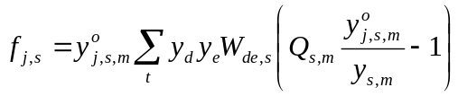 (5.2-5)
where (eq 5.1-6). For the asymmetric interactions,
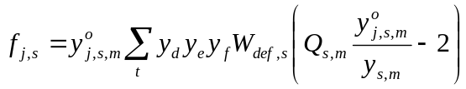 (5.2-6)
where either d and e or e and f indexes refer to the same moiety on s-th site in the case of a pseudo-binary interaction, and all three indexes are different in a ternary interaction.
In addition to tables and 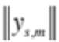 taken over from the calculation of ideal contributions to end member activities (see Section 5.1), another set of tables 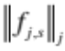 is needed in the algorithm to collect the contributions to terms 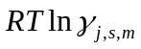 (see eq 5.2-3).
In the TSolMod class implementation, the setup of interaction parameters (IP) is done in the Phase definition record. Upon calculation of equilibria, the IP list is passed automatically into the TSolMod instance for calculation of end-member activity coefficients. In the microscopic non-ideality model, the IP list needs to be arranged in the following format:
IP index Site index Moiety indexes IP coefficients (J, K, bar)
p |  | s | d | e | f |  | a | b | c
0 |  | 0 | 0 | 1 | -1 |  | -6000 | -1.3 | 0.4
1 |  | 1 | 3 | 3 | 4 |  | 17000 | 5.1 | 0.1
… |  | … | … | … | … |  | … | … | …

IP coefficients refer to eq (5.2-4), W_{def,s} = a - b⋅T + c⋅P (note the minus sign at bT term), T in K, P in bar, a in J/mol.

Example: Muscovite (white mica) solid solution (Parra et al. 2002)

End-members:
muscovite (mu), celadonite (cel), ferrous celadonite (fcel), Na-celadonite (ncel), Na-ferrous celadonite (nfcel), paragonite (pa), and pyrophyllite (prl).

Moiety- sublattice site allocation table (encoded in end-member formulae).

Sublattice  End member | A  (0) | M23  (1) | T2  (2) | T1  (3) | End-member formula  (as written in DComp record)
(0) fcel | K | Al Fe | Si₂ | Si₂ | {K}:{Al}{Fe}:{Si}2:{Si}2:O10(OH)2
(1) cel | K | Al Mg | Si₂ | Si₂ | {K}:{Al}{Mg}:{Si}2:{Si}2:O10(OH)2
(2) mu | K | Al₂ | Al Si | Si₂ | {K}:{Al}2:{Al}{Si}:{Si}2:O10(OH)2
(3) nfcel | Na | Al Fe | Si₂ | Si₂ | {Na}:{Al}{Fe}:{Si}2:{Si}2:O10(OH)2
(4) ncel | Na | Al Mg | Si₂ | Si₂ | {Na}:{Al}{Mg}:{Si}2:{Si}2:O10(OH)2
(5) pa | Na | Al₂ | Al Si | Si₂ | {Na}:{Al}2:{Al}{Si}:{Si}2:O10(OH)2
(6) prl | Va | Al₂ | Si₂ | Si₂ | {Va}:{Al}2:{Si}2:{Si}2:O10(OH)2

Microscopic interaction parameters (J, K, bar).

W_{KKNa,A} = 19460 - 1.65⋅T - 0.46⋅P
W_{KNaNa,A} = 12230 - 5.0⋅T + 0.67⋅P
W_{KKVa,A} = 35000 + 25.0⋅T – 0.85⋅P
W_{KVaVa,A} = 45000 + 10.0⋅T – 0.85⋅P
W_{NaNaVa,A} = 40000 + 5.0⋅T
W_{NaVaVa,A} = 40000 + 5.0⋅T
W_{KNaVa,A} = 95480 +19.13 ⋅T – 0.745 ⋅P
W_{AlMg,M23} = –30500 + 15.0⋅T + 0.78⋅P
W_{AlFe,M23} = –5500 + 15.0⋅T + 0.65⋅P
W_{MgFe,M23} = 0
W_{AlSi,T2} = 0

In GEMS Phase window (Page 3), the recalculation results in the following allocation table:

End member- moiety multiplicity number table (multiplicity numbers can be non-integer).

m | 0 | 1 | 2 | 3 | 4 | 5 | 6 | 7 | 8
j | {K}0 | {Al}1 | {Fe]}1 | {Si}2 | {Si}3 | {Mg}1 | {Al}2 | {Na}0 | {Va}0
0 | 1 | 1 | 1 | 2 | 2 | 0 | 0 | 0 | 0
1 | 1 | 1 | 0 | 2 | 2 | 1 | 0 | 0 | 0
2 | 1 | 2 | 0 | 1 | 2 | 0 | 1 | 0 | 0
3 | 0 | 1 | 1 | 2 | 2 | 0 | 0 | 1 | 0
4 | 0 | 1 | 0 | 2 | 2 | 1 | 0 | 1 | 0
5 | 0 | 2 | 0 | 1 | 2 | 0 | 1 | 1 | 0
6 | 0 | 2 | 0 | 2 | 2 | 0 | 0 | 0 | 1
Indexes m and j are shown for the reader’s convenience
To set up interaction parameters, remake the Phase record and set the Berman (B) built-in (S) model with total number of input interaction parameters (in this example, 11). On Page 3 of Phase window, you will see a combined list filled with zeros.
As shown below, for each interaction parameter, the indexes of sublattice s and moieties d,e,f should be entered into four ipxT colums (for a symmetric interaction parameter, index f should be set to -1). For each moiety, its sublattice index can be found right after its name, e.g. {K}0. For example, the parameter W_{KKNa,A} = 19460 - 1.65⋅T - 0.46⋅P will be set as shown below:

s | d | e | f | a | b | c
ipxT[0] | ipxT[1] | ipxT[2] | ipxT[3] | ph_cf[0] | ph_cf[1] | ph_cf[2]
0 | 0 | 0 | 7 | 19460 | -1.65 | -0.46
… | … | … | … | … | … | …

The complete list for this example is shown below. The interaction parameters (rows) can be given in an arbitrary sequence. Two rows with zero IPs can, in principle, be dropped (by remaking the Phase record and setting the number of rows to 9 instead of 11). However, the sequence of end members and moieties is essential; if it changes, the indexation in ipxT columns must be revised according to the new moiety allocation table.

Interaction parameters setup in Phase record for the Muscovite example.
ipxT[0] | ipxT[1] | ipxT[2] | ipxT[3] | ph_cf[0] | ph_cf[1] | ph_cf[2]
0 | 0 | 0 | 7 | 19460 | -1.65 | -0.46
0 | 0 | 7 | 7 | 12230 | -5 | 0.67
0 | 0 | 0 | 8 | 35000 | 25 | -0.85
0 | 0 | 8 | 8 | 45000 | 10 | -0.85
0 | 7 | 7 | 8 | 40000 | 5 | 0
0 | 7 | 8 | 8 | 40000 | 5 | 0
0 | 0 | 7 | 8 | 95840 | 19.13 | -0.745
1 | 1 | 5 | -1 | -30500 | 15 | 0.78
1 | 1 | 2 | -1 | -5500 | 15 | 0.65
1 | 5 | 2 | -1 | 0 | 0 | 0
2 | 6 | 3 | -1 | 0 | 0 | 0

Worked test examples of multi-site solid solution models with Berman microscopic non-ideality will be provided in the BermanMSS test project and its documentation (TBD).

5.3. Reciprocal part of the end-member activity term (TBD)
The typical multi-site solid solution with two or more sublattices and two or more moieties substituted on each sublattice is ‘reciprocal’. Meaning of this term is best illustrated using the system {A,B}₂:{D,E}₂: (e.g. Wood and Nicholls, 1978; Hillert, 2001). All possible compositions can be represented on a ‘composition square’ formed by four possible end members: A₂:D₂, B₂:D₂, A₂:E₂, B₂:E₂. It is evident that there are four end members, but only three are needed to describe any bulk composition of this solution phase. For instance, the center of the square can be obtained by mixing equal amounts of either A₂:D₂ and B₂:E₂ or A₂:E₂ and B₂:D₂, hence the name ‘reciprocal’. Any three of four end members can be declared as ‘independent’, while the remaining one will be ‘dependent’ because it’s composition and thermodynamic properties can be obtained from that of ‘independent’ end members and of a ‘reciprocal reaction’
A₂:E₂ + B₂:D₂ A₂:D₂ + B₂:E₂ (5.2-1)
with a standard molar Gibbs energy effect
ΔºG_{A,B:D,E} = Gº_{A:D} + Gº_{B:E} - Gº_{A:E} - Gº_{B:D} (5.2-2).
(stoichiometry coefficients 2 omitted in subscripts for brevity). For example, if the B₂:E₂ end member is declared as ‘dependent’ then it’s standard molar Gibbs energy can be obtained from eq (5.2-2) as Gº_{B:E} = ΔºG_{A,B:D,E} + Gº_{A:E} + Gº_{B:D} - Gº_{A:D} , provided that the Gibbs energy effect of the reciprocal reaction is known (e.g. fitted from the experimental data).

<to be continued>

References
Abrams D.S., Prausnitz J.M. (1975) Statistical thermodynamics of liquid mixtures: A new expression for the excess Gibbs energy of partly or completely miscible systems. Amer. Inst. Chem. Eng. J., 21, 116-128.
Anderson G.M., Crerar D.A. (1993) Thermodynamics in geochemistry: The equilibrium model. Oxford Univ. Press, New York, 588 p.
Anderson G.M. (2006) Thermodynamics of natural systems. Second ed., Cambridge University Press, Cambridge, 648 p.
Berman R.G. (1988) Internally-consistent thermodynamic data for minerals in the system Na₂O-K₂O-CaO-MgO-FeO-Fe₂O₃-Al₂O₃-SiO₂-TiO₂-H₂O-CO₂. Journal of Petrology 29(2), 445-522.
Borisov M.V., Shvarov Y.V. (1992) Thermodynamics of geochemical processes. Moscow, MSU Publ., 254 p. (in Russian).
Evans K.A., Powell R., Holland T.J.B. (2010) Internally-consistent data for sulphur-bearing phases and application to the construction of pseudosections for mafic greenschist facies rocks in NCKFMASCOSH. J. Metam. Geol. (in press)
Glynn P. (2000) Solid solution solubilities and thermodynamics: Sulfates, carbonates and halides. Rev. Mineral. Geochem., 40, 481-511.
Grenthe I., Puigdomenech I. (1997) Modelling in aquatic chemistry, NEA OECD, Paris, 724 p.
Helffrich G., Wood B. (1989) Subregular model for multicomponent solutions. Amer. Mineral., 74, 1016-1022.
Hillert M. (1998) Phase equilibria, phase diagrams and phase transformations. Cambridge University Press, Cambridge, 538 p.
Holland T.J.B., Powell R. (2003) Activity-composition relationships for phases in petrological calculations: an asymmetric multicomponent formulation. Contrib. Mineral. Petrol., 145, 492-501.
Holland T.J.B., Powell R. (1996) Thermodynamics of order-disorder in minerals. 2. Symmetric formalism applied to solid solutions. Amer. Mineral., 81, 1425-1437.
Karpov I.K., Chudnenko K.V., Kulik D.A. (1997) Modeling chemical mass-transfer in geochemical processes: Thermodynamic relations, conditions of equilibria and numerical algorithms. Amer. J. Sci., 297, 767-806.
Karpov I.K., Chudnenko K.V., Kulik D.A., Avchenko O.V., Bychinski V.A. (2001) Minimization of Gibbs free energy in geochemical systems by convex programming. Geochem. Internat., 39, 1108-1119.
Lukas H. L., Fries S., Sundman B. (2007) Computational thermodynamics: The Calphad method. Cambridge, Cambridge University Press.
Nordstrom D.K., Munoz J.L. (1994) Geochemical thermodynamics. Palo Alto, CA, Blackwell Scientific.
Oates W.A. (1969) Ideal solutions. J. Chem. Educ., 46, 501-504.
Parra T., Vidal O., Agard P. (2002) A thermodynamic model for Fe-Mg dioctahedral K white micas using data from phase-equilibrium experiments and natural politic assemblages. Contrib. Mineral. Petrol. 143, 706-732.
Powell R., Holland T.J.B. (1993) On the formulation of simple mixing models for complex phases. Amer. Mineral., 78, 1174-1180.
Price J.G. (1985) Ideal site mixing in solid solutions, with an application to two-feldspar geothermometry. Amer. Mineral., 70, 696-701.
Renon H., Prausnitz J.M. (1968) Local compositions in thermodynamic excess functions for liquid mixtures. AIChE J., 14, 135-144.

Appendix 5.2. Built-in options for activity coefficients for end members of condensed (solid and liquid) non-electrolyte solution phases (GEM-Selektor v. 3.1).

Code | Model | Equations | Interaction parameters (to enter into ph_cf array)
G | Redlich-Kister model (binary) | 4.2-36 to 4.2-38 | three constant binary interaction parameters
M | Subregular model (binary) | 4.2-10 to 4.2-13 | two binary interaction parameters, each represented with 3 coefficients as a – b⋅T + c⋅P
T | Regular model (ternary) | 4.2-21 to 4.2-24 | one binary interaction parameter per pair and 1 ternary interaction parameter, each represented with 3 coefficients as a – b⋅T + c⋅P
R | Regular model (multicomponent) | 4.2-29, 4.2-30 | one binary interaction parameter per pair of components, represented as a + b⋅T + c⋅P
V | Van Laar model (multicomponent) | 4.2-31 to 4.2-35 | one binary interaction parameter per pair of components, represented as a + b⋅T + c⋅P  one size parameter per component (end member) in dc_cf array
B | Berman multisite (multicomponent) | 5.1-14 to 5.2-6 | one binary or ternary interaction parameter for moieties on a sublattice site, represented as a – b⋅T + c⋅P
K | Redlich-Kister model (multicomponent) | 4.2-41, 4.2-42 | four binary interaction parameters per pair of components, represented as a + b⋅T + c⋅T⋅ln(T) + d⋅P
L | NRTL model (multicomponent) | 4.2-50, 4.2-51 | two normalized binary interaction energies per pair of components, represented as A + B/T + C⋅T + D⋅ln(T)  1 parameter α per pair of components: E + F⋅ (T-273.15)
W | Wilson model (multicomponent) | 4.2-59, 4.2-60 | two binary interaction energies per pair of components, represented as exp[ A + B/T + C⋅T + D⋅ln(T) ]
U | User-defined |  | Must be provided as Phase scripts and parameters

