Part 2. Pressure corrections for standard molar thermodynamic properties of condensed substances and fluids using data from DComp records of GEM-Selektor

2.1. Pressure corrections to condensed substances
After correction from reference temperature (T_{r}, usually 298.15 K) to temperature of interest T, the molar thermodynamic functions of substances can be corrected from reference pressure P_{r} (usually 1 bar) to elevated pressure of interest P using the standard molar volume Vº.

At moderate pressures and temperatures (100-200 ºC), molar volumes of solids and liquids can be assumed constant, or V_{T} = Vº₂₉₈. This leads to the following simple corrections:

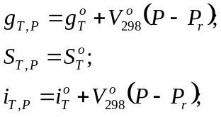 (2-1a,b,c)

At higher temperatures and pressures P ⟩⟩ 1 bar (when P ≈ P - P_{r}), molar volumes of condensed substances are no longer constant. There are several ways to describe the thermal expansion and the compressibility of minerals, melts and liquid water.

According to Dorogokupets et al. [1988], the dependence of molar volume V_{T} on T and P at P ⟩⟩ 1 bar (P ≈ P - P_{r}) is taken in the following form:

(2-2).

The above equation becomes equivalent to that given by Berman [1988] after setting A₂=0.
Using eqn (2-2), the molar Gibbs energy function at T and P can be obtained as:

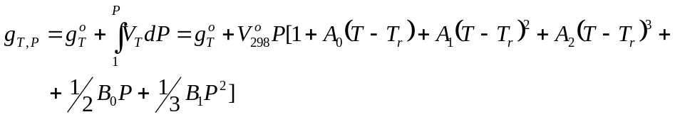 (2-3).

The molar entropy at T and P bar can be calculated as

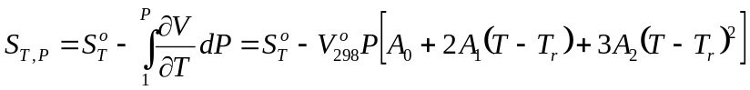 (2-4),

and the molar enthalpy function – as
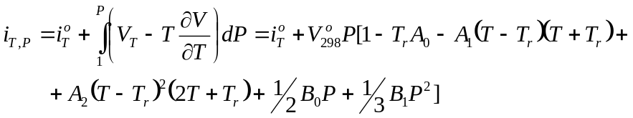 (2-5).

These calculations are implemented in Selektor codes since 1988. From eqn (2-2), coefficients of thermal expansion α and compressibility β can be evaluated as:

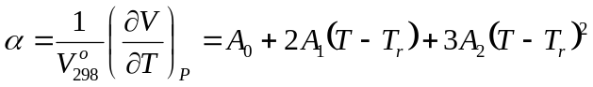 (2-6);
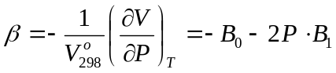 (2-7).

Using thermal expansion and compressibility coefficients and assuming that both are constant, the molar volume at T, P can be alternatively calculated as:

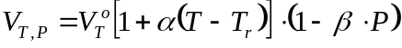 (2-8).

Alternatively, instead of the empirical eqn (2-2) or the approximate eqn (2-8), one can consider using temperature-dependent isobaric thermal expansion and compressibility, as suggested by Holland and Powell [1998]. They defined the thermal expansion coefficient as

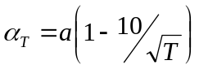 (2-9),

where the input parameter a is a “limiting” thermal expansion value at high temperatures. This gives the following temperature correction for the standard molar volume:

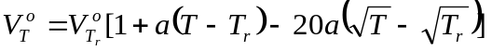 (2-10).

Compressibility of solid phases as function of pressure is handled using the Murnaghan equation of state (EoS):

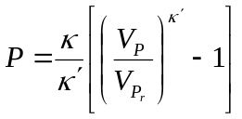, (2-11),

where κ is the bulk modulus (in units of pressure) and κ’ = 4 is the pressure derivative of the bulk modulus. Upon rearranging, one obtains

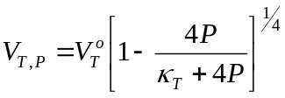 (2-12),

where 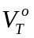 is given in eqn (2-10) and 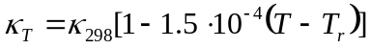 [Holland and Powell, 1998]. Values of κ_{T} and κ₂₉₈ should be taken in kbar in eqns (2-11) to (2-13) and (2-15). This results in the following expression for the molar Gibbs energy at T,P:
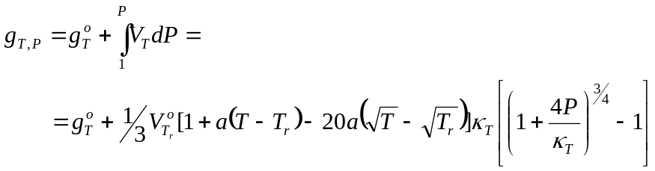 (2-13).
It follows from eqn (2-10) and the definition 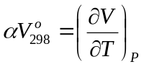that the molar entropy at T,P is
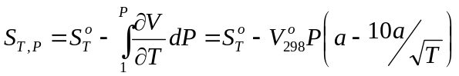 (2-14),

For the molar enthalpy function at T,P, one then calculates
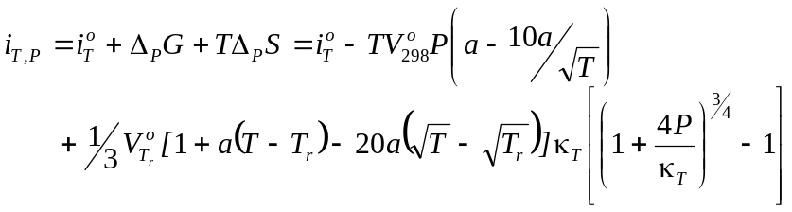 (2-15).

Alternative pressure corrections (using a different approximation of the Birch-Murnaghan EoS and a different form of thermal expansion) are implemented for the data from M. Gottschalk’s database [1997] imported into GEM-Selektor DComp format (to be described in a separate document).

2.2. Pressure corrections to aqueous nonelectrolytes through properties of hydration

The most commonly used approach for calculating the standard state thermodynamic properties of aqueous species at elevated temperatures and pressures applies the revised Helgeson-Kirkham-Flowers (HKF) equation of state [Tanger and Helgeson, 1988]. This model was originally developed for charged aqueous species and its extension to aqueous nonelectrolyte species [Shock and Helgeson, 1989] generally lacks a rigorous theoretical basis. Consequently, application of this model to aqueous nonelectrolytes faces intrinsic limitations. The performance of the HKF model at supercritical conditions and in the near-critical region of water is not very good, which has resulted in ongoing efforts to develop more adequate equations of state for aqueous nonelectrolytes [Plyasunov et al., 2000a; 2000b; Sedlbauer et al., 2000; Akinfiev and Diamond, 2003]. These models are all based on the Gibbs energy (and other properties) of hydration of aqueous species, which is defined as follows

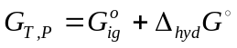 (2-16),

where 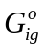is the Gibbs energy of the aqueous solute in the ideal gas state, and 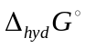is the Gibbs energy of hydration. This accounts for the transfer of the aqueous solute from the ideal gas state to the solvated aqueous species. All other partial molal properties of the aqueous species are calculated through statements analogous to eq. (2-16). The only exception is the partial molal volume of species, which is calculated directly from the equation of state without reference to the volumetric properties of the ideal gas. The Akinfiev-Diamond model for aqueous nonelectrolytes was implemented into GEM-Selektor as a special case of pressure correction. The molal thermodynamic properties of the species in the ideal gas state are calculated through standard heat capacity integration, and the hydration properties are then added as a pressure correction. The Gibbs energy of hydration is calculated as [Akinfiev and Diamond, 2003]
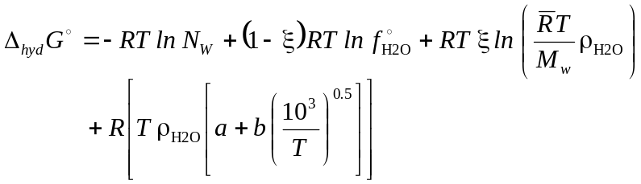 (2-17)

Here, 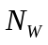 is the number of moles H₂O in 1 kg (55.51), 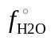is the standard state fugacity of H₂O, 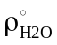is water density, 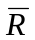is equal to 83.1451. The parameters a, b and ξ are empirical coefficients of the EoS model. The partial molal volume, entropy and heat capacity are calculated as [Akinfiev and Diamond, 2003]
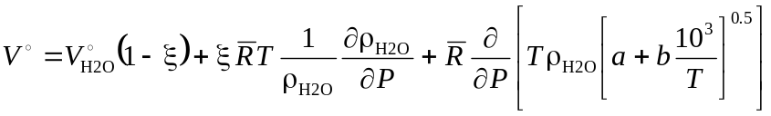 (2-18)
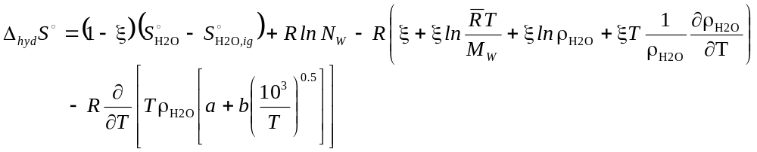 (2-19)
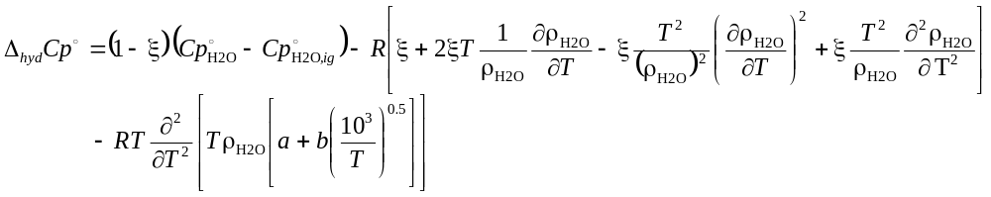 (2-20)

Solutions for the partial derivatives given in eqs. (2-18), (2-19) and (2-20) are given in Akinfiev and Diamond [2003]. The enthalpy of hydration is obtained from the standard relationship

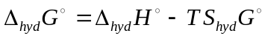 (2-21),

The model requires the ideal gas properties of the aqueous solute and three empirical parameters, which are available for a number of common solutes such as CO₂(aq), H₂(aq), O₂(aq) and H₂S(aq). These empirical parameters can also be estimated from standard state properties at T_{r} and P_{r} using correlation equations from [Akinfiev and Diamond, 2003].

References to Part 2

Akinfiev N.N., Diamond L.W. (2003) Thermodynamic description of aqueous nonelectrolytes at infinite dilution over a wide range of state parameters. Geochim. Cosmochim. Acta 67, 613-627.
Berman R.G. (1988) Internally consistent thermodynamic data for minerals in the system Na₂O-K₂O-CaO-MgO-FeO-Fe₂O₃-Al₂O₃-SiO₂-TiO₂-H₂O-CO₂. Journal of Petrology 29, 445-522.
Dorogokupets P.I., Karpov I.K., Lashkevich V.V., Naigebauer V.A., Kazmin L.A. (1988) Isobaric-isothermal potentials of minerals, gases and aqueous species in the “Selektor” program package. In: Physicochemical models in geochemistry (eds. Kiselev A.I. and Karpov I.K.), Nauka Publ., Novosibirsk, p. 124-147 (in Russian).
Holland T.J.B., Powell R. (1998) An internally consistent thermodynamic data set for phases of petrological interest. Journal of Metamorphic Geology 16, 309-343.
Gottschalk M. (1997) Internally consistent thermodynamic data for rock-forming minerals in the system SiO₂-TiO₂-Al₂O₃-Fe₂O₃-CaO-MgO-FeO-K₂O-Na₂O-H₂O-CO₂. Eur. J. Mineral. 9, 175-223.
Plyasunov A.V., O´Connell J.P., Wood R.H. (2000a) Infinite dilution partial molar properties of aqueous solutions of nonelectrolytes. I. Equations for partial molar volumes at infinite dilution and standard thermodynamic functions of hydration of volatile nonelectrolytes over wide ranges of conditions. Geochim. Cosmochim. Acta 64, 495-512.
Plyasunov A.V., O´Connell J.P., Wood R.H., Shock E.H. (2000b) Infinite dilution partial molar properties of aqueous solutions of nonelectrolytes. II. Equations for standard thermodynamic functions of hydration of volatile nonelectrolytes over wide ranges of conditions including the subcritical temperatures. Geochim. Cosmochim. Acta 64, 2779-2795.
Sedlbauer J., O´Connell J.P., Wood R.H. (2000) A new equation of state for correlation and prediction of standard molal properties of aqueous electrolytes and nonelectrolytes at high temperatures and pressures. Chem. Geol. 163, 43-63.
Shock E.L., Helgeson H.C. (1989) Calculation of the thermodynamic properties of aqueous species at high pressures and temperatures: Standard partial molal properties of inorganic neutral species. Geochim. Cosmochim. Acta 53, 2157-2183.
Tanger J.C.IV., Helgeson H.C. (1988) Calculation of the thermodynamic and transport properties of aqueous species at high pressures and temperatures: Revised equations of state for standard partial molal properties of ions and electrolytes. Amer. J. Sci. 288, 19-98.

