Temperature, pressure and composition corrections for molar thermodynamic properties of non-electrolyte fluids and their mixtures

Contributed by Sergey V. Churakov (Centro Swizzero di Calcolo Scientifico (CSCS), Via Cantonale, CH-6928 Manno, Switzerland, e-mail: churakov@cscs.ch)

Theoretical Background

Strong intermolecular interaction in real multi-component fluids is responsible for their non-ideal behavior. Types of interactions involve repulsion due to a finite size of the molecules, attraction between permanent and induced dipoles, quadrupole and higher multipoles, and dispersion forces. In the case of permanently charged molecules, Coulomb interaction forces must be taken into account. Knowing intermolecular interaction forces between molecules, one can calculate thermodynamic properties of the fluid, at least in principle.
The equation of state proposed by Churakov and Gottschalk [2003a,2003b] is designed to predict thermodynamic properties of multi-component mixtures of non-electrolytes. In that model, intermolecular interaction is approximated by Lennard-Jones potential, dipole-dipole and dipole induced dipole interaction:

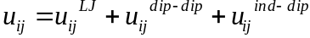 (1)

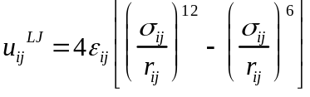 (2)

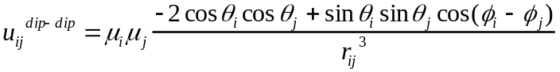 (3)

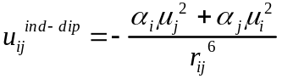 (4)

Here r_{ij} is the distance between the centers of two molecules, θ and φ are the angles defining the relative orientation of its dipoles, α is the average polarizability of a molecule and μ its dipole moment. The σ_{ij} and ε_{ij} are the specific parameters of interaction of the Lennard-Jones potential meaning of molecular size and interaction energy, respectively. For unlike molecules, the parameters of cross interaction are determined as arithmetic and geometric mean:

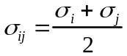 (5)
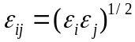 (6)
Thus, for every component in the fluid mixture, just four fitting parameters (σ_{i}, ε_{i}, μ _{i} and α _{i}) are required. The parameters used in the EoS are listed in the Appendix 1.
The molar residual Helmholtz free energy Ares of fluid mixture interacting according to equations (1)-(4) at constant temperature-T and density-ρ is derived using thermodynamic perturbation theory [Carnahan and Starling, 1969; Gubbins and Twu, 1978; Shmulovich et al., 1982; Stell et al., 1972,1974; Tereshchenko et al. 1981; Verlet and Weis, 1972a, 1972b; Weeks et al., 1971], as sum of Lennard-Jones, dipole-dipole and dipole-induced dipole interaction:
(7)
where ni is the number of moles of molecule i. The detailed expressions for these contributions can be found elsewhere [Churakov and Gottschalk, 2003a,2003b].
The compressibility Z is obtained from the above equation by differentiation with respect to density:
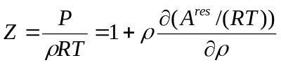 (8)
where P is the pressure and R is the universal gas constant.
The fugacity coefficient ϕi of component i is obtained by differentiation of the residual Helmholtz free energy Ares=Ares(T,ρ,n1,n2,...) with respect to the fluid composition:
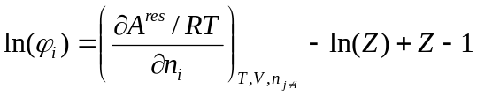 (9)
where ni is the number of moles of molecule i.
To calculate fugacities in the fluid mixture at isothermal-isobaric conditions, the corresponding fluid density must be found first solving eqn (8) iteratively. Then the fugacity coefficients are calculated from eqn (9) at given temperature and density.
The CG EoS calculations outlined above were implemented as a set of C++ classes and functions, either available separately from the author, or incorporated into GEM-Selektor code (version 2.1-PSI or higher). Details on temperature and pressure corrections for the standard molar properties of pure fluid components, pertinent to the implementation in GEM-Selektor code, are given in Appendix 2. Briefly, the fugacities of pure fluid species are calculated first at T,P of interest before starting the GEM calculation of chemical equilibrium in the system. Then, on each GEM iteration, some built-in CG EoS functions are called to obtain the activity coefficients of fluid components in the non-ideal fluid mixture phase from their current mole quantities (Appendix 3).

LIMITATIONS OF THE CG EOS

The EoS is just a model! Do not expect it to be universal. It uses approximations that can be appropriate for one system and unacceptable for another. For pure fluids, both homogeneous region and vapor-liquid equilibria are reproduced accurately. While the EoS is robust for homogeneous fluid mixtures, the agreement with the experimental vapor-liquid equilibria is qualitative. Therefore, we recommend applying EoS for mixtures only above highest critical temperature of fluid components in the system (see Appendix 2). At lower temperatures, the results must be considered only qualitatively. The applicability of the EoS at high pressure is limited by solidification of the fluid. Although solid-fluid phase boundary is not known for arbitrary composition, we recommend to limit application of the EoS by 10GPa. Every substance becomes ionised at high temperatures. This is not taken into account in our model. Therefore, we suggest 2000 K to be a highest temperature limit for the EoS. The fluid chemistry is responsible for the other limitations of the EoS.
The first question to be addressed in any thermodynamic calculation is whether the fluid speciation in the thermodynamic model adequately represents the natural system of interest. Let us consider H-O-S system as an example. At high temperatures, above critical temperature of water, fluids in that system can be represented by a mixture of H₂O, H₂, SO₂, O₂, H₂S, SO₃, S₂ molecules. At the ambient conditions, however, various sulphuric acids will be formed. Therefore, the particles like SO₄²⁻, SO₃²⁻, H₃O⁺ and HSO₃⁻ must be included in the system. Those species are not available in the present EoS. Thus, no matter how accurately the EoS reproduces properties of H₂O, H₂, SO₂, O₂, H₂S, SO₃, S₂, the model is inadequate for modelling thermodynamic properties of the H-O-S system at ambient conditions.
The second question is the accuracy of the EoS itself. The EoS presented includes the following simplifications. Firstly, the molecules are treated as Lennard-Jones spheres with a permanent point-dipole moment. However, typical poly-atomic molecules also possess quadrupole and higher order moments leading to dipole-quadrupole, quadrupole-quadrupole, induced dipole–quadrupole and other interactions. The polarizability of complex molecules depends substantially on their orientation with respect to the applied electric field, while the EoS takes only the average isotropic polarizability into account. Additional interactions between some molecules will occur if the intermolecular distance is short and the electron shells overlap. Contributions of such forces to the total interaction energy could be significant for some species. In general, there are more physically realistic model potentials available than those used here. Potentials using non-spherical cores are definitely more successful at very high pressures, as well as the exponential potentials mimic the intermolecular repulsion better. The reasons for using the potential described above are rather practical. Theoretical EoSs for non-spherical molecules are available only for rigid-body models. However, while many results from molecular dynamics and Monte Carlo calculations are available using more accurate potentials for these, no appropriate EoS have been developed. And from our point of view the rigid-body potential model is a significant drawback comparing to a more simple Lennard-Jones fluid.
The intermolecular interactions are treated here to be pair additive. In real fluids, the interaction energy of three and more molecules differs from the sum of the pair-wise contributions. But this difference is substantial only if all interacting molecules are close together. In low-density fluids the probability of simultaneous collision of more than two molecules is low, allowing higher order interactions to be neglected at such conditions. To use the pair additive model at high densities, triple- and higher order interactions must be included in the pair interaction term implicitly, which is called the effective pair-wise potential. While such effective pair-wise potentials would lead to an accurate description of the fluids at the high and intermediate densities, for low densities these are less accurate.
Yet another problem is that the perturbation expansion is only reasonable if the properties of the target fluid are close to that of the reference system. In our particular case, this requires that the energy due to dipole-dipole interaction is small relative to the contribution due to Lennard-Jones interaction. Computer experiments showed [Stell et al., 1972] that the perturbation expansion in the proposed form will be very accurate if the square of the reduced dipole moment
μ*2=μ2/(εσ3) (10)
is lower than 3, less accurate in the range of 3 < μ*2 < 4, and inaccurate for values greater than 4. The squares of reduced dipole moments of slightly polar compounds like CO and HCl are smaller than 3, but for strong dipoles like H2O it is in the range of 3<μ*2<4 or even larger. The dipole moment of molecules in fluids changes with temperature, density and fluid composition, while it is treated here, with the exception of H2O, as being constant. At high temperatures (above critical point), molecules are free to rotate, and the dipole interaction eventually becomes less important even for highly polar molecules. Special care must be taken, however, in cases when the thermodynamic conditions of interest are close or lower then critical temperature of fluid components (Table 1).

Parameters of intermolecular interactionS

Quite a number of interaction parameters for various molecules is summarized in the Appendix 1. Little effort is needed to include a new component in the system if necessary. Here we describe some simple methods to estimate interaction Lennard-Jones parameters of neutral molecules.
For each pure fluid species, the EOS requires four parameters ε, σ, μ, α to be evaluated from the experimental data. If thermodynamic data (PVT-data, phase equilibria) for a considered fluid are available then it is always advantageous to fit ε, σ, μ and α directly to the experimental results. As an alternative, these potential parameters can be derived from other experimental sources. Values for the electric dipole moment μ and the polarizability α of molecules in fluids are readily available from spectroscopy measurements. Parameters of the Lennard-Jones potential ε and σ can be derived from the experimental determination of the second virial coefficient or from fluid viscosities. However, both methods are suffering from the same kind of limitations,. Parameters derived from experimental second virial coefficient data or fluid viscosities usually fail to describe the fluid properties at liquid-like densities or vapour-liquid equilibria (see [van Leeuwen, 1994] for a more detailed discussion).
Because of these limitations, it seems advantageous to derive the values of the required parameters from phase equilibria. Liquid-vapour equilibria of pure fluids or critical properties are readily available. Potoff and Panagiotopoulos [1998] determined critical properties for a Lennard-Jones fluid by computer simulations. They reported values for the reduced (dimensionless) critical temperature (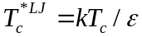), critical density (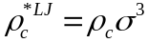) and critical pressure (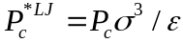) of 1.312, 0.316 and 0.1279, respectively. Using these values and the critical temperature Tc of a real fluid, ε can be obtained with eq. (11) applying the corresponding-states theory [e.g. Prausnitz et al., 1999]:
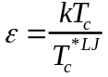 (11)
and σ can be derived from either with eqs. (12) or (13) using the critical density
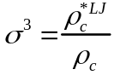 (12)
or its critical pressure:
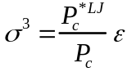 (13)
For real fluids, eqs. (12) and (13) provide slightly different values for σ. This difference can be considered as a measure of the validity of the Lennard-Jones model. The best agreement is observed for noble gases. For simple non-polar molecules, the difference in the obtained σ-values from critical pressure and density does not exceed 1-2%. For non-polar molecules which posess a strong quadrupole moment (e.g. CO2), the deviation is in the range of 4-5%. For highly polar molecules, this difference is up to 10%, indicating that the derivation using the Lennard-Jones approximation is unacceptable for such fluids.
For polar molecular fluids, an effective method of determination of the Stockmayer potential parameters (Lennard-Jones plus dipole-dipole interaction), was introduced by van Leeuwen [1994]. This method requires knowledge of the critical temperature 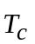 and density of the boiling liquid 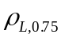 at the temperature 0.75·Tc. Based on results of computer simulations, the specific properties of a Stockmayer fluid were expressed as a function of the square of the reduced dipole moment μ*2:
(14)
(15)
were 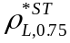 is the reduced density at 0.75·Tc:
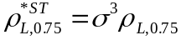 (16)
μ*2 can be obtained from eq. (17) which is a combination of eqs. (10), (14), (15), (16) and the definition of the reduced temperature (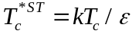), if a value for μ is available.
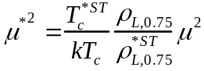 (17)
Knowing μ*2, ε and σ can be calculated from eqs. (11,14,15,16).
If the liquid density at T*= 0.75 is unknown, the critical density or pressure can be used instead and eq. (15) is replaced by either eq. (18) or (19) (van Leeuwen, 1994):
(18)
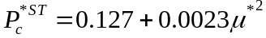 (19)
The reduced dipole moment μ2* is then calculated by eq. (20) or (21), respectively.
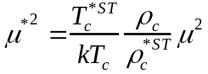 (20)
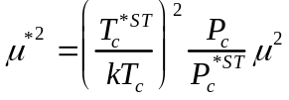 (21)
The parameters ε and σ are then calculated in the same way as shown above. The latter approach, however, is less accurate [van Leeuwen, 1994].
It should be remembered that the corresponding state theory approach can be applied only to non-polar molecules (µ = 0). For such fluids, the terms 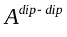, 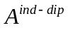in eq. (7) are zeros. However, the polarizabilities of non-polar molecules are non-zero.
The approach of van Leeuwen [1994] for polar molecules requires also some additional assumptions. According to this approach, the potential interaction energy of two molecules of the same kind is given by sum of the Lennard-Jones and the dipole-dipole interaction. The dipole-induced dipole interaction is neglected ( = 0) and implicitly included in the Lennard-Jones and dipole-dipole terms, i.e. the molecular polarizability α must be set to zero.

References

Carnahan N.F. and Starling K.E. (1969) Equation of state for non-attracting rigid spheres. J. Chem. Phys. 51, 635-636.
Churakov S.V. and Gottschalk M. (2003) Perturbation theory based equation of state for polar molecular fluids. I. Pure fluids. Geochim. Cosmochim. Acta 67(13), 2397–2414.
Churakov S.V. and Gottschalk M. (2001) Perturbation theory based equation of state for polar molecular fluids. II. Fluid mixtures. Geochim. Cosmochim. Acta, 67(13), 2415–2425.
Gubbins K.E. and Twu C.H. (1978) Thermodynamics of polyatomic fluid mixtures. I. Theory, Chem. Eng. Sci. 33, 863-878.
Leeuwen van M.E. (1994) Derivation of Stockmayer potential parameters for polar fluids. Fluid Phase Equilib. 99, 1-18.
Prausnitz J. M., Lichtenthaler R.N. and Azevedo E.G. (1999) Molecular thermodynamics of fluid-phase equilibria. Third edition, Prentice Hall, New Jersey.
Potoff J.J. and Panagiotopoulos A.Z. (1998). Critical Point and phase behaviour of the pure fluids and a Lennard-Jones mixture. J. Chem. Phys. 109, 14-20.
Shmulovich K.I., Tereshchenko Ye.N. and Kalinichev A.G. (1982) An equation of state and isochors for nonpolar gases to 2000K and 10 GPa. Geochem. Internat. 19, 49-64.
Stell G., Rasaiah J.C. and Narang H. (1972) Thermodynamic perturbation theory for simple polar fluids. I. Mol. Phys. 23, 393-406.
Stell G., Rasaiah J.C. and Narang H. (1974) Thermodynamic perturbation theory for simple polar fluids. II. Mol. Phys. 27, 1393-1414.
Tereshchenko E.N., Kalinichev A.G., Shmulovich K.I. (1981) Application of the equation of state of the Lennard-Jones fluid to density calculations under high pressures. In: Equations of State under Extreme Conditions, Novosibirsk, ITPM SO AN SSSR, 12-19 (in Russian).
Verlet L. and Weis J.J. (1972a) Perturbation theory for the thermodynamic properties of simple liquids. Mol. Phys. 24, 1013-1024.

Verlet L. and Weis J.J. (1972b) Equilibrium theory of simple liquids. Phys. Rev. 5, 939-952.
Weeks J.D., Chandler D. and Andersen H. C. (1971) Role of repulsive forces in determinig the equilibrium structure of simple liquids. J. Chem. Phys, 54, 5237-5247.

Appendix 1. Critical temperature, parameters of Lennard-Jones interaction, dipole moment and polarizability for selected molecules.

 | Τ_{c}  [Κ] | ε/k  [K] | σ  [Å] | μ  [D] | α  [Å3]
He | 5.19 | 3.96 | 3.104 | 0.0 | 0.204956
Ne | 44.4 | 33.84 | 2.804 | 0.0 | 0.3956
Ar | 150.87 | 114.99 | 3.402 | 0.0 | 1.6411
Kr | 209.41 | 159.61 | 3.628 | 0.0 | 2.4844
Xe | 289.73 | 220.83 | 3.957 | 0.0 | 4.044
F₂ | 144.13 | 109.86 | 3.260 | 0.0 | 1.38
Br₂ | 588 | 448.17 | 4.055 | 0.0 | 7.02
I₂ | 819 | 624.24 | 4.333 | 0.0 | 10
Cl₂ | 416.9 | 317.76 | 4.012 | 0.0 | 4.61
O₂ | 154.59 | 117.83 | 3.371 | 0.0 | 1.5812
S | 1314 | 1001.52 | 4.361 | 0.0 | 2.9
N₂ | 126.21 | 96.20 | 3.615 | 0.0 | 1.7403
H₂ | 32.97 | 25.13 | 3.243 | 0.0 | 0.81
CS₂ | 552 | 420.73 | 4.495 | 0.0 | 8.74
CO₂ | 304.1282 | * | * | 0.0 | 2.65
CH₄ | 190.53 | 145.22 | 3.732 | 0.0 | 2.593
C₂H₆(ethane) | 305.4 | 232.77 | 4.267 | 0.0 | 4.47
C₃H₈(propane) | 369.82 | 281.88 | 4.741 | 0.0 | 6.29
C₂H₄(ethylene) | 282.34 | 215.20 | 4.097 | 0.0 | 4.252
C₄H₁₀(butane) | 425.14 | 324.04 | 5.115 | 0.0 | 8.2
BF₃ | 260.8 | 198.78 | 3.923 | 0.0 | 3.31
BCl₃ | 455 | 346.80 | 5.006 | 0.0 | 9.38
SiF₄ | 259 | 197.41 | 4.444 | 0.0 | 5.45
SiH₄ | 269.7 | 205.56 | 3.744 | 0.0 | 5.44
SiCl₄ | 508.1 | 387.27 | 5.552 | 0.0 | 12
H₂O | 647.096 | 192.814 | 2.97509 | * | *
HBr | 363.2 | 272.4 | 3.705 | 0.827 | 0.0
HF | 461.0 | 237.0 | 3.058 | 1.826 | 0.0
NO₂ | 431.2 | 328.1 | 3.431 | 0.316 | 0.0
HCl | 324.7 | 230.9 | 3.455 | 1.109 | 0.0
HI | 424.0 | 322.5 | 4.050 | 0.448 | 0.0
NH₃ | 405.4 | 200.0 | 3.294 | 1.849 | 0.0
C₃H₆(propene) | 364.9 | 277.7 | 4.490 | 0.366 | 0.0
C₄H₈ (isobutene) | 417.9 | 318.0 | 4.927 | 0.503 | 0.0
SiClF₃ | 307.7 | 233.5 | 4.715 | 0.686 | 0.0
SiCl₂ | 369.0 | 280.3 | 4.984 | 0.7329 | 0.0
SiCl₃ | 438.6 | 333.8 | 5.218 | 0.49 | 0.0
N₂O | 309.6 | 235.7 | 3.658 | 0.161 | 0.0
NO | 180.0 | 137.0 | 3.094 | 0.159 | 0.0
H₂S | 373.4 | 277.2 | 3.680 | 0.97 | 0.0
SO₂ | 430.8 | 302.7 | 3.903 | 1.633 | 0.0
COS | 378.8 | 286.9 | 4.099 | 0.715 | 0.0
CO | 132.9 | 101.2 | 3.623 | 0.11 | 0.0
PH₃ | 324.5 | 302.7 | 3.903 | 0.55 | 0.0
HCN | 456.7 | 149.7 | 3.796 | 2.984 | 0.0
* Parameter depends on temperature:
μ_{H2O}[D] =2.16312 +68.2631/(T +13.1904)
α _{H2O}[Å3]= 0.207114 +76.2066/(T+100.453)
σ _{CO2}[Å] 3.81773 – 0.2037820 *exp(–0.00101206*T)
ε/k _{CO2}[K]=192.192 – 136.307*exp(–0.00353196 *T)

Appendix 2. Temperature- and pressure corrections for pure fluid species as implemented in GEM-Selektor code

The standard molar apparent Gibbs energy function gº_{T} of a fluid substance will be calculated first at reference pressure P_{r} = 1 bar and temperature of interest T ≠ T_{r} (reference temperature T_{r} = 298.15 K) using input data provided in the DComp record format:
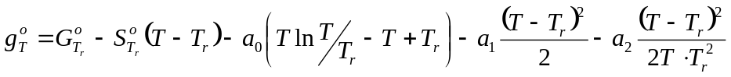 (A2-1)
where a₀, a₁ and a₂ are the Maier-Kelly coefficients of the Cp = f(T) dependence (details in the T-corrections.pdf document), or Cp = a₀ + a₁T + a₂ T ⁻² .
The standard molar entropy and apparent enthalpy functions are also calculated as usual:
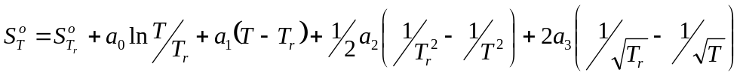 (A2-2),
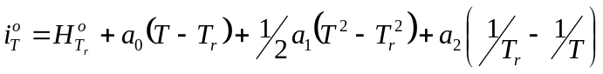 (A2-3).
Next, the GC EoS built-in function is called for calculation of the molar volume and the fugacity of a pure fluid component (mole fraction χ = 1) at T and P of interest:
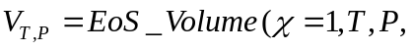T_{c}, ε/κ, σ, μ, α) (A2-4) 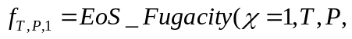T_{c}, ε/κ, σ, μ, α) (A2-5)
where T_{c}, ε/κ, σ, μ, α are the input EoS parameters collected from the DComp format records (and summarized in the Appendix 1). Since, by definition, the fugacity coefficient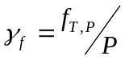
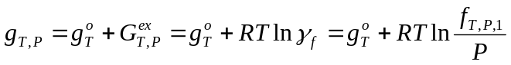 (A2-6);
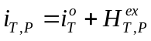 (A2-7);
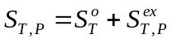 (A2-8).
Eqns (A2-7) and (A2-8) assume the values 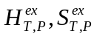to be computed as derivatives of 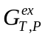and returned by the EOS_Fugacity() functions (eqn A2-5). The reason for eqn (A2-7) is that in the GEM-Selektor code, the chemical potential of a j-th gas (fluid) mixture component is approximated [Karpov et al., 1997; 2001] as
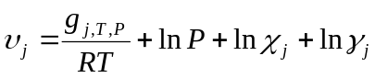 (A2-9).
In other words, the non-ideality of j-th pure fluid component has to be incorporated into the g_{T,P} term, whereas its non-ideal mixing with other fluid components (at the mole fraction χ_{j} < 1) can be described, as usual, by the activity coefficient term ln γ_{j}.

Appendix 3. Calculation of activity coefficients for components in the mixed fluid phase as implemented in the GEM-Selektor code

The activity coefficient γ_{j} describes a deviation from Raoultian ideal behaviour of j-th component in the mixed fluid phase at current fluid composition and T,P of interest. In other words, the activity coefficient of j-th species depends, in general, on the mole fractions of all other components at the fluid phase. Since these mole fractions are unknown at the beginning of calculations, the values of γ_{j} must be re-calculated at each iteration of the GEM algorithm. This is done by calling the built-in CG EoS functions as follows:
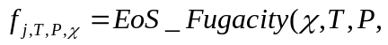param ), j ∈ L_{F} (A3-1),
where f_{j,T,P,χ} is the fugacity of j-th component at χ, T, P of interest; χ = {χ₀, χ₁ , χ₂, … } stands for a vector of mole fractions of all n(L_{F}) components of the fluid phase (forming a set L_{F}), and param denotes a matrix of T_{c}, ε/κ, σ, μ, α parameters (one line per each fluid species) at T,P of interest.
The activity coefficient of j-th component in the fluid mixture is calculated as follows from eqns (A2-7) and (A2-8):
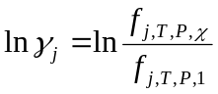 (A3-2),
where f_{j,T,P,1} is the fugacity of pure j-th component at T,P of interest, calculated previously using eqn (A2-5).

The and terms in eq. (7) are explicit functions of fluid composition, temperature, density and (ε_{i}/κ, σ _{i}, μ _{i}, α _{i} ) – parameters for pure fluids (see [Churakov and Gottschalk, 2003b] for more details). In contrast, the Lennard-Jones contribution 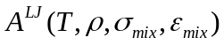 is originally designed for one component fluid. The Lennard-Jones contributions to the mixture are calculated using the van der Waals one-fluid theory:
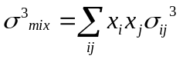 (A3-3),
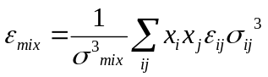 (A3-4),
where the cross terms σ_{ij} and ε_{ij} are calculated using eqns (5) and (6).

References to Appendix 2 and 3
Karpov, I.K., Chudnenko, K.V., and Kulik, D.A., 1997, Modeling chemical mass-transfer in geochemical processes: Thermodynamic relations, conditions of equilibria and numerical algorithms: American Journal of Science, v. 297, p. 767-806.
Karpov, I.K., Chudnenko, K.V., Kulik, D.A., Avchenko, O.V., and Bychinski, V.A., 2001, Minimization of Gibbs free energy in geochemical systems by convex programming: Geochemistry International, v.39, p.1108-1119.

