How To Create a project in GEMS using the THEREDA database
THEREDA - Thermodynamic Reference Database: Homepage
THEREDA is distributed with GEMS-Selektor package.
The database files are found in Gems3-app\Resources\DB.default
Attention!! If you downloaded these files form thereda.de you need to copy them to Gems3-app\Resources\DB.default (overwrite)

Create a new project
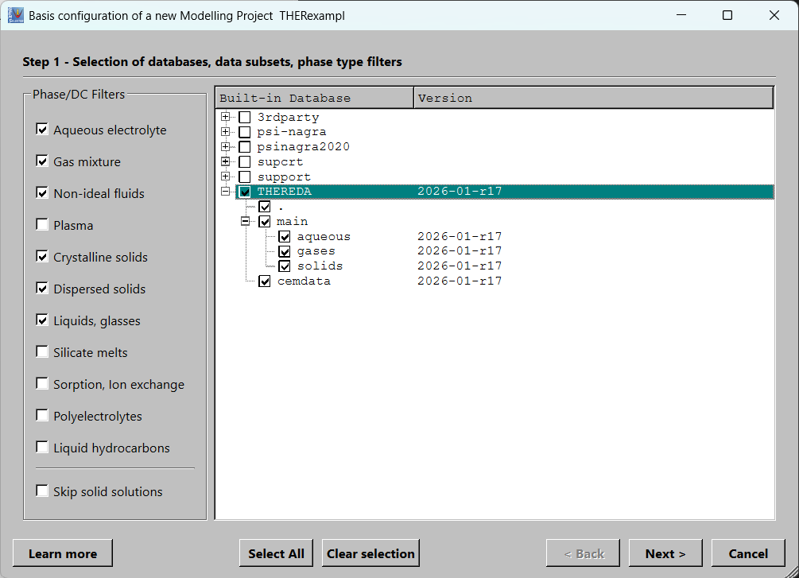
* if cement phases are not of interest untick cemdata

Select the elements you wish to use in the chemical system.
Attention!! To add a new element afterwords can be done only by cloning the project (create a new project using the selected one as template).
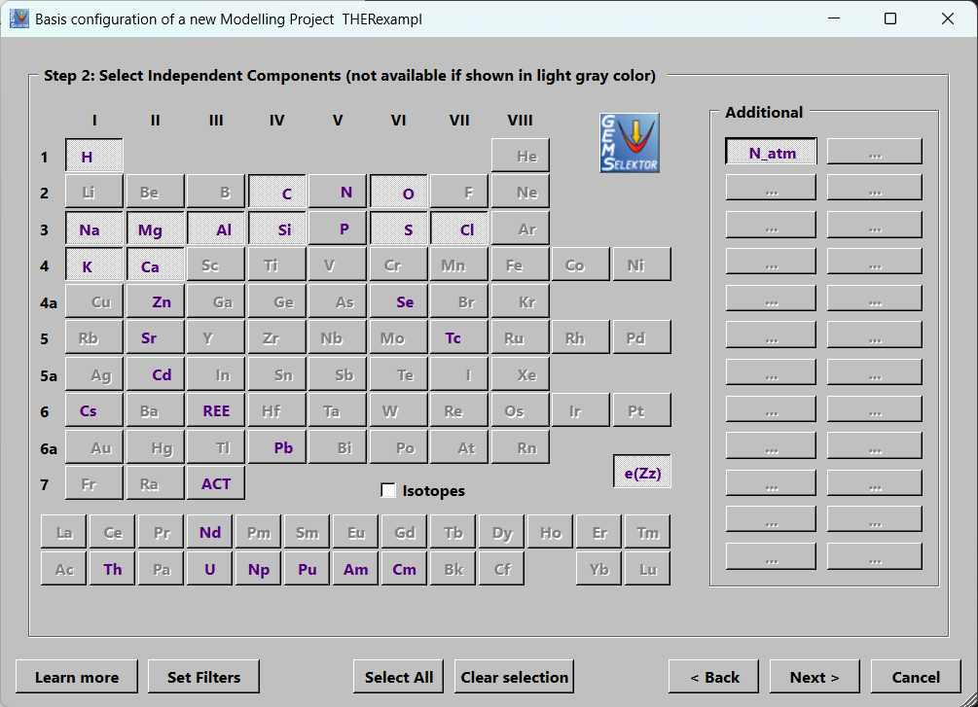
The Pitzer based aqueous phase is a defined phase record in the database (Check and OK) - tick that option.


