Part 3. Temperature corrections of standard molar (partial molal) thermodynamic properties of substances and reactions using data in ReacDC records of GEM-Selektor
(version 2.3 and later)
3.1. General overview
The ReacDC record format can be used for defining thermodynamic properties of minerals (e.g. solid-solution end-members), aqueous or surface complexes, for which measured thermochemical data are not available; or predicted thermochemical data are too uncertain; or it is not possible to predict the HKF EoS parameters. In such cases, only logK of the dissolution, association or surface complexation reaction is usually known at 25 ºC.
A chemical reaction involving any number of dependent components taken as reactants and products can be written as
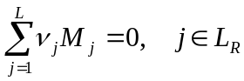 (3-1)
where L_{R} is a set of n(L_{R}) dependent components (chemical species) involved in the reaction, M_{j} stands for a (formula of) chemical species and, ν_{j} represents the stoichiometric coefficients, negative for reactants and positive for products.
Because the GEM algorithm cannot use reactions and their equilibrium constants to calculate the equilibrium speciation in phases, each ReacDC record also provides a set of standard molar properties for a "new" species - the last one in eqn (3-1) having the greatest index L. It is called “new” in a sense that its standard molar properties are defined through properties of the reaction and that of other species involved (and provided as records in the database); the “new” species also gives a name to the reaction. Obviously, the "new" reaction-defined species can be either a product or a reactant given the sign of its stoichiometry coefficient.
Any molar property of the “new” species in the reaction at temperature T and pressure P of interest can be found algebraically from the respective property of the reaction and all but one of involved species. For instance, the standard Gibbs energy change in reaction 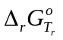 (in J⋅mol⁻¹; instead of Δ_{r}, Δ will be written everywhere below for brevity) at reference temperature T_{r} and pressure P_{r} is
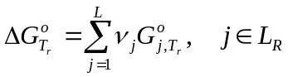 (3-2),
where R = 8.31451 J⋅K⁻¹⋅mol⁻¹ is the universal gas constant and
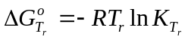 (3-3),
where 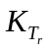is a thermodynamic equilibrium constant at T_{r}, P_{r} (Anderson and Crerar, 1993). From eqn (3-2), the value 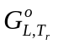of the new species can be found if value is independently known, and standard molar Gibbs energies of other involved species are available:
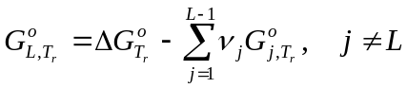 (3-4).
Using eqn (3-3), one can alternatively obtainusing the known equilibrium constant:
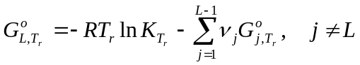 (3-5).
Equations of the form (3-4) hold for other standard molar (or partial molal) properties:
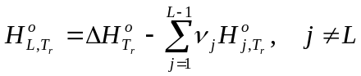 (3-6),
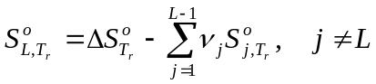 (3-7),
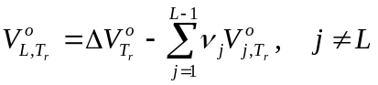 (3-8),
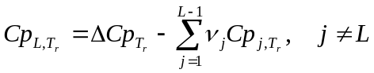 (3-9),
where H, S, V, and Cp stand for enthalpy, third-law entropy, volume and isobaric heat capacity, respectively. If properties standing on the right side of eqns (3-4) to (3-9) are corrected to T,P of interest then respective properties of the new species can be found at T,P:
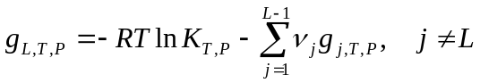 (3-10).
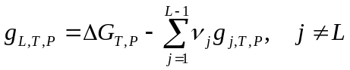 (3-11).
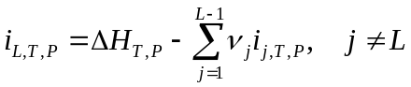 (3-12).
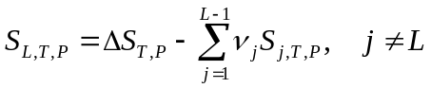 (3-13).
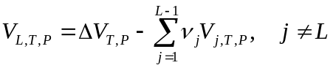 (3-14).
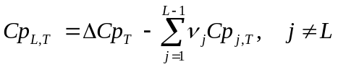 (3-15).
Here, g_{L,T,P} is the apparent molar Gibbs function and i_{L,T,P} is the apparent molar enthalpy function of the L-th (new) species. Calculation of these (and other) functions at T,P for species available as DComp records in the GEMS database are described separately (see files T-corrections.pdf, P-corrections.pdf and HKF-corrections.pdf). Hence, the algorithm for calculating temperature and pressure corrections for the reaction-defined species consists of three steps:
- Correct to T,P of interest the molar properties of all reaction species but the L-th one using independently the standard state data, parameter sets, and correction techniques defined in the DComp and ReacDC records available in the database;
- Correct to T,P of interest the corresponding effects of reaction ( ΔG,ΔH,ΔS,ΔV,ΔCp );
- Apply eqns (3-11) to (3-15) to obtain molar properties of “new” L-th species at T,P.

Note that, if a link to the reaction-defined species (ReacDC data) is given for any of j-th species (j < L) in eqns (3-11) to (3-15), the above algorithm becomes recursive because it first has to be used for obtaining the molar properties at T,P for that j-th species. In the GEM-Selektor code, up to seven levels of such recursion are possible (see documentation for ReacDC module for details).
Now, it becomes clear that the whole problem is reduced to step (ii) of the above algorithm, i.e. to temperature and pressure corrections of the standard effects of reaction, based on the available equilibrium constants and other data. There seems to be no general solution but many specific ones, depending on the data and chemical species involved.
The most straightforward way is to provide equilibrium constants for the reaction as discrete logK values on a P,T grid Q having n(Q) = n(Q_{P})⋅ n(Q_{T}) nodes. Then, for any intermediate values of T,P between the nodes, the logK_{T,P} value can be found by interpolation. Historically, this method was implemented in the SOLMNEQ.88 code (Kharaka et al., 1988).
In GEMS implementation, an internal subroutine for Lagrange polynomial table interpolation is used for this purpose, similar to that in SOLMNEQ code. The drawback of this technique is that the variation of K_{T,P} values cannot be analytically (functionally) connected to other properties of the reaction such that ΔH, ΔS, ΔV, ΔCp (remember that only g_{T,P} values are necessary for GEM calculations of equilibria). The advantage of the interpolation technique lies in its simplicity and universality.
A more theoretically sound thing is to use a power-series function of logK or lnK on temperature T. From theory (Anderson and Crerar, 1993), it follows that
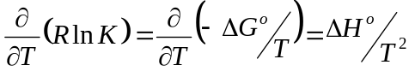 (3-16).
To integrate eqn (3-16), we need to know how ΔHº varies with temperature. Knowledge of this dependence is equivalent to knowledge of the Cpº = f(T) dependences (see document T-corrections.pdf) for all species involved in the reaction, or at least, the ΔCpº = f(T) dependence. For practical purposes, it is sufficient to limit the underlying ΔCpº = f(T) function (eqn 1-2 in T-corrections.pdf) to five terms corresponding to the Haas-Fisher equation:
ΔCp_{T} = Δa₀ + Δa₁T + Δa₂ T ⁻² + Δa₃ T ^{-0.5} + Δa₄ T ² (3-17).
The integration (Nordstrom and Munoz, 1988; Anderson and Crerar, 1993) results in the following expression for logK_{T}:
(3-18).
These seven coefficients can be directly entered into ReacDC records of GEM-Selektor (some or all can be zeros, of course). If not entered, they will be automatically computed from ΔCpº = f(T) coefficients (only the first five will be used according to eqn 3-17), 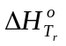, and 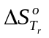as follows. First, the standard “energy” properties of reaction are connected by the equation:
(3-19).
If all these parameters have been entered then their consistency will be checked; otherwise, a missing parameter(s) will be retrieved from eqn (3-19).

Then, coefficients A₀ to A₆ of eqn (3-18) will be calculated:
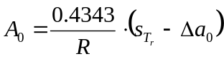 (3-20).
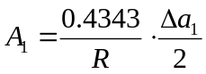 (3-21).
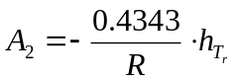 (3-22).
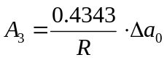 (3-23).
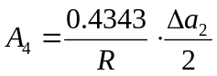 (3-24).
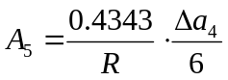 (3-25).
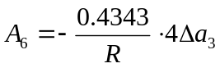 (3-26).
Here, the entropy and enthalpy terms at T_{r}, respectively, are:
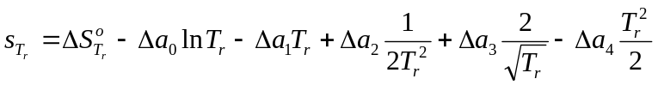 (3-27);
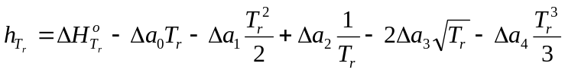 (3-28).
Combining eqns (3-13) to (3-28) yields an equation to calculate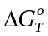:
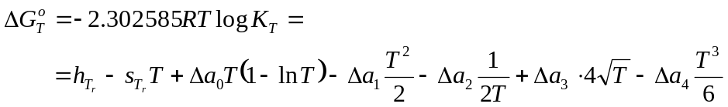 (3-29).
The entropy change in reaction at T is found as
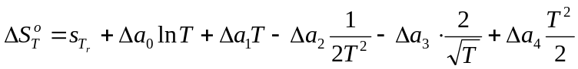 (3-30),
and the enthalpy of reaction is corrected to temperature of interest as follows:
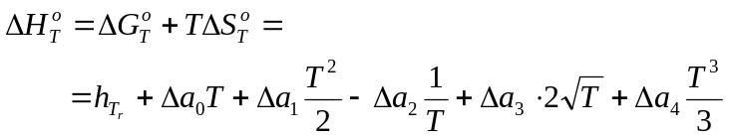 (3-31).
Conversely, coefficients of eqn (3-17), as well as 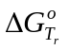, 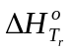and, if unknown, can be calculated from known coefficients of eqn (3-18):
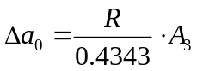 (3-32).
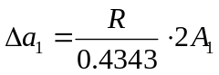 (3-33).
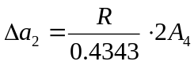 (3-34).
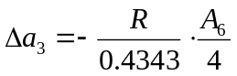 (3-35).
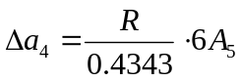 (3-36).
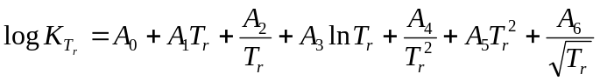 (3-37).
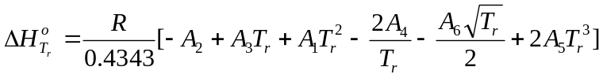 (3-38).
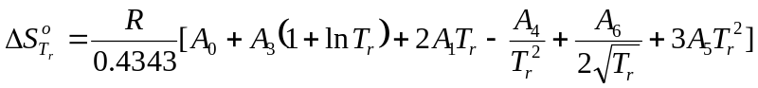 (3-39).
After that,can be found from eqn (3-19). Calculation of the properties of reaction at T of interest can be performed using eqns (3-17), (3-18), and (3-29) to (3-31). Alternatively (as done in the GEM-Selektor code), 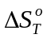 and 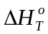 at temperature of interest T are computed using the equations analogous to (3-18), (3-38) and (3-39):
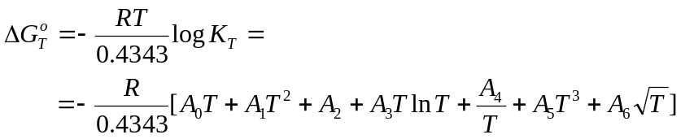 (3-40).
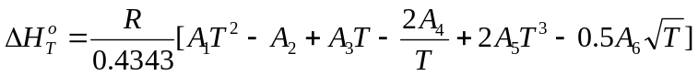 (3-41).
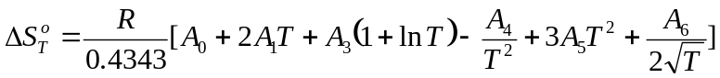 (3-42).
Depending on how many non-zero coefficients of eqn (3-18) are known, different temperature extrapolations of reaction properties can be distinguished. The most practically important ones are: zero-term (all effects of reaction are zeros at all temperatures); two kinds of one-term (at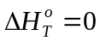and at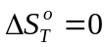); two-term (Van’t Hoff extrapolation, at Cp_{T} = 0); and three-term (at non-zero Cp_{T} = const) extrapolations. These simple dependencies are especially useful for the so-called isocoulombic or isoelectric reactions (having equal number of species with equal charges or having equal sum of charges on both sides, respectively) involving colloidal minerals, aqueous or surface species (Gu et al., 1994; Puigdomenech et al., 1997; Kulik, 2000, 2002).
Extrapolations of higher order may be appropriate for the mineral-mineral or mineral-fluid reactions, though rarely used in low-temperature geochemistry.

3.2. Special cases of simple temperature extrapolations
Equations for three-term temperature extrapolations of logK can be obtained by zeroing off the coefficients Δa₁ to Δa₄ in eqn (3-17), yielding:
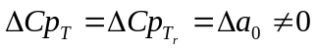 (3-43);
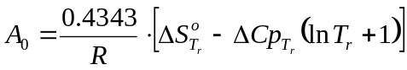 (3-44);
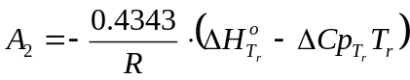 (3-45);
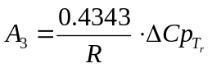 (3-46);
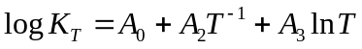 (3-47);
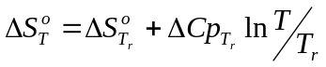 (3-48);
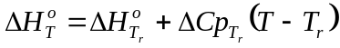 (3-49);
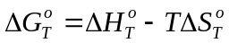 (3-50).
The three-term extrapolation (eqns 3-43 to 3-50) is best suited for isoelectric reactions, and it appears to be still good for non-isoelectric reactions up to T around 150 ºC. The two-term (Van’t Hoff) extrapolation (eqns 3-51 to 3-54), the use of which should be limited to isoelectric cases, is obtained further by zeroing Δa₀ and A₃ off, or 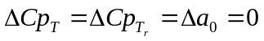:
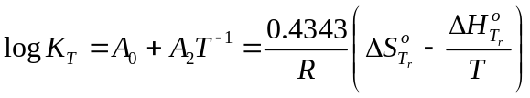 (3-51);
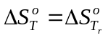 (3-52);
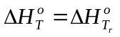 (3-53);
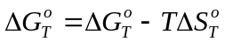 (3-54).
The one-term extrapolation (eqns 3-55 and 3-56) at 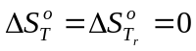has the only non-zero A₂ coefficient, which leads to ΔG_{T} =ΔH_{T} = const (independent of temperature):
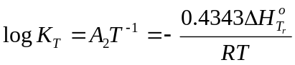 (3-55);
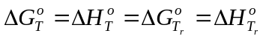 (3-56).
Another one-term extrapolation is obtained from the Van’t Hoff equation (3-51) by setting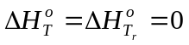, resulting in the equilibrium constant K independent of temperature:
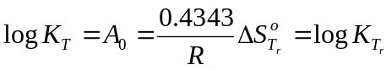 (3-57);
(3-58);
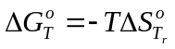 (3-59).
These one-term extrapolations should be applied to isocoulombic reactions, where they can produce good predictions up to 300 ºC (Gu et al., 1994; Kulik, 2002). The above four specific cases are implemented in GEM-Selektor code separately. If one of them is specified then the necessary A_{i} and Δa_{i} coefficients will be computed from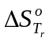,and 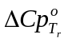values, after all unnecessary coefficients have been zeroed off.

3.3. Pressure corrections of logK
Pressure corrections require that at least the volume change 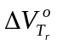in the reaction is known. In the GEM-Selektor ReacDC format, only the constant volume approximation is used, i.e. it is assumed that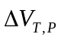=at any P and T of interest. This is a good approximation for “new” substances since molar volumes and fugacities of pure gases that participate in the reaction are automatically corrected to T,P using EoS or another appropriate technique; the molar volumes of minerals are corrected as well from thermal expansion/compressibility data; and the partial molar volumes of aqueous species are corrected using the HKF EoS coefficients. At constant, the pressure correction to ΔG is
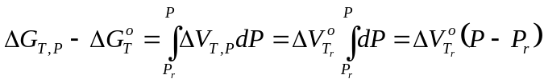 (3-60),
and the pressure correction to the equilibrium constant becomes
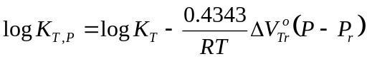 (3-61).
As in this case 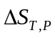= then, analogous to eqn (3-57),
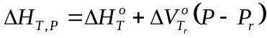 (3-62).

3.4. TP-corrections applying electrostatic and density models
(added by Th. Wagner and D.Kulik to GEM-Selektor v. 2.2.0 on August 10, 2007 )
The modified Ryzhenko-Bryzgalin (MRB) model is based on earlier electrostatic models that were developed to extrapolate equilibrium constants of aqueous complexes to elevated temperatures and pressures. The original model formulation included an explicit dependence of the equilibrium constants (or pK, the negative logarithm of the equilibrium constant) on water density and dielectrical constant (Ryzhenko and Bryzgalin, 1985; Bryzgalin, 1986; 1989)
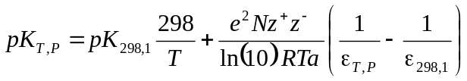 (3-63)
Here, e is the electron charge, N is the Avogadro number, z⁺ and z⁻ are the ionic charges, and ε is the dielectrical constant of water at P and T of interest. The term a stands for 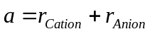, i.e. the sum of the crystallographic radii of the ions. By comparing the model predictions with experimental data, it was found that the parameter a would differ from the sum of the crystallographic radii. Therefore, this parameter was combined with the ionic charges into the adjustable parameter 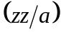, similar to the effective electrostatic radii in the HKF model. From this, the new basic model equation would become (Shvarov and Bastrakov, 1999)
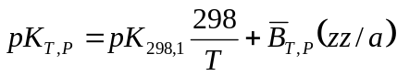 (3-64)
The parameter 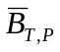does not depend on the complex type, but only on pressure and temperature. It would be calculated from the dissociation constant of water as given by Marshall and Franck (1981)
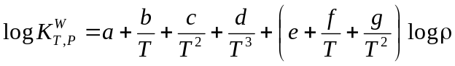 (3-65)
This would result in a best-fit value of 1.0107 for 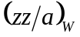(Shvarov and Bastrakov, 1999). The function can now be calculated at any pressure and temperature
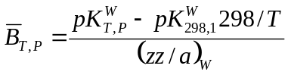 (3-66)
To improve the representation of experimentally determined complex dissociation constants, the parameter would become temperature dependent (Shvarov and Bastrakov, 1999)
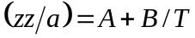 (3-67)
By noting the relationship between 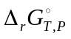 and the equilibrium constant
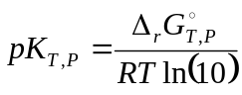 (3-68)
the full expression for the can be obtained through combination of eqns (3-64), (3-65), (3-67) and (3-68). The analytical expressions for 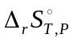, 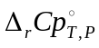 and 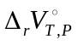are then obtained from the temperature and pressure derivatives of thefunction. These equations are not given in the literature and were developed for a consistent implementation of the MRB model into the GEM-Selektor code. The enthalpy of reaction, 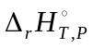, is calculated from entropy and Gibbs energy by difference. The full derivation of these equations is given in Appendix 1. Implementation of the modified Ryzhenko-Bryzgalin (MRB) model in GEM-Selektor is realized as a special case of the ReacDC database module, i.e. reaction-defined dependent components.
The Marshall-Franck density model (Marshall and Franck, 1981; Mesmer et al., 1991) allows calculation of the dissociation constants of aqueous electrolytes at elevated temperatures and pressures from the empirical equation:
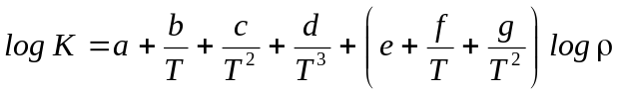 (3-69)
The analytical expressions for , and are readily obtained from the temperature and pressure derivatives of thefunction, and are similar to those for the modified Ryzhenko-Bryzgalin model. Fit coefficients for this model are available for a number of common electrolytes such as NaCl, KCl, NaOH and KOH (Ho et al., 1994; Ho and Palmer, 1996; 1997). The density model would potentially allow to extrapolate equilibrium constants beyond the current 5 kbar pressure limit of the HKF model, if an appropriate equation of state for the thermodynamic properties of aqueous ions at high pressures would become available.

References
Anderson G.M., Crerar D.A. (1993) Thermodynamics in geochemistry: The equilibrium model. Oxford Univ. Press, N.Y., Oxford.
Bryzgalin O.V. (1986) Estimating dissociation constants in the supercritical region for some strong electrolytes from an electrostatic model. Geochem. Internat., 23 (2), 84-95.
Bryzgalin O.V. (1989) Electrostatic-model estimate of electrolyte dissociation constants up to 800°C and 5 kbar. Geochem. Internat., 26 (10), 63-70.
Gu Y., Gammons C.H., Bloom M.S. (1994) A one-term extrapolation method for estimating equilibrium constants of aqueous reactions at elevated temperatures. Geochim. Cosmochim. Acta, 58, 3545-3560.
Ho P.C., Palmer D.A., Mesmer R.E. (1994) Electrical conductivity measurements of aqueous sodium chloride solutions to 600 °C and 300 MPa. J. Solut. Chem., 23, 997-1018.
Ho P.C., Palmer D.A. (1996) Ion association of dilute aqueous sodium hydroxide solutions to 600 °C and 300 MPa by conductance measurements. J. Solut. Chem., 25, 711-729.
Ho P.C., Palmer D.A. (1997) Ion association of dilute aqueous potassium chloride and potassium hydroxide solutions to 600 °C and 300 MPa determined by electrical conductance measurements. Geochim. Cosmochim. Acta, 61, 3027-3040.
Kulik D.A. (2000) Geochim. Cosmochim. Acta, 64, 3161-3179.
Kulik D.A. (2002) In: The use of thermodynamic databases in performance assessment. Workshop proceedings, Barcelona, Spain, 29-30 May 2001. OECD, Paris, p. 125-137.
Kharaka Y.K., Gunter W.D., Aggarwal P.K. et al. (1988) SOLMINEQ.88: A computer program for geochemical modeling of water-rock interactions. USGS WRIR 88-4227. Menlo Park, CA.
Marshall W.L., Franck E.U. (1981) Ion product of water substance, 0-1000°C, 1-10000 bars. New international formulation and its background. J. Phys. Chem. Ref. Data, 10, 295-304.
Mesmer R.E., Palmer D.A., Simonson J.M. (1991) Ion association at high temperatures and pressures. In: Pitzer K.S. (ed.) Activity coefficients in electrolyte solutions. CRC Press, Boston.
Nordstrom D.K., Munoz J.L. (1988) Geochemical thermodynamics, Blackwell, Boston.
Puigdomenech I., Rard J.A., Plyasunov A.V., Grenthe I. (1997) Chapter X in: Modelling in aquatic chemistry, OECD Paris, 427-493.
Ryzhenko B.N., Bryzgalin O.V., Artamkina I.Y., Spasennykh M.Y., Shapkin A.I. (1985) An electrostatic model for the electrolytic dissociation of inorganic substances dissolved in water. Geochem. Internat., 22 (9), 138-144.
Shock E.L., Helgeson H.C. (1988) Calculation of the thermodynamic and transport properties of aqueous species at high pressures and temperatures: Correlation algorithms for ionic species and equation of state predictions to 5 kb and 1000°C. Geochim. Cosmochim. Acta, 52, 2009-2036.
Shock E.L., Sassani D.C., Willis M., Sverjensky D.A. (1997) Inorganic species in geologic fluids: Correlations among standard molal thermodynamic properties of aqueous ions and hydroxide complexes. Geochim. Cosmochim. Acta, 61, 907-950.
Sverjensky D.A., Shock E.L., Helgeson H.C. (1997) Prediction of the thermodynamic properties of aqueous metal complexes to 1000°C and 5 kb. Geochim. Cosmochim. Acta, 61, 1359-1412.
Shvarov Y., Bastrakov E. (1999) HCh: a software package for geochemical equilibrium modelling. Users guide. Australian Geological Survey Organisation, Record 1999/25, 61 pp.

Appendix 3.1. Derivative reaction properties calculated from the MRB model.
The full expression for the is given by
(3.A1) 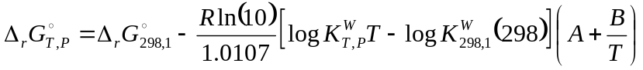
Rearranging and substituting the expression for the dissociation constant of water from Marshall and Franck (1981) results in
(3.A2)

Now we define the following terms
(3.A3) 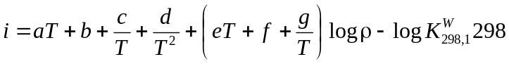
(3.A4) 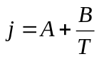

The derivative thermodynamic properties are then obtained as
(3.A5) 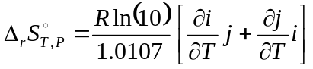
(3.A6) 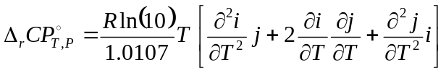
(3.A7) 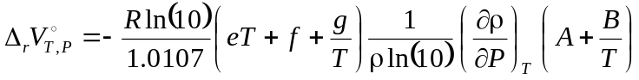

with the partial derivatives of i and j given by

(3.A8) 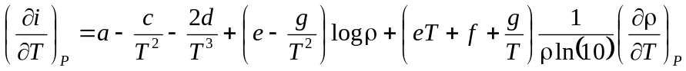
(3.A9) 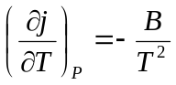
(3.A10) 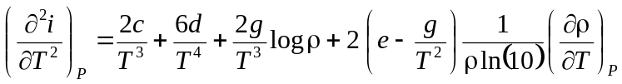
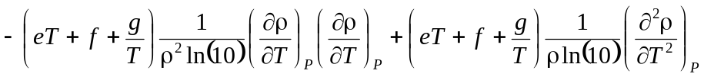
(3.A11) 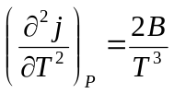

Appendix 3.2. Built-in options for calculation of temperature and pressure correction to standard molar (partial molal) properties of substances and reactions using data in ReacDC records (GEM-Selektor v.2.3 PSI).

Code | Model | Input parameters
KZZ | Langrangian interpolation of discrete logK values | table with experimental logK values (up to 20 temperatures and 10 pressures), entered into logKTP array
K3C | 3-term extrapolation with constant reaction volume | logK of reaction at at 25 °C and 1 bar, constant heat capacity and volume of reaction
K2C | 2-term extrapolation with constant reaction volume | logK of reaction at at 25 °C and 1 bar, constant entropy (dCpr = 0) and volume of reaction
K1C | 1-term extraplolation with constant reaction volume | logK of reaction at at 25 °C and 1 bar, constant Gibbs energy and volume of reaction
K0C | 1-term extrapolation with constant reaction volume | logK of reaction at at 25 °C and 1 bar, constant logK (dHr = 0) and volume of reaction
KLC | empirical function logK = f(T) with constant reaction volume | logK of reaction at at 25 °C and 1 bar, up to 7 empirical coefficients (a₀ to a₆), entered into aiLgKr array
KXC | empirical function dCp_{r} = f(T) with constant reaction volume | logK of reaction at at 25 °C and 1 bar, up to 5 empirical coefficients (a₀ to a₄), entered into adCpT array
KY0 | modified Ryzhenko-Bryzgalin (MRB) model | logK of reaction at at 25 °C and 1 bar, MRB coefficients (pK₂₉₈, A, B) entered into a_dST array
KR0 | Marshall-Franck density model | logK of reaction at at 25 °C and 1 bar, up to 7 empirical coefficients (a to g) entered into a_dST array
K3P | prediction of Sº, Cpº and Vº of aqueous complexes using Pronsprep97 algorithm from Sverjensky et al. (1997) | logK of dissociation reaction at at 25 °C and 1 bar (see Appendix 3.3)
KEP | prediction of Sº, Cpº and Vº of aqueous hydroxide complexes using an algorithm from Shock et al. (1997) | logK of dissociation reaction at at 25 °C and 1 bar (see Appendix 3.3)

Note: alternative to assuming constant molar volume of reaction (as set by the third letter 'C' in the code), the molar volume can also be calculated from five empirical coefficients. This option is invoked by setting the third letter to 'K' (e.g., K3K instead of K3C) and entering the empirical cofficients for V=f(T,P) into adVTP array.

Appendix 3.3. Using Pronsprep, Pronsprep-OH and Parcor algorithms for prediction of standard state and HKF equation of state parameters in GEM-Selektor
These methods for estimation of standard state and HKF (Helgeson-Kirkham-Flowers equation of state) parameters for aqueous species were developed by E.L.Shock and D.A.Sverjensky as supporting tools for the extension of SUPCRT92 data base. The algorithms are now built into the GEM-Selektor code; they only work for two specific classes of species where empirical correlations between properties have been found (Sverjensky et al., 1997; Shock et al., 1997; Shock and Helgeson, 1988). These include (1) simple mononuclear metal complexes with simple ligands (Sverjensky et al., 1997), and (2) mononuclear hydroxide complexes (Shock et al., 1997), both with ligand numbers up to 4. Possible ligands for the metal complexes are halides (F⁻, Cl⁻, Br⁻, I⁻), carbonates (CO₃²⁻ and HCO₃⁻), sulfates and bisulfides (SO₄²⁻, HSO₄⁻, HS⁻), with possible extension to phosphates (H₂PO₄⁻, HPO₄²⁻, PO₄³⁻) and nitrates (NO₃⁻).
In both Pronsprep and Pronsprep-OH variants, the procedure includes two principal steps. In step one, the standard state properties (Sº, Cpº, Vº) are predicted using the Pronsprep (simple metal complexes) or Pronsprep-OH (hydroxide complexes) algorithm. This part is done in ReacDC module in Thermodynamic Database Management group. Execution of either Pronsprep or Pronsprep-OH will automatically create a new DComp record. The prediction of HKF parameters from the standard state properties is then done through the Parcor algorithm (Shock and Helgeson, 1988) by recalculating that record in the DComp module. It is very important that definition of the metal complex species (including hydroxides) is (1) always done in terms of dissociation and (2) that stepwise formation constants (that are commonly reported in experimental papers) are recalculated to give cumulative formation constants. Examples for typical reaction stoichiometries for Th fluoride and hydroxide species are given below.
Th fluoride complexes:
ThF⁺³ = Th⁺⁴ + F⁻ (log K: –8.0)
ThF₂⁺² = Th⁺⁴ + 2 F⁻ (log K: –14.2)
ThF₃⁺ = Th⁺⁴ + 3 F⁻ (log K: –18.9)
ThF₄ = Th⁺⁴ + 4 F⁻ (log K: –22.3)
Th hydroxide complexes
ThOH⁺³ = Th⁺⁴ + OH⁻ (log K: –11.8)
ThO⁺² + H₂O = Th⁺⁴ + 2 OH⁻ (log K: –22.0)
ThO₂H⁺ + H₂O = Th⁺⁴ + 3 OH⁻ (log K: –31.0)
ThO₂ + 2 H₂O = Th⁺⁴ + 4 OH⁻ (log K: –38.5)
Note that for hydroxide species, non-conventional (dehydrated) stoichiometries must be used, and that the reactions need to be written exactly according to the scheme that is listed above. Otherwise the correlation algorithm will either produce incorrect results or reaction properties of those reactions that involve H₂O will not be correct. After both Pronsprep calculations are completed, properties of species with conventional stoichiometry can be obtained by simply adding the appropriate properties of water. This has to be done before the Parcor algorithm in DComp is used to obtain HKF parameters from standard state properties. This utilizes the convention that all thermodynamic properties for reactions between non-conventional and conventional hydroxide species are zero. For the Th hydroxide complexes in the example above, properties for conventional species are obtained from the relationships:
Th(OH)₂⁺² = ThO⁺² + H₂O (Δ_{r}G = 0, Δ_{r}S = 0, Δ_{r}H = 0, Δ_{r}Cp = 0, Δ_{r}V = 0)
Practically, using the Pronsprep and Parcor algorithms requires that first a new ReacDC record is created (using ReacDC wizard), where the new complex is defined as given in the examples above. It is important to set the RecMod codes (step 1 of the wizard) to K3P for normal Pronsprep and to KEP for Pronsprep-OH. After completing steps 1 - 3 of the wizard, a dialog box appears that allows selecting the component species (cation and ligands, in addition water in case of Pronsprep-OH). Now Page1 of the new ReacDC record should be visible. Next you need to set up the stoichiometric coefficients for the reaction in the SC_DC field. Remember that the reaction has to be written as dissociation, so the new complex always gets a coefficient of –1 (reactant side), whereas cation and ligand have positive values (product side). Then you need to fill the remaining entries on Page1 of ReacDC. Essentially all values are set to 0 or unknown value (---) except the equilibrium constant (log K) of the reaction that is placed in the logKr[1] field. For filling these fields correctly, simply follow the list below:

V0r[0] molar volume effect of the reaction: set to 0
logKr[0] K of the reaction: set to unknown value (---)
G0r[0] Gibbs free energy of reaction: set to (---)
H0r[0] enthalpy of the reaction: set to (---)
S0r[0] entropy of the reaction: set to 0
Cpr[0] heat capacity of the reaction: set to 0
V0r[1] molar volume of the new complex: set to (---)
logKr[1] logK of the reaction at 298.15 K and 1 bar: put here logK of dissociation
G0r[1] Gibbs free energy of the new complex: set to (---)
H0r[1] enthalpy of the new complex: set to (---)
S0r[1] entropy of the new complex: set to (---)
Cpr[1] heat capacity of the new complex: set to (---)
Save the record and recalculate it. Answer all the appearing questions with yes. The properties will be calculated and a new DComp record with estimated HKF parameters for the new complex automatically created. Now you have to change to the DComp module. Find the newly-created Dcomp record with your complex, and go to Page2 of the DComp window. There the TPcMod flags should be already set automatically to the code combination HKP to activate the Parcor estimation procedure. For some hydroxide complexes this currently does not work correctly, so one need to do remake of the DComp record and set the TPcMod codes to HKP manually on step 1 of the DComp wizard. Recalculate the record and you will see that the flags on Page2 will change to HKF. Recalculate the record once more (to get correct Cpº, Vº and Hº of the complex), and your new estimated data are ready for use in modeling.

